# Brandon Allenczy

## Clustering Assignment

library("tidyverse")

## -- Attaching packages -------------------------------------------------------------------------------------------------- tidyverse 1.2.1 --

## v ggplot2 3.1.0 v purrr 0.3.0  
## v tibble 2.0.1 v dplyr 0.7.8  
## v tidyr 0.8.2 v stringr 1.3.1  
## v readr 1.3.1 v forcats 0.3.0

## -- Conflicts ----------------------------------------------------------------------------------------------------- tidyverse_conflicts() --  
## x dplyr::filter() masks stats::filter()  
## x dplyr::lag() masks stats::lag()

library("cluster")  
library("factoextra")

## Welcome! Related Books: `Practical Guide To Cluster Analysis in R` at https://goo.gl/13EFCZ

library("dendextend")

##   
## ---------------------  
## Welcome to dendextend version 1.9.0  
## Type citation('dendextend') for how to cite the package.  
##   
## Type browseVignettes(package = 'dendextend') for the package vignette.  
## The github page is: https://github.com/talgalili/dendextend/  
##   
## Suggestions and bug-reports can be submitted at: https://github.com/talgalili/dendextend/issues  
## Or contact: <tal.galili@gmail.com>  
##   
## To suppress this message use: suppressPackageStartupMessages(library(dendextend))  
## ---------------------

##   
## Attaching package: 'dendextend'

## The following object is masked from 'package:stats':  
##   
## cutree

# Read in dataset

library(readxl)  
trucks <- read.csv("~/BAN 502/Module 6/trucks.csv")  
View(trucks)

# Distance and speeding relationship

ggplot(trucks)+  
 geom_point(mapping=aes(x=Distance,y=Speeding))

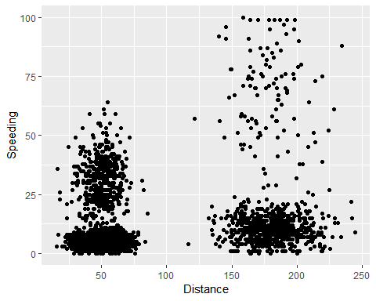

Just from looking at the natural relationship in our data, we can already see a few clusters that exist. Two main clusters exist: One between 0 and 100, with the other betweeen 150 and 250. Within these clusters, we can see other sub-clusters that start to form.

# Creating and scaling trucks2

trucks2=select(trucks,"Distance","Speeding")

trucks2=as.data.frame(scale(trucks2))

# K means clustering

set.seed(1234)  
cluster1=kmeans(trucks2,2)

fviz_cluster(cluster1,trucks2)

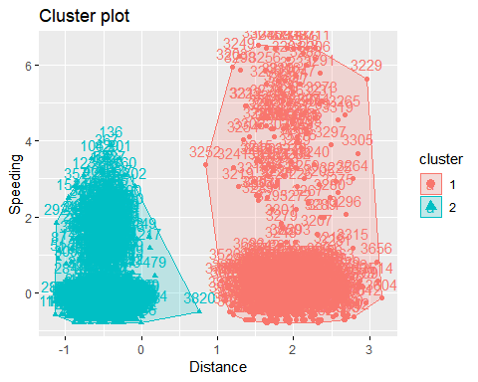

From this dataset, it doesn’t look like our drivers share any of the same characteristics. Cluster 2 is significantly tigter and more centralized than cluster 1 as cluster 1 has many values that are scattered around.

# Different clustering methods

set.seed(123)  
fviz_nbclust(trucks2,kmeans,method="wss")

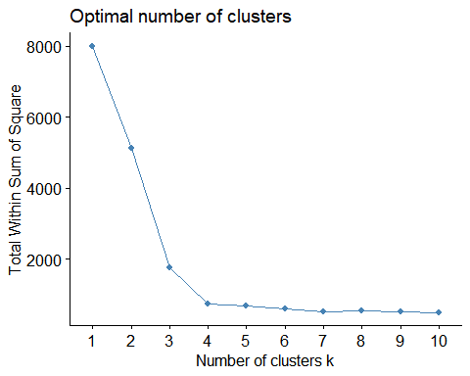

set.seed(123)  
fviz_nbclust(trucks2,kmeans,method = "silhouette")

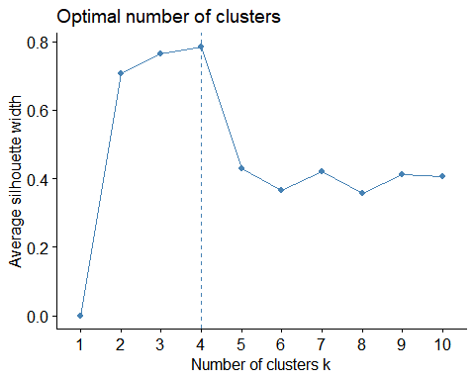

It seems like there is a general consensus as to the optimum number of clusters from these two models. Though one is probably closer to 3 and the other closer to 4, they are generally around the same area.

set.seed(1234)  
cluster2=kmeans(trucks2,4)  
cluster2

## K-means clustering with 4 clusters of sizes 695, 2774, 104, 427  
##   
## Cluster means:  
## Distance Speeding  
## 1 1.9523882 -0.01396965  
## 2 -0.4867234 -0.40244705  
## 3 1.9037667 4.34528041  
## 4 -0.4794634 1.57889429  
##   
## Clustering vector:  
## [1] 4 4 4 4 4 2 4 2 4 4 4 4 4 4 4 4 4 4 4 4 4 4 2 4 4 4 4 2 4 4 4 4 4 4  
## [35] 4 4 4 4 4 4 4 2 4 4 4 2 4 4 4 4 4 4 4 4 4 4 4 4 2 4 4 4 4 4 4 4 4 4  
## [69] 4 4 4 2 4 4 4 4 4 4 4 4 4 2 4 2 4 2 4 4 4 4 4 2 4 4 4 4 4 4 4 4 4 4  
## [103] 2 4 4 4 4 4 4 4 4 2 4 4 4 4 4 4 4 4 4 4 4 4 4 4 4 4 4 4 4 4 4 2 4 4  
## [137] 4 4 2 4 4 4 4 4 2 4 2 4 4 4 4 4 4 4 4 4 4 2 4 4 4 4 4 4 2 4 4 4 4 4  
## [171] 4 4 4 4 4 4 4 4 4 4 2 4 4 4 4 4 4 4 2 4 2 4 4 4 4 4 4 4 4 4 4 4 4 4  
## [205] 4 4 4 4 4 4 2 4 4 4 4 4 4 4 4 4 4 4 4 4 4 4 4 4 4 4 4 4 4 4 4 4 4 4  
## [239] 4 4 4 4 4 4 4 4 4 4 4 2 4 4 4 2 4 4 4 4 4 4 4 4 4 2 4 4 4 4 4 4 4 4  
## [273] 4 4 4 4 2 4 4 4 4 4 4 2 4 4 2 4 4 4 4 4 4 4 4 2 4 4 4 4 4 4 4 4 4 4  
## [307] 4 4 4 4 4 4 4 4 4 4 4 2 4 4 4 4 4 4 4 2 4 4 4 4 4 4 4 4 4 4 4 2 4 4  
## [341] 4 4 4 4 4 2 4 2 4 4 4 4 4 4 4 4 4 4 4 2 4 4 4 4 4 4 4 4 4 4 4 4 4 4  
## [375] 4 4 4 4 4 4 4 4 4 4 4 4 4 2 4 4 4 2 4 4 4 4 4 4 4 4 4 4 4 4 4 4 4 4  
## [409] 2 2 4 4 4 4 2 2 2 4 4 2 4 4 4 4 4 4 4 4 4 4 4 4 4 4 4 4 4 2 4 2 2 2  
## [443] 2 4 4 4 4 4 4 4 4 4 2 4 2 4 4 4 4 4 4 4 4 4 4 4 4 4 4 4 4 4 4 4 4 4  
## [477] 4 4 2 4 2 2 2 2 2 2 2 2 2 2 2 2 2 2 2 2 2 2 2 2 2 2 2 2 2 2 2 2 2 2  
## [511] 2 2 2 2 2 2 2 2 2 2 2 2 2 2 2 2 2 2 2 2 2 2 2 2 2 2 2 2 2 2 2 2 2 2  
## [545] 2 2 2 2 2 2 2 2 2 2 2 2 2 2 2 2 2 2 2 2 2 2 2 2 2 2 2 2 2 2 2 2 2 2  
## [579] 2 2 2 2 2 2 2 2 2 2 2 2 2 2 2 2 2 2 2 2 2 2 2 2 2 2 2 2 2 2 2 2 2 2  
## [613] 2 2 2 2 2 2 2 2 2 2 2 2 2 2 2 2 2 2 2 2 2 2 2 2 2 2 2 2 2 2 2 2 2 2  
## [647] 2 2 2 2 2 2 2 2 2 2 2 2 2 2 2 2 2 2 2 2 2 2 2 2 2 2 2 2 2 2 2 2 2 2  
## [681] 2 2 2 2 2 2 2 2 2 2 2 2 2 2 2 2 2 2 2 2 2 2 2 2 2 2 2 2 2 2 2 2 2 2  
## [715] 2 2 2 2 2 2 2 2 2 2 2 2 2 2 2 2 2 2 2 2 2 2 2 2 2 2 2 2 2 2 2 2 2 2  
## [749] 2 2 2 2 2 2 2 2 2 2 2 2 2 2 2 2 2 2 2 2 2 2 2 2 2 2 2 2 2 2 2 2 2 2  
## [783] 2 2 2 2 2 2 2 2 2 2 2 2 2 2 2 2 2 2 2 2 2 2 2 2 2 2 2 2 2 2 2 2 2 2  
## [817] 2 2 2 2 2 2 2 2 2 2 2 2 2 2 2 2 2 2 2 2 2 2 2 2 2 2 2 2 2 2 2 2 2 2  
## [851] 2 2 2 2 2 2 2 2 2 2 2 2 2 2 2 2 2 2 2 2 2 2 2 2 2 2 2 2 2 2 2 2 2 2  
## [885] 2 2 2 2 2 2 2 2 2 2 2 2 2 2 2 2 2 2 2 2 2 2 2 2 2 2 2 2 2 2 2 2 2 2  
## [919] 2 2 2 2 2 2 2 2 2 2 2 2 2 2 2 2 2 2 2 2 2 2 2 2 2 2 2 2 2 2 2 2 2 2  
## [953] 2 2 2 2 2 2 2 2 2 2 2 2 2 2 2 2 2 2 2 2 2 2 2 2 2 2 2 2 2 2 2 2 2 2  
## [987] 2 2 2 2 2 2 2 2 2 2 2 2 2 2 2 2 2 2 2 2 2 2 2 2 2 2 2 2 2 2 2 2 2 2  
## [1021] 2 2 2 2 2 2 2 2 2 2 2 2 2 2 2 2 2 2 2 2 2 2 2 2 2 2 2 2 2 2 2 2 2 2  
## [1055] 2 2 2 2 2 2 2 2 2 2 2 2 2 2 2 2 2 2 2 2 2 2 2 2 2 2 2 2 2 2 2 2 2 2  
## [1089] 2 2 2 2 2 2 2 2 2 2 2 2 2 2 2 2 2 2 2 2 2 2 2 2 2 2 2 2 2 2 2 2 2 2  
## [1123] 2 2 2 2 2 2 2 2 2 2 2 2 2 2 2 2 2 2 2 2 2 2 2 2 2 2 2 2 2 2 2 2 2 2  
## [1157] 2 2 2 2 2 2 2 2 2 2 2 2 2 2 2 2 2 2 2 2 2 2 2 2 2 2 2 2 2 2 2 2 2 2  
## [1191] 2 2 2 2 2 2 2 2 2 2 2 2 2 2 2 2 2 2 2 2 2 2 2 2 2 2 2 2 2 2 2 2 2 2  
## [1225] 2 2 2 2 2 2 2 2 2 2 2 2 2 2 2 2 2 2 2 2 2 2 2 2 2 2 2 2 2 2 2 2 2 2  
## [1259] 2 2 2 2 2 2 2 2 2 2 2 2 2 2 2 2 2 2 2 2 2 2 2 2 2 2 2 2 2 2 2 2 2 2  
## [1293] 2 2 2 2 2 2 2 2 2 2 2 2 2 2 2 2 2 2 2 2 2 2 2 2 2 2 2 2 2 2 2 2 2 2  
## [1327] 2 2 2 2 2 2 2 2 2 2 2 2 2 2 2 2 2 2 2 2 2 2 2 2 2 2 2 2 2 2 2 2 2 2  
## [1361] 2 2 2 2 2 2 2 2 2 2 2 2 2 2 2 2 2 2 2 2 2 2 2 2 2 2 2 2 2 2 2 2 2 2  
## [1395] 2 2 2 2 2 2 2 2 2 2 2 2 2 2 2 2 2 2 2 2 2 2 2 2 2 2 2 2 2 2 2 2 2 2  
## [1429] 2 2 2 2 2 2 2 2 2 2 2 2 2 2 2 2 2 2 2 2 2 2 2 2 2 2 2 2 2 2 2 2 2 2  
## [1463] 2 2 2 2 2 2 2 2 2 2 2 2 2 2 2 2 2 2 2 2 2 2 2 2 2 2 2 2 2 2 2 2 2 2  
## [1497] 2 2 2 2 2 2 2 2 2 2 2 2 2 2 2 2 2 2 2 2 2 2 2 2 2 2 2 2 2 2 2 2 2 2  
## [1531] 2 2 2 2 2 2 2 2 2 2 2 2 2 2 2 2 2 2 2 2 2 2 2 2 2 2 2 2 2 2 2 2 2 2  
## [1565] 2 2 2 2 2 2 2 2 2 2 2 2 2 2 2 2 2 2 2 2 2 2 2 2 2 2 2 2 2 2 2 2 2 2  
## [1599] 2 2 2 2 2 2 2 2 2 2 2 2 2 2 2 2 2 2 2 2 2 2 2 2 2 2 2 2 2 2 2 2 2 2  
## [1633] 2 2 2 2 2 2 2 2 2 2 2 2 2 2 2 2 2 2 2 2 2 2 2 2 2 2 2 2 2 2 2 2 2 2  
## [1667] 2 2 2 2 2 2 2 2 2 2 2 2 2 2 2 2 2 2 2 2 2 2 2 2 2 2 2 2 2 2 2 2 2 2  
## [1701] 2 2 2 2 2 2 2 2 2 2 2 2 2 2 2 2 2 2 2 2 2 2 2 2 2 2 2 2 2 2 2 2 2 2  
## [1735] 2 2 2 2 2 2 2 2 2 2 2 2 2 2 2 2 2 2 2 2 2 2 2 2 2 2 2 2 2 2 2 2 2 2  
## [1769] 2 2 2 2 2 2 2 2 2 2 2 2 2 2 2 2 2 2 2 2 2 2 2 2 2 2 2 2 2 2 2 2 2 2  
## [1803] 2 2 2 2 2 2 2 2 2 2 2 2 2 2 2 2 2 2 2 2 2 2 2 2 2 2 2 2 2 2 2 2 2 2  
## [1837] 2 2 2 2 2 2 2 2 2 2 2 2 2 2 2 2 2 2 2 2 2 2 2 2 2 2 2 2 2 2 2 2 2 2  
## [1871] 2 2 2 2 2 2 2 2 2 2 2 2 2 2 2 2 2 2 2 2 2 2 2 2 2 2 2 2 2 2 2 2 2 2  
## [1905] 2 2 2 2 2 2 2 2 2 2 2 2 2 2 2 2 2 2 2 2 2 2 2 2 2 2 2 2 2 2 2 2 2 2  
## [1939] 2 2 2 2 2 2 2 2 2 2 2 2 2 2 2 2 2 2 2 2 2 2 2 2 2 2 2 2 2 2 2 2 2 2  
## [1973] 2 2 2 2 2 2 2 2 2 2 2 2 2 2 2 2 2 2 2 2 2 2 2 2 2 2 2 2 2 2 2 2 2 2  
## [2007] 2 2 2 2 2 2 2 2 2 2 2 2 2 2 2 2 2 2 2 2 2 2 2 2 2 2 2 2 2 2 2 2 2 2  
## [2041] 2 2 2 2 2 2 2 2 2 2 2 2 2 2 2 2 2 2 2 2 2 2 2 2 2 2 2 2 2 2 2 2 2 2  
## [2075] 2 2 2 2 2 2 2 2 2 2 2 2 2 2 2 2 2 2 2 2 2 2 2 2 2 2 2 2 2 2 2 2 2 2  
## [2109] 2 2 2 2 2 2 2 2 2 2 2 2 2 2 2 2 2 2 2 2 2 2 2 2 2 2 2 2 2 2 2 2 2 2  
## [2143] 2 2 2 2 2 2 2 2 2 2 2 2 2 2 2 2 2 2 2 2 2 2 2 2 2 2 2 2 2 2 2 2 2 2  
## [2177] 2 2 2 2 2 2 2 2 2 2 2 2 2 2 2 2 2 2 2 2 2 2 2 2 2 2 2 2 2 2 2 2 2 2  
## [2211] 2 2 2 2 2 2 2 2 2 2 2 2 2 2 2 2 2 2 2 2 2 2 2 2 2 2 2 2 2 2 2 2 2 2  
## [2245] 2 2 2 2 2 2 2 2 2 2 2 2 2 2 2 2 2 2 2 2 2 2 2 2 2 2 2 2 2 2 2 2 2 2  
## [2279] 2 2 2 2 2 2 2 2 2 2 2 2 2 2 2 2 2 2 2 2 2 2 2 2 2 2 2 2 2 2 2 2 2 2  
## [2313] 2 2 2 2 2 2 2 2 2 2 2 2 2 2 2 2 2 2 2 2 2 2 2 2 2 2 2 2 2 2 2 2 2 2  
## [2347] 2 2 2 2 2 2 2 2 2 2 2 2 2 2 2 2 2 2 2 2 2 2 2 2 2 2 2 2 2 2 2 2 2 2  
## [2381] 2 2 2 2 2 2 2 2 2 2 2 2 2 2 2 2 2 2 2 2 2 2 2 2 2 2 2 2 2 2 2 2 2 2  
## [2415] 2 2 2 2 2 2 2 2 2 2 2 2 2 2 2 2 2 2 2 2 2 2 2 2 2 2 2 2 2 2 2 2 2 2  
## [2449] 2 2 2 2 2 2 2 2 2 2 2 2 2 2 2 2 2 2 2 2 2 2 2 2 2 2 2 2 2 2 2 2 2 2  
## [2483] 2 2 2 2 2 2 2 2 2 2 2 2 2 2 2 2 2 2 2 2 2 2 2 2 2 2 2 2 2 2 2 2 2 2  
## [2517] 2 2 2 2 2 2 2 2 2 2 2 2 2 2 2 2 2 2 2 2 2 2 2 2 2 2 2 2 2 2 2 2 2 2  
## [2551] 2 2 2 2 2 2 2 2 2 2 2 2 2 2 2 2 2 2 2 2 2 2 2 2 2 2 2 2 2 2 2 2 2 2  
## [2585] 2 2 2 2 2 2 2 2 2 2 2 2 2 2 2 2 2 2 2 2 2 2 2 2 2 2 2 2 2 2 2 2 2 2  
## [2619] 2 2 2 2 2 2 2 2 2 2 2 2 2 2 2 2 2 2 2 2 2 2 2 2 2 2 2 2 2 2 2 2 2 2  
## [2653] 2 2 2 2 2 2 2 2 2 2 2 2 2 2 2 2 2 2 2 2 2 2 2 2 2 2 2 2 2 2 2 2 2 2  
## [2687] 2 2 2 2 2 2 2 2 2 2 2 2 2 2 2 2 2 2 2 2 2 2 2 2 2 2 2 2 2 2 2 2 2 2  
## [2721] 2 2 2 2 2 2 2 2 2 2 2 2 2 2 2 2 2 2 2 2 2 2 2 2 2 2 2 2 2 2 2 2 2 2  
## [2755] 2 2 2 2 2 2 2 2 2 2 2 2 2 2 2 2 2 2 2 2 2 2 2 2 2 2 2 2 2 2 2 2 2 2  
## [2789] 2 2 2 2 2 2 2 2 2 2 2 2 2 2 2 2 2 2 2 2 2 2 2 2 2 2 2 2 2 2 2 2 2 2  
## [2823] 2 2 2 2 2 2 2 2 2 2 2 2 2 2 2 2 2 2 2 2 2 2 2 2 2 2 2 2 2 2 2 2 2 2  
## [2857] 2 2 2 2 2 2 2 2 2 2 2 2 2 2 2 2 2 2 2 2 2 2 2 2 2 2 2 2 2 2 2 2 2 2  
## [2891] 2 2 2 2 2 2 2 2 2 2 2 2 2 2 2 2 2 2 2 2 2 2 2 2 2 2 2 2 2 2 2 2 2 2  
## [2925] 2 2 2 2 2 2 2 2 2 2 2 2 2 2 2 2 2 2 2 2 2 2 2 2 2 2 2 2 2 2 2 2 2 2  
## [2959] 2 2 2 2 2 2 2 2 2 2 2 2 2 2 2 2 2 2 2 2 2 2 2 2 2 2 2 2 2 2 2 2 2 2  
## [2993] 2 2 2 2 2 2 2 2 2 2 2 2 2 2 2 2 2 2 2 2 2 2 2 2 2 2 2 2 2 2 2 2 2 2  
## [3027] 2 2 2 2 2 2 2 2 2 2 2 2 2 2 2 2 2 2 2 2 2 2 2 2 2 2 2 2 2 2 2 2 2 2  
## [3061] 2 2 2 2 2 2 2 2 2 2 2 2 2 2 2 2 2 2 2 2 2 2 2 2 2 2 2 2 2 2 2 2 2 2  
## [3095] 2 2 2 2 2 2 2 2 2 2 2 2 2 2 2 2 2 2 2 2 2 2 2 2 2 2 2 2 2 2 2 2 2 2  
## [3129] 2 2 2 2 2 2 2 2 2 2 2 2 2 2 2 2 2 2 2 2 2 2 2 2 2 2 2 2 2 2 2 2 2 2  
## [3163] 2 2 2 2 2 2 2 2 2 2 2 2 2 2 2 2 2 2 2 2 2 2 2 2 2 2 2 2 2 2 2 2 2 2  
## [3197] 2 2 2 2 3 3 3 3 3 3 1 3 3 3 3 3 3 1 3 1 3 3 3 3 1 3 3 3 3 3 3 3 3 3  
## [3231] 3 3 3 3 3 3 3 3 3 3 3 1 3 3 3 3 3 1 3 1 3 3 3 3 3 3 3 3 3 3 3 1 3 3  
## [3265] 3 3 3 3 3 3 3 3 3 3 3 3 3 3 1 3 1 3 3 3 3 3 3 3 1 3 3 3 1 3 3 1 3 3  
## [3299] 3 3 1 3 3 3 3 3 3 3 3 3 3 3 3 1 1 3 3 3 3 3 1 1 1 1 1 1 1 1 1 1 1 1  
## [3333] 1 1 1 1 1 1 1 1 1 1 1 1 1 1 1 1 1 1 1 1 1 1 1 1 1 1 1 1 1 1 1 1 1 1  
## [3367] 1 1 1 1 1 1 1 1 1 1 1 1 1 1 1 1 1 1 1 1 1 1 1 1 1 1 1 1 1 1 1 1 1 1  
## [3401] 1 1 1 1 1 1 1 1 1 1 1 1 1 1 1 1 1 1 1 1 1 1 1 1 1 1 1 1 1 1 1 1 1 1  
## [3435] 1 1 1 1 1 1 1 1 1 1 1 1 1 1 1 1 1 1 1 1 1 1 1 1 1 1 1 1 1 1 1 1 1 1  
## [3469] 1 1 1 1 1 1 1 1 1 1 1 1 1 1 1 1 1 1 1 1 1 1 1 1 1 1 1 1 1 1 1 1 1 1  
## [3503] 1 1 1 1 1 1 1 1 1 1 1 1 1 1 1 1 1 1 1 1 1 1 1 1 1 1 1 1 1 1 1 1 1 1  
## [3537] 1 1 1 1 1 1 1 1 1 1 1 1 1 1 1 1 1 1 1 1 1 1 1 1 1 1 1 1 1 1 1 1 1 1  
## [3571] 1 1 1 1 1 1 1 1 1 1 1 1 1 1 1 1 1 1 1 1 1 1 1 1 1 1 1 1 1 1 1 1 1 1  
## [3605] 1 1 1 1 1 1 1 1 1 1 1 1 1 1 1 1 1 1 1 1 1 1 1 1 1 1 1 1 1 1 1 1 1 1  
## [3639] 1 1 1 1 1 1 1 1 1 1 1 1 1 1 1 1 1 1 1 1 1 1 1 1 1 1 1 1 1 1 1 1 1 1  
## [3673] 1 1 1 1 1 1 1 1 1 1 1 1 1 1 1 1 1 1 1 1 1 1 1 1 1 1 1 1 1 1 1 1 1 1  
## [3707] 1 1 1 1 1 1 1 1 1 1 1 1 1 1 1 1 1 1 1 1 1 1 1 1 1 1 1 1 1 1 1 1 1 1  
## [3741] 1 1 1 1 1 1 1 1 1 1 1 1 1 1 1 1 1 1 1 1 1 1 1 1 1 1 1 1 1 1 1 1 1 1  
## [3775] 1 1 1 1 1 1 1 1 1 1 1 1 1 1 1 1 1 1 1 1 1 1 1 1 1 1 1 1 1 1 1 1 1 1  
## [3809] 1 1 1 1 1 1 1 1 1 1 1 2 1 1 1 1 1 1 1 1 1 1 1 1 1 1 1 1 1 1 1 1 1 1  
## [3843] 1 1 1 1 1 1 1 1 1 1 1 1 1 1 1 1 1 1 1 1 1 1 1 1 1 1 1 1 1 1 1 1 1 1  
## [3877] 1 1 1 1 1 1 1 1 1 1 1 1 1 1 1 1 1 1 1 1 1 1 1 1 1 1 1 1 1 1 1 1 1 1  
## [3911] 1 1 1 1 1 1 1 1 1 1 1 1 1 1 1 1 1 1 1 1 1 1 1 1 1 1 1 1 1 1 1 1 1 1  
## [3945] 1 1 1 1 1 1 1 1 1 1 1 1 1 1 1 1 1 1 1 1 1 1 1 1 1 1 1 1 1 1 1 1 1 1  
## [3979] 1 1 1 1 1 1 1 1 1 1 1 1 1 1 1 1 1 1 1 1 1 1  
##   
## Within cluster sum of squares by cluster:  
## [1] 206.0752 181.9107 165.5278 185.4551  
## (between_SS / total_SS = 90.8 %)  
##   
## Available components:  
##   
## [1] "cluster" "centers" "totss" "withinss"   
## [5] "tot.withinss" "betweenss" "size" "iter"   
## [9] "ifault"

fviz_cluster(cluster2,trucks2)

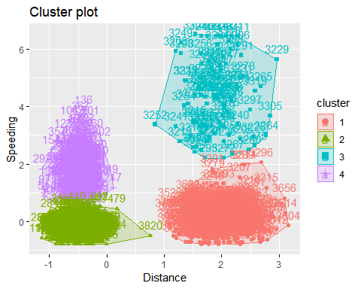

While there are still two areas where the clusters are clearly separated, there are now two clusters within each of those. These seem to be clearly defined with the exception of clusters 2 & 4. These appear to have some overlap, meaning their observations may share some of the same traits.

# Read in wine dataset

library(readxl)  
wine <- read.csv("~/BAN 502/Module 6/wineprice.csv")  
View(wine)

# scaling variables

wine2=select(wine,"Price","WinterRain","AGST","HarvestRain","Age")  
wine2=as.data.frame(scale(wine2))

set.seed(123)  
fviz_nbclust(wine2,kmeans,method="wss")

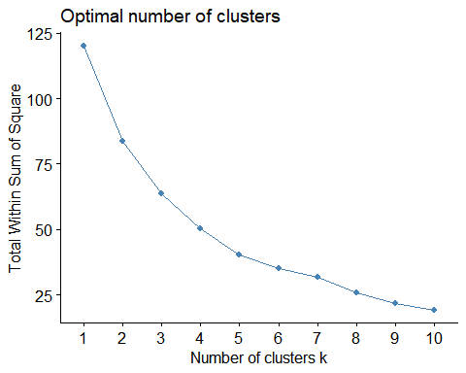

set.seed(123)  
fviz_nbclust(trucks2,kmeans,method = "silhouette")



There looks like there is consensus between the two models, however they vary slightly. The first method looks like the optimum number of clusters should be around 5, whereas the silhouette method recommends using 4 as the optimum number.

set.seed(1234)  
cluster3=kmeans(wine2,4)  
cluster3

## K-means clustering with 4 clusters of sizes 5, 8, 3, 9  
##   
## Cluster means:  
## Price WinterRain AGST HarvestRain Age  
## 1 1.2047467 0.954958750 0.3020210 -1.06907515 0.44201842  
## 2 -0.9973408 0.007333043 -0.7633638 0.98851827 -0.04225176  
## 3 -0.4700981 1.215017181 -0.9351085 -0.84959852 -1.06604442  
## 4 0.3739208 -0.942056626 0.8224590 -0.00155276 0.14733947  
##   
## Clustering vector:  
## [1] 4 1 4 4 2 4 2 1 1 2 4 2 1 3 2 2 1 4 2 4 2 4 4 3 3  
##   
## Within cluster sum of squares by cluster:  
## [1] 7.991457 15.666435 3.498321 24.609221  
## (between_SS / total_SS = 56.9 %)  
##   
## Available components:  
##   
## [1] "cluster" "centers" "totss" "withinss"   
## [5] "tot.withinss" "betweenss" "size" "iter"   
## [9] "ifault"

fviz_cluster(cluster3,wine2)

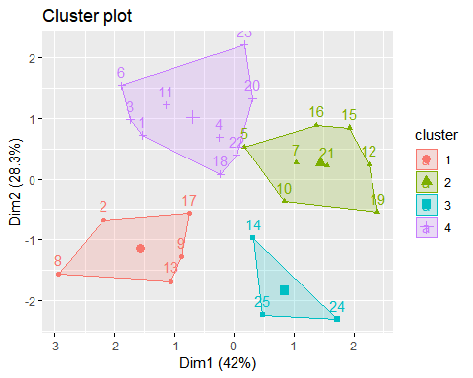

# Agglomerative Clustering

m=c("average", "single", "complete", "ward")  
names(m)=c("average","single","complete","ward")  
  
ac=function(x){  
 agnes(wine2,method=x)$ac  
}  
map_dbl(m,ac)

## average single complete ward   
## 0.5666719 0.2920143 0.7196616 0.8112139

Wards cluster method provides the highest coefficient we will use this to develop the dendogram.

hc=agnes(wine2,method="ward")  
pltree(hc,cex=0.6,hang=-1,main="Agglomerative Dendogram")

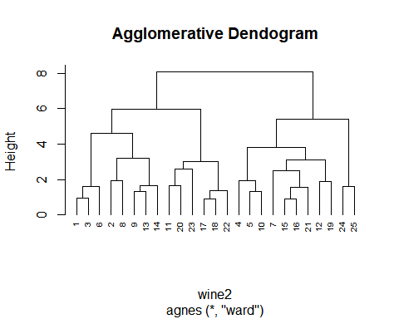

# Diversive Clustering

hc2=diana(wine2)  
pltree(hc2,cex=0.6,hang=-1,main="Divisive Dendogram")

