Project Overview
The application is a client facing dashboard designed by Grazioso Salvare. It is used as an animal rescue training organization identifying dogs that are qualified for specialized search and rescue training. It uses a MongoDB database with outcomes from the Austin Animal Center (AAC) to allow users to select and display available candidate rescue dogs for specific rescue types. The application has been created using development best practices to create an intuitive, user friendly interface which will reduce the amount of time spent in training as well as reduce user errors while providing the capability to make data driven decisions.
Included in the dashboard are the Grazioso Salvare logo; a unique identifier which contains my name; an interactive filter feature to select data; a dynamic data table where I can see all of my data; a geolocation map that will update based on the filter selected; and a second chart that is also going to be updated based on what was selected as a filter.
Functionality
The functional aspects include the following:
Selecting an interactive filter option from the four provided options:
• Water Rescue
• Mountain/Wilderness Rescue
• Disaster/Individual Tracking
• Reset
A dynamic update to the data table that changes with each selection of a filter
Dynamic updates to both charts including;
- A Geolocation Chart
- A Pie Chart
The breed, gender and age of dogs used for each type of rescue filter was based on specifications in the Dashboard Specification document.
Breed/sex/age specs. for each type of rescue filter are as follows:
Rescue from Water:
• Labrador Retriever Mix
• Chesapeake Bay Retriever
• Newfoundland
Age Range = 26 to 156 weeks
Rescue in Mountains/Wilderness Areas:
• German Shepherd
• Alaskan Malamute
• Old English Sheepdog
• Siberian Husky
• Rottweiler
Age Range = 26 to 156 weeks
Tracking/Individual Disaster Search:
• Doberman Pinscher
• German Shepherd
• Golden Retriever
• Bloodhound
• Rottweiler
Age Range = 20 to 300 weeks

Dashboard Functionality Screenshots
1. Starting Dashboard State
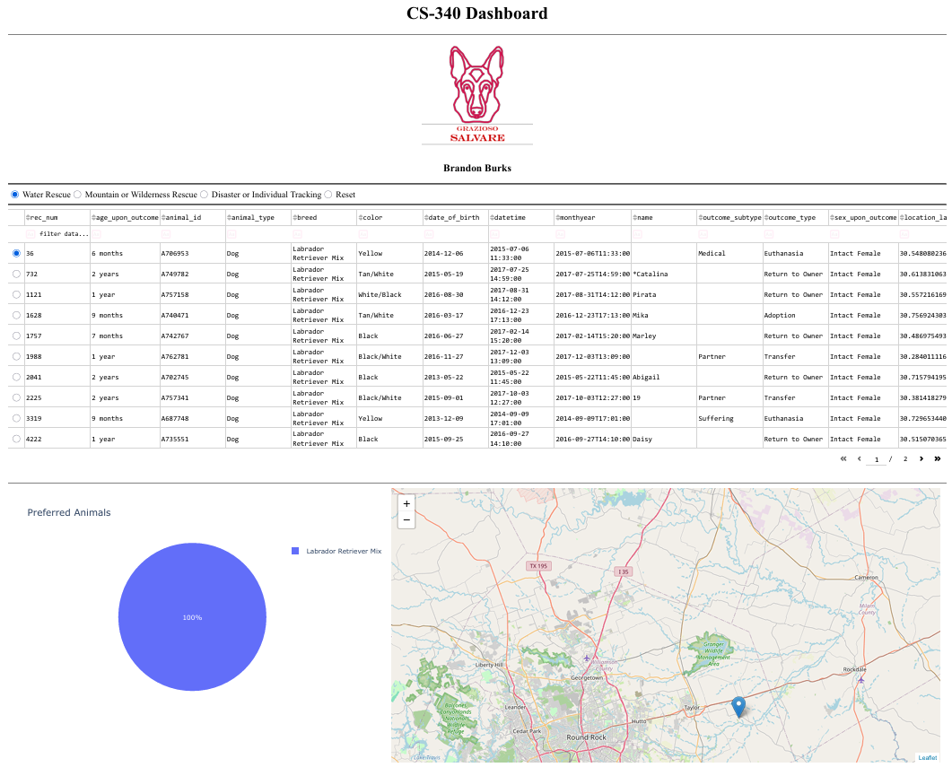This screenshot above shows the dashboard in its default unfiltered state, with the logo, unique identifier, filter controls, the data table, pie chart, and the geolocation map.
2. Water Rescue Filter Applied
This screenshot above shows the dashboard after selecting the Water Rescue filter.
3. Mountain or Wilderness Rescue Filter Applied
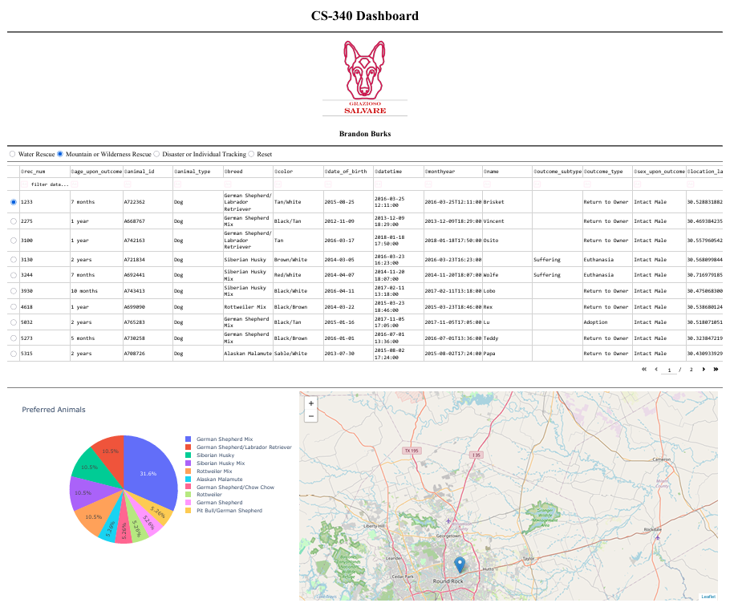This screenshot above shows the dashboard after selecting the Mountain or Wilderness Rescue filter.
4. Disaster Rescue or Individual Tracking Filter Applied
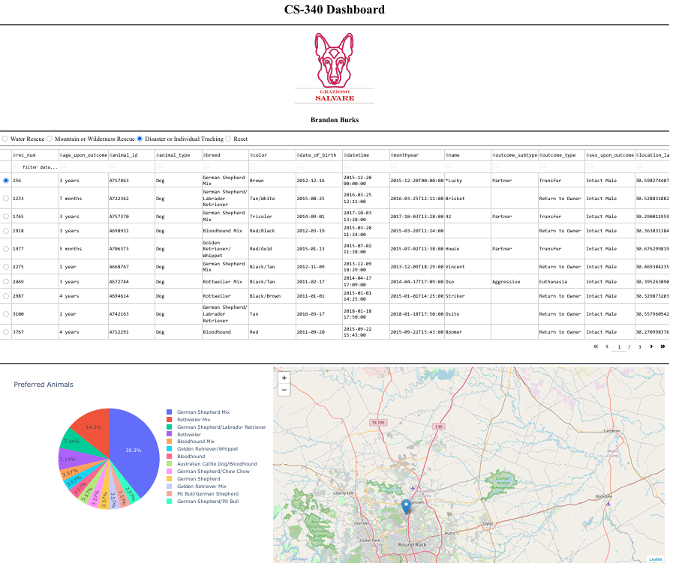This screenshot shows the dashboard after selecting the Disaster or Individual Tracking filter.
5. Reset Filter Applied
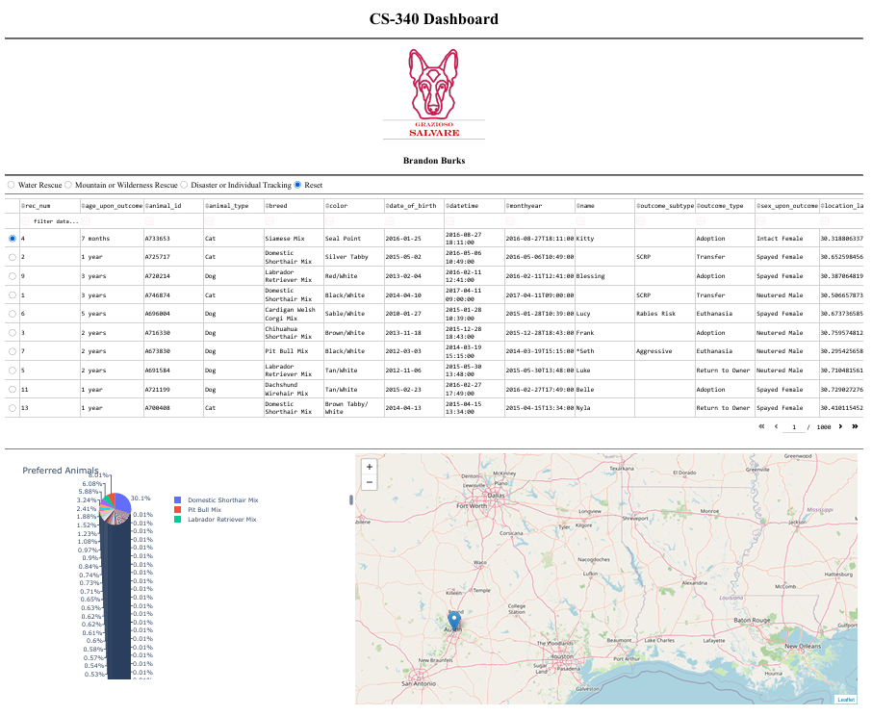This screenshot shows the dashboard returned to its original, unfiltered state.
Tools Utilized and Justification
MongoDB
In utilizing MongoDB as the database modeling portion of this project, I utilized MongoDB as a NoSQL document-based database. MongoDB allows for storing data in various formats, like JSON, based on flexible document structure. The format of MongoDB is ideal for large amounts of descriptive data, such as, the information stored regarding an animal's record. Additionally, because I used the pymongo library to interface with MongoDB using python, I had the ability to utilize mongoDB's capabilities of querying, retrieving, updating, etc., within my dashboard application. Therefore, given the requirements of the MVC style design needed for the project, MongoDB fit perfectly into the model layer of my design.
Python
I used Python to create all of the logic associated with the CRUD module, along with the logic associated with creating the interactive dashboard. In addition to being able to easily interact with MongoDB via Python, I was also able to use python to take data retrieved from MongoDB and put it in pandas data frames. Furthermore, since python allowed me to develop much of the application logic for my interactive dashboard, I was able to effectively utilize its functionality.
Dash Framework
The dash framework was used for the development of the component parts that make up the controller and view of the dashboard. It enabled the project to place all of the HTML components, interactive widget elements, dynamic data table, and visual charting tools into one Python application. The dynamic connections between filters, tables, and charts on the dashboard were accomplished using the Dash callback function. This allows the user to interact with the filter controls on the dashboard to select a rescue category which will cause the data table and charts to be updated automatically in real time based upon their selection.
Pandas
Pandas was used to convert mongodb query results into dataframes for easier manipulation and display inside of the dashboard. It also made it easier to build the interactive table with filtered data and feed that filtered data into the pie chart and geollocation chart.
Dash Leaflet
The geolocation map for each animal was created using dash leaflet. This interactive feature in the dash board displays the selected animals map coordinates on an actual map.
Plotly Express
Plotly express was used to develop the secondary chart that is displayed as a pie chart (breed distribution) based on filtered data.
Challenges Faced & Resolution Process
During the build phase I experienced an initial problem with getting the MongoDB link set up in Codio. The first obstacle was a database naming issue. The existing environment had a database named “aac” and I attempted to import into this database but due to the case-sensitivity of the system the names could not be imported as they needed to be in all lower-case.
The second challenge arose in relation to authentication and how the various environments interacted differently within Codio. Therefore I tested our connection settings and verified the CRUD module matched the environment's actual database configuration.
These troubleshooting steps greatly enhanced the reliability of the dashboard and confirmed that the final product functioned as intended.

