Brandon Cao

Spring 16’

CIS 425

Assignment 3

1)

a) 1

b) 4

c) 3

2)

1. 8

b)

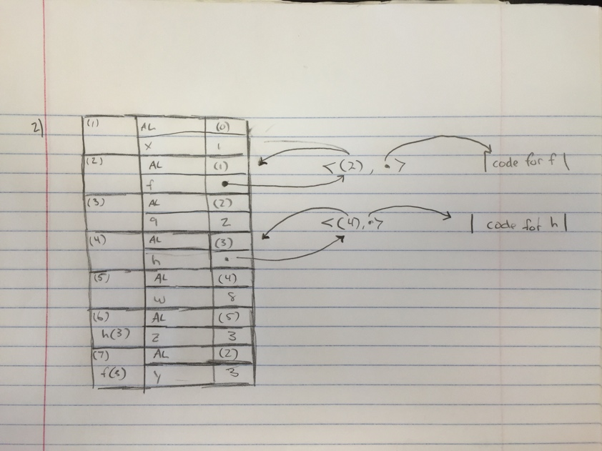

3)

a)

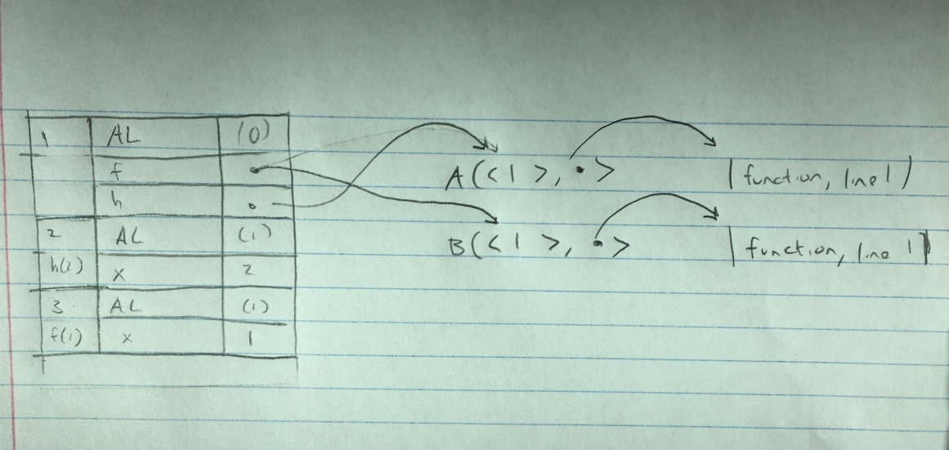

b) A

c) h (2) returns 20 because on line 1, f is stack so the function returns 2\*f(2-1)

d)

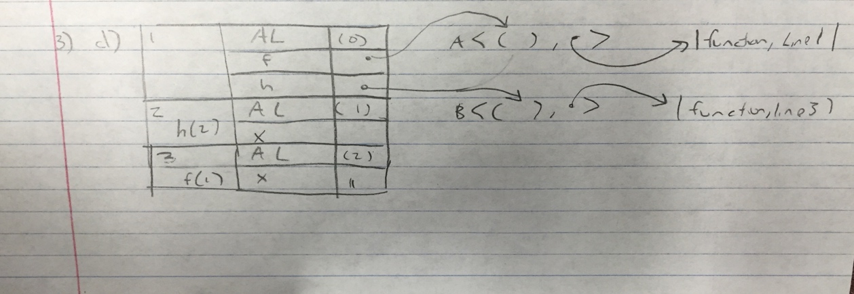

e) 2 because h is assigned to the first declared function f. With the parameter equaling to two, it gets passed into the function g(x). The instructions are to multiply x by the value returned by the recursive call of g, which in this case is g(1). G(1) returns 1 according to the instructions, therefore, h(2) = (2\*1) = 2.

4)

a) 8

b) 6

c) When applying the beta reductions, the outer x is captured. The first argument is never considered.

d) 6

5)

a)

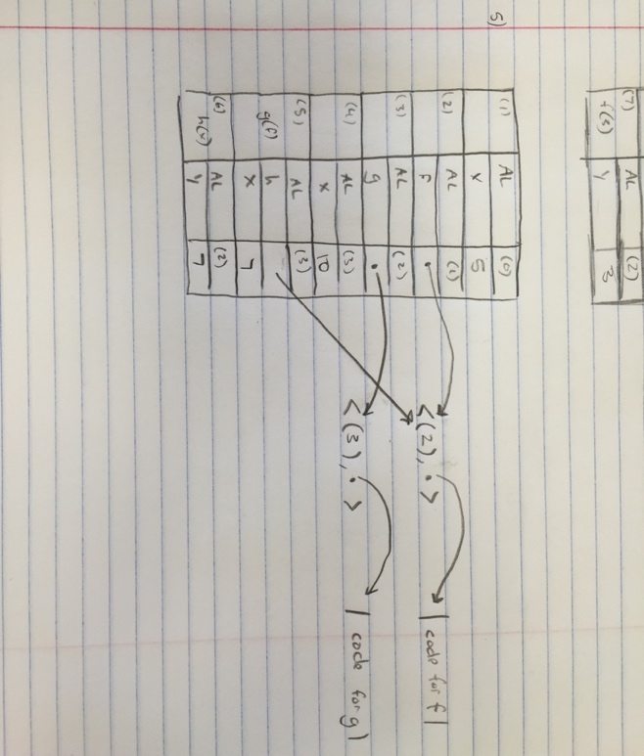

b) The value of this expression is 15. This is because x = 10 before we called g(f). x in the function g is defined as a local variable equaling to 3 which gets passed into h(x) which is also f(x). When defining f, the formal parameter is the variable y, so the value of x = 7 is actually y = 7. X is grabbed from our most recent assignment of x = 10 before calling g(f). So (10+7)-2 = 15.

6)

b)

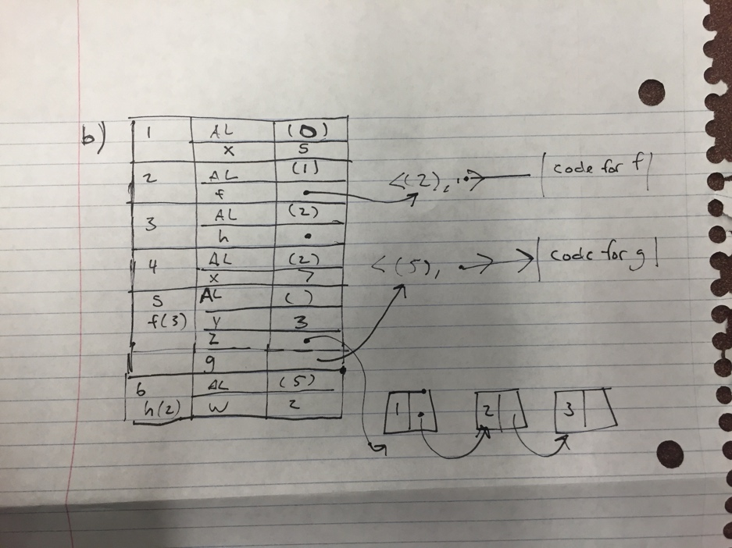

c) h(2) = 10

2+5+3 = 10.

7) ANSI C does not require closures because the score is always enclosed in the function. This is because it cannot return a function from a function of higher order.

“C and C++ do not support closures because of the implementation costs involved.” (pg 182).