HTML Code Snippets:
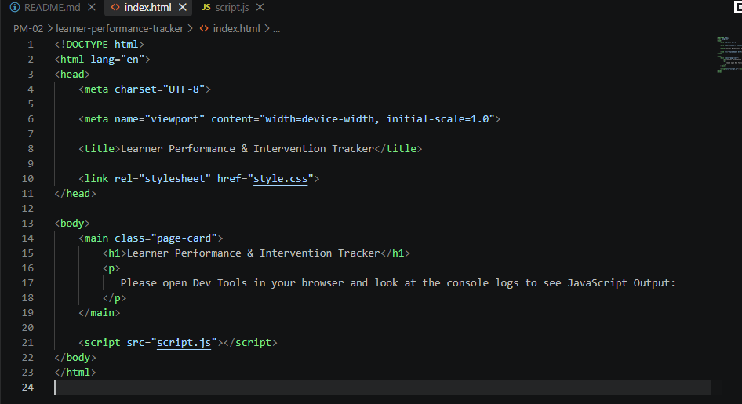
Testing:
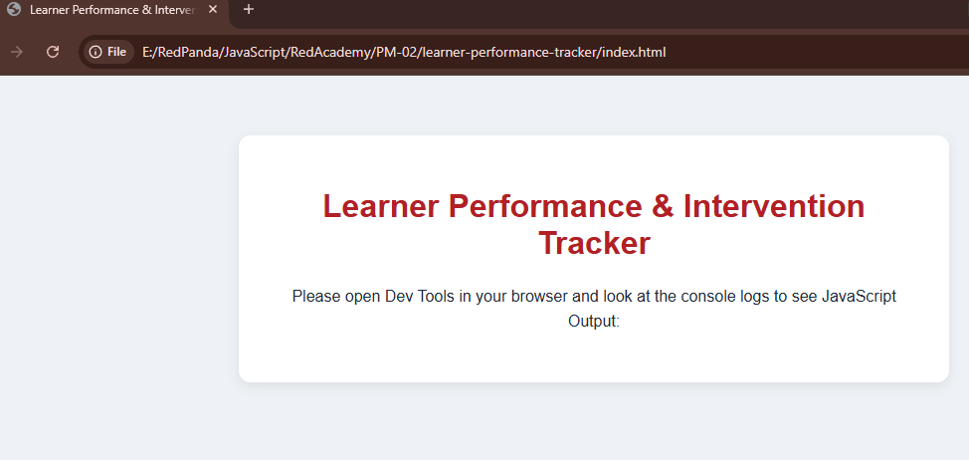

JavaScript Code Snippets:

Array – Hold Student Information:
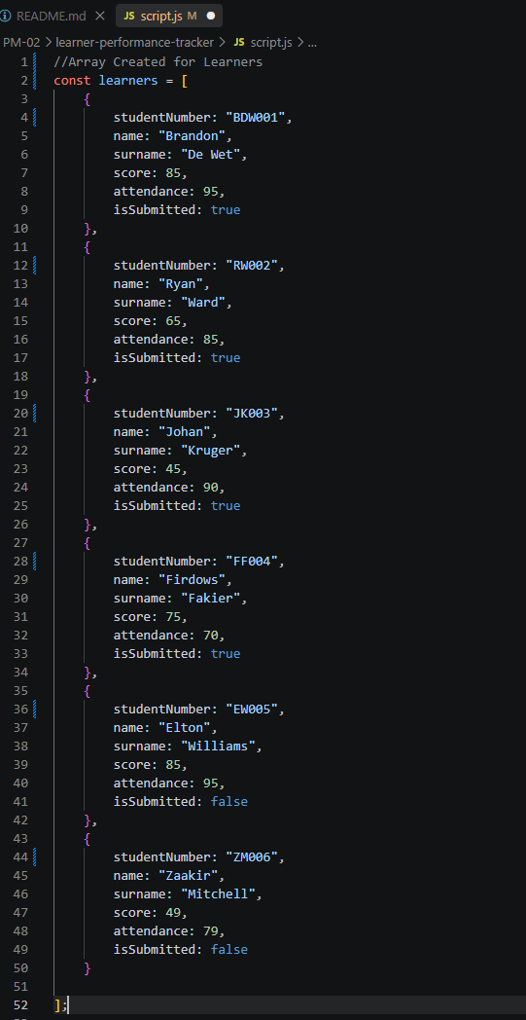

Functions – Display Student Information and Validate Results:

validateLearner(learner)
Checks that a learner's score and attendance are realistic (0-100).
Returns an object describing whether the learner's data is valid, and a list of any problems found.
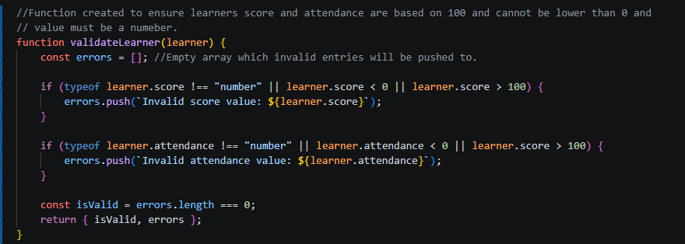

getLearnerStatus(learner)
If score is above or equal to 80 and attendance is above or equal to 90 and must have submitted is true = Excellent. If score is above or equal to 50 and attendance is above or equal to 80 and must have submitted is true = Competent. If none of the criteria is met, then return Not Yet Competent
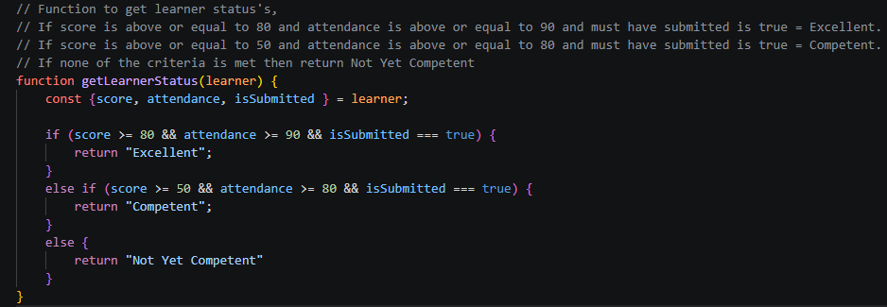

displayLearner(learner, status)
Display learner information in the console.log()
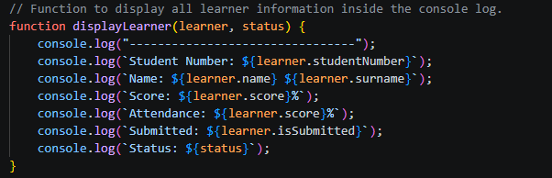

processAllLearners(learnerList)
Loops through the learner’s array once, displaying each valid learner and builds the structure required for the summary breakdown.
Checks invalid entries and is pushed to a new array called invalidLearners.
Calculations are done here to determine how many entries exist for each criteria
Returns values once Function is executed.
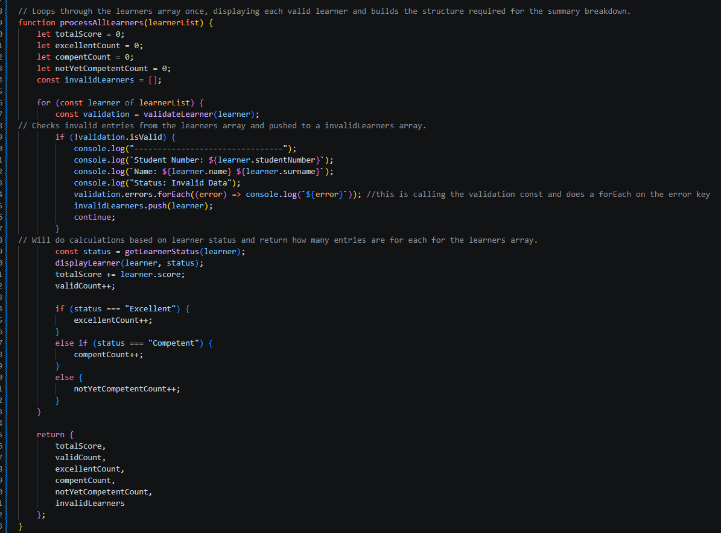

Test Evidence:
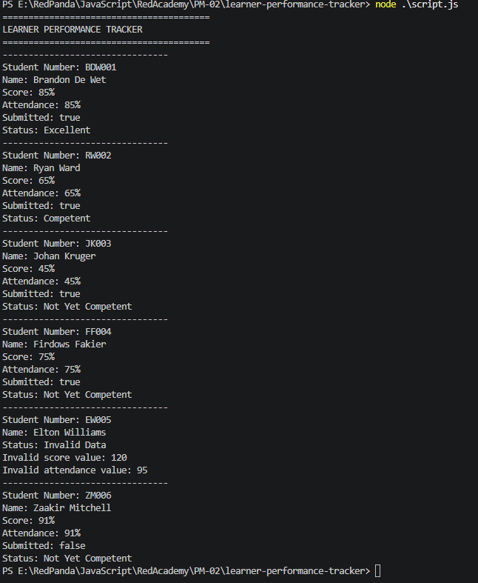

displaySummary(stats)
will display the totals of learner results in the console.log()
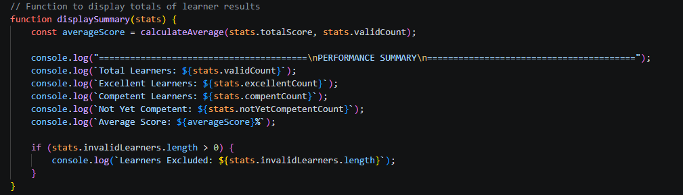
Testing:
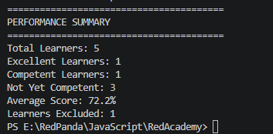

displayInterventionReport(learnerList)
Function to generate a List of learners needing intervention and reason why
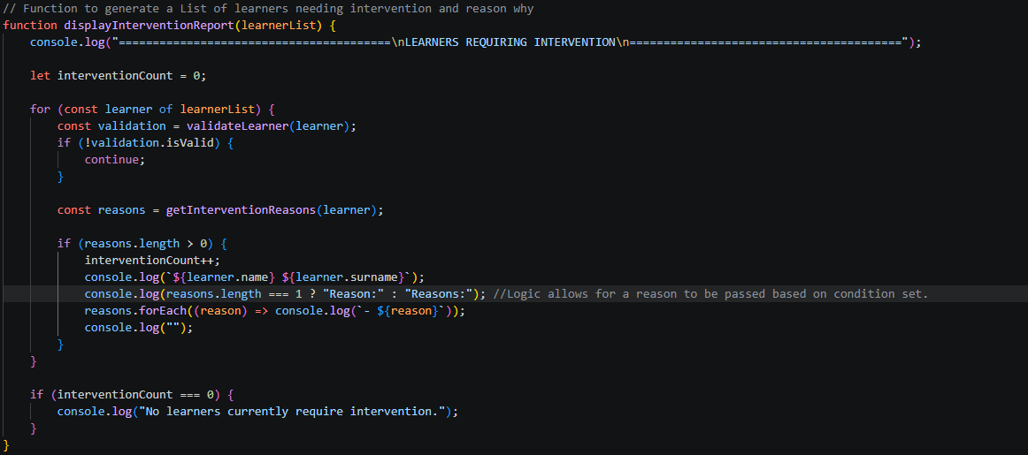
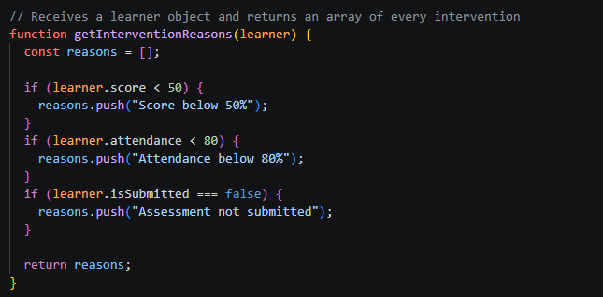
Testing:
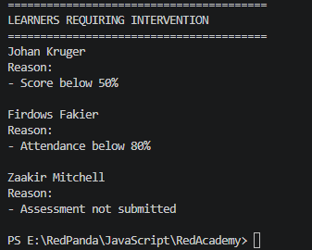

calculateAverage(total, count)
calculates average totals and returns as string and a single decimal point
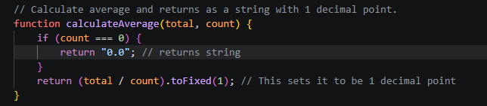

runTests()
Function to create some test data to check if expected results would show correctly
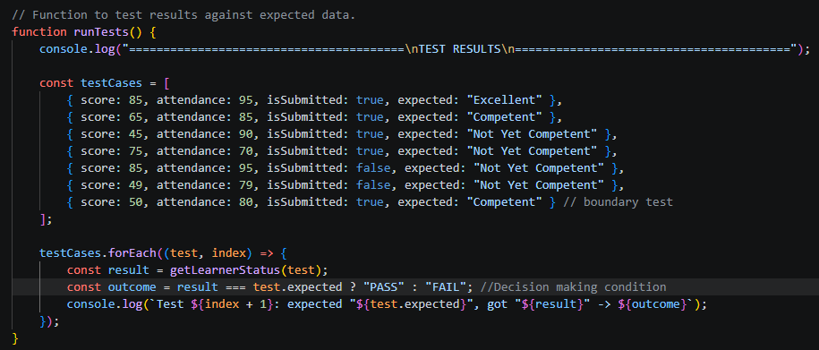
Testing:
