Practical Skill 1 - Reading Error Messages
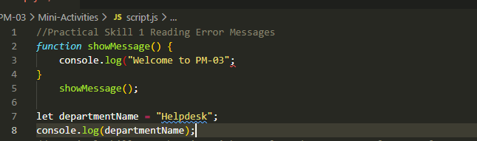
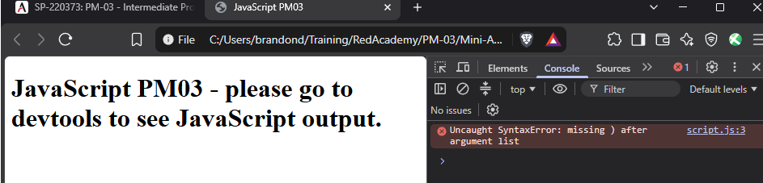
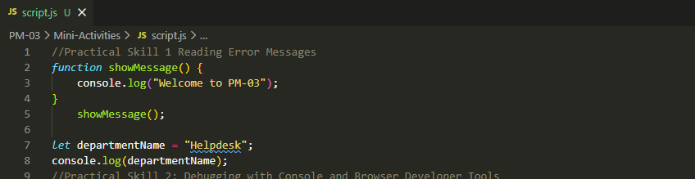
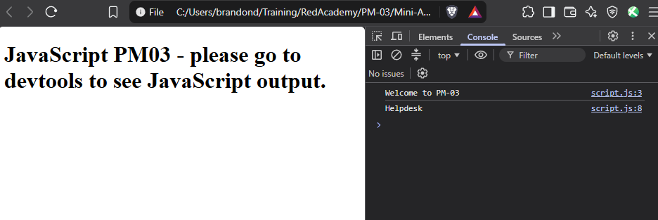

Practical Skill 2 – Debugging with Console and Browser Developer Tools
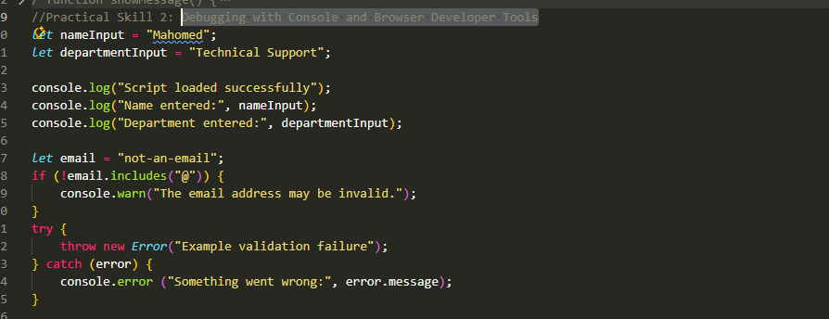
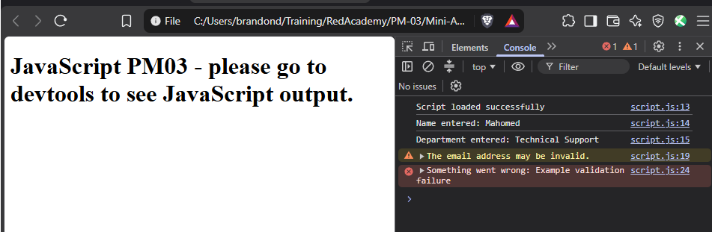

Practical Skill 3 – Error Handling with try ... catch
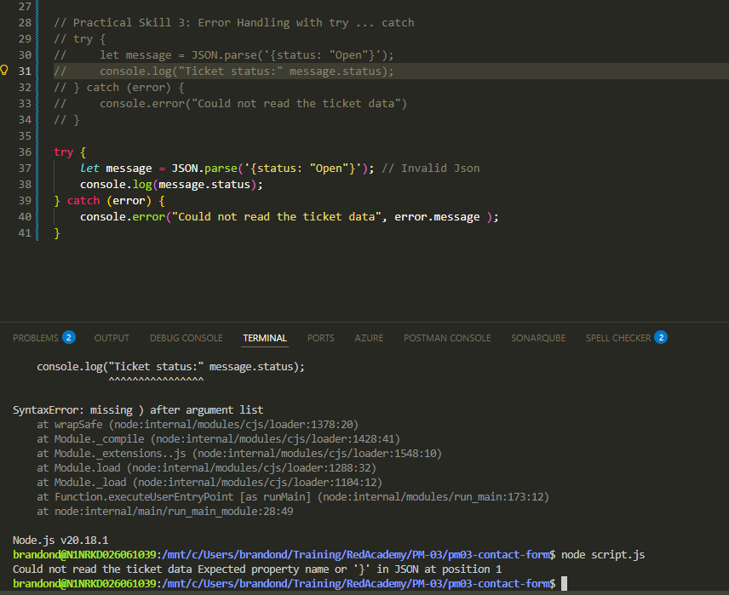

Practical Skill 4 – DOM Manipulation

