Linked JavaScript to the HTML page for the submit button and added console log outputs to see user activity
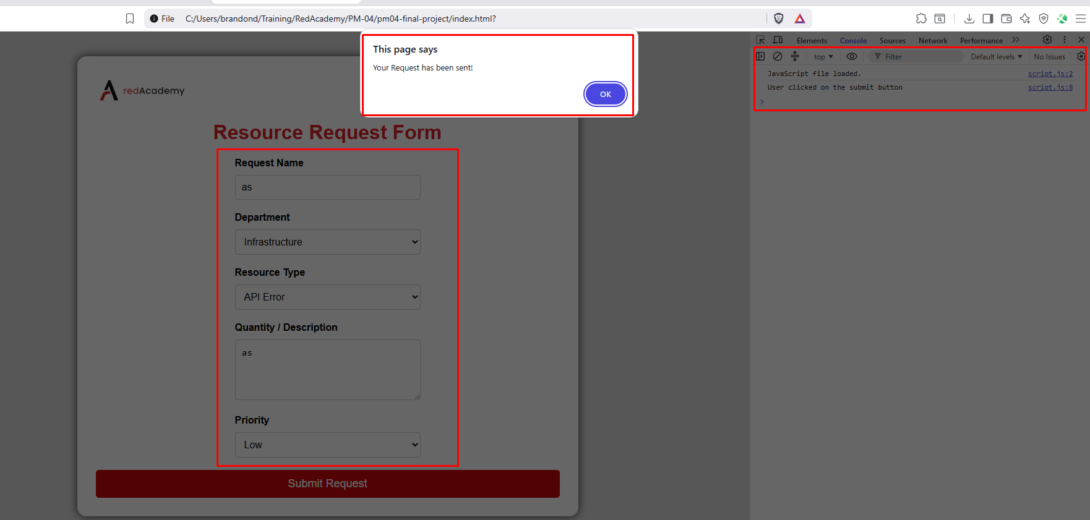

Added function logic to stop a page refreshing after submit button is pressed, and added variables to my JS to allow to capture data into an array and set const variables
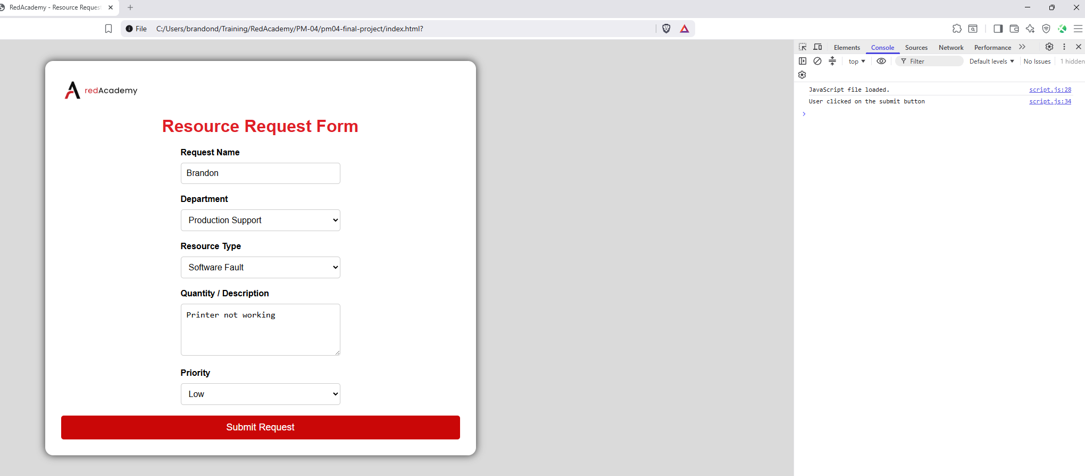
Updated the HTML and added functions to the JS to return the output of user input:
- Page loads and additional div showing as expected
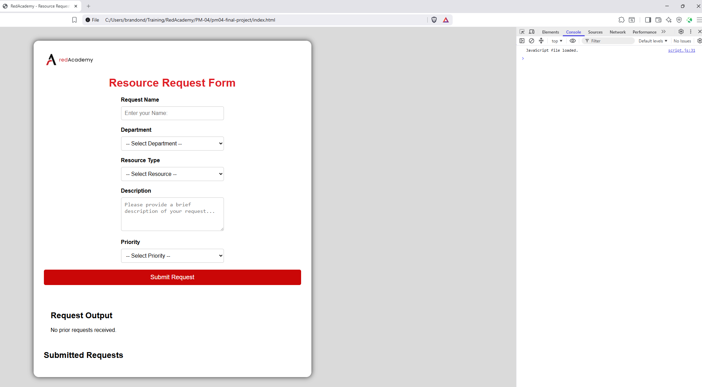

- User entered details and clicks on the submit button, alert pops up and console log shows the submit button clicked
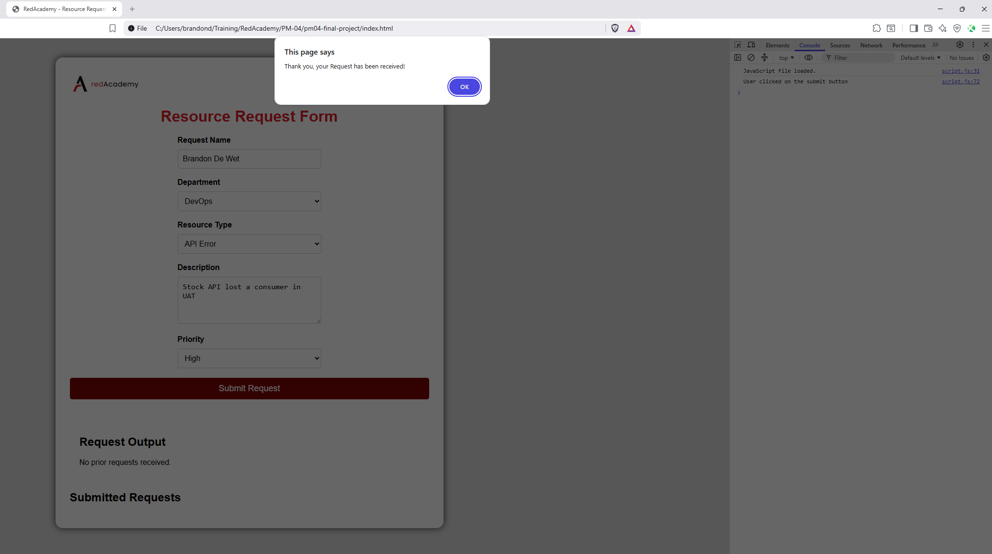
- After clicking the OK button, the Request output shows however I have a undefined error coming from my JS in my console log
