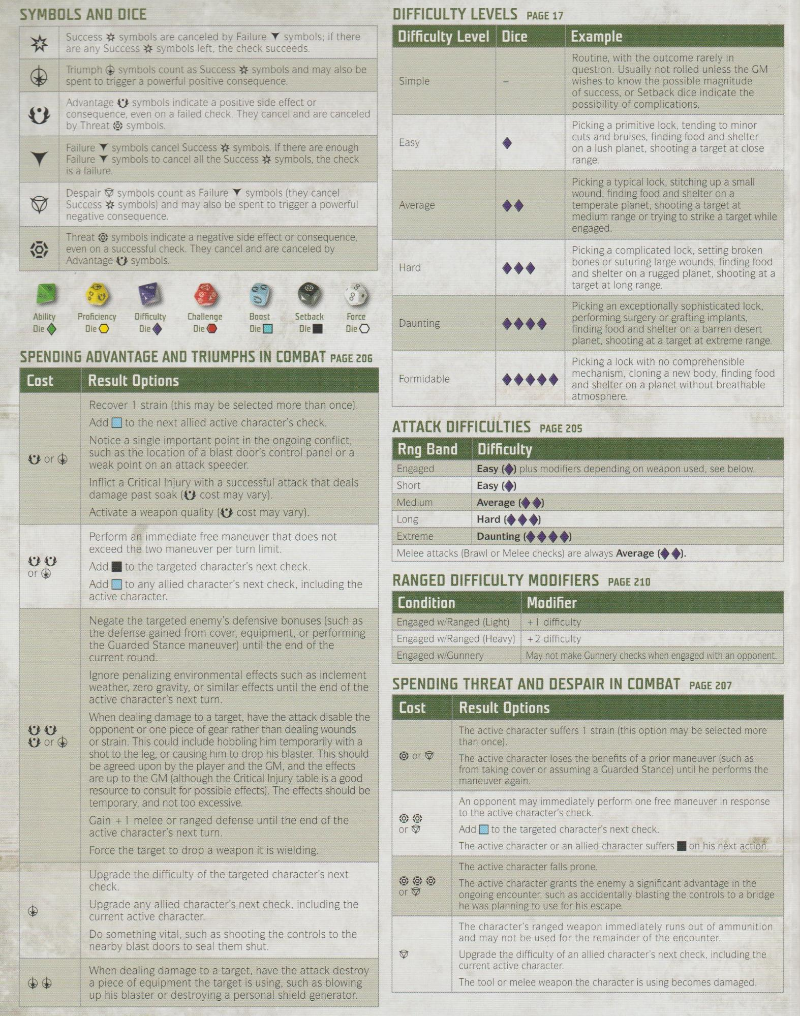

SYMBOLS AND DICE

Success symbols are canceled by Failure symbols; if there are any Success symbols left, the check succeeds.

Triumph symbols count as Success symbols and may also be spent to trigger a powerful positive consequence.

Advantage symbols indicate a positive side effect or consequence, even on a failed check. They cancel and are canceled by Threat symbols.

Failure symbols cancel Success

**DIFFICULTY LEVELS PAGE 17**

**Difficulty Level Dice**

Simple

Easy

symbols. If there are enough

Failure ▼ symbols to cancel all the Success

symbols, the check

is a failure.

Despair

symbols count as Failure symbols (they cancel Success symbols) and may also be spent to trigger a powerful negative consequence.

Average

Threat symbols indicate a negative side effect or consequence, even on a successful check. They cancel and are canceled by Advantage

symbols.

Hard

Ability

Die

Proficiency Die O

Difficulty Die

Challenge Die

Boost Die

Setback Die

Force

Die O

Daunting

SPENDING ADVANTAGE AND TRIUMPHS IN COMBAT PAGE 206 Cost

or

**Result Options**

Recover 1 strain (this may be selected more than once). Add to the next allied active character's check. Notice a single important point in the ongoing conflict, such as the location of a blast door's control panel or a weak point on an attack speeder.

Inflict a Critical Injury with a successful attack that deals damage past soak ( cost may vary). Activate a weapon quality (✪ cost may vary).

Perform an immediate free maneuver that does not exceed the two maneuver per turn limit.

Add

or

00

or

to the targeted character's next check.

Add to any allied character's next check, including the active character.

Negate the targeted enemy's defensive bonuses (such as the defense gained from cover, equipment, or performing the Guarded Stance maneuver) until the end of the current round.

Ignore penalizing environmental effects such as inclement weather, zero gravity, or similar effects until the end of the active character's next turn.

When dealing damage to a target, have the attack disable the opponent or one piece of gear rather than dealing wounds or strain. This could include hobbling him temporarily with a shot to the leg, or causing him to drop his blaster. This should be agreed upon by the player and the GM, and the effects are up to the GM (although the Critical Injury table is a good resource to consult for possible effects). The effects should be temporary, and not too excessive.

Formidable

**Example**

Routine, with the outcome rarely in

question. Usually not rolled unless the GM wishes to know the possible magnitude of success, or Setback dice indicate the possibility of complications.

Picking a primitive lock, tending to minor cuts and bruises, finding food and shelter on a lush planet, shooting a target at close range.

Picking a typical lock, stitching up a small wound, finding food and shelter on a temperate planet, shooting a target at medium range or trying to strike a target while engaged.

Picking a complicated lock, setting broken bones or suturing large wounds, finding food and shelter on a rugged planet, shooting at a target at long range.

Picking an exceptionally sophisticated lock, performing surgery or grafting implants, finding food and shelter on a barren desert planet, shooting at a target at extreme range.

Picking a lock with no comprehensible mechanism, cloning a new body, finding food and shelter on a planet without breathable atmosphere.

**ATTACK DIFFICULTIES PAGE 205**

Rng Band Engaged

Short

**Difficulty**

**Easy**

**Easy**

Medium

Average

Hard Daunting

Long

Extreme

plus modifiers depending on weapon used, see below.

Melee attacks (Brawl or Melee checks) are always Average RANGED DIFFICULTY MODIFIERS PAGE 210 Condition

Engaged w/Ranged (Light) Engaged w/Ranged (Heavy) Engaged w/Gunnery

**Modifier**

+ 1 difficulty

+2 difficulty

May not make Gunnery checks when engaged with an opponent.

SPENDING THREAT AND DESPAIR IN COMBAT PAGE 207 Cost

or

**Result Options**

The active character suffers 1 strain (this option may be selected more than once).

The active character loses the benefits of a prior maneuver (such as from taking cover or assuming a Guarded Stance) until he performs the maneuver again.

An opponent may immediately perform one free maneuver in response to the active character's check.

The active character or an allied character suffers on his next action. The active character falls prone.

Gain +1 melee or ranged defense until the end of the active character's next turn.

or

Add to the targeted character's next check.

Force the target to drop a weapon it is wielding.

Upgrade the difficulty of the targeted character's next check.

or

Upgrade any allied character's next check, including the current active character.

Do something vital, such as shooting the controls to the nearby blast doors to seal them shut.

When dealing damage to a target, have the attack destroy a piece of equipment the target is using, such as blowing up his blaster or destroying a personal shield generator.

The active character grants the enemy a significant advantage in the ongoing encounter, such as accidentally blasting the controls to a bridge he was planning to use for his escape.

The character's ranged weapon immediately runs out of ammunition and may not be used for the remainder of the encounter.

Upgrade the difficulty of an allied character's next check, including the current active character.

The tool or melee weapon the character is using becomes damaged.