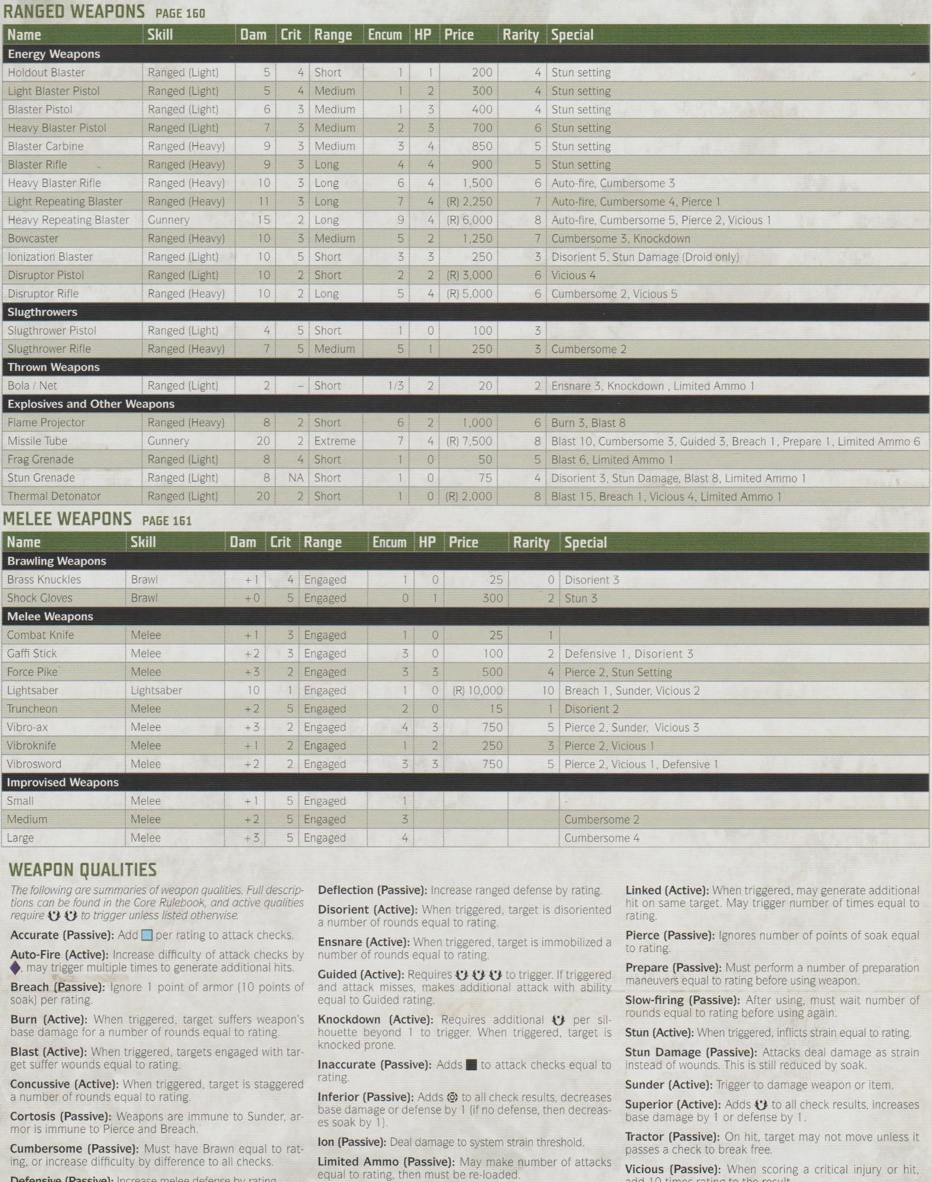

Ranged (Light)

Light Blaster Pistol

Ranged (Light)

5

**RANGED WEAPONS PAGE 160**

**Name**

**Energy Weapons**

Holdout Blaster

**Skill**

**Dam Crit Range Encum HP Price Rarity Special**

LO

LO

1

4 Short

1

200

4 Stun setting

4 Medium

1

2

300

4 Stun setting

Blaster Pistol

Ranged (Light)

6

3 Medium

1

3

400

4 Stun setting

Heavy Blaster Pistol

Ranged (Light)

7

3 Medium

Blaster Carbine

Ranged (Heavy)

9

3 Medium

Blaster Rifle

Ranged (Heavy)

9

3 Long

23

+4

3

700

6 Stun setting

4

850

5 Stun setting

4

900

5 Stun setting

Heavy Blaster Rifle

Ranged (Heavy)

10

3 Long

Light Repeating Blaster

Ranged (Heavy)

11

3 Long

19

6

4

1,500

6 Auto-fire, Cumbersome 3

*7*

4

(R) 2,250

7 Auto-fire, Cumbersome 4, Pierce 1

Heavy Repeating Blaster

Gunnery

15

2 Long

9

4

(R) 6,000

Bowcaster

Ranged (Heavy)

10

3 Medium

lonization Blaster

Ranged (Light)

10

5 Short

Disruptor Pistol

Ranged (Light)

10

2 Short

23

53 2

2

1,250

3

250

2

(R) 3,000

6

Vicious 4

Disruptor Rifle

Ranged (Heavy)

10

2 Long

LO

4 (R) 5,000

8 Auto-fire, Cumbersome 5, Pierce 2, Vicious 1 7 Cumbersome 3, Knockdown

3 Disorient 5, Stun Damage (Droid only)

6 Cumbersome 2, Vicious 5

**Slugthrowers**

Slugthrower Pistol

Ranged (Light)

4

5 Short

1

O

Slugthrower Rifle

Ranged (Heavy)

7

5 Medium

LO

5

1

100 250

3

3 Cumbersome 2

**Thrown Weapons**

Bola / Net

Ranged (Light)

2

Short

1/3

2

20

2 Ensnare 3, Knockdown, Limited Ammo 1

**Explosives and Other Weapons**

Flame Projector

Ranged (Heavy)

00

8

2 Short

CO

6

2

1,000

6 Burn 3, Blast 8

Missile Tube

Gunnery

20

2 Extreme

7

4

(R) 7,500

8 Blast 10, Cumbersome 3, Guided 3, Breach 1, Prepare 1, Limited Ammo 6

Frag Grenade

Ranged (Light)

8

4 Short

1

0

50

5

Blast 6, Limited Ammo 1

Stun Grenade

Ranged (Light)

8 NA Short

1

0

75

4

Disorient 3, Stun Damage, Blast 8, Limited Ammo 1

Thermal Detonator

Ranged (Light)

20 2 Short

0 (R) 2,000

8 Blast 15, Breach 1, Vicious 4, Limited Ammo 1

**MELEE WEAPONS PAGE 161**

**Name**

**Skill**

Dam Crit Range

**Encum HP Price**

**Rarity Special**

**Brawling Weapons**

Brass Knuckles

Brawl

+1 4 Engaged

이

25

Disorient 3

Shock Gloves

Brawl

+0

5 Engaged

300

2 Stun 3

**Melee Weapons**

Combat Knife

Melee

+1

3 Engaged

0

25

1

Gaffi Stick

Melee

+2

3 Engaged

3

0

100

2 Defensive 1, Disorient 3

Force Pike

Melee

+3

2 Engaged

3

3

500

4 Pierce 2, Stun Setting

Lightsaber

Lightsaber

10

1 Engaged

1

0

(R) 10,000

10

Breach 1, Sunder, Vicious 2

Truncheon

Melee

+2

5 Engaged

2

0

15

1

Disorient 2

Vibro-ax

Melee

+3

2 Engaged

4

3

750

Vibroknife

Melee

+1

2 Engaged

1

2

250

3

Pierce 2, Vicious 1

Vibrosword

Melee

+2

2 Engaged

3

3

750

5 Pierce 2, Sunder, Vicious 3

5 Pierce 2, Vicious 1, Defensive 1

**Improvised Weapons**

Small

Melee

+1

5 Engaged

1

Medium

Melee

+2 5 Engaged

3

Large

Melee

+3

5 Engaged

4

Cumbersome 2 Cumbersome 4

**WEAPON QUALITIES**

*The following are summaries of weapon qualities. Full descrip- tions can be found in the Core Rulebook, and active qualities require to trigger unless listed otherwise. Accurate (Passive): Add per rating to attack checks. Auto-Fire (Active): Increase difficulty of attack checks by may trigger multiple times to generate additional hits. Breach (Passive): Ignore 1 point of armor (10 points of soak) per rating.*

Burn (Active): When triggered, target suffers weapon's base damage for a number of rounds equal to rating. Blast (Active): When triggered, targets engaged with tar- get suffer wounds equal to rating.

Concussive (Active): When triggered, target is staggered a number of rounds equal to rating.

Cortosis (Passive): Weapons are immune to Sunder, ar- mor is immune to Pierce and Breach."

**Cumbersome (Passive): Must have Brawn equal to rat- ing, or increase difficulty by difference to all checks.**

Defensive (Passive): Increase melee defense by rating.

Deflection (Passive): Increase ranged defense by rating. Disorient (Active): When triggered, target is disoriented a number of rounds equal to rating.

Ensnare (Active): When triggered, target is immobilized a number of rounds equal to rating.

Guided (Active): Requires

to trigger. If triggered and attack misses, makes additional attack with ability equal to Guided rating.

Knockdown (Active): Requires additional per sil- houette beyond 1 to trigger. When triggered, target is knocked prone.

Linked (Active): When triggered, may generate additional hit on same target. May trigger number of times equal to rating.

Pierce (Passive): Ignores number of points of soak equal to rating.

Prepare (Passive): Must perform a number of preparation

maneuvers equal to rating before using weapon. Slow-firing (Passive): After using, must wait number of rounds equal to rating before using again.

Stun (Active): When triggered, inflicts strain equal to rating. Stun Damage (Passive): Attacks deal damage as strain Inaccurate (Passive): Adds to attack checks equal to instead of wounds. This is still reduced by soak. rating.

Inferior (Passive): Adds to all check results, decreases base damage or defense by 1 (if no defense, then decreas- es soak by 1).

lon (Passive): Deal damage to system strain threshold. Limited Ammo (Passive): May make number of attacks equal to rating, then must be re-loaded.

Sunder (Active): Trigger to damage weapon or item. Superior (Active): Adds to all check results, increases base damage by 1 or defense by 1.

Tractor (Passive): On hit, target may not move unless it passes a check to break free.

Vicious (Passive): When scoring a critical injury or hit,

add 10 times rating to the result.