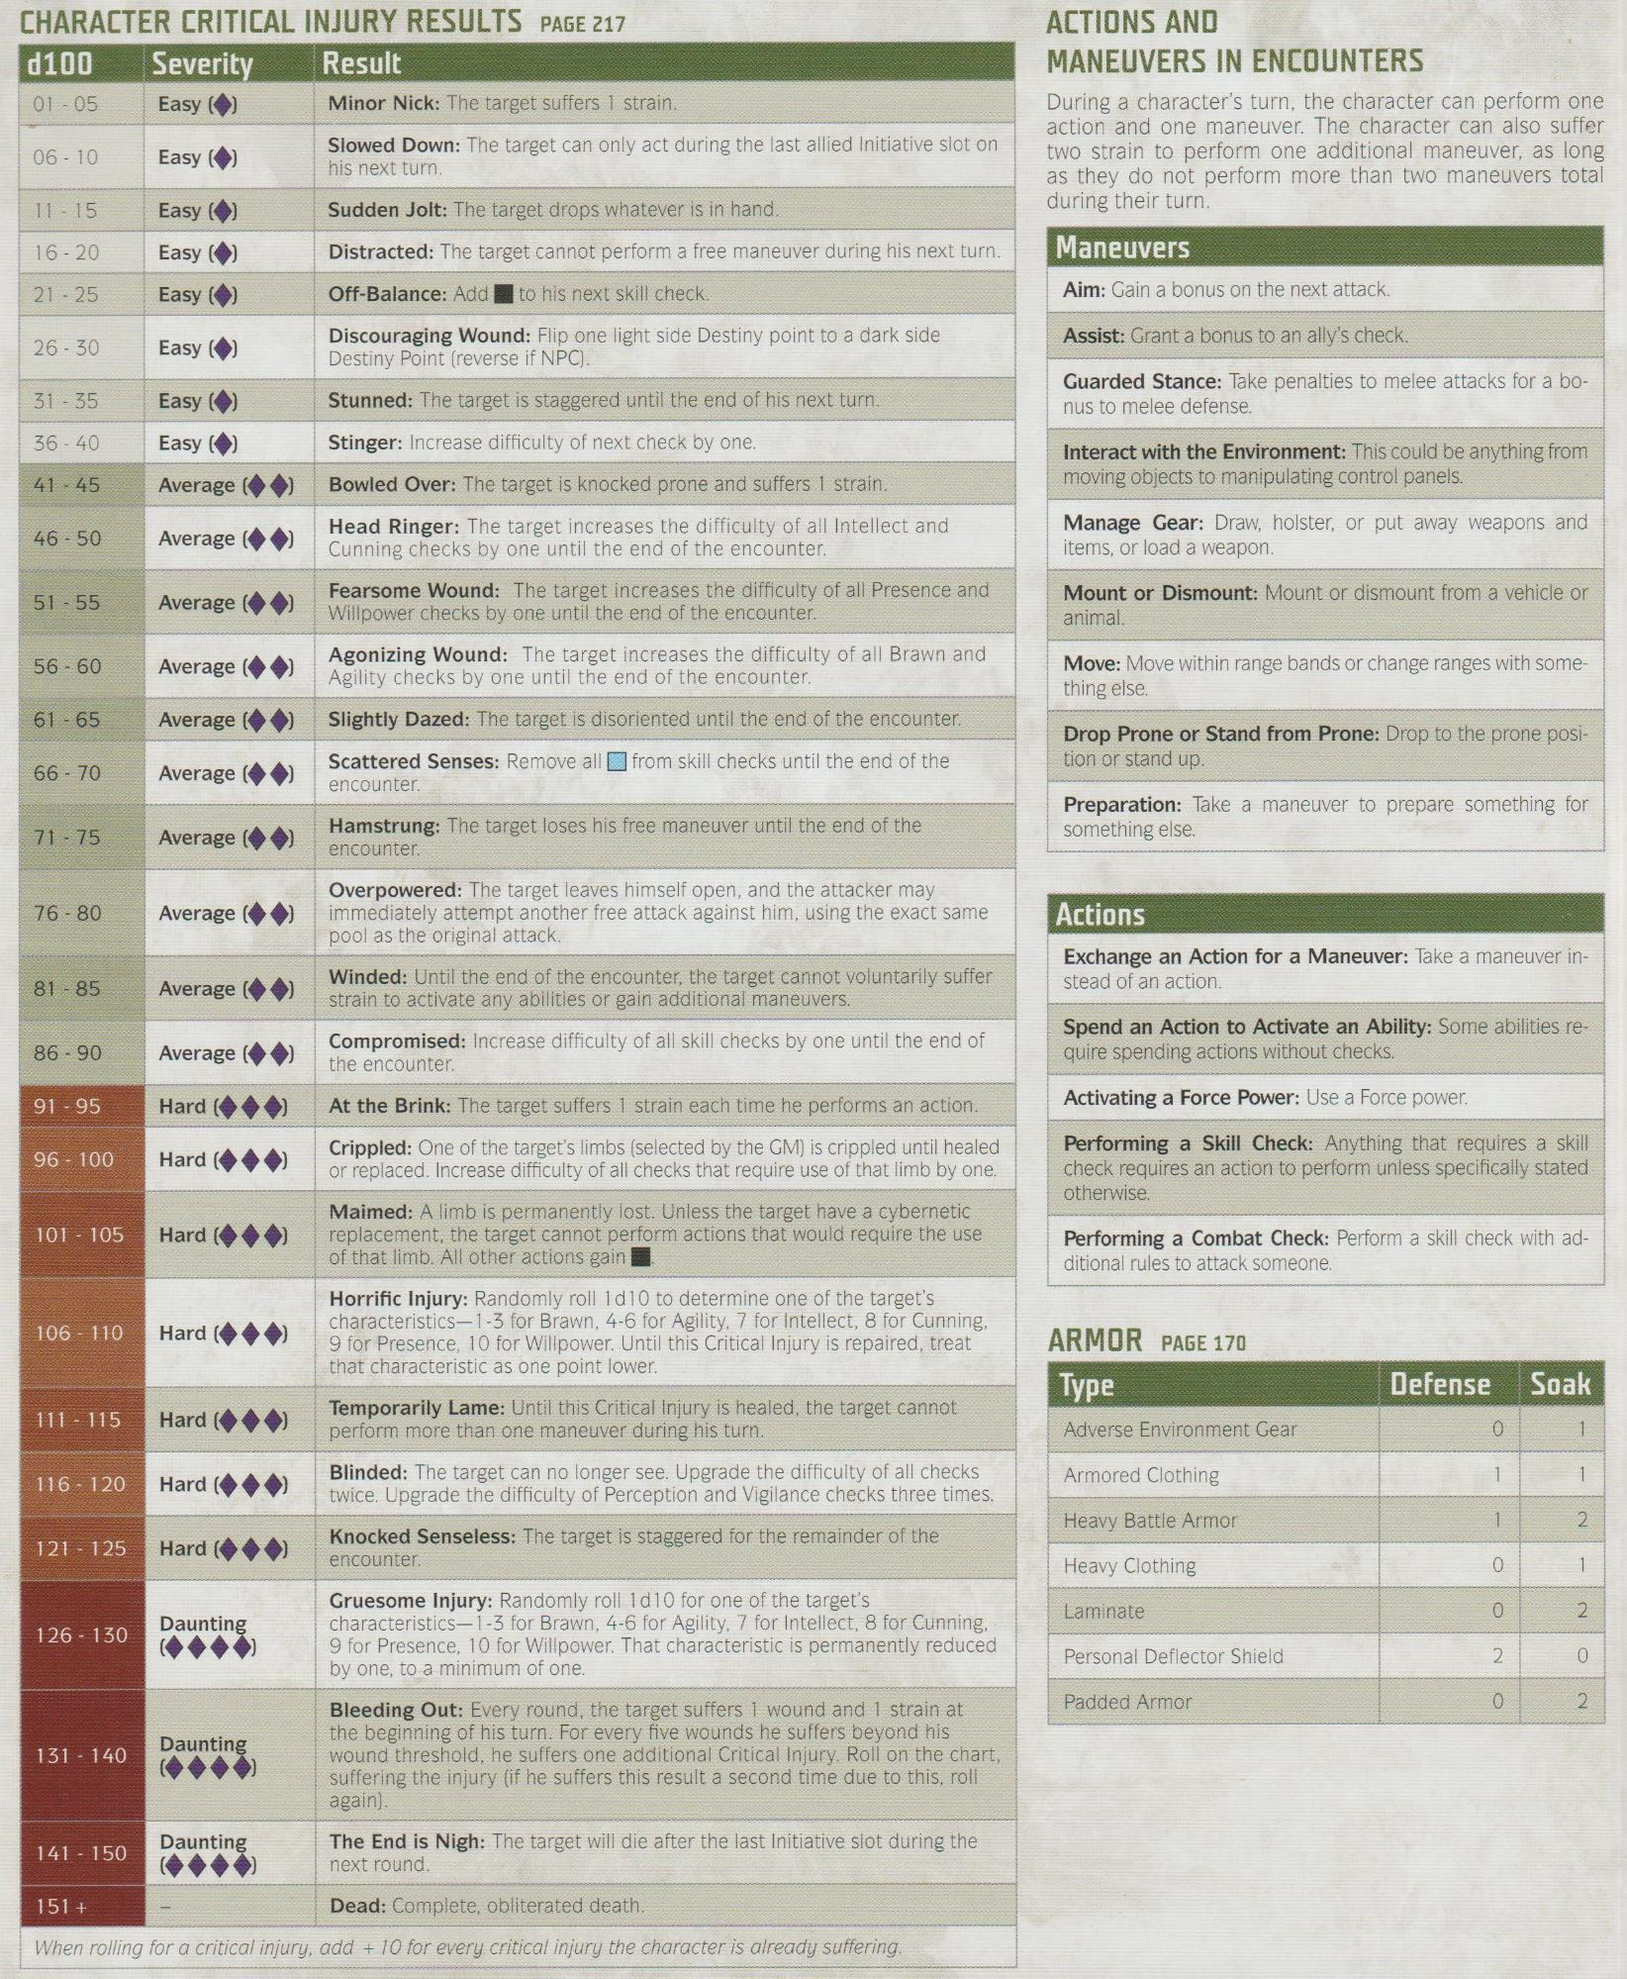

**CHARACTER CRITICAL INJURY RESULTS PAGE 217**

**Result**

Minor Nick: The target suffers 1 strain.

Slowed Down: The target can only act during the last allied Initiative slot on his next turn.

Sudden Jolt: The target drops whatever is in hand.

Distracted: The target cannot perform a free maneuver during his next turn.

Off-Balance: Add to his next skill check.

Discouraging Wound: Flip one light side Destiny point to a dark side Destiny Point (reverse if NPC).

Bowled Over: The target is knocked prone and suffers 1 strain. Head Ringer: The target increases the difficulty of all Intellect and Cunning checks by one until the end of the encounter.

Fearsome Wound: The target increases the difficulty of all Presence and Willpower checks by one until the end of the encounter.

d100

**Severity**

01 - 05

Easy

06-10

Easy

11-15

Easy

16-20

Easy

21-25

Easy

26-30

Easy

31 - 35

Easy

36-40

Easy

Stunned: The target is staggered until the end of his next turn. Stinger: Increase difficulty of next check by one.

41 - 45

46-50

Average Average

51-55

Average

56-60

61-65

66-70

Average Average Average

71 75

Average

76-80

Average

81-85

Average (◆◆)

86-90

91-95

96-100

Average (◆◆) Hard (◆◆◆) Hard (◆◆◆)

101 - 105

Hard (◆◆◆)

106 110

Hard

111 - 115

Hard (◆◆◆)

116-120

Hard (◆◆◆)

121 - 125

Hard

Daunting

126-130

131 - 140

**Daunting**

Daunting

141 - 150

151+

Agonizing Wound: The target increases the difficulty of all Brawn and Agility checks by one until the end of the encounter.

Slightly Dazed: The target is disoriented until the end of the encounter. Scattered Senses: Remove all from skill checks until the end of the encounter.

**Hamstrung: The target loses his free maneuver until the end of the**

encounter.

Overpowered: The target leaves himself open, and the attacker may immediately attempt another free attack against him, using the exact same pool as the original attack.

Winded: Until the end of the encounter, the target cannot voluntarily suffer strain to activate any abilities or gain additional maneuvers.

**Compromised: Increase difficulty of all skill checks by one until the end of the encounter.**

At the Brink: The target suffers 1 strain each time he performs an action. Crippled: One of the target's limbs (selected by the GM) is crippled until healed or replaced. Increase difficulty of all checks that require use of that limb by one.

Maimed: A limb is permanently lost. Unless the target have a cybernetic replacement, the target cannot perform actions that would require the use of that limb. All other actions gain |

Horrific Injury: Randomly roll 1d10 to determine one of the target's characteristics-1-3 for Brawn, 4-6 for Agility, 7 for Intellect, 8 for Cunning, 9 for Presence, 10 for Willpower. Until this Critical Injury is repaired, treat that characteristic as one point lower.

Temporarily Lame: Until this Critical Injury is healed, the target cannot perform more than one maneuver during his turn.

Blinded: The target can no longer see. Upgrade the difficulty of all checks twice. Upgrade the difficulty of Perception and Vigilance checks three times.

Knocked Senseless: The target is staggered for the remainder of the encounter.

Gruesome Injury: Randomly roll 1d10 for one of the target's characteristics-1-3 for Brawn, 4-6 for Agility, 7 for Intellect, 8 for Cunning, 9 for Presence, 10 for Willpower. That characteristic is permanently reduced by one, to a minimum of one.

Bleeding Out: Every round, the target suffers 1 wound and 1 strain at the beginning of his turn. For every five wounds he suffers beyond his wound threshold, he suffers one additional Critical Injury. Roll on the chart, suffering the injury (if he suffers this result a second time due to this, roll again).

The End is Nigh: The target will die after the last Initiative slot during the next round.

Dead: Complete, obliterated death.

*When rolling for a critical injury, add + 10 for every critical injury the character is already suffering.*

**ACTIONS AND**

MANEUVERS IN ENCOUNTERS

During a character's turn, the character can perform one action and one maneuver. The character can also suffer two strain to perform one additional maneuver, as long as they do not perform more than two maneuvers total during their turn.

**Maneuvers**

Aim: Gain a bonus on the next attack.

**Assist: Grant a bonus to an ally's check.**

Guarded Stance: Take penalties to melee attacks for a bo- nus to melee defense.

Interact with the Environment: This could be anything from moving objects to manipulating control panels.

Manage Gear: Draw, holster, or put away weapons and items, or load a weapon.

Mount or Dismount: Mount or dismount from a vehicle or animal.

Move: Move within range bands or change ranges with some- thing else.

Drop Prone or Stand from Prone: Drop to the prone posi- tion or stand up.

Preparation: Take a maneuver to prepare something for something else.

**Actions**

Exchange an Action for a Maneuver: Take a maneuver in- stead of an action.

Spend an Action to Activate an Ability: Some abilities re- quire spending actions without checks.

Activating a Force Power: Use a Force power.

Performing a Skill Check: Anything that requires a skill check requires an action to perform unless specifically stated otherwise.

Performing a Combat Check: Perform a skill check with ad- ditional rules to attack someone.

ARMOR PAGE 170

**Type**

**Defense**

**Soak**

Adverse Environment Gear

0

Armored Clothing

1

1

2

0

Heavy Battle Armor Heavy Clothing

Laminate

Personal Deflector Shield

Padded Armor

O

2

2

0

0

2