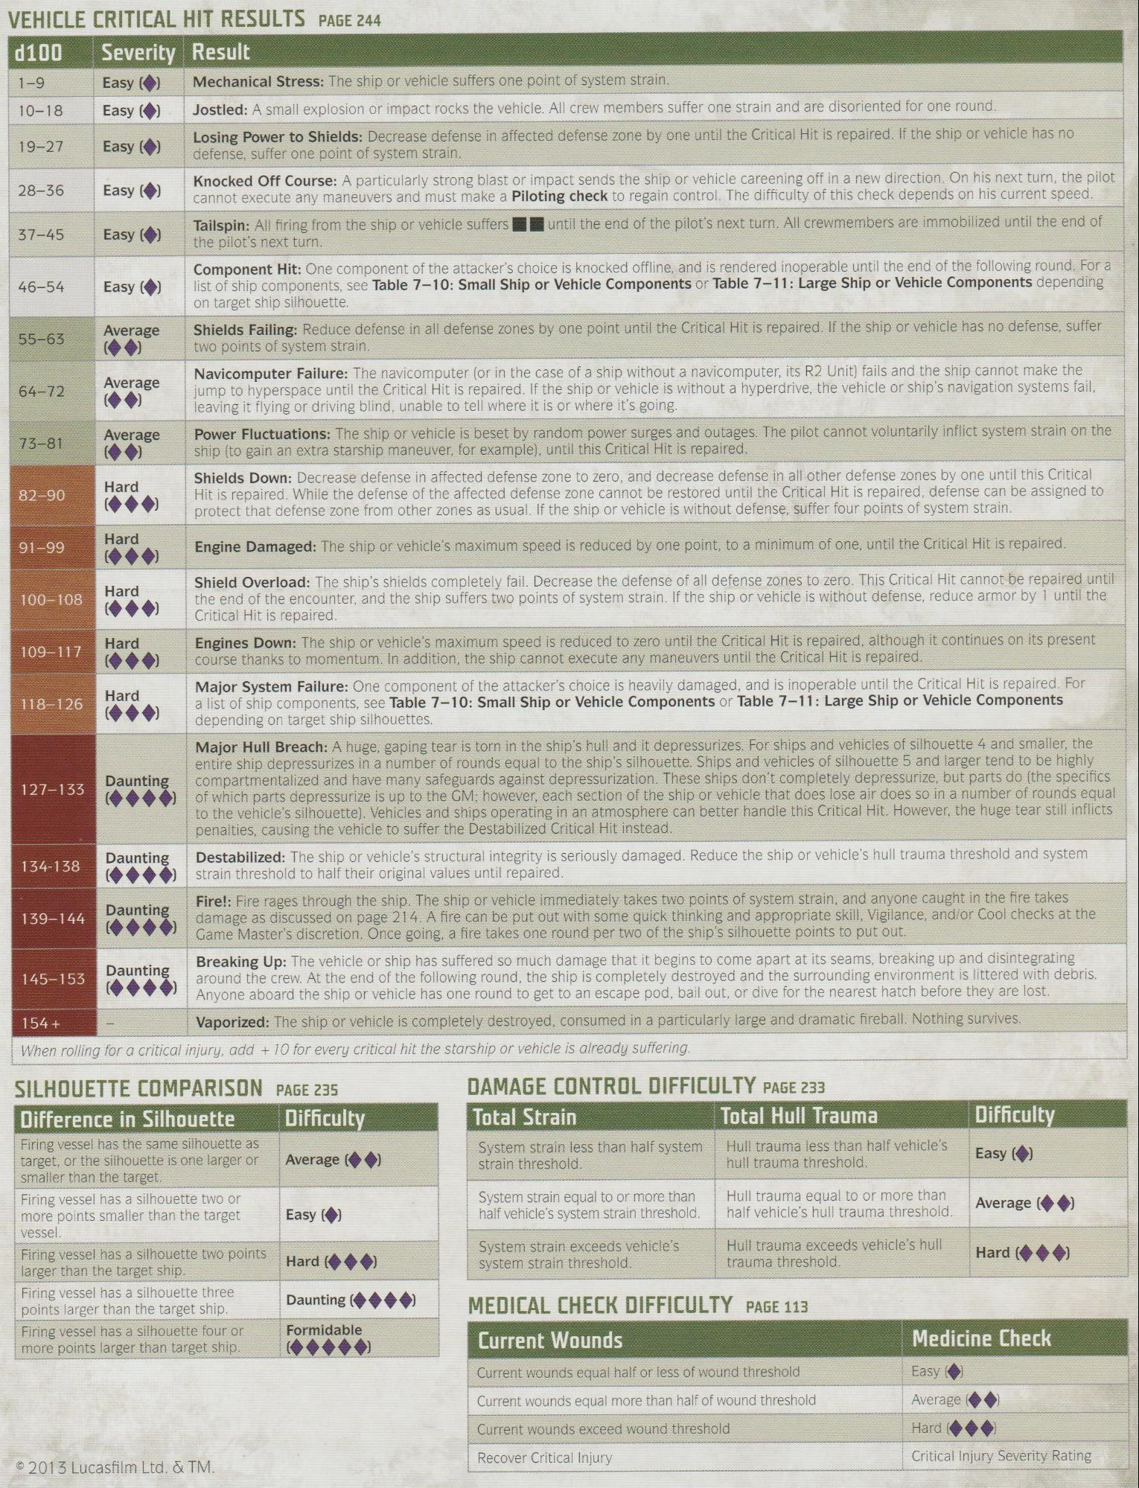

VEHICLE CRITICAL HIT RESULTS PAGE 244

**Severity Result**

**d100 1-9**

Easy

10-18

Easy ()

19-27

Easy

28-36

Easy

37-45

Easy (→)

46-54

Easy ()

Average

55-63

Average

64-72

73-81

Average

Hard

82-90

Hard

91-99

Hard

100-108

Hard

109-117

Hard

118-126

127-133

**Daunting**

134-138

Daunting

139-144

Daunting

Daunting

145-153

154+

Mechanical Stress: The ship or vehicle suffers one point of system strain.

Jostled: A small explosion or impact rocks the vehicle. All crew members suffer one strain and are disoriented for one round.

Losing Power to Shields: Decrease defense in affected defense zone by one until the Critical Hit is repaired. If the ship or vehicle has no defense, suffer one point of system strain.

Knocked Off Course: A particularly strong blast or impact sends the ship or vehicle careening off in a new direction. On his next turn, the pilot cannot execute any maneuvers and must make a Piloting check to regain control. The difficulty of this check depends on his current speed. Tailspin: All firing from the ship or vehicle suffers until the end of the pilot's next turn. All crewmembers are immobilized until the end of the pilot's next turn.

Component Hit: One component of the attacker's choice is knocked offline, and is rendered inoperable until the end of the following round. For a list of ship components, see Table 7-10: Small Ship or Vehicle Components or Table 7-11: Large Ship or Vehicle Components depending on target ship silhouette.

Shields Failing: Reduce defense in all defense zones by one point until the Critical Hit is repaired. If the ship or vehicle has no defense, suffer two points of system strain.

Navicomputer Failure: The navicomputer (or in the case of a ship without a navicomputer, its R2 Unit) fails and the ship cannot make the jump to hyperspace until the Critical Hit is repaired. If the ship or vehicle is without a hyperdrive, the vehicle or ship's navigation systems fail, leaving it flying or driving blind, unable to tell where it is or where it's going.

Power Fluctuations: The ship or vehicle is beset by random power surges and outages. The pilot cannot voluntarily inflict system strain on the ship (to gain an extra starship maneuver, for example), until this Critical Hit is repaired.

Shields Down: Decrease defense in affected defense zone to zero, and decrease defense in all other defense zones by one until this Critical Hit is repaired. While the defense of the affected defense zone cannot be restored until the Critical Hit is repaired, defense can be assigned to protect that defense zone from other zones as usual. If the ship or vehicle is without defense, suffer four points of system strain. Engine Damaged: The ship or vehicle's maximum speed is reduced by one point, to a minimum of one, until the Critical Hit is repaired. Shield Overload: The ship's shields completely fail. Decrease the defense of all defense zones to zero. This Critical Hit cannot be repaired until the end of the encounter, and the ship suffers two points of system strain. If the ship or vehicle is without defense, reduce armor by 1 until the Critical Hit is repaired.

Engines Down: The ship or vehicle's maximum speed is reduced to zero until the Critical Hit is repaired, although it continues on its present course thanks to momentum. In addition, the ship cannot execute any maneuvers until the Critical Hit is repaired.

Major System Failure: One component of the attacker's choice is heavily damaged, and is inoperable until the Critical Hit is repaired. For a list of ship components, see Table 7-10: Small Ship or Vehicle Components or Table 7-11: Large Ship or Vehicle Components depending on target ship silhouettes.

Major Hull Breach: A huge, gaping tear is torn in the ship's hull and it depressurizes. For ships and vehicles of silhouette 4 and smaller, the entire ship depressurizes in a number of rounds equal to the ship's silhouette. Ships and vehicles of silhouette 5 and larger tend to be highly compartmentalized and have many safeguards against depressurization. These ships don't completely depressurize, but parts do (the specifics of which parts depressurize is up to the GM; however, each section of the ship or vehicle that does lose air does so in a number of rounds equal to the vehicle's silhouette). Vehicles and ships operating in an atmosphere can better handle this Critical Hit. However, the huge tear still inflicts penalties, causing the vehicle to suffer the Destabilized Critical Hit instead.

Destabilized: The ship or vehicle's structural integrity is seriously damaged. Reduce the ship or vehicle's hull trauma threshold and system strain threshold to half their original values until repaired.

Fire!: Fire rages through the ship. The ship or vehicle immediately takes two points of system strain, and anyone caught in the fire takes damage as discussed on page 214. A fire can be put out with some quick thinking and appropriate skill, Vigilance, and/or Cool checks at the Game Master's discretion. Once going, a fire takes one round per two of the ship's silhouette points to put out.

Breaking Up: The vehicle or ship has suffered so much damage that it begins to come apart at its seams, breaking up and disintegrating around the crew. At the end of the following round, the ship is completely destroyed and the surrounding environment is littered with debris. Anyone aboard the ship or vehicle has one round to get to an escape pod, bail out, or dive for the nearest hatch before they are lost. Vaporized: The ship or vehicle is completely destroyed, consumed in a particularly large and dramatic fireball. Nothing survives.

*When rolling for a critical injury, add + 10 for every critical hit the starship or vehicle is already suffering.*

SILHOUETTE COMPARISON PAGE 235

**Difference in Silhouette**

**Difficulty**

Firing vessel has the same silhouette as target, or the silhouette is one larger or smaller than the target.

Average

Firing vessel has a silhouette two or more points smaller than the target vessel.

Easy

Firing vessel has a silhouette two points

Hard (◆◆◆)

larger than the target ship.

Firing vessel has a silhouette three points larger than the target ship. Firing vessel has a silhouette four or more points larger than target ship.

2013 Lucasfilm Ltd. & TM.

Daunting Formidable

DAMAGE CONTROL DIFFICULTY PAGE 233 Total Strain

System strain less than half system strain threshold.

System strain equal to or more than half vehicle's system strain threshold.

System strain exceeds vehicle's system strain threshold.

**Total Hull Trauma**

Hull trauma less than half vehicle's hull trauma threshold.

Hull trauma equal to or more than half vehicle's hull trauma threshold.

Hull trauma exceeds vehicle's hull trauma threshold.

MEDICAL CHECK DIFFICULTY PAGE 113

**Current Wounds**

Current wounds equal half or less of wound threshold

Current wounds equal more than half of wound threshold Current wounds exceed wound threshold

Recover Critical Injury

**Difficulty**

Easy

Average

Hard (◆◆◆)

**Medicine Check**

Easy

Average

Hard

Critical Injury Severity Rating