Project: Spokane Club Child Care Application
Team Lead: Nathan Graham
Team Members: Blaine Abbott, Brian Lollis, Brandon Fowler

Iteration 3 Completed User Stories
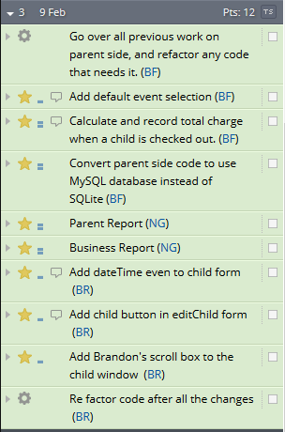
Incomplete/Iteration 4 Stories
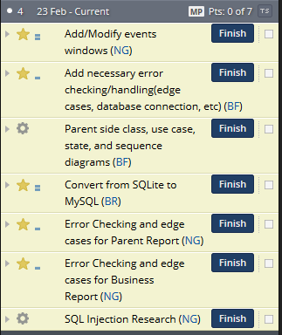

Brandon continued work on the functionality for the Parent side of the application including calculating charges for when kids were checked in and out, and converting his code to use MySQL instead of SQLite. His initials in Pivotal Tracker are (BF).

Brian primarily worked on continuing to add functionality to the Manager side of the application for editing and adding children, including getting a scroll box implemented in the child window. He also started updating his code to read from the MySQL database instead of a SQLite database. His initials in Pivotal Tracker are (BR).

Blaine … His initials in Pivotal Tracker are (BA).

Nathan provided functionality the functionality required for the Parent and Business Report windows as well as starting work on the Add/Modify events windows. He also updated his code to read from the new MySQL database instead of from a SQLite one. His initials in Pivotal Tracker are (NG).

