**CSIS1175-01 Assignment #2 (5 %) Fall 2015**

**Due Date: Oct. 20th/2015**

You can do this **assignment with ONE partner**

You are given the following 2 files:

1. **SalesPerson.txt**

This is a sequential text file showing the sales person, with the following content.

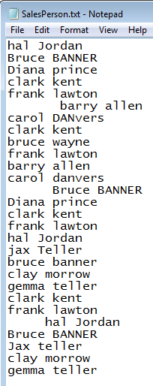

You can assume that there will always be a **one character space** between the **first name and the lastname**, however there may be leading and trailing spaces. Also some of the names have **mixed casing**.

1. **SalesNumbers.txt**

This is a sequential text file showing the **corresponding** sales figures, with the following content.

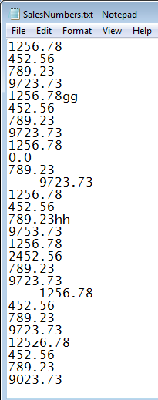

So if we refer to the first record of each file, it will indicate that **hal Jordan** made **$1256.78** in sales. Bruce banner made sales of **$452.56** in the second record and so on.

Note that some of the numbers have **leading and trailing spaces**. Also some numbers are not valid, as they **have letters mixed in**.

You will also need to create a **sequential text file** called ***SalesError.txt***, to log any errors (see **Functionality** below)

Create the following application called Assign Sales Total, with the following GUI interface.

Text boxes with black background, yellow foreground

listBox with Beige background, black foreground

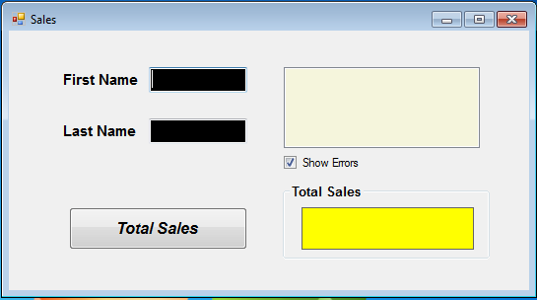

Label with yellow background, blue foreground

The main font on the GUI is **Arial.** Note also the label on the Total Sales button is in **italics**.

You can use **your own judgment on the exact sizes** of the various components

Note the  should be **checked** initially.

**Functionality**

The user will first enter the first name and lastname in their respective text boxes. When the Total Sales button is clicked, it should display in the list box all the sales made by that sales person and the total sales displayed in the label. The list box should display the sales person’s name as it appears in the **FILE**, along with the sales amount.

The list box should be cleared of the previous sales display, before displaying the new information. If there are any errors in the sales figures encountered in **SalesNumbers.txt** file, then a record of it should be made in **SalesError.txt** file. This log file should **NOT be cleared**, but should **continuously** record any errors found. The corrupted **figure should NOT be added to the total** of course. The corrupted record will be displayed in the list box ONLY if the  is selected, otherwise it will not show up in the list box (**but a record of it should still be written in the SalesError.txt file**).

The group text box title “Total Sales” should also display the sales person’s **name in lowercase** when the Total Sales button is clicked.

**Example 1**

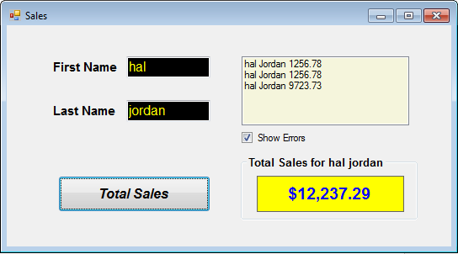

Notice the name “hal jordan” is displayed in the group box’s title.

**Example 2**

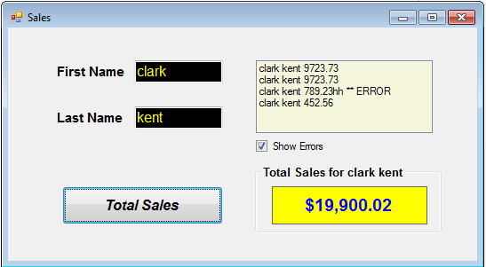

Note there is an error in one of clark kent’s record. **If there is some corrupted data, then a record of it should be written into the SalesError.txt file (see later for content)**.

**Example 3**

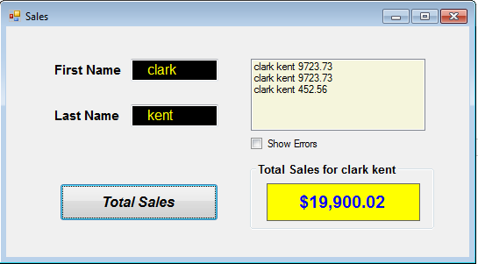

Above shows the same search, but the  is **unchecked**, so the error record is not shown, however a record of it should still be logged in the **SalesError.txt file**

**Example 4**

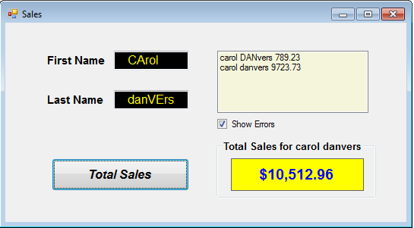

Notice any **leading and/or trailing spaces** in the first and lastname **should NOT** affect your search. Neither should **the case sensitivity.**

**Example 5**

The following is the content of the SalesError.txt file:

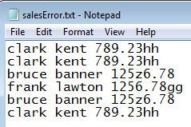

It should record the sales person’s name and corresponding corrupted sales figure. So above shows that when **clark kent** was being searched it encountered an error. Later on **clark kent** was searched again and there was an error. Later on when bruce banner was searched it had a problem, and so it was logged. The **sales person’s name here is as it is from the FILE.**

**What to hand in:**

1. Front cover page with your name (your partner’s name), course, assignment number, instructor’s name, section and due date. (If you did this assignment with a partner, then hand in **ONE** piece of work with **BOTH** your names on it).
2. **Hardcopy** of the program listing of Form1 class.
3. Either zip up all files, call it **CSIS1175F2015yourNameAS2.zip and upload via File submission through myDouglas**

**OR**

Hand in Disk containing all necessary **source** files.

**(If you did this with a partner, then please hand in one piece of work with both your names on the cover page.)**

**PLEASE ENSURE THAT THIS IS YOUR OWN WORK OTHERWISE MARKS WILL BE LOST AND WORSE !!!!!!**