Artemis Financial

Developer:

Brandon Gallagher

1. Algorithm Cipher
   * The chosen encryption cipher for Artemis Financial is the AES with SHA-256. AES is chosen for its levels of efficiency and security. SHA-256 provides a robust encryption generating 256-bit hash values to ensure the best security. Random number generation is used in encryption keys to ensure each key is unique. Symmetric keys are used for the encryption and decryption of data such as user information. Non-symmetric keys are used for added secure communication.
2. Certificate Generation
   * 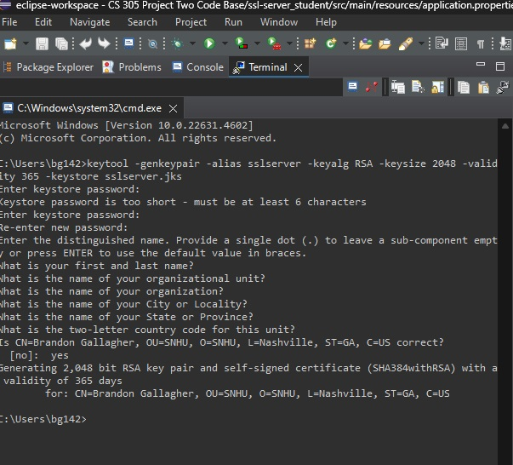
3. Deploy Cipher
   * 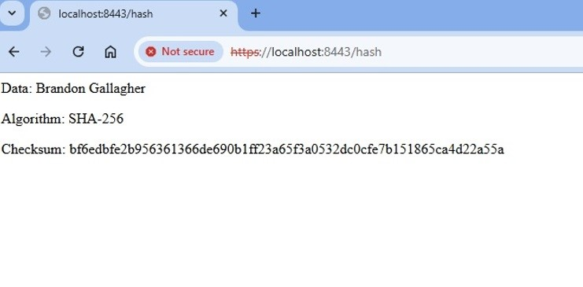
4. Secure Communications
   * 
5. Secondary Testing
   * 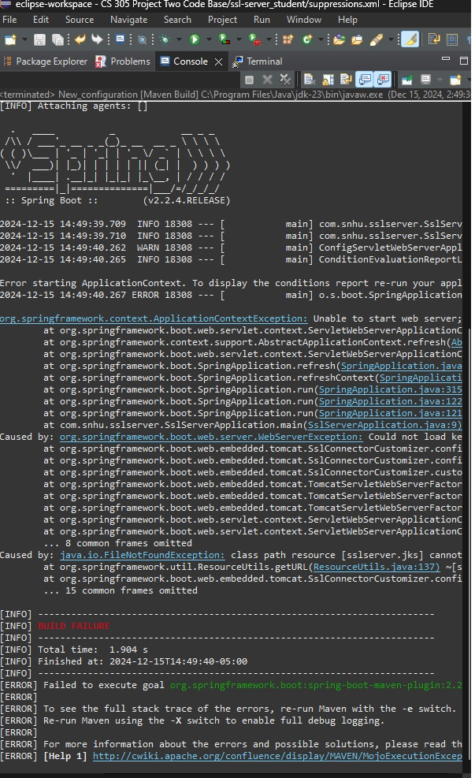
6. Functional Testing
   * After adding the SHA-256 encryption the code within should be up to date on security and should function correctly. Unfortunately, the maven dependency is throwing an error that I can’t figure out quite yet. On paper the code should be running correctly otherwise but there's something I’m missing from my additions to the code.
7. Summary
   * After checking the dependency check and adding the suppressions to the suppression.xml the code for Artemis Financial should be within security testing protocols. Adding AES with SHA-256 for Artemis Financials security adds a very robust encryption method for security. Each key is uniquely generated with 256 hash bits providing a difficult cipher to break.
8. Industry Standard Best Practices
   * In order to keep the business secure and safe while maintaining industry standard best practices I applied SHA-256 to provide a robust encryption cipher for the company. Converting HTTP to HTTPS and manually reviewing the code add additional layers of security for the best levels of protection. Providing the best level of security with industry standard best practices are vital for keeping a positive and nurturing relationship with your clients but it's also important to keep the clients software and information secure. Without following these principles and industry standards weakness pop up and leave the entire company vulnerable to attacks.