Product Requirements Document
Purpose: This Product Requirements Document (PRD) outlines the planned features, functionality, design specifications, user stories, and any technical or business constraints for the product. It acts as a communication bridge between business stakeholders and the development team.

Overview
Product Name: Smart Café Mobile Ordering & Management App
Prepared By: Brandon Hextall
Date: 28/10/2026
Version: 1.0

Problem & Value
Problem | Value / Propose Solution
A café requires a functional mobile application that supports customer ordering and café management | Develop a customer ordering application incorporating relevant and desired features from the client / customer base.
Application needs secure authentication and reliable database integration | Use Firebase Authentication to provide user authentication and cloud-based NoSQL data storage.
Database needs to accommodate potential growth in the user base | Use Firebase cloud infrastructure which supports scalable database operations as demand increases.
Users need to navigate the application easily without unnecessary complexity | Design the interface around user needs and consider navigation, page layouts, accessibility and ease of use.
Uncertainty about interface layouts and navigation patterns | Investigate existing food delivery applications to identify effective design patterns and user-friendly designs.
Requires at least one meaningful advanced integration | Investigate REST API integration and data analytics to identify an advanced feature that supports the application’s objectives and provides meaningful functionality.

A mobile application for a café needs to be designed, developed, tested and demonstrated to have a functional customer ordering system or café management system. I am working alone and have decided to develop the customer ordering system, but may still integrate some management functionality if needed to use and demonstrate certain aspects of the application.
The application needs to be intuitively designed that has secure authentication and database integration. I have decided to use Firebase with NOSQL cloud database, due to the feature of horizontal scaling for the database if the application user base grows, which is more effective for mobile applications.
To make the intuitive designs, I need to think from the perspective of a user (how users would like to navigate the pages, layouts that are easy to navigate, etc) which will allow for me to create an application tailored closer to the needs of users for the application. It may be useful to investigate other food delivery apps, which can provide a better idea of what users would prefer for the general layout and navigation of the app.
There is an expectation of having “one meaningful advanced integration” and I currently have no immediate plans on what I am going to use but will be most likely to use a REST API or Data Analytics, as these options fit best for the objectives of this project.

User Roles
Guest:
- User who is not logged in
- Only perform basic tasks (view products and their details, search/filter menu items, go to login/register page)
Member:
- User who is logged in with their credentials
- Can perform all guest actions
- Can create and manage shopping cart
- Can place orders and receive confirmation
- Track order statuses
- View past orders
- Submit feedback and product ratings
- Receive notifications when order status changes
Administrator:
- Authorized staff member
- View/manage menu items and their details
- Change availability status of products
- View/manage all orders and their details
- View/manage user accounts and information

Scope
This project involves the design and development of a café ordering application that allows customers to create accounts, browse the café’s menu and place orders. The application will include the following features:
- User account management: user registration, secure login/ logout, account authentication
- Menu browsing: display café products (drinks, cakes, etc) with their names, descriptions, prices, categories and availability
- Search and filtering: customers can search for products and filter menu items by category, price and availability
- Shopping cart management: allow customers to add/ remove products from their cart, view selected items, update quantities and view order subtotal
- Order placement and confirmation: customers can view previous orders, view order details and monitor current order statuses
- Feedback and ratings: customers can submit product/ service ratings and feedback for the café
- Notifications: notify customers when order status changes
- Data management and security: store and manage customer accounts, menu info, shopping carts, orders, feedback and notifications while protecting customer information from unauthorized access

Requirements
- Functional:
  - System allows user to register an account using required registration details
  - System should validate registration details and prevent duplicate accounts with the same email address
  - Allow registered users to long in/out securely
  - Allow users to browse café menu and view products and their details (name, description, price, availability)
  - System organizes products into categories (drinks, cakes, sandwiches, etc)
  - Allow user to search products by name/ keyword
  - Allow user to filter products by category, price and availability
  - Allow user to add available products to their shopping cart
  - Allow user to view shopping cart including products, quantities, individual prices, and subtotal
  - Allow users to update product quantities/ remove products from their cart
  - System should validate product availability before an order is placed
  - Allow users to submit an order containing items in their shopping cart
  - System should generate order reference and confirmation when an order is successfully placed
  - System should allow users to view current status of their orders
  - System should update an order’s status throughout café’s fulfilment process
  - System should notify users when order status changes
  - Users can submit ratings and feedback about café’s products/ services
  - System should associate every user’s cart, orders, feedback and notifications with the correct account
  - System should prevent users from viewing/ modifying another user’s account and order information.
  - System should clear/ reset shopping cart after a successful order submission
- Non-functional:
  - System stores passwords using a secure hashing algorithm, never in plain text
  - System should protect authenticated sessions and prevent unauthorized access to restricted functions
  - System should validate user input and protect against common/ basic security vulnerabilities (SQL Injection, cross-site scripting, etc)
  - System should encrypt sensitive data in transit using HTTPS
  - System should display menu pages within 2 seconds under normal operating conditions (optional)
  - Must provide clear error messages when registration/ login/ checkout/ etc fail
  - Must provide consistent and intuitive interface across supported devices and screen sizes
  - System must maintain accurate order totals, prices and order statuses throughout ordering process
  - Prevent duplicate orders caused by repeated checkout submissions
  - Make customer info only accessible to authorized users
  - Must meet UK data protection requirements including GDPR
  - Must maintain reliable records of confirmed orders and status changes
  - System should support agreed target number of concurrent users without exceeding defined performance limits

Data
- Member: first and last name, username (optional), password (hashed), account creation date, phone number (optional), notification preferences (optional), address, shopping cart data
- Orders: product name/ID, amount each product, delivery address, order total
- Products: ID, name, price, ingredients, description, image, availability, allergen information, category

Constraints
- Kotlin is mandatory
- Jetpack Compose for UI development
- Firebase and NoSQL for database
- Application must rely on an available internet connection
- Passwords never stored in plain text
- Access to personal info and order records must be restricted to appropriate customer/ authorized staff
- Personal data must be handles in accordance with UK data protection laws
- Data transmitted between client and server must be appropriately encrypted

Acceptance Criteria
- Users can create an account by providing all required information. Invalid info is rejected with clear error messages, and duplicate email addresses cannot be registered
- Registered user can log in with valid credentials. Invalid credentials rejected without revealing whether email or password was incorrect
- Users can log out, and authenticated session is invalidated. Pages requiring login cannot be accessed again without authentication
- Users can view available products and their details (name, description, price, category, availability, image, etc)
- Users can search by name or keyword and filter product by category, price and availability. Results must match selected criteria
- Logged-in users can add an available product to their cart and see correct product details and quantity. Unavailable products cannot be added
- Logged-in users can change product quantities, and cart subtotal updates correctly
- Logged-in users can remove items, updating cart and subtotal accordingly
- Logged-in users can submit a valid cart. System validates availability and prices, records the order and prevents duplicate submissions from creating duplicate orders
- After order creation, user sees a confirmation containing unique order reference, ordered items and total price
- Logged-in users can view previous orders including dates, items, total and status
- Logged-in users can view latest status of current order and displayed status reflects updates made by authorized staff
- Logged-in users can submit ratings and written feedback about café’s products/ services. Submission is saved and associated with the correct user and product/ service
- System creates a notification for relevant customer when an order’s status changes. Notification identifies the order and its new status
- Users cannot view/ modify another users cart, orders, feedback or account information by changing URL or request
- Purchased items are removed from active cart after an order is successfully placed. Cart remains available to user if checkout fails
- Passwords stored using secure hashing, and sensitive data transmitted over HTTPS
- Users can complete main ordering journey without encountering broken controls, unclear navigation or unhandled errors
- Interface remains usable on agreed supported mobile, tablet and desktop screen sizes
- Order totals equal sum of relevant item prices multiplied by their quantities
- Invalid input, unavailable products and failed operations produce clear feedback without corrupting saved data
- Confirmed orders remain accessible in order history after the user logs out and back in
- Users can access only the personal information and records permitted by their account permissions

Authentication and user Journey
Welcome screen Register Validate create account authenticated dashboard
Login validate authenticate authenticated dashboard
Dashboard logout login screen
Dashboard shopping cart checkout order validate availability validate order details order successfully placed display unique order reference number
Order unsuccessful meaningful error; remain on current screen
Shopping cart Click “remove item” item removed; cart and order details updated
Increase/ decrease quantity of item cart updates; items and subtotal update accordingly
Dashboard account options delete account user details, order history, other info removed from database logout login screen

Incorrect input/ service failure meaningful error; remain on current screen

User Stories / Backlog
ID | User Story | Priority
US-01 | As a new customer, I want to register an account to use the café’s ordering system. | Must
US-02 | As a registered user, I want to log in securely so I can access my personal account | Must
US-03 | As a logged-in customer, I want to log out so my account cannot be accessed by someone else using my device | Must
US-04 | As a customer, I want to recover my password so that I can regain access to my account | Should
US-05 | As a customer, I want to browse the café’s menu | Must
US-06 | As a customer, I want to view product descriptions and prices so I can make an informed decision | Must
US-07 | As a customer, I want to filter out products with certain allergens to avoid buying potentially harmful products | Should
US-08 | As a customer, I want to search for products by name/keyword | Must
US-09 | As a customer, I want to filter products by category | Must
US-10 | As a customer, I want to filter products by price | Should
US-11 | As a logged-in customer, I want to add products to my shopping cart | Must
US-12 | As a logged-in customer, I want to view my shopping cart so that I can review my products before ordering | Must
US-13 | As a logged-in customer, I want to remove products from my cart | Must
US-14 | As a logged-in customer, I want to see my cart subtotal so I know how much my selected products cost | Must
US-15 | As a logged-in customer, I want to place an order using my shopping cart so I can purchase selected products | Must
US-16 | As a logged-in user, I want to receive an order confirmation and unique order reference number so I know my order was successfully placed | Must
US-17 | As a logged-in user, I want to review my order details before submitting so that I can check that everything is correct | Should
US-18 | As a logged-in user, I want to view my previous orders | Must

Backlog
ID | Role | Acceptance Criteria | Priority | Status
SCA-01 | Customer | Register with email and password | Must | Complete
SCA-02 | Customer | Login with email and password | Must | Complete
SCA-03 | Customer | View café’s menu | Must | In progress
SCA-04 | Customer | Add and remove items from basket | Must
SCA-05 | Customer | Place orders | Must
SCA-06 | Customer | View past orders | Must

The 8 Vs
V | Question to Discuss | Answer
Volume | What changes at 100 users versus 1 million users? | The database will scale horizontally, increasing the number of servers to allow more data to be stored without losing processing speed.
Velocity | How quickly should order status updates and notifications be delivered? | Around 5 seconds at the slowest.
Variety | What types of data will the application need to handle (text, images, numerical, etc)? | Images, test, floating point numbers, Date/Time, transactional (order IDs, purchased products, prices, etc), location data (customer delivery address)
Veracity | How will the application ensure that product prices, availability and order information remain accurate? | Product prices will be stored in the database with the rest of the product information, retrieve latest price when a customer views a product or their cart, recalculate order total using current prices at checkout, allow staff to update availability, check availability when viewing items or adding to cart and before confirming an order
Value | How can the café use collected customer and order data to improve products and services? | Identify trends and customer preferences to improve menu, customer experience and overall service. Can analyze commonly ordered products and recommend popular items
Variability | How will the application handle fluctuations in customer demand during busy periods / season changes? | Data analytics can detect commonly ordered items during certain periods, allowing workers staff prepare additional ingredients for those high-demand periods. If a product is out of stock, staff can update its availability so customers can no longer or it.
Visualization | How should information be presented to customers to make it easy to understand? | Keep elements reasonably spaced apart, size text to be easy to read without taking tons of space, group relevant information and elements together
Vulnerability | How will the application protect customer information and prevent unauthorized access to accounts and orders? | Common prevention methods such as invalid character detection (to stop SQL injection), encrypting sensitive user information (passwords), and user access restrictions such as limiting what unregistered users can see and access, not allowing unregistered users to view shopping cart and order history, and only allowing logged-in users to view data related to their account.

Entity Relationship Diagram
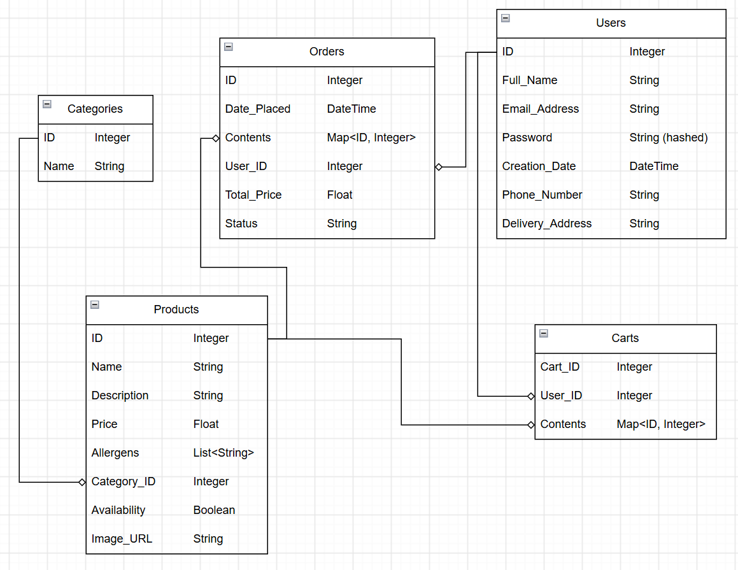

Meeting Notes
Date | Notes | Action(s) Taken
29th October 2026 | Finish project planning | Finished project planning
5th November 2026 | Simplify PRD large paragraphs and extensive explanations. Keep better track of time spent. Create Agile backlog | Cut down on detail where I can swap from a paragraph to bullet points or a table. Created an Excel table for hours spent on the project. Will make agile backlog to track tasks and monitor performance.
12th November 2026 | Change existing code format from MVC to MVVM format for better structure with Jetpack Compose

Timing Tracker

