System Design Document

Team Two

3/5/2024

Table of Contents
Introduction 3
Purpose 3
System Overview 3
Design Constraints 4
Roles and Responsibilities 5
Project References 5
System Architecture 6
Database Design 7
Hardware and Software Detailed Design 7
System Security and Integrity Controls 8

Introduction
This document’s purpose is to outline in detail the top-down role-playing game being created by Team Two. Through detailed planning, rigorous testing, and the release of the game, we hope the public will find it to be an enjoyable source of entertainment.

Purpose
The outline of how this game will be built will be documented here. We will adhere to the strictest requirements of quality for testing and creating, as well as the methodology and actions necessary as outlined in the given framework for this project provided by Dr. Wang.

System Overview
The game will be built using Unity to provide entertainment through exploration and puzzle solving, utilizing team work to both achieve our goals in the game and outside of it.

Design Constraints
The constraints of this project are those provided by Dr. Wang. We will be making a game to fit within those specifications, using API’s and cutting-edge technology in the timeline specified.

Roles and Responsibilities
 | PROJECT MANAGER | DEVELOPER | DEVELOPER | DEVELOPER
PROJECT TASK | ELIZABETH | ANDREW | JAMES | JOEL
SYSTEM DESIGN DOCUMENT | R | C | C | C
MILESTONE LIST | R | C | C | C
DURATION ESTIMATE | R | C | C | C
GANTT CHART | R | C | C | C
SPRITE CREATION | C | A | A | R
SPRITE MOVEMENT | C | R | A | A
POWERS AND INTERACTIONS | C | A | A | R
MAP DESIGN | C | R | A | A
INTERACTABLES | C | A | R | A
 | R = Responsible | A = Accountable | C = Consulted | I = Informed

NAME | ROLE | E-MAIL
ELIZABETH | PROJECT MANAGER | ec268930@my.stchas.edu
ANDREW | DEVELOPER | al231511@my.stchas.edu
JAMES | DEVELOPER | bd265996@my.stchas.edu
JOEL | DEVELOPER | je240398@my.stchas.edu

Project References
The reference documents used are:
- Class Schedule
- Course Syllabus
- Project Proposal

System Architecture and Database Design
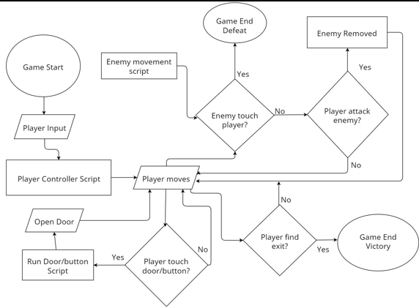

Hardware and Software Detailed Design
Hardware required to run this game, at a minimum:
  - 2gb Graphics Card
  - Windows 7
  - Intel i5 processor
Software required to run this game:
- Game Download

System Security and Integrity Controls
Internal security measures on Github have been taken to ensure that nobody but the team and Dr. Wang have access to the code and documents for this game. For the playing side, we will have a secure log in to the game for the “host” and the secondary player will need a password to join the game.
Sponsor Acceptance

Approved by the Project Sponsor:

Date:
<Faculty Sponsor>
<Faculty Sponsor Title>

This free System Design Document Template is brought to you by www.ProjectManagementDocs.com

