**Retro Gaming Store**

**User’s MANUAL**

A Computer Science

Systems Analysis and Design

Project

By

Team # 2

Ekaterina Hillary

Brandon LaDuke

Bruce Durham

Eric Taylor

November 2019

**Revision Sheet**

|  |  |  |
| --- | --- | --- |
| **Release No.** | **Date** | **Revision Description** |
| Rev. 0 | 11/10/2019 | User’s Manual Template |
| Rev. 1 | 11/11/2019 | Initial Work |
| Rev. 2 | 11/16/2019 | Revision 1 |
| Rev. 3 | 11/10/2010 |  |
|  |  |  |
|  |  |  |
|  |  |  |

**USER'S MANUAL**

**TABLE OF CONTENTS**

Page #

A. GENERAL INFORMATION A-1

1.1 System Overview A-1

1.2 Points of Contact A-2

1.2.1 Information A-2

1.2.2 Coordination A-2

1.2.3 Help Desk A-2

1.3 Organization of the Manual A-2

1.4 Acronyms and Abbreviations A-2

B. SYSTEM SUMMARY B-1

2.1 System Configuration B-1

2.2 Data Flows B-1

2.3 User Access Levels B-1

C. GETTING STARTED C-1

3.1 Logging On C-1

3.2 System Menu C-1

3.2.1 Home C-1

3.2.2 Buy C-1

3.2.3 Sell C-1

3.2.4 FAQ C-1

3.2.5 Contact Us C-2

3.3 Changing User ID and Password C-2

3.4 History C-2

3.4.1 About Us C-2

3.4.2 Looking Towards the Future C-2

3.5 Exit System C-2

**1.0 GENERAL INFORMATION**

# GENERAL INFORMATION

## 1.1 System Overview

A gaming store focused on the buying and reselling games of previous era’s:

1. As the administrator for the Retro Gaming Website, Admin shall be able to access all of the functionalities of the improved site, including adding or removing user accounts, items, posts, and pictures.
2. As an account user, the specific member will have limited access to the site. Account users only have privileges to login, as well as creating and editing their items and posts. The account users will also have access to adding pictures to specified albums.
3. The website and all its functionalities including the database for the Retro Gaming Store will be hosted on the Sullivan server.
4. The Retro Gaming Website in itself is a graphical user interface.
5. Created using Github incorporating languages including HTML, PHP, and Java Script.
6. System category:
7. *Major application:* performs clearly defined functions for which there is a readily identifiable security consideration and need
8. Operational status:
9. Partially Operational
10. Under development

## 1.2 Points of Contact

### 1.2.1 Information

The points of organizational contact (POCs) that may be needed by the document user for informational and troubleshooting purposes are currently not available.

### 1.2.2 Coordination

The list of organizations that require coordination between the project and its specific support function (e.g., installation coordination, security, etc.) are currently not available.

### 1.2.3 Help Desk

Help desk information including responsible personnel phone numbers for emergency assistance is currently not available.

## 1.3 Organization of the Manual

User’s Manual v0.01.

1.0: General Information

This section contains general information about the Retro Gaming Website, including the system overview, points of contact, and acronyms and abbreviations

2.0: System Summary

This section is an overview of the functionality the Retro Gaming Website contains in non-technical terminology.

3.0: Getting Started

This section contains the information to get started in using the Retro Gaming Website, which includes logging in and out of the system as well as the different main menu options and what they do.

## 1.4 Acronyms and Abbreviations

Provide a list of the acronyms and abbreviations used in this document and the meaning of each.

App: Application

MS: Microsoft

MSDN: Microsoft Developer Network

Wiki: Wikipedia

**2.0 SYSTEM SUMMARY**

# SYSTEM SUMMARY

## 2.1 System Configuration

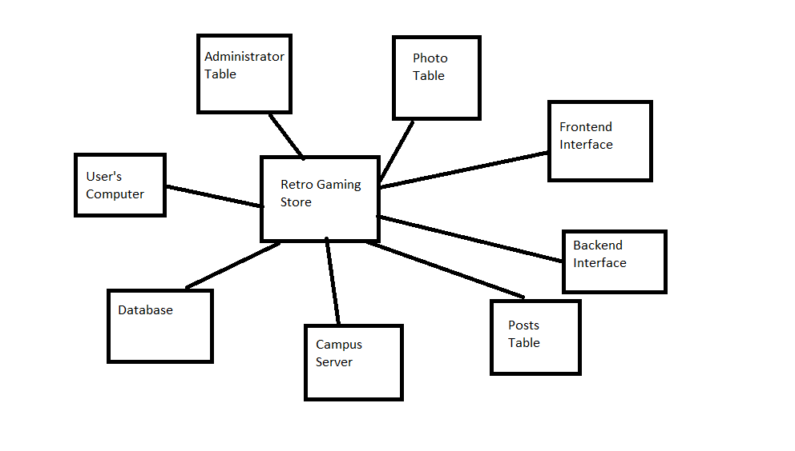

## 2.2 Data Flows

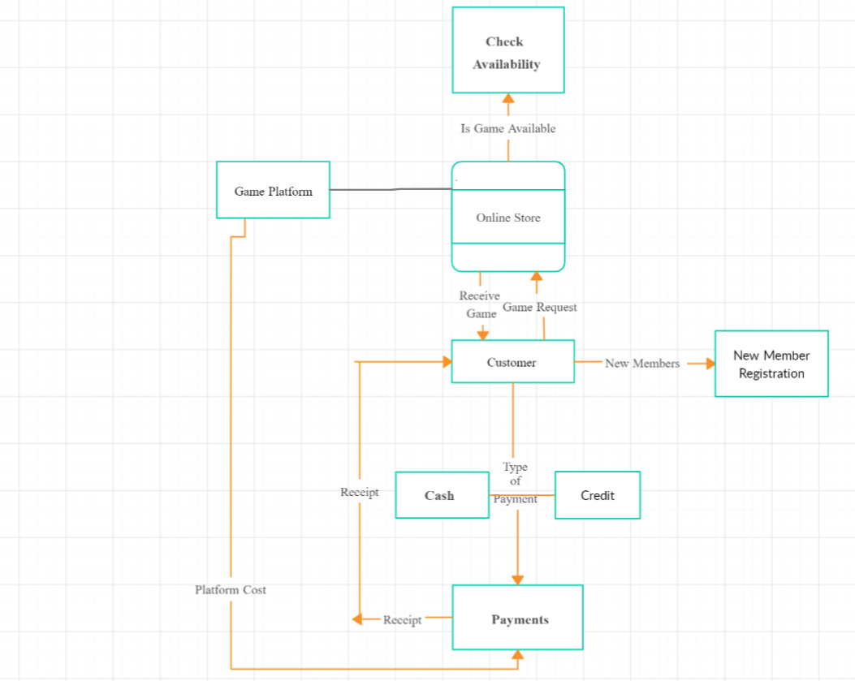

## 2.3 User Access Levels

Administrator: The administrator for the Retro Gaming Store shall be able to have access to the Github backend. Here, the administrator can remove or add different users as needed and create specific categories for each individual need. They can approve or disapprove games and posts. The administrator can delete photos and posts.

User: Each individual user is assigned to the “member” user level. This means that they can upload photos to a specific album. They can also add and edit their own posts. They will not be able to log into the Github backend or have their posts published right away.

**3.0 GETTING STARTED**

# GETTING STARTED

## 3.1 Logging On

Each individual user will need an email to create a membership in the Retro Gaming Store. From there, the user will register himself by setting up a username and password. After they set up their information, the user can logon through the Retro Gaming Store main page.

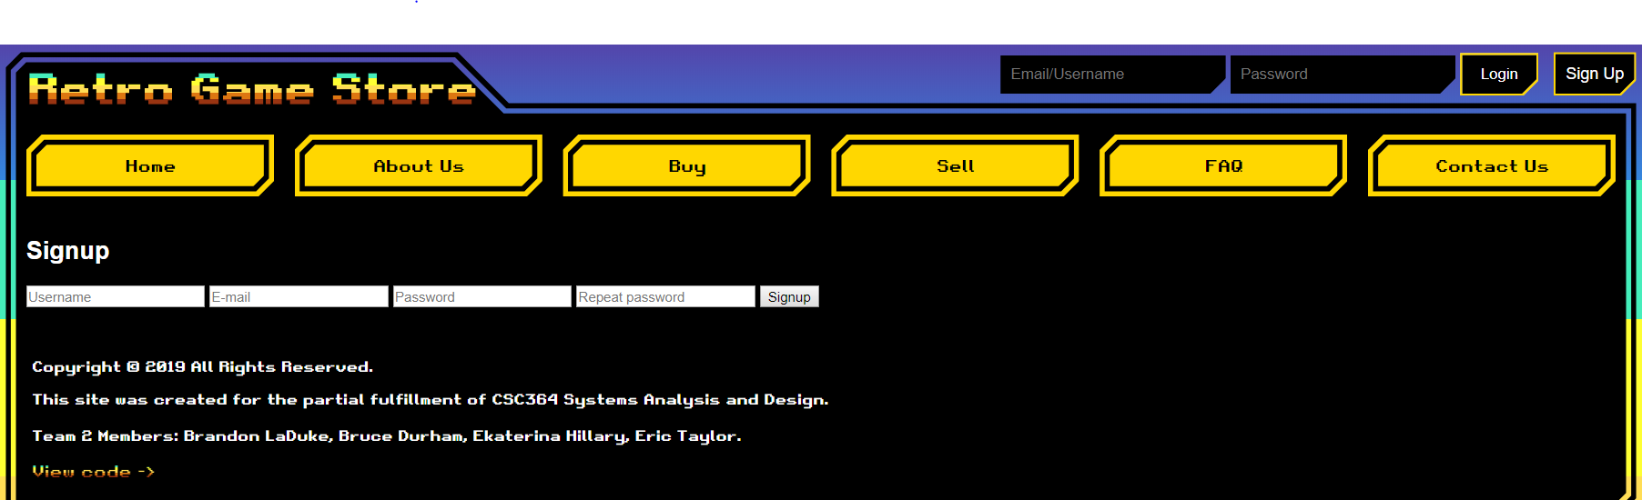

## 3.2 System Menu

When a user first appears on the Retro Gaming Store main page, there will be a top header menu (that will appear on all pages) containing menu links. On the top right-hand side there will be a login form for users to log into the site.

### 3.2.1 Home

The Home section of the website will take you to the home screen.

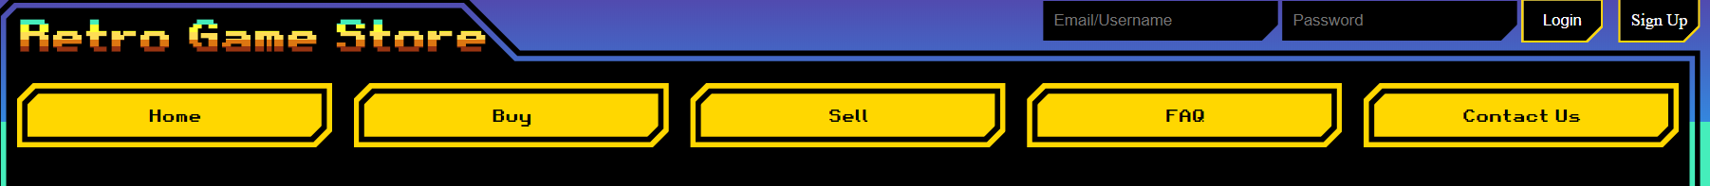

### 3.2.2 Buy

The Buy section of the website will take you to the screen where a user would be able to select an item on sale and purchase the item.



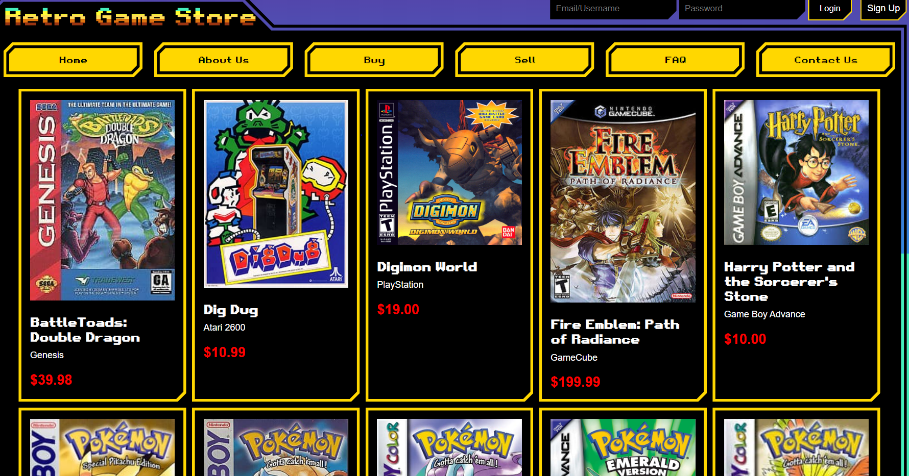

### 3.2.3 Sell

The Sell section of the website will take the user to the screen where he can sell his own item.



Once the user has created an account and has logged in, they may now sell their own games.

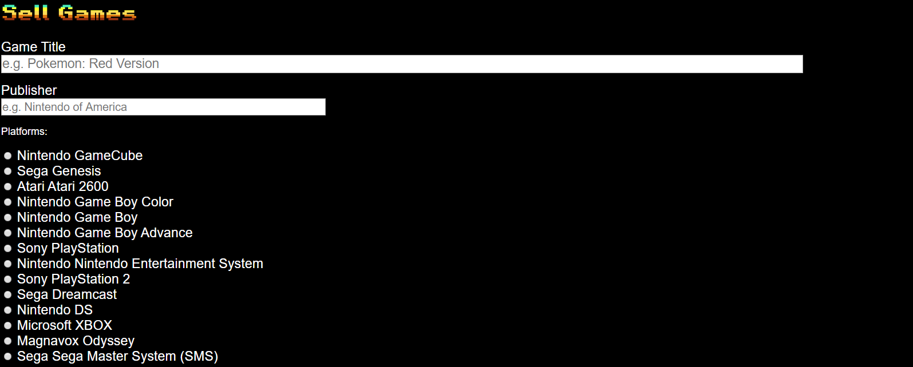



### 3.2.4 FAQ

The FAQ (frequently asked questions) section of the website will take the user to the screen where the most common questions asked can be answered.

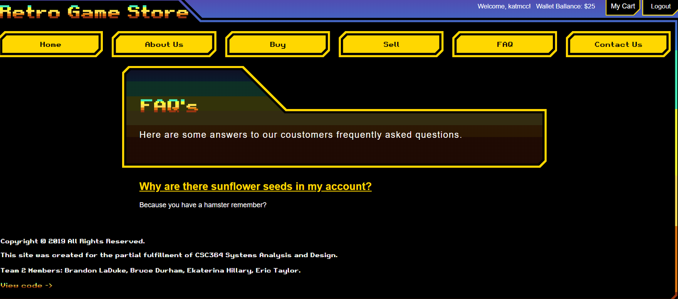

### 3.2.5 Contact Us

The Contact Us section of the website will take the user to the screen in order to contact an administrator in order to assist with an order or the selling of an item.

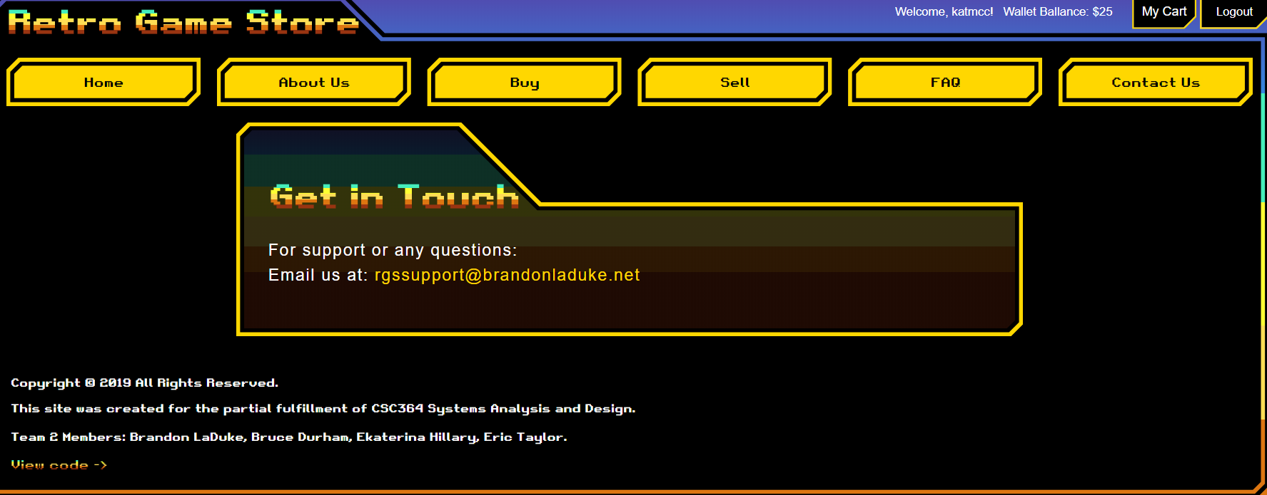

## 3.3 Changing User ID and Password

Sign in to the Web Interface.

## 3.4 History

### 3.4.1 About Us

This link takes the user to an article that describes to the user some brief information about the founders of the Retro Gaming Store why it was formed

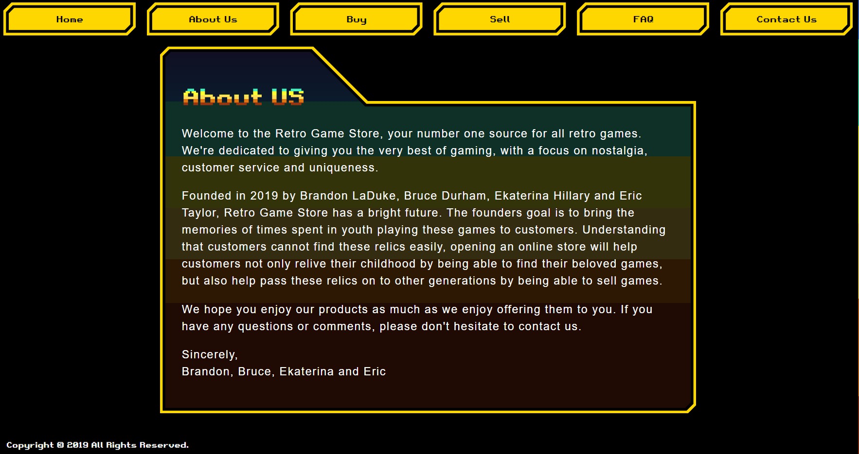

### 3.4.2 Looking Towards the Future

## 3.5 Exit System

Click on Log Out