THE UNIVERSITY O ZAMBIA

SCHOOL OF NATURAL SCIENCES

COMPUTER SCIENCE DEPARTMENT

GROUP 3

CONTEXT FREE GRAMMER ASSINGMENT REPORT.

The picture below shows the Grammar we defined 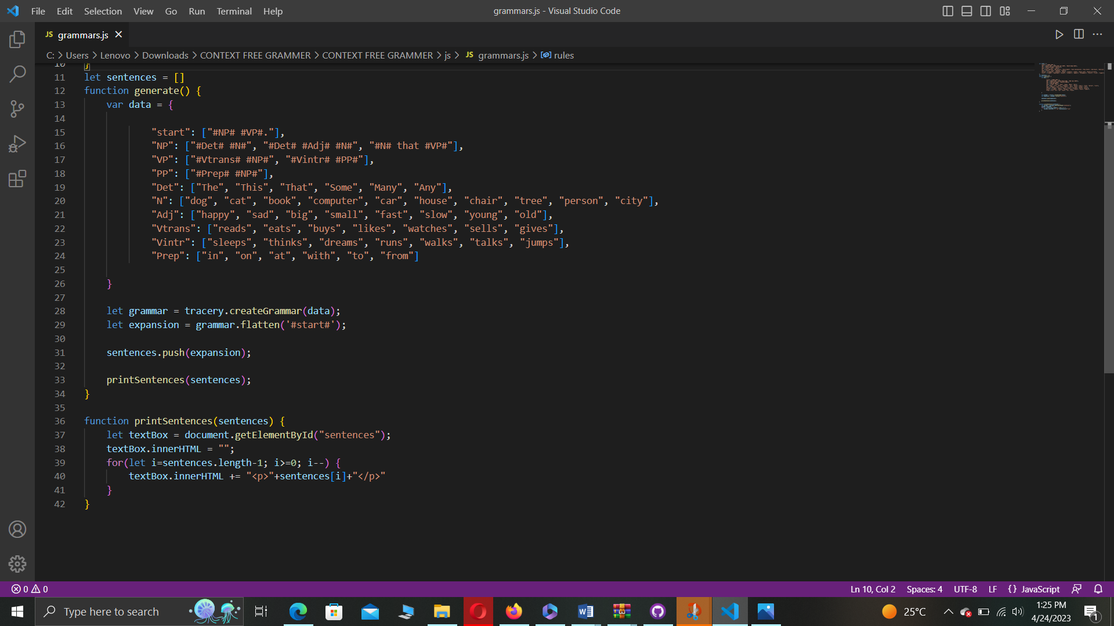

HTML INTERFACE

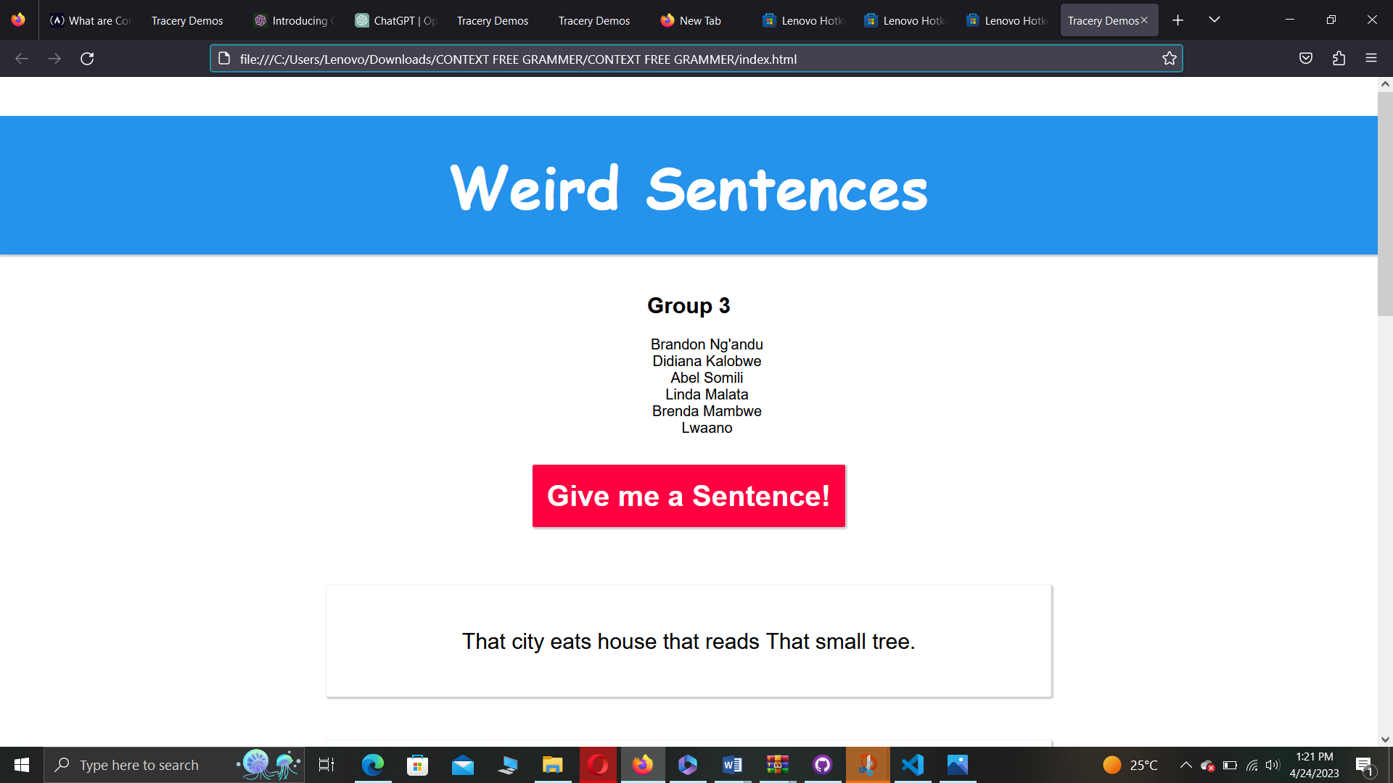

HERE ARE A FEW RANDOM “ WEIRED SENTENCES” GENERETED

