Deep Sea Fishing

Mobile Project Design Document



Prepared by: Brandon Morrissey

Date Submitted: 1/29/2016

# Document Change Control

|  |  |  |
| --- | --- | --- |
| *Date* | *Author(s)* | *Details* |
|  |  |  |
| 1/28/2016 | Brandon Morrissey | Created and finished Design documentation. |
|  |  |  |
|  |  |  |
|  |  |  |
|  |  |  |
|  |  |  |
|  |  |  |
|  |  |  |
|  |  |  |
|  |  |  |

# Document Sign-off

|  |  |  |  |
| --- | --- | --- | --- |
| *Position* | *Name* | *Signature* | *Date* |
|  |  |  |  |
|  |  |  |  |
|  |  |  |  |
|  |  |  |  |
|  |  |  |  |
|  |  |  |  |
|  |  |  |  |
|  |  |  |  |
|  |  |  |  |
|  |  |  |  |

Contents

Document Change Control 2

Document Sign-off 2

Description 4

Primary Functions 4

Login 4

User creation 4

Book a session 4

Secondary Functions 4

Interface Design 5

Login Screen 5

Account Creation 6

Session Booking 7

# Description

The Deep Sea Fishing mobile application will be the mobile platform for performing basic client transactions. The user will be able to create an account or use an existing account to book a session, view the available session timeslots and book a session. No payment information is taken, the booking is to act as a reservation for a slot (or many slots). The application will also serve as an easy way to access any contact information. The application main goal is to provide a mobile front for performing transactions on the fly.

# Primary Functions

## Login

Clients will be able to log into their pre-existing accounts that they would have created for the web application. This will be done with a Username and Password.

## User creation

Clients will be able to create an account to access the content and services that the application provides to basic users. This account will also work on the web application.

## Book a session

The user will be able to book a session, it will show a list of bookable sessions and if the session is fully booked then an error will be returned (or the listing will be removed and won’t even be an option to book).

# Secondary Functions

In the future, the mobile application should provide a full calendar of all bookable sessions. Additionally it should also show if the booking is full or show if it’s almost fully booked. The mobile application should also provide some admin services which when the user signs in performs a check for the type_id of the user. If admin value is returned an admin panel should be added to the applications action menu.

# Interface Design

## Login Screen

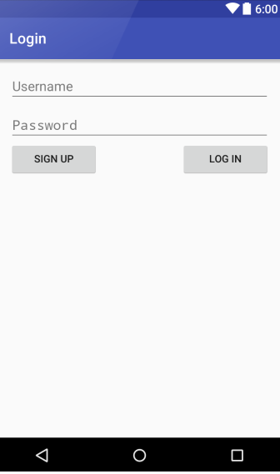

The login screen is fairly straightforward. It provides the user the option to login or create an account which takes them to the account creation form.

## Account Creation

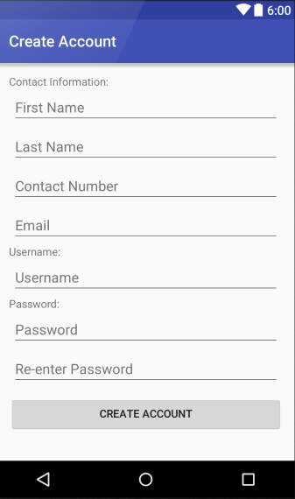

The user creation page is also straight forward. The contact info is taken and then the user enters a username and password twice. If the passwords match and the username isn’t taken then the user is created.

## Session Booking

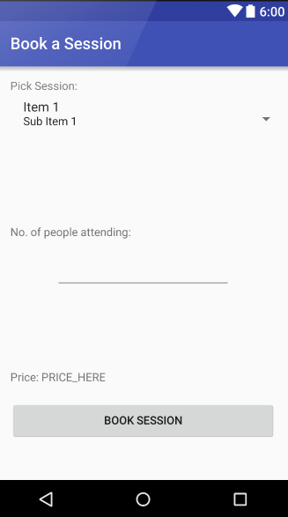This is a very conceptual view on what the booking layout will look like, but essentially there will be a spinner containing all available sessions to book (sessions that are booked will either appear as disabled or won’t be in the spinner at all). After the user chooses a day to book they will set the amount of people attending and then a price (including tax) will be calculated. Then once the user presses the book session button a toast will alert the user that either the reservation was successful or an error occurred. This is subject to change and additional features may be implemented throughout the course of early development.