Intro to Computer Science 420-121-VA

Assignment 3

Geon Kim, Elia Morhej, Brandon Nguyen

Fall 2019

Teacher: Tassia Camoes-Araujo

Assignment 3

Theme: Gas emissions

Table 1

This table provides information about 7 different countries’ total billion tons of CO2 emissions in 2016 and their population count in 2016. Finally, the third row for each country will use a formula to display the tons of CO2 emissions per person in that country (per capita).

In the chart the population of each country is discarded because of the disparity of the numbers with the two other statistics. The chart is a way to visualize which country’s emission problems are on an individual level and which are not.

|  |  |  |  |  |  |  |  |  |
| --- | --- | --- | --- | --- | --- | --- | --- | --- |
|  | Country: | China | USA | India | Japan | Canada | Russia | Saudi Arabia |
|  | Total GtCO2: | 9.0568 | 4.8331 | 2.0768 | 1.1471 | 0.5408 | 1.4386 | 0.5272 |
|  | Population in M: | 1434 | 329.1 | 1366 | 126.9 | 37.4 | 145.8 | 34.3 |
|  | tCO2 / CAPITA: | 6.316 | 14.69 | 1.52 | 9.0394 | 14.46 | 9.86694 | 15.37 |

Table 2

This table shows the emissions of CO2 per continent, the average amount of CO2 emissions per person for each continent, and the percentage of total worldwide emissions, all during the year of 2017. This table adds new information to the prior one, by showing us where in the world most of the emissions are coming from.

|  |  |  |  |  |  |  |
| --- | --- | --- | --- | --- | --- | --- |
| Continent | Asia | North America | Europe | Africa | South America | Total |
| Population  (billion) | 4.181 | 0.490 | 0.743 | 1.255 | 0.424 | 7.6 |
| CO2 (billion tons) | 16.918 | 6.333 | 5.693 | 1.332 | 1.147 | 36.153 |
| Percentage of all emissions | 46.8% | 17.5% | 15.7% | 3.6% | 3.1% | 100% |
| (tons)CO2/  capita | 4.0 | 13 | 7.7 | 1.1 | 2.7 | **-** |

**total refers to the entire planet

 Data Interpretation

This topic is interesting for many reasons. A more specific fun aspect of it is that the statistics for the tons of CO2 emissions per capita do not always align with one’s expectations. Let’s take China as an example. Judging by their total CO2 emissions, you’d expect their tons of CO2 emissions per capita to be decently high, however it’s less than half of Canada’s, and the latter country’s total CO2 emissions don’t even come close to China’s.

Taking China as an example again, by analyzing these statistics, we can say the huge amount of CO2 they produce is very barely the majority of the population’s fault.

Furthermore, almost half the total global CO2 emissions came from Asia in 2017, and as we all know, Asia’s population is much less privileged and rich than other parts of the world such as Europe and North America. This must mean that a minority is responsible for most of the CO2 emissions worldwide, whom are all probably factory owners and huge companies.Top of FormBottom of Form

Entity Relation Diagram

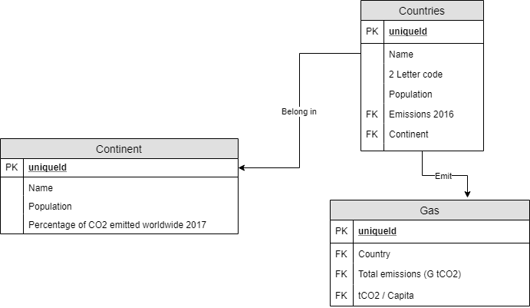

Ethical Question & Paramedic Ethics

**Ethical question:**

Has reducing gas emissions become a worldwide responsibility for everyone despite it not affecting everyone equally?

**Paramedic Ethics:**

Stakeholders: People indirectly affected (IDR), People directly affected (DR), Government, Companies

Gains and losses:

* DR: Get more support/help from organizations (gain)
* DR: Mental and physical health (loss)
* Government: Gains more taxes (gain)
* IDR: Effort and time to adapt to a new lifestyle (loss)
* Government: Reduced funding for other sectors (loss)
* Companies: Product ideas (ex. Eco-friendly products) (gain)
* Companies: Impaired assets and market relevancy (loss)
* Everyone: A more ecological and safer environment (gain)
* Everyone: Threatened livelihoods (loss)

Duties and Obligations:

* IDR: a moral duty to help those in need
* Government: research to facilitate being ecological for the people
* Government: sensitize more people to the need of acting against climate change
* Companies: use more renewable energy options for their industrial needs

Final Decision:

From a consequentialist point of view, the world will overall be a better place for absolutely everyone if everyone truly sees taking care of the environment as a responsibility. Being unaffected by environmental deterioration will only be temporary, and as much of a change as adapting to new regulations is for companies and unaffected people alike, it should be considered standard for our time.

From a deontological point of view, it is the right course of action to take. You have a duty as a citizen of the Earth to take care of the environment for your sake and for others.

So to sum it all up and answer our ethical question, yes it has become a responsibility for every person to take care of the environment.

References

1. www.globalcarbonatlas.org/en/CO2-emissions
2. ucsusa.org/global-warming/science-and-impacts/science/each-countrys-share-of-co2.html
3. worldometers.info/geography/countries-of-the-world/