**Autonomous Position and Altitude Control System for High Altitude Balloons**

ECE4011 Senior Design Project

High Ball

Cohen, Morris

MIT Lincoln Labs

Manning, Mathew W - mathew@gatech.edu

Redder, Brandon A - brandonr@gatech.edu

Richardson, David K - drichardson42@gatech.edu

Sanchez, David - dsanchez36@gatech.edu

Scott, Kristine L - kscott43@gatech.edu

Watters, Kyle - kwatters6@gatech.edu

Submitted

July 20, 2018

**Table of Contents**

**Executive Summary** ii

1. **Introduction** 1
   1. Objective 1
   2. Motivation 1
   3. Background 2
2. **Project Description and Goals** 2
3. **Technical Specification** 4
4. **Design Approach and Details** 5
   1. Design Approach 5
      1. Mechanical Design 5
      2. Electrical Design 7
      3. Software Design 9
   2. Codes and Standards 10
   3. Constraints, Alternatives, and Tradeoffs 11

1. **Schedule, Tasks, and Milestones** 12
2. **Project Demonstration** 12
3. **Marketing and Cost Analysis** 13
   1. Marketing Analysis 13
   2. Cost Analysis 13
      1. Hardware Costs 13
      2. Development Costs 15
4. **Current Status** 17
5. **Leadership Roles** 18
6. **References** 19

**Appendix A: Relevant FAA Regulations** 22

**Appendix B: Project Gantt Chart** 29

**Appendix C: Project PERT Chart** 31

**Appendix D: Planned Hardware Purchases** 32

**Executive Summary**

The Georgia Institute of Technology in collaboration with the Massachusetts Institute of Technology Lincoln Laboratory proposes a low-cost autonomous control system for high altitude balloons (HABs). There has been substantial interest in the application of HABs in communication and monitoring of regions not served by traditional infrastructure. Several examples include disaster recovery scenarios, rural areas, and active conflict regions. Many HAB designs suffer from short flight durations, prohibitive cost, or lack position control. The proposed system will employ a low cost altitude and position control system to increase flight duration and regional coverage. The payload will weigh under six pounds to minimize the regulatory burden and allow the balloon to be operated during inclement weather conditions. In order to keep the design under the weight limit and improve structural stability, a novel cutdown mechanism is proposed. To maximize flight duration and regional coverage, an altitude control system will be developed using mechanical methods to release helium and ballast as well as a control algorithm. This algorithm can be combined with measured wind data and weather forecasts to direct the balloon to a specific location. With this extended control, high altitude balloons will be capable of maintaining regional coverage for long periods of time. RF or sensor packages can be deployed using the altitude and position controlled HAB as a stable aerial platform to conduct research, carry out experiments, or conduct surveillance. The expected development cost for the design is $56,649.98 with the cost of hardware per payload being $910.65.

**Autonomous Position and Altitude Control System for High Altitude Balloons**

**1. Introduction**

The MITLL High Ball team’s directive is to design, launch, and control a high altitude balloon (HAB). A control system will use varying wind currents at different altitudes to adjust the balloon’s position. The High Ball team is requesting $1000 for development and testing of a viable HAB control system.

* 1. **Objective**

The goal of this project is to develop an altitude and location control system for a latex HAB to allow long duration flights over a general location. Algorithms take into account current pressure and temperature conditions when venting helium or dropping ballast to estimate altitude changes. Weather forecasts from the National Oceanic and Atmospheric Administration provide wind speeds at distinct pressure levels allowing for prediction of horizontal movement over time [1]. Using this prediction along with altitude control, the balloon’s position can be controlled.

* 1. **Motivation**

High altitude balloons offer a low cost solution for deploying RF and sensor packages. Traditionally, the flight time of an HAB is limited by the balloon bursting. The creation of an altitude control system will drastically improve the flight duration resulting in a larger variety of applications. The proposed control system will allow for prolonged deployment over a specific region.

Project Loon, a balloon system developed by Google, uses tennis court sized balloons to provide cellular service to low population regions. These balloons are capable of multi-month flights with both altitude and location control [2]. Although this system has proven to perform well, it is prohibitively expensive for many applications. A similar position control system deployed on a latex balloon will provide a low cost alternative.

* 1. **Background**

As latex HABs rise, the decreasing air pressure causes the balloon to expand until the balloon bursts, ending the flight. Flight times are limited to approximately 3 hours. To overcome this hurdle, balloons have been designed to increase flight durations by venting excess helium upon reaching a predetermined altitude and utilizing polyethylene film which has a lower elasticity than latex to minimize expansion [3]. Zero-pressure balloons must drop ballast to maintain altitude during diurnal cycles, and they can carry loads of up to 6,000 lbs for flights lasting 7-15 days on average [3]. Super pressure balloons rely on a thicker more rigid film material to limit expansion due to changing temperatures, and they can carry loads of up to 2000 lbs for flights lasting over 100 days [3]. For smaller organizations with instrument packages on the scale of 5 lbs these balloon options are unrealistic.

ValBal is a project out of Stanford that produced an altitude control system for latex balloons. The ValBal system holds the current world record for latex balloon flight duration, 121.5 hours [4]. The current design weighs approximately 2.5 kg without ballast and uses a 1500 g balloon with 9 kg of lift allowing the user to include 5 kg of ballast and instruments [4]. Each payload costs $1000 which makes it viable for a much broader range of users [4].

**2. Project Description and Goals**

The goal is to design a location control system to be used with HABs. The design will utilize altitude change and wind currents to control the location of the balloon. The altitude control system will consist of pressure sensors and an IMU for determining altitude as well as a mechanical release method for ballast and helium. Motion and location of the balloon will be monitored through the use of GPS and an IMU. A microcontroller will be used for data processing and control of mechanical components. The system will be deployed in a single payload so that an additional payload may be attached. The second payload could be used for RF or sensing applications. System features include the following:

* Physical control mechanism for helium and ballast release
* Altitude determination through sensor integration
* Position determination through sensor integration
* Manual control of HAB from ground station
* Autonomous HAB flight
* HAB must be able to reach an altitude of 90,000 ft while maintaining functionality
* Position control using wind currents
* Recoverable payload

**3. Technical Specifications**

Table 1. Technical Specifications

|  |  |
| --- | --- |
| **Feature** | **Specifications** |
| Operating Voltages | 3.3v, 5v |
| Battery Capacity | 21000 mAh |
| Payload Weight | 2500 g |
| Ballast Weight | 220 g |
| Operating Altitude | 18 km to 27.4 km |
| Ambient Operating Temperature | -60℃ to 40℃ |
| Internal Operating Temperature | -35℃ to 40℃ |
| Operating Pressure | 1.0 to 1000.0 hPa |
| Maximum Recoverable Drop Velocity | 7 m/s |
| Water Resistance | IPX4 |
| Flight Duration | 24 hours |

Table 2. Communications Specifications

|  |  |
| --- | --- |
| **Feature** | **Specifications** |
| Latency | 5 seconds (for message <70 bytes) |
| Maximum Usable Distance | Global |

**4. Design Approach and Details**

**4.1 Design Approach**

**4.1.1 Mechanical Design**

***Ballast Release***

Ballast will be dispensed via a rotary mechanism from the base of the control payload. The dispenser assembly will consist of 3D printed parts which operate similar to a gumball machine. A 3D rendering of the proposed design is shown in Figure 1. The ballast will be released via a rotating hopper. A set amount of ballast will first move from the chamber to the hopper. This ballast will then be released from the payload. The design prevents a direct connection out of the chamber. The hopper is driven by an aluminum rod connected to a servomotor stored within the electronics bay.

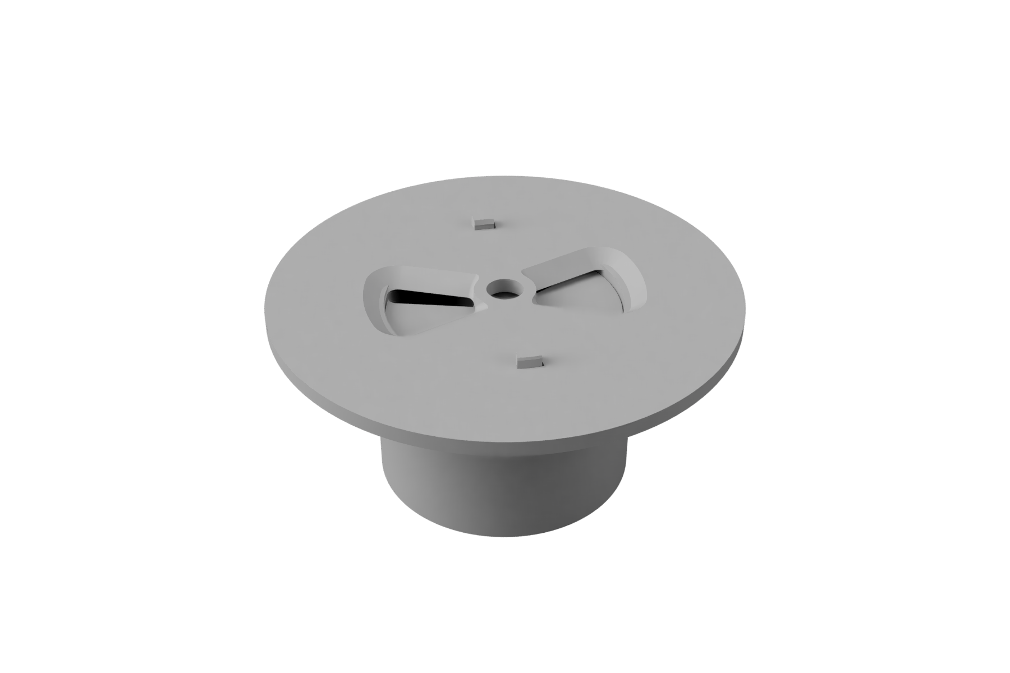

Figure 1. 3D rendering of the proposed ballast dispenser assembly

***Helium Venting***

Traditional HABs are connected to their payload by a long cord, but to facilitate venting helium from the balloon, a more direct connection is required. This connection is comprised of an adapter attached to the balloon and a bracket mounted to the payload. The adapter has four protruding fins that are locked into place by clamps on the bracket to keep the adapter ending secure. A rubber stopper attached to a spring at the bottom of the bracket plugs the adapter vent preventing helium from escaping during normal operation. This system can be seen in Figure 2. The stopper is attached to a servo located within the payload by a thin rod allowing the servo to adjust the position of the stopper. The rate at which helium leaves the balloon is a function of the size of the opening, atmospheric conditions, and the amount of helium left in the balloon.

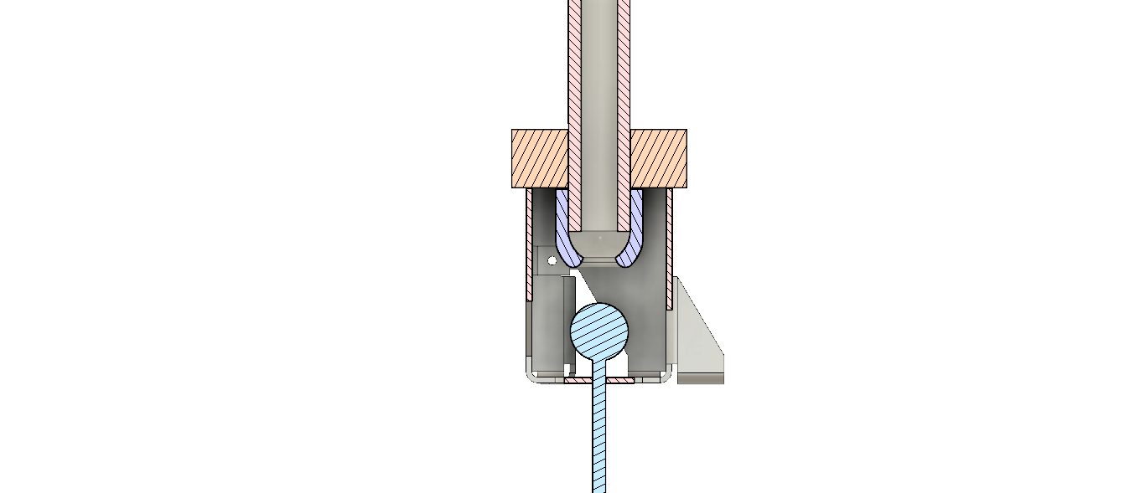

Figure 2. A mockup of the ball and spring valve used for controlling the release of helium from the balloon.

***Cutdown***

The balloon will be rigidly connected to the control payload through the helium venting assembly. This connection is held in place with a small section of cord as shown in Figure 3. Nichrome heater wire is threaded within the cord. When the command is given to cutdown the balloon, the controller will energize the nichrome wire by biasing an N-Channel Mosfet driver. This will provide power directly from the battery to the nichrome wire, bypassing the voltage regulation circuitry. To control current, the driver is connected to a pulse width modulation pin on the controller.

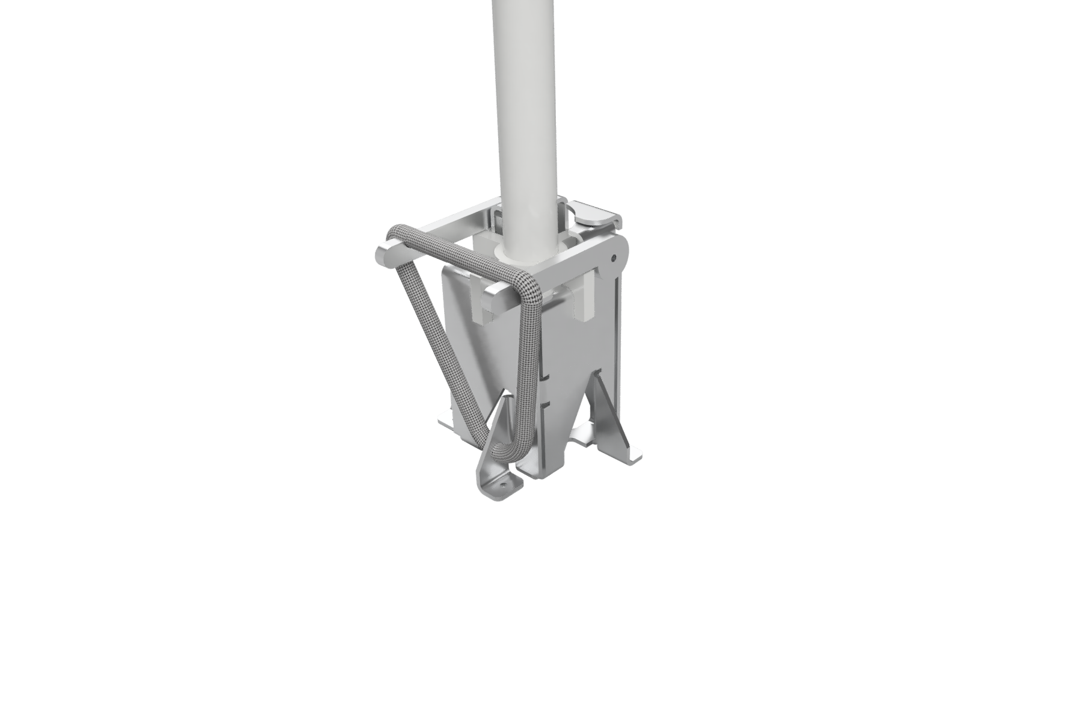

Figure 3. A 3D model balloon cutdown mechanism and its connection to the helium venting assembly

* + 1. **Electrical Design**

***Communication***

Communications between the balloon and the ground station are facilitated through the Iridium satellite network by an Iridium short burst data transceiver. To conserve data, information sent over satellite is not stored in traditional data types. Taking advantage of the minimum and maximum values expected for each data field (the altitude will be between -5000 and 35000 meters) and the precision of current hardware (altitude will be accurate to within 3 meters), it is possible to store the data using the smallest number of bits without decreasing the precision.

***Microcontroller***

The microcontroller will be an Arduino Mega 2560 development board (based on the ATmega2560). It was selected due to its ease of use, low cost, and communication capabilities. The controller is connected to the other sensors with headers attached to a custom PCB.

***Sensors***

Several sensors will be used to provide data to the controller. Each of the sensors are summarized below:

* GPS Module
  + The GPS module is the primary method of monitoring the position of the balloon. It was specially chosen due to its “balloon mode” which allows it to continue functioning beyond 65,000 feet.
* Altimeters (2x)
  + The altimeters provide critical altitude information which is used to control helium and ballast releases. They are included as a pair to mitigate the potential of sensor failure.
* Inertial Measurement Unit
  + The inertial measurement unit (IMU) will be used to provide an estimation of the payloads orientation and position. This data will also be used for fall detection should the balloon burst or unintentionally separate from the payload.
* Analog Temperature Sensor
  + The temperature sensor will be used to monitor payload temperature and control the payload heater as needed. For the first flight, it will be configured to operate the heater with proportional integral derivative (PID) control.

**4.1.3 Software**

***Ground Station Interface***

The ground station interface will consist of a GUI displaying the current condition of the HAB and options to change the altitude. The location of the HAB will be displayed as well as the direction of movement. The GUI will also show live wind data at different altitudes. The user will have an option to manually control the altitude of the balloon as well as cutdown.

***Altitude Control***

Changing altitude will be the main method of directing the HAB to stay within a set radius by following wind currents. To do this, both wind data and altitude measurements are required. To determine altitude, altimeter and IMU data will be fused [5]. Having the inertial data from the IMU will also give insight into when to stop releasing ballast or venting helium so that the balloon will stop ascending/descending at the correct altitude.

***Temperature Control***

The temperature of the payload will be regulated with a small heating element. This heater will be controlled with a PID algorithm that using measurements from the analog temperature sensor.

***Wind Detection***

The effects of wind will be seen in the movement of the HAB. In order to reliably and precisely determine change in position, GPS and IMU data will be fused. GPS location outputs can be unreliable in certain locations and the selected GPS has a position resolution of 3 m. Fusing the data from the GPS with inertial data from the IMU will provide more accurate information than if either method is used alone. The fused data will be used to calculate horizontal movement which correlates with wind currents.

* 1. **Codes and Standards**

FAA Title 14 - Part 101 - Subpart A (Appendix A) describes the conditions under which unmanned civilian vehicles may be operated within the United States. Part 101.1 specifies that any unmanned free balloon must comply with subpart D with the exception of balloons that:

* Carries a payload package that weighs more than four pounds and has a weight/size ratio of more than three ounces per square inch on any surface of the package, determined by dividing the total weight in ounces of the payload package by the area in square inches of its smallest surface
* Carries a payload package that weighs more than six pounds
* Carries a payload of two or more packages that weighs more than 12 pounds
* Uses a rope or other device for suspension of the payload that requires an impact force of more than 50 pounds to separate the suspended payload from the balloon

The regulations in Subpart D (Appendix A) directly interfere with the intended application of the system, so the payload is designed to comply with the exceptions listed in Part 101.1.

Part 101.7, as it applies to unmanned free balloons, prohibits the operation of the balloon in a manner that may be hazardous to other persons, or their property. It also prohibits dropping any objects, if such an action creates a hazard [6].

FCC Title 47 - Part 97.113 lists prohibited transmissions on amateur radio wavelengths. Relating to this project, no station shall transmit communications for hire or for material compensation, direct or indirect, paid or promised, except as otherwise provided in these rules [7]. This regulation makes amatueur radio an unsuitable means of communication for the system due to the commercial nature of the project.

FCC Title 47 - Part 22.925 prohibits the use of cellular phones while airborne, preventing the system from using a cellular phone to communicate with the payload during flight [8].

The Iridium 9603 transceiver utilized in this design has been granted authorization by the FCC as a Licensed Non-Broadcast Station Transmitter under the conditions listed in FCC Title 47 - Part 25 [9]. The grant of equipment authorization requires that the transmitter be installed to provide 20 cm of separation distance from all persons, and must not be operation in conjunction with any other transmitter within a host device [10].

* 1. **Constraints, Alternatives, and Tradeoffs**

Due to FAA regulations, the payload weight must be less than 6 lb [6]. This restriction results in a tradeoff between component selection and ballast weight. Maximizing the amount of ballast is important for increasing flight duration, but longer flights require a larger power supply. Further testing will allow optimization of this tradeoff.

Due to the altitude of HAB flights, the system must be able to sustain operations in temperatures as low as -60°C. Many electronic components fail at this temperature, so special considerations must be made to insulate the payload. An insulated enclosure will protect the electronics from cold temperatures. Additionally, a heater will be installed during the initial test flight to insure correct operation.

1. **Schedule, Tasks, and Milestones**

The expected GANTT and PERT chart are shown below in Appendix B and C respectively.

1. **Project Demonstration**

***Demonstration***

The project demonstration will consist of an HAB launch followed by monitoring from the ground station. Validation of the project specifications will be based on data gathered from the ground station and the payload. Retaining control of the altitude during the demonstration will validate the altitude control system. Navigating the balloon to a region and maintaining position within that region will validate the position control system. Validation of both the altitude and position control systems constitutes a successful demonstration.

***Testing***

Replicating the conditions of the stratosphere on the ground will not be feasible for this project, so ground testing will not be enough to validate the overall system feasibility. Instead, the predicted conditions will be simulated to test the control algorithm. The ballast release and cutdown mechanisms can be tested at ground level by performing the tests in a freezer. Initial tests for the helium release mechanism will be performed on the ground; however, they will not be able to fully account for the actual conditions. Ground tests will be used to test position and altitude determination algorithms, but they will not allow for sufficient hardware testing. Battery life can be calculated by measuring power draw from each electrical component. This will provide an estimate for maximum flight duration.

1. **Marketing and Cost Analysis**
   1. **Marketing Analysis**

It is not plausible to launch a HAB project at the same scale as Project Loon unless adequate funding is acquired [2]. Stanford University's ValBal team developed a low cost alternative. The ValBal project utilized less than $1,000 to achieve the longest recorded latex balloon flight. The Stanford team’s aircraft used an altitude control system to extend the flight duration [11]. In addition to altitude control, the proposed design aims to develop a position control system. Position control is a novel concept in the domain of inexpensive HABs.

The ValBal design exceeds the weight limit specification which requires users to follow FAA regulations 101.33, 101.35, 101.37, and 101.39 [6] [11]. The proposed design will weigh less than six pounds which will allow for an additional six pound payload without needing to follow the above FAA regulations. Of particular importance, the proposed system may be operated during inclement weather conditions without prior notice to the FAA [6].

* 1. **Cost Analysis**

**7.2.1 Hardware Costs**

The HAB control system will consist of electronic, mechanical, and structural components. The previous design effort purchased some supplies that can be reused shown in Table 3. These items are not included in the final cost calculations.

Table 3. Previous Supplies

|  |  |
| --- | --- |
| **Item** | **Estimated Cost** |
| Arduino Mega 2560 | $38.50 |
| 5 ft Diameter Parachute | $50 |
| 1200 g Latex Balloon | $120 |
| RockBLOCK Iridium Module | $250 |
| Servos | $80 |

The additional parts necessary to build the proposed design are listed in Appendix D. The listed components provide enough materials for a single launch. Further launches will require additional balloons and potentially hardware if the payload is not recovered.

In addition to hardware, the satellite communication in use will require a data plan with monthly costs and additional charges for data usage, checking for messages, and registering the device as shown in Table 4.

Table 4. Communication Data Plan Charges

|  |  |
| --- | --- |
| Monthly Subscription Fee | $14.99 |
| Data Charge | $1.09 / KB |
| Minimum Billing Increment per Message | 30 bytes |
| Cost of 30 Byte Message | $0.03 |
| Mailbox Check | $0.05 |
| Registration Fee | $0.05 |

Table 5 estimates the total cost communication for each predicted flight. These costs are calculated based on 20 messages and 12 mailbox checks per hour. The total estimated cost for the communication plan over 3 months is $112.69.

Table 5. Balloon Communication Costs

|  |  |  |  |  |  |
| --- | --- | --- | --- | --- | --- |
| Flight Number | Duration (hrs) | Monthly Cost | Message Cost | Mailbox Cost | Total |
| 1 | 6 | $14.99 | $3.92 | $3.60 | $22.51 |
| 2 | 24 | $14.99 | $15.70 | $14.4 | $45.09 |
| 3 | 24 | $14.99 | $15.70 | $14.4 | $45.09 |
| **Total Cost** | | | | | $112.69 |

**7.2.2 Development Costs**

The design team will consist of six engineers. Table 6 shows the number of work hours per engineer estimated for the duration of the project.

Table 6. Number of Work Hours per Engineer

|  |  |
| --- | --- |
| **Task** | **Hours** |
| Sensor Integration | 8 |
| Algorithm Development and Implementation | 20 |
| Research | 5 |
| Meetings | 15 |
| Parts Fabrication | 10 |
| Assembly | 10 |
| Ground Testing | 5 |
| Launches and Launch Preparation | 15 |
| Presentation | 2 |
| Reports | 12 |
| **Total** | 102 |

Each engineer is estimated to have a salary of $65,000, per year [12]. The United States Office of Personnel Management defines one work year as 2087 hours [13]. Using these estimates, the hourly rate of a single engineer is $31.15. A fringe benefit rate of 31.9% and an overhead rate of 120% are assumed [14]. The total development costs under these assumptions are shown in Table 7.

Table 7. Total Project Costs

|  |  |
| --- | --- |
| **Project Section** | **Cost** |
| Parts | $492.15 |
| Communication Costs | $112.69 |
| Labor | $19,063.80 |
| Fringe Benefits (31.9% of Labor) | $6081.35 |
| **Subtotal** | **$25,749.99** |
| Overhead (120% of Subtotal) | $30,899.99 |
| **Total** | **$56,649.98** |

1. **Current Status**

The previous design team took significant steps towards implementing a functional altitude control system. Unfortunately, many of the components are not rated at the altitudes and temperatures experienced during a HAB flight. The proposed design overhauls the existing hardware and large sections of the code to account for the replacement hardware. At this time, a bill of materials has been created and is in the process of being ordered. In the immediate future, the team will begin work on developing a functional altitude control system for the new hardware and will prepare for a launch late August.

1. **Leadership Roles**

Mathew’s leadership duties include ensuring the team follows proper operating protocol to better ensure safety and is the embedded systems lead. Brandon’s leadership duties include acting as the main correspondent and webmaster as well as leading hardware assembly. David R.’s leadership duties include being the software lead in addition to ensuring documentation is complete and all writing guidelines and deadlines are met. David S.’s leadership role includes procuring and managing transportation in addition to being the communication systems lead. Kristine’s leadership duties include coordinating the final expo as well as leading sensor integration and GUI development. Kyle’s leadership positions include launch preparation and control systems lead.

1. **References**

[1] National Oceanic and Atmospheric Administration, “Global Forecast System (GFS),” July 14, 2018. [Online]. Available: https://www.ncdc.noaa.gov/data-access/model-data/model-datasets/global-forcast-system-gfs  
 [Accessed: July 20, 2018].

[2] X Development LLC, “Technology,” *Project Loon*, 2018, [Online]. Available: <https://loon.co/technology/> [Accessed: Jun. 8, 2018].

[3] B. Dunbar, H. Zell, “Types of Balloons”, *National Aeronautics and Space Administration*, Aug. 3, 2017 [Online]. Available: https://www.nasa.gov/scientific-balloons/types-of-balloons [Accessed July 19, 2018].

[4] Andrey Sushko, Aria Tedjarati, Joan Creus-Costa, Kai Marshland, Paige Brown, Davy Ragland, John Dean, Sasha Maldonado, John M. Pauly, “Advancements in low-cost, long endurance, altitude controlled latex balloons (ValBal),” In Proc. *2018 IEEE Aerospace Conference*, 2017 pp. 1-9. [Online]. Available: <https://ieeexplore.ieee.org/document/8396588/> [Accessed: July 20, 2018].

[5] Y. Son and S. Oh, "A barometer-IMU fusion method for vertical velocity and height estimation," *2015 IEEE SENSORS*, Busan, 2015, pp. 1-4. [Online]. Available: <https://ieeexplore.ieee.org/stamp/stamp.jsp?tp=&arnumber=7370269> [Accessed: July 19, 2018].

[6] Code of Federal Regulations Title 14 Part 101 (14CFR101), Moored Balloons, Kites, Amateur Rockets, Unmanned Free Balloons, and Certain Model Aircraft [Online]. Available: <https://ecfr.io/Title-14/pt14.2.101#sp14.2.101> [Accessed: July 19, 2018].

[7] Code of Federal Regulations Title 47 Part 97.113, Amateur Radio Service, Prohibited Transmissions [Online]. Available: <https://ecfr.io/Title-47/se47.5.97_1113> [Accessed: July 19, 2018].

[8] Code of Federal Regulations Title 47 Part 22.925, Public Mobile Services, Prohibition on Airborne Operation of Cellular Telephones [Online]. Available: <https://ecfr.io/Title-47/pt47.2.22#se47.2.22_1925> [Accessed: July 19, 2018].

[9] Code of Federal Regulations Title 47 Part 25, Satellite Communications [Online]. Available: <https://ecfr.io/Title-47/pt47.2.25> [Accessed: July 19, 2018].

[10] Iridium Communications Inc, “Iridium 9603 Short Burst Data Modem: Declaration of Conformity,” *Iridium Short Burst Data (SBD)*, July 19, 2018. [Online]. Available: <https://www.iridium.com/file/24245/> [Accessed: July 20, 2018].

[11] A. Sushko, A. Tedjarati, J. Crues-Costa, S. Maldonado, K. Marshland, and M. Pavone, “Low Cost, High Endurance, Altitude-Controlled Latex Balloon for Near-Space Research (ValBal),” In Proc. *IEEE Aerospace Conference ’03*, 2017, pp. 1-9. [Online]. Available: <http://ieeexplore.ieee.org/stamp/stamp.jsp?tp=&arnumber=7943912&isnumber=7943554> [Accessed: July 20, 2018].

[12] Georgia Tech School of Electrical and Computer Engineering, “What is ECE at Georgia Tech,” *Georgia Institute of Technology*, 2018. para. 11, Apr. 4, 2018 [Online]. Available: <https://www.ece.gatech.edu/what-ece-georgia-tech> [Accessed July 19, 2018].

[13] US Office of Personnel Management, “ Pay & Leave: Pay Administration,” *OPM.gov*, para. 1. [Online]. Available: <https://www.opm.gov/policy-data-oversight/pay-leave/pay-administration/fact-sheets/computing-hourly-rates-of-pay-using-the-2087-hour-divisor/> [Accessed: July 19, 2018].

[14] Georgia Tech Office of Sponsored Programs, “Facilities & Administrative Rates,” *Georgia Tech Office of Sponsored Programs*, para. 3, July 6, 2018. [Online]. Available: <http://www.osp.gatech.edu/rates> [Accessed: July 19, 2018].

**Appendix A: Relevant FAA Regulations**

**Subpart A—General**

**§101.1 Applicability.**

(a) This part prescribes rules governing the operation in the United States, of the following:

(1) Except as provided for in §101.7, any balloon that is moored to the surface of the earth or an object thereon and that has a diameter of more than 6 feet or a gas capacity of more than 115 cubic feet.

(2) Except as provided for in §101.7, any kite that weighs more than 5 pounds and is intended to be flown at the end of a rope or cable.

(3) Any amateur rocket except aerial firework displays.

(4) Except as provided for in §101.7, any unmanned free balloon that—

(i) Carries a payload package that weighs more than four pounds and has a weight/size ratio of more than three ounces per square inch on any surface of the package, determined by dividing the total weight in ounces of the payload package by the area in square inches of its smallest surface;

(ii) Carries a payload package that weighs more than six pounds;

(iii) Carries a payload, of two or more packages, that weighs more than 12 pounds; or

(iv) Uses a rope or other device for suspension of the payload that requires an impact force of more than 50 pounds to separate the suspended payload from the balloon.

(5) Any model aircraft that meets the conditions specified in §101.41. For purposes of this part, a model aircraft is an unmanned aircraft that is:

(i) Capable of sustained flight in the atmosphere;

(ii) Flown within visual line of sight of the person operating the aircraft; and

(iii) Flown for hobby or recreational purposes.

(b) For the purposes of this part, a *gyroglider* attached to a vehicle on the surface of the earth is considered to be a kite.

[Doc. No. 1580, 28 FR 6721, June 29, 1963, as amended by Amdt. 101-1, 29 FR 46, Jan. 3, 1964; Amdt. 101-3, 35 FR 8213, May 26, 1970; Amdt. 101-8, 73 FR 73781, Dec. 4, 2008; 74 FR 38092, July 31, 2009; Docket FAA-2015-0150, Amdt. 101-9, 81 FR 42208, June 28, 2016]

**§101.3 Waivers.**

No person may conduct operations that require a deviation from this part except under a certificate of waiver issued by the Administrator.  
[Doc. No. 1580, 28 FR 6721, June 29, 1963]

**§101.5 Operations in prohibited or restricted areas.**

No person may operate a moored balloon, kite, amateur rocket, or unmanned free balloon in a prohibited or restricted area unless he has permission from the using or controlling agency, as appropriate.  
[Doc. No. 1457, 29 FR 46, Jan. 3, 1964, as amended at 74 FR 38092, July 31, 2009]

**§101.7 Hazardous operations.**

(a) No person may operate any moored balloon, kite, amateur rocket, or unmanned free balloon in a manner that creates a hazard to other persons, or their property.  
(b) No person operating any moored balloon, kite, amateur rocket, or unmanned free balloon may allow an object to be dropped therefrom, if such action creates a hazard to other persons or their property.  
(Sec. 6(c), Department of Transportation Act (49 U.S.C. 1655(c)))  
[Doc. No. 12800, 39 FR 22252, June 21, 1974, as amended at 74 FR 38092, July 31, 2009]

**Subpart D—Unmanned Free Balloons**  
Source: Docket No. 1457, 29 FR 47, Jan. 3, 1964, unless otherwise noted.

**§ 101.31 Applicability.**This subpart applies to the operation of unmanned free balloons. However, a person operating an unmanned free balloon within a restricted area must comply only with § 101.33 (d) and (e) and with any additional limitations that are imposed by the using or controlling agency, as appropriate.

**§ 101.33 Operating limitations.**No person may operate an unmanned free balloon—

(a) Unless otherwise authorized by ATC, below 2,000 feet above the surface within the lateral boundaries of the surface areas of Class B, Class C, Class D, or Class E airspace designated for an airport;  
(b) At any altitude where there are clouds or obscuring phenomena of more than five-tenths coverage;  
(c) At any altitude below 60,000 feet standard pressure altitude where the horizontal visibility is less than five miles;  
(d) During the first 1,000 feet of ascent, over a congested area of a city, town, or settlement or an open-air assembly of persons not associated with the operation; or  
(e) In such a manner that impact of the balloon, or part thereof including its payload, with the surface creates a hazard to persons or property not associated with the operation.

[Doc. No. 1457, 29 FR 47, Jan. 3, 1964, as amended by Amdt. 101-5, 56 FR 65662, Dec. 17, 1991]

**§ 101.35 Equipment and marking requirements.**  
(a) No person may operate an unmanned free balloon unless—

(1) It is equipped with at least two payload cut-down systems or devices that operate independently of each other;

(2) At least two methods, systems, devices, or combinations thereof, that function independently of each other, are employed for terminating the flight of the balloon envelope; and

(3) The balloon envelope is equipped with a radar reflective device(s) or material that will present an echo to surface radar operating in the 200 MHz to 2700 MHz frequency range. The operator shall activate the appropriate devices required by paragraphs

(a) (1) and (2) of this section when weather conditions are less than those prescribed for operation under this subpart, or if a malfunction or any other reason makes the further operation hazardous to other air traffic or to persons and property on the surface.

(b) No person may operate an unmanned free balloon below 60,000 feet standard pressure altitude between sunset and sunrise (as corrected to the altitude of operation) unless the balloon and its attachments and payload, whether or not they become separated during the operation, are equipped with lights that are visible for at least 5 miles and have a flash frequency of at least 40, and not more than 100, cycles per minute.  
(c) No person may operate an unmanned free balloon that is equipped with a trailing antenna that requires an impact force of more than 50 pounds to break it at any point, unless the antenna has colored pennants or streamers that are attached at not more than 50 foot intervals and that are visible for at least one mile.

(d) No person may operate between sunrise and sunset an unmanned free balloon that is equipped with a suspension device (other than a highly conspicuously colored open parachute) more than 50 feet along, unless the suspension device is colored in alternate bands of high conspicuity colors or has colored pennants or streamers attached which are visible for at least one mile.

(Sec. 6(c), Department of Transportation Act (49 U.S.C. 1655(c)))  
[Doc. No. 1457, 29 FR 47, Jan. 3, 1964, as amended by Amdt. 101-2, 32 FR 5254, Mar. 29, 1967; Amdt. 101-4, 39 FR 22252, June 21, 1974]

**§ 101.37 Notice requirements.**

(a) Prelaunch notice: Except as provided in paragraph (b) of this section, no person may operate an unmanned free balloon unless, within 6 to 24 hours before beginning the operation, he gives the following information to the FAA ATC facility that is nearest to the place of intended operation:

(1) The balloon identification.

(2) The estimated date and time of launching, amended as necessary to remain within plus or minus 30 minutes.

(3) The location of the launching site.

(4) The cruising altitude.

(5) The forecast trajectory and estimated time to cruising altitude or 60,000 feet standard pressure altitude, whichever is lower.

(6) The length and diameter of the balloon, length of the suspension device, weight of the payload, and length of the trailing antenna.

(7) The duration of flight.

(8) The forecast time and location of impact with the surface of the earth.

(b) For solar or cosmic disturbance investigations involving a critical time element, the information in paragraph (a) of this section shall be given within 30 minutes to 24 hours before beginning the operation.

(c) Cancellation notice: If the operation is canceled, the person who intended to conduct the operation shall immediately notify the nearest FAA ATC facility.

(d) Launch notice: Each person operating an unmanned free balloon shall notify the nearest FAA or military ATC facility of the launch time immediately after the balloon is launched.

**§ 101.39 Balloon position reports.**

(a) Each person operating an unmanned free balloon shall:

(1) Unless ATC requires otherwise, monitor the course of the balloon and record its position at least every two hours; and

(2) Forward any balloon position reports requested by ATC.

(b) One hour before beginning descent, each person operating an unmanned free balloon shall forward to the nearest FAA ATC facility the following information regarding the balloon:

(1) The current geographical position.

(2) The altitude.

(3) The forecast time of penetration of 60,000 feet standard pressure altitude (if applicable).

(4) The forecast trajectory for the balance of the flight.

(5) The forecast time and location of impact with the surface of the earth.

(c) If a balloon position report is not recorded for any two-hour period of flight, the person operating an unmanned free balloon shall immediately notify the nearest FAA ATC facility. The notice shall include the last recorded position and any revision of the forecast trajectory. The nearest FAA ATC facility shall be notified immediately when tracking of the balloon is re-established.

(d) Each person operating an unmanned free balloon shall notify the nearest FAA ATC facility when the operation is ended.

**Appendix B: Project Gantt Chart**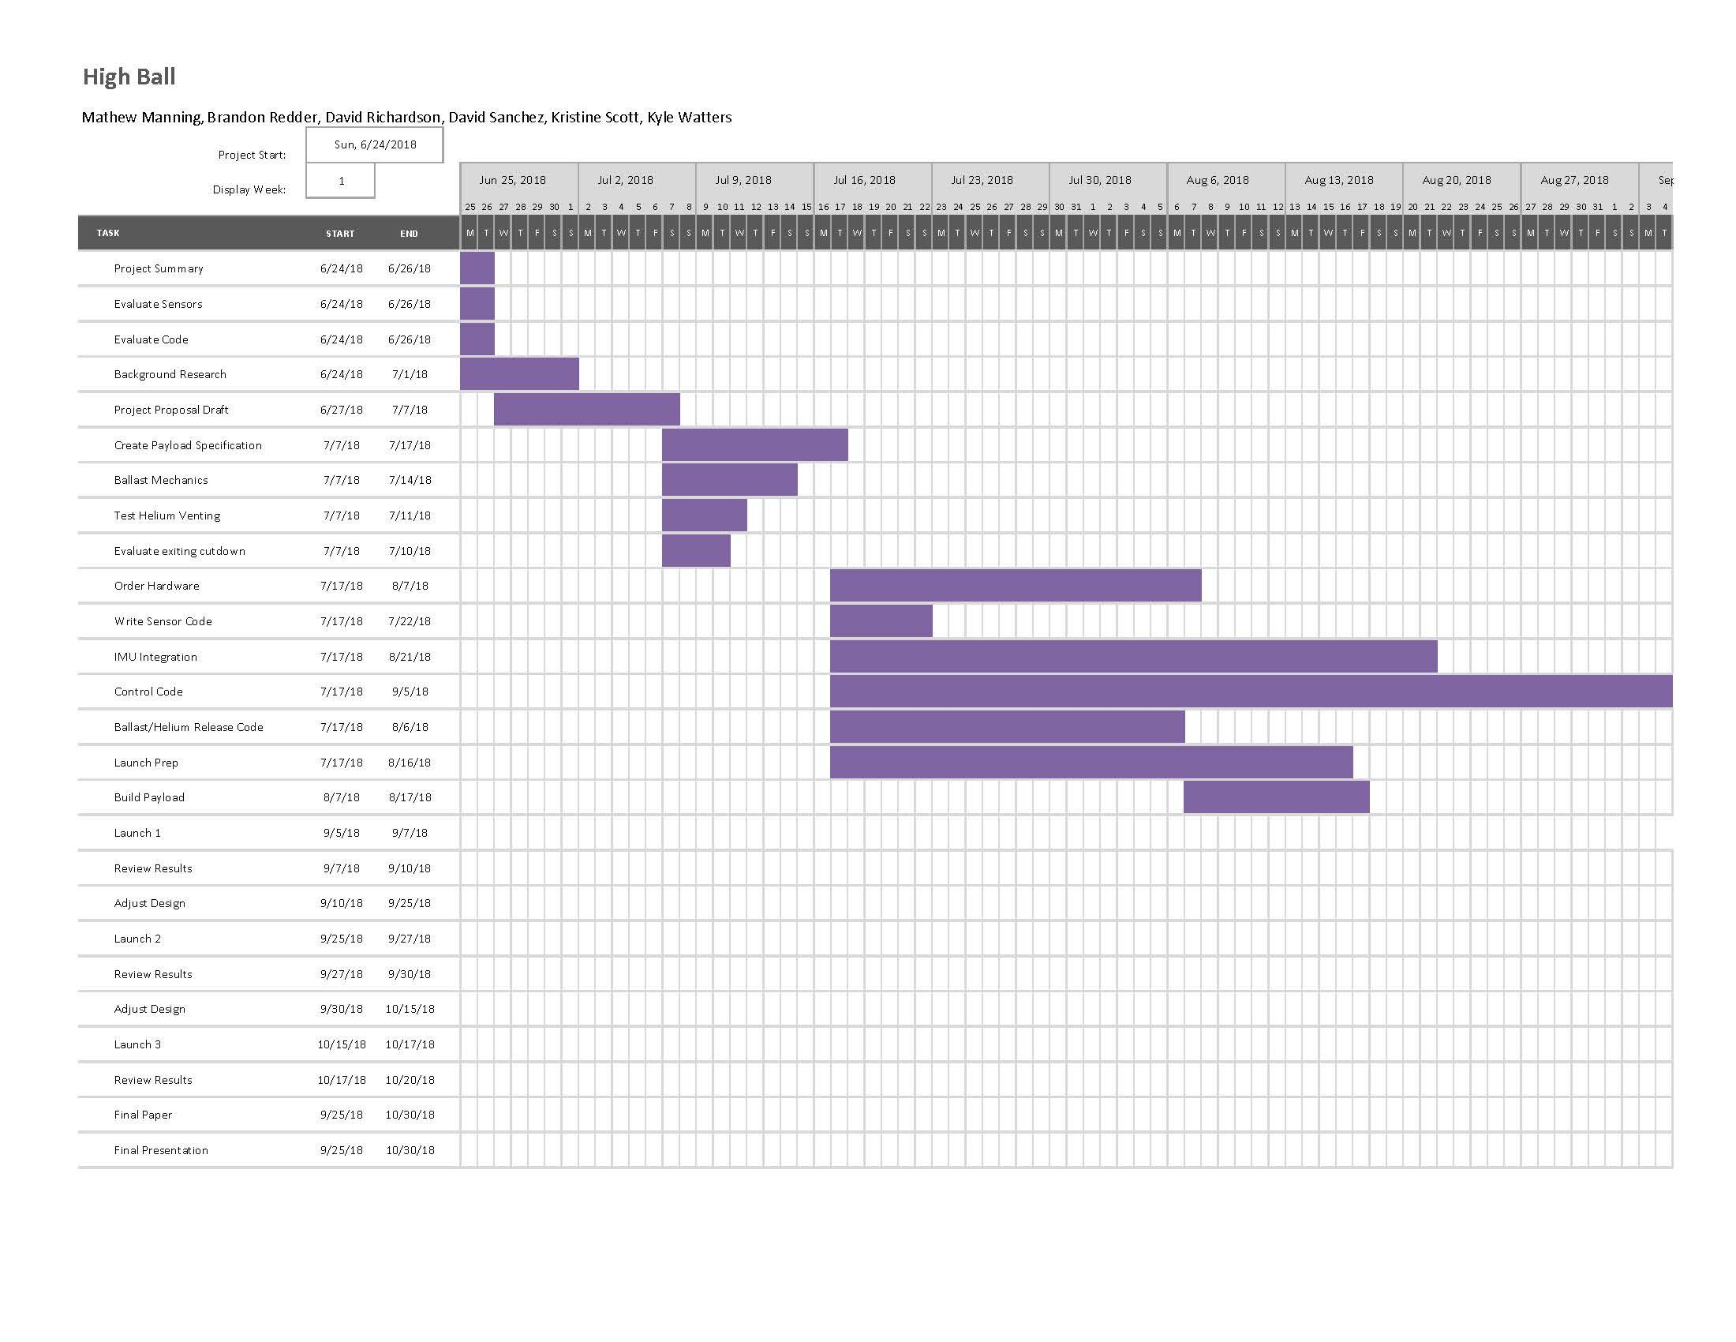

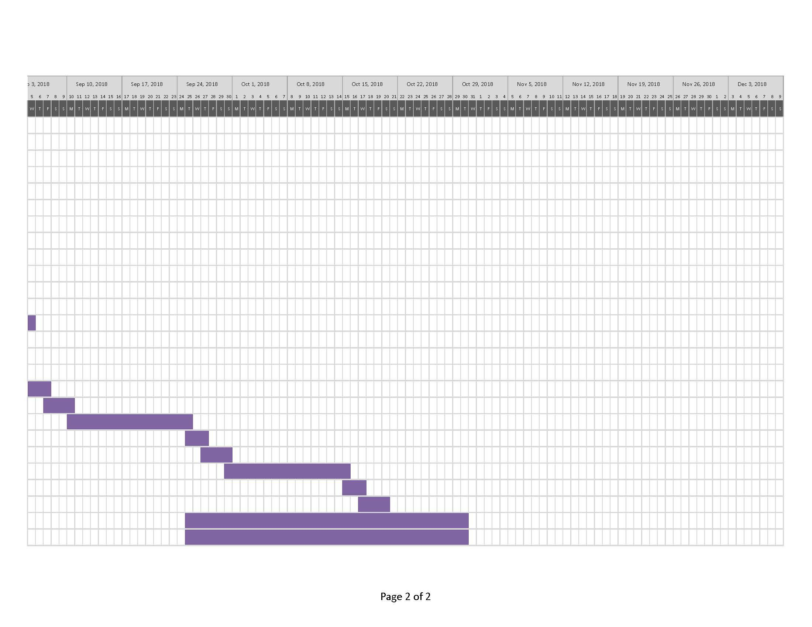

**Appendix C - PERT Chart**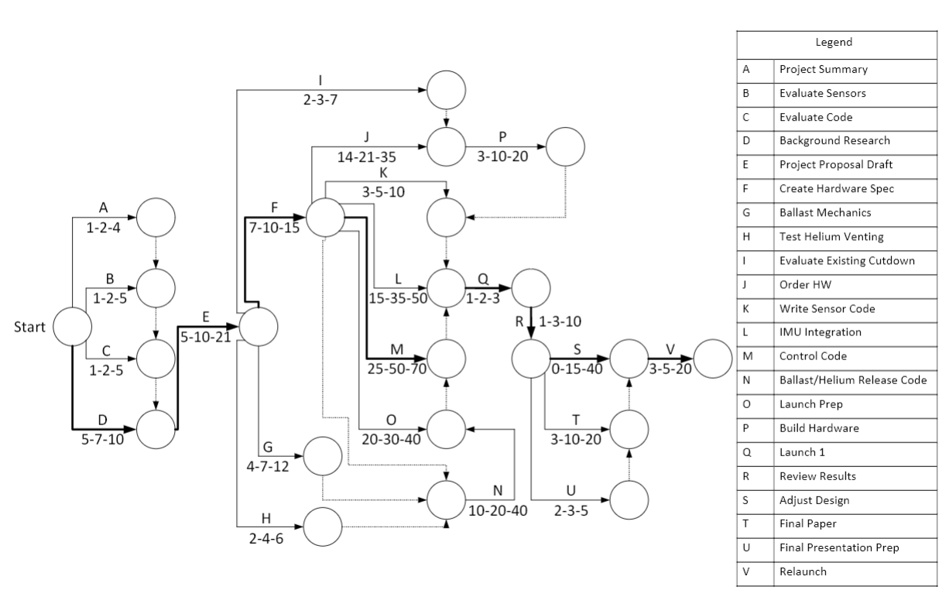

**Appendix D: Planned Hardware Purchases**

|  |  |  |  |  |  |
| --- | --- | --- | --- | --- | --- |
| **Name** | **Vendor** | **SKU** | **Quantity** | **Unit Cost** | **Subtotal** |
| Nichrome Wire | Amazon | - | 1 | $6.49 | $6.49 |
| SENSOR TEMP ANLG VOLT TO-92-3 | Digikey | LM335ZNS/NOPB-ND | 1 | $1.32 | $1.32 |
| 1200g Balloon | High Altitude Science | - | 1 | $120.00 | $120.00 |
| .75" to .5" PVC Reducer | Home Depot | PVC 02100 3400HD | 2 | $0.58 | $1.16 |
| .5" PVC Pipe | Home Depot | 22015 | 2 | $1.26 | $2.52 |
| .5" PVC Cap | Home Depot | C447-005 | 2 | $0.49 | $0.98 |
| FOAMULAR 150 1 in. x 4 ft. x 8 ft. R-5 Scored Square Edge Rigid Foam Board Insulation Sheathing | Home Depot | - | 2 | $18.98 | $37.96 |
| 1/4" Aluminum Round Bar (24" long) | Metal Supermarkets | AR6061/14 | 1 | $13.33 | $13.33 |
| 0.08" Aluminum Sheet (8.5" x 8.5") | Metal Supermarkets | ASH6061/080 | 1 | $21.42 | $21.42 |
| Iridium SBD Plan | Satphone Store | 13-SBD-BASIC | 1 | $14.99 | $14.99 |
| SparkFun Pressure Sensor Breakout - MS5803-14BA | Sparkfun | SEN-12909 | 2 | $59.95 | $119.90 |
| 3D Download: STL, IGES, STEP  Servo Shaft Coupler - Hitec Standard | Sparkfun | ROB-12501 | 2 | $4.99 | $9.98 |
| SparkFun GPS Breakout - XA1110 (Qwiic) | Sparkfun | SEN-12909 | 1 | $59.95 | $59.95 |
| Screw Terminal | Sparkfun | PRT-10571 | 1 | $0.75 | $0.75 |
| 9DoF Razor IMU M0 | Sparkfun | SEN-14001 | 1 | $34.95 | $34.95 |
| SparkFun Logic Level Converter - Bi-Directional | Sparkfun | BOB-12009 | 1 | $2.95 | $2.95 |
| Heating Pad - 5x10cm | Sparkfun | COM-11288 | 1 | $3.95 | $3.95 |
| 3/8" Plastic Standoff | Sparkfun | PRT-10461 | 2 | $2.95 | $5.90 |
| #4-40 Machine Screw | Sparkfun | PRT-10453 | 2 | $1.50 | $3.00 |
| N-Channel Mosfet | Sparkfun | COM-10213 | 2 | $0.95 | $1.90 |
| Servo Cable | Sparkfun | ROB-08738 | 2 | $2.95 | $5.90 |
| RockBLOCK 9603 Accessory Cable | Sparkfun | CAB-14720 | 1 | $4.95 | $4.95 |
| Interface Cable SMA to U.FL | Sparkfun | WRL-09145 | 1 | $4.95 | $4.95 |
| Antenna GPS 3V Magnetic Mount SMA | Sparkfun | GPS-00464 | 1 | $12.95 | $12.95 |
| **Total Hardware Purchases** | | | | | **$492.15** |