Screenshot Documentation

1. Create Datebase
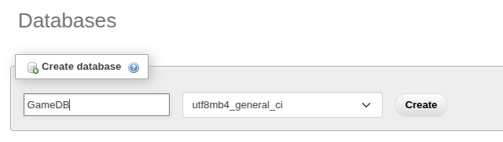
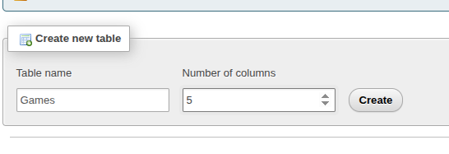
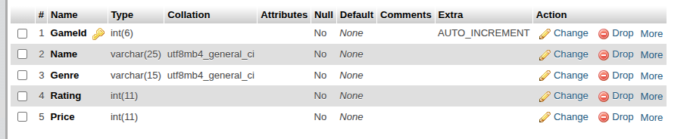
2. Create Table with 5 Columns
3. Provide correct Data types for the choosen Columns

4. Insert data into table either by an SQL statement, or by using myphpadmin UI
INSERT SQL Query
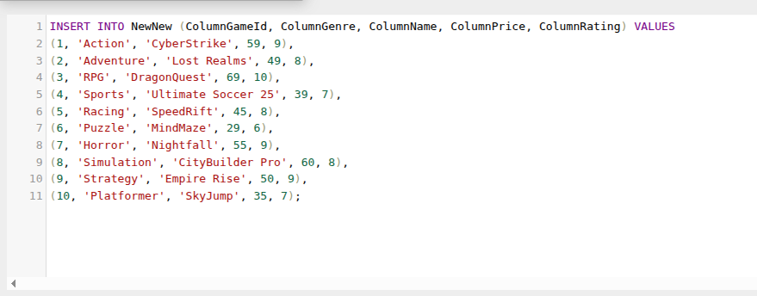

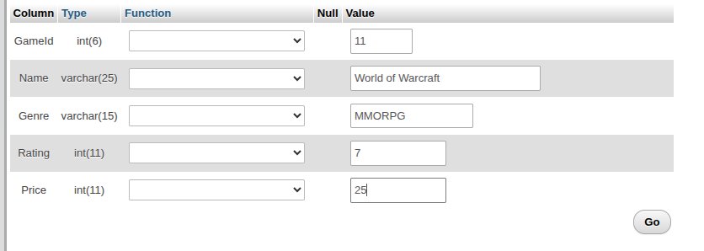
UI INSERT
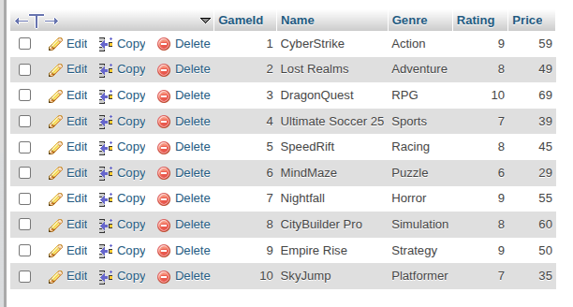
5. Fully populated Table

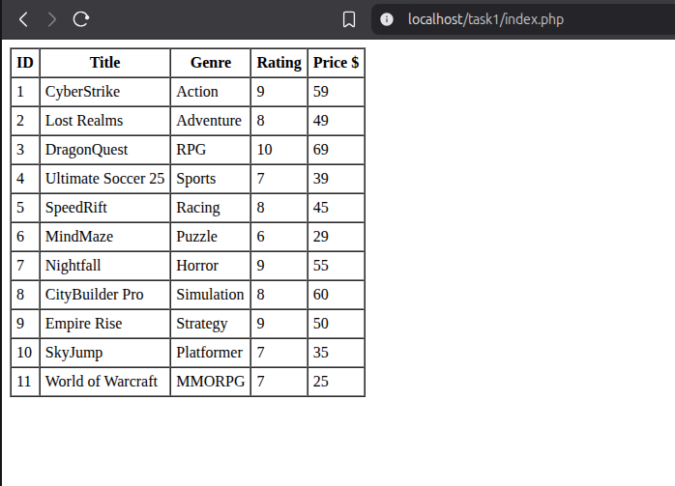
6. index.php showing data from DB

