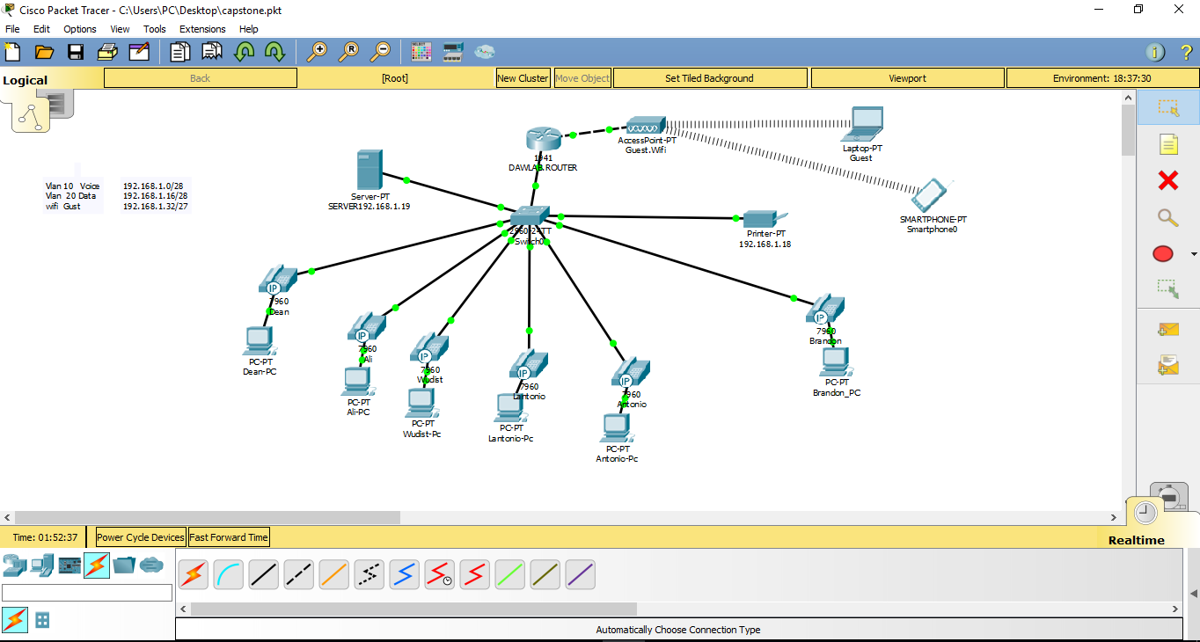

|  |  |  |
| --- | --- | --- |
| PRODUCTS | PRICE | FEATURES |
| **Cisco Switch 2960** | $11200 | * Enterprise-class standalone and stackable access-layer switches that provide the foundation for full convergence between wired and wireless on a single platform. * Built on the advanced Cisco StackWise160, and takes advantage of the new Cisco Unified Access Data Plane (UADP) application-specific integrated circuit (ASIC). * This switch can enable uniform wired-wireless policy enforcement, application visibility, flexibility, application optimization, and superior resiliency. * Support full IEEE 802.3at Power over Ethernet Plus (PoE+), Cisco Universal Power over Ethernet (Cisco UPOE®) * 802.1x authentication, ARP inspection, Dynamic Trunking Protocol (DTP) support, Energy Efficient Ethernet, Flexible NetFlow (FNF), Link Aggregation Control Protocol (LACP), Multiple Spanning Tree Protocol (MSTP) support, PIM snooping, Port Aggregation Protocol (PAgP) support, Quality of Service (QoS), Rapid Per-VLAN Spanning Tree Plus (PVRST+), Remote Switch Port Analyzer (RSPAN), ARP support, SSH support, Shaped Round Robin (SRR), Syslog support, Trivial File Transfer Protocol (TFTP) support, Uni-Directional Link Detection (UDLD), VLAN Trunking Protocol (VTP), Virtual Route Forwarding-Lite (VRF-Lite), Virtual Routing and Forwarding (VRF), Weighted Tail Drop (WTD), front to back airflow, Access Control List (ACL) support, radio resource management (RRM), Bridge protocol data unit (BPDU), Cisco StackPower technology, Cisco StackWise-480 technology, Control plane protection (CoPP), DHCP snooping, DHCP support |
| Dell OptiPlex 7450 All-in-One (7 PCS) | $1249.10 (EACH) | * Excellent graphics and multimedia performance. * Crisp and responsive 4K touch display. * Maximize space and improve productivity with the world’s most secure, manageable and reliable commercial all-in-one desktop * Intel® Core™ i7-7700 (QC/8MB/8T/3.6GHz/65W); supports Windows 10/Linux * Windows 10 Pro, 64bit English, French, Spanish * 8GB DDR4 at 2400MHz * 500GB 2.5inch Serial ATA * Intel® Dual Band Wireless AC 8265 (802.11ac) 2x2 + Bluetooth |
| **Brother MFC-L8900cdw Business Color Laser All-in-One Printer** | $599.99 | * Breakthrough printer for high-speed office printing. * Delivering ultra-fast print speeds and low running costs. * Incredibly energy efficient, the L8900CDW is a powerful output solution to your printing needs. * Enterprise Level Security. Includes support for IPSec, 802.1x Authentication (Wired/ Wireless) SSL and Secure Function Lock. * Convenient Mobile Device Printing. Print from your mobile device with the Brother iPrint&Scan app |
| Backup- Zetta (arcserve) | $175/month for 500GB | Zetta Backup and Recovery offers a refreshingly fast and powerful option for true disaster recovery-as-a-service (DRaaS) at the right price. |
| Microsoft Office 365 business premium | $89.7 /month | * Email with 50GB mailbox * 1 TB OneDrive and SharePoint for file storage and sharing * Skype for Business video conferencing * Fully-installed Office on PC/Mac |
| Adobe Acrobat Professional 2017 for Windows | $155.88/yr each | * Create PDFs and export to Word, Excel, or PowerPoint * Edit text and images right in your PDF * Turn scanned documents into editable, searchable PDFs |
| **Cisco SPA 504G4-Line IP Phone (6)** | $199.99 one time hardware cost and  139.93/month | Cisco's Small Business SPA 504G IP Phone features exceptional voice clarity and enhanced speaker quality. It has a 2-port Fast Ethernet switch with PoE (Power over Ethernet) support, a monochrome LCD display with backlight, 4 line keys, 4 soft keys, and a 2.5 mm jack connector for optional headset. It supports up to 8 simultaneous calls. |
| PowerEdge T640 Tower Server (2) | $2,159.00 | A comprehensive, cyber-resilient architecture with security embedded into every server helps to protect your data.   * Protect server configuration and firmware from malicious changes with new Configuration Lock-down. * Use system erase of local storage to help ensure data privacy when you repurpose or retire servers. * Automate updates that check file dependencies and proper update sequence, before deploying them independently from the OS/hypervisor. * Take control of your firmware consoles with embedded authentication that is designed to allow only properly signed updates to run. |

**Hardware Configuration**

Dell OptiPlex 7450 All-in-One (6)

Cisco switch 2960 (2 )

Printer- Brother MFC-L8900cdw laser all-in one

Cisco SPA 504G4-Line IP Phone (6 phones)

Dell PowerEdge T640 Tower Server (2)

**Software Configuration**

Windows 10 Pro 64-bit – OEM

Microsoft Office 365 business premium

Adobe Acrobat Professional 2017 for Windows

Window server 2016

**Backup and Utility**

**Zetta/arcserve**

**Adobe dc professional**

Network Configuration