Software Requirements Specification
Strubby’s Diabetic Management System
Version 1.1 approved
Prepared by: Brandon Strub
Non-Functional Pancreas inc.
05/06/2021
Table of Contents
Table of Contents ii
Revision History ii
1. Introduction 1
1.1 Purpose 1
1.2 Document Conventions 1
1.3 Intended Audience and Reading Suggestions 1
1.4 Project Scope 1
1.5 References 1
2. Overall Description 2
2.1 Product Perspective 2
2.2 Product Features 2
2.3 User Classes and Characteristics 2
2.4 Operating Environment 2
2.5 Design and Implementation Constraints 2
2.6 User Documentation 2
2.7 Assumptions and Dependencies 3
3. System Features 3
3.1 System Feature 1 3
3.2 System Feature 2 4
3.3 System Feature 3……………………………………………………………………………………4
4. External Interface Requirements 5
4.1 User Interfaces 5
4.2 Hardware Interfaces 5
4.3 Software Interfaces 5
4.4 Communications Interfaces 5
5. Other Nonfunctional Requirements 5
5.1 Performance Requirements 5
5.2 Safety Requirements 5
5.3 Security Requirements 5
5.4 Software Quality Attributes 6
6. Other Requirements 6
Appendix A: Glossary 7
Appendix B: Analysis Models 8
Appendix C: Issues List 9

Revision History
Name | Date | Reason For Changes | Version
Brandon Strub | 12/04/2020 | Addition to chapter 6 | 1.0
Brandon Strub | 05/05/21 | Overall Brush-Up | 1.1

Introduction

Purpose
This SRS conveys the function of Strubby’s Diabetic Management System V1.0. This mobile application is designed to function as an insulin pump for those who do not have an insulin pump. Even without the latest greatest technology out there, a Type 1 Diabetic should be able to calculate how much insulin to give themselves as well as be able to monitor their performance effectively without spending thousands of dollars.

Document Conventions
This SRS document will contain the use of a bold typeface on many occasions. A Bold Typeface will be used in cases of emphasis or with the use of user interface elements. Bold Capital Letters may be used in the case of the description of keys or key functions such as “ENTER”.

Intended Audience and Reading Suggestions
This document is designed for the team’s developers, managers, users (if they’re interested in reading this), testers, and any documentation writers. This document contains info on the purpose, function, features, and the requirements for this application.

Project Scope
Strubby’s Diabetic Management System provides a way for people to calculate how much insulin to give themselves along with the ability to monitor their performance effectively without spending thousands of dollars on an insulin pump. Being able to monitor a Type 1 Diabetic’s performance with their blood glucose levels is the key to being able to improve their well-being and their overall treatment. The user will be able to share their information with their Endocrinologist where they in turn can provide help and knowledge of how to improve the habits or treatment of the user. While it’s preferred for a Type 1 Diabetic to use an insulin pump, we understand that not everybody can afford one and technology can sometimes malfunction which leads diabetics to go back to the “old school way”. Non-Functional Pancreas inc. wants to be able to help those who fit these scenarios.

References
PyCharm – IDE
Python - Language
KivyMD – Addon to python

Overall Description

Product Perspective
Strubby’s Diabetic Management System is a replacement for certain existing systems but. Most of the time, such systems require a piece of technology such as an insulin pump or a continuous glucose monitor. What inspired the creation of this system was an individual with type 1 diabetes who’s Omnipod (wireless insulin pump) experienced a catastrophic malfunction that resulted in the failure of the system. Luckily it was under warranty for him, but he still had to go back to insulin injections (shots) for over a week. Having an application such as SDMS (Strubby’s Diabetic Management System) would’ve helped him during this situation. Imagining people in those same shoes or even worse cases inspired the creation of this project.

Product Features
The features that this system contains are a calculator in which the user inputs their data such as their blood glucose level and the amount of carbs (if any) that they will be consuming. With this data, the system will calculate how much insulin to give themselves. Another feature that this system provides is a settings function that allows the user to change their settings needed in order to calculate the amount of insulin they need.

User Classes and Characteristics
Anybody who is a Type 1 Diabetic and has access to a phone can use this application. It will be so easy to use that a child could use it effectively.

Operating Environment
This software will be accessible through the app store. It will be accessible for IOS and Windows devices.

Design and Implementation Constraints
The only constraint that this project will face will be memory. Currently we are unsure of how much we can store into our database.

User Documentation
There will be a HELP tab that contains information on how to use the application.

Assumptions and Dependencies
We assume that we might run into medical companies trying to hit us with copyright claims. Insulin pump companies such as Medtronic or Omnipod might try to keep us from doing the same functions as them but as a free service and without the requirement of having any of their products. However, people could use this system even if they have products from such companies. Non-Functional Pancreas inc. will be ensuring that we do not break any copyright laws.
A feature of our system will be dependent on the use of Microsoft Access.

System Features

Feature 1: Insulin Calculator
3.1.1 Description and Priority
This feature will contain information from the user, such as their Insulin to carb ratio, insulin sensitivity factor. Blood glucose level, and number carbs. This feature is a high priority of the system as in order to calculate how much insulin to give, you need all of this information. You will also need the data for the blood glucose levels in order to access the second feature.
3.1.2 Stimulus/Response Sequences
The user will have their insulin to carb ratio and insulin sensitivity factor saved into their settings. The info that the user will input is their blood glucose level and the amount of carbs they will be consuming. After this they will press the tab “SUBMIT” and it will show them the recommended amount of insulin that it calculates.
3.1.3 Functional Requirements
The software will take the information that it’s given and in turn go through a mathematical equation. When or if an error occurs, the system will let the user know what went wrong and how to fix it before taking in the information.

REQ-1: Insulin to Carb Ratio (tag #20)
REQ-2: Insulin Sensitivity Factor (tag #21)

Feature 2: Settings
3.2.1 Description and Priority
This feature will contain the data for the insulin to carb ratio and insulin sensitivity factor. Another action the user can make is changing their settings just in case these two data points ever change for them. This feature is high level priority as it is required for the user to calculate the amount of insulin needed.
3.2.2 Stimulus/Response Sequences
After creating a profile, the user will enter in their insulin sensitivity factor and insulin to carb ratio for the system to store into the settings tab. After entering the numbers into the prompt, the user will tap on the button “SUBMIT”.
3.2.3 Functional Requirements
Functional requirements are that they have entered in this information after setting up an account.

REQ-1: Create an account (tag #1)

Feature 3: Sign up/Log in
3.3.1 Description and Priority
This feature will allow the user to create an account for the system to store an data. The feature also allows the users to log in with their existing account. This is a high level priority, as it is needed in order for the user to actually access the remaining features of this app and its capabilities.
3.3.2 Stimulus/Response Sequences
The user will have their sign in info saved into a database. In order to make an account, the user will have to create a username and password in which they will need in order to log in to their account. Once saved into the database, the system can then save data under that user’s username. When creating an account the user will enter the information into the open prompts and tap the button titled, “SUBMIT.” When signing in, they will type in their username and password where they then tap the button “LOGIN.”
3.3.3 Functional Requirements
Functional requirements are that they have a username and password set up to be able to sign in..

REQ-1: Username (tag # 2)
REQ-2: Password (tag # 3)

External Interface Requirements

User Interfaces
This application will provide GUI features such as menus, buttons, panels, and text boxes. It will be compatible with IOS or Windows devices.

Hardware Interfaces
It is helpful to have internet on the device as it may be necessary for keeping track of data, however the app can be used without internet as not everyone can have access at every second or situation, especially when they need it most. In the case that internet is accessible, the hardware must have access to a modem or WAN – LAN.

Software Interfaces
The system shall communicate with the app store so that the user can install the application. The system must also have access to the keyboard so the user can type into required fields.

Communications Interfaces
The system will use an HTTP protocol for communicating with the internet

Other Nonfunctional Requirements

Performance Requirements
Having access to the internet is more of an option rather than a requirement. To use the application, the user won’t necessarily need it as it can function as an insulin calculator regardless. The only function that the user won’t be able to access is the graph. To use the graph the user will have to be signed in.

Safety Requirements
If an error is to ever occur in the database there will be a recovery method present to help restore the data.

Security Requirements
Most mobile phones have security built into its system, however, to establish security in the system’s database the system will need to follow some security standards. The system will need to be partnered with OWASP.

Software Quality Attributes
Availability: The user must be able to access this application without the use of internet, as it must be available to any user at any time in case of emergency. Regardless of connection to internet the user should be able to calculate how much insulin they shall inject themselves with.
Budget Friendly: This application will be accessed for free.

Other Requirements
The system will require 50kb of storage as well as it will need to go through the process of being put into the app store for both Apple and Android.

Appendix A: Glossary
Insulin Sensitivity Factor (ISF) | The insulin sensitivity factor tells you how many points, in mg/dL, your blood sugar will drop for each unit of insulin that you take. The insulin sensitivity factor is also sometimes called a “correction factor.” You need to know this number to correct a blood sugar level that's too high.
Insulin to Carb Ratio (ITC) | The insulin-to-carb ratio means you will take 1 unit of insulin for a certain amount of carbohydrate. For example, if your insulin-to-carb ratio is 1 unit of insulin for every 10 grams of carbohydrate (written 1:10), you will take 1 unit of insulin for every 10 grams of carbohydrate you eat.
Blood Sugar (Glucose) | The blood sugar level, blood sugar concentration, or blood glucose level is the concentration of glucose present in the blood of humans and other animals. Glucose is a simple sugar and approximately 4 grams of glucose are present in the blood of a 70-kilogram human at all times.
Bolus | In medicine, a bolus is the administration of a discrete amount of medication, drug, or other compound within a specific time, generally within 1 - 30 minutes, in order to raise its concentration in blood to an effective level. Like a dosage.
Insulin Pump | An insulin pump is a medical device used for the administration of insulin in the treatment of diabetes mellitus, also known as continuous subcutaneous insulin therapy.
Continuous Glucose Monitor (CGM) | A continuous glucose monitor is a device used for monitoring blood glucose on a continual basis by people with either type I or type II diabetes. A continuous glucose monitor takes a reading on set intervals with a small electrode placed under the skin and held in place by an adhesive.
Appendix B: Analysis Models
Data Flow Diagram:
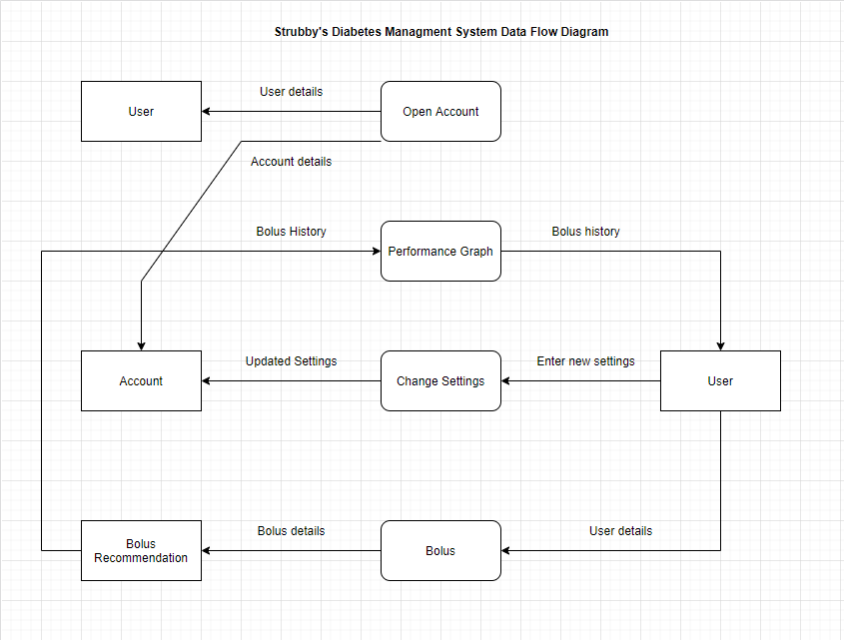

Use Case Diagram:
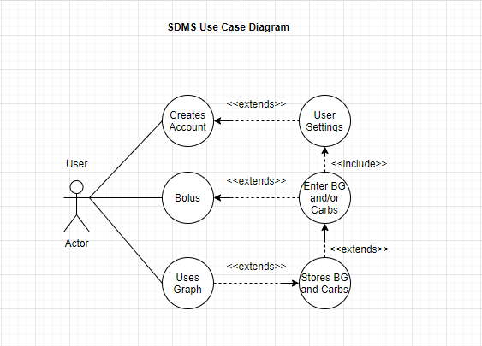
Appendix C: Issues List
There currently are no issues that this project is facing.

