## Mixed Signal Ground Technique Experiment

# Goal

* Goal of this experiment is to teach users about signal degradation issues that occur as a result of improper ground techniques in mixed signal applications. The user will be able to see the effect that isolated return paths, proximity, and correct power decoupling have on analog output signal.

# Detailed requirements:

* Powered by USB 2.0
* Include 1-8 MHz clock
* Have two ground planes that can be connected by a jumper
* Have power supply capacitors that can be bypassed by jumper
* Have multiple sockets for demonstrating proximity effects
* Include Test points near input and output
* User must be able to perform experiment using USB powered board and oscilloscope
* Experiment intended for 2 layer PCB.

# Equipment:

* Power source with USB 2.0 cable
* Oscilloscope

# Description

This experiment will demonstrate signal degradation issues that occur due to improper grounding in mixed signal applications. To highlight common issues the experiment will purposely have analog and digital circuitry sharing the same return path, show the effect of isolating analog and digital ground planes, show the effect of placing digital circuitry in close proximity to the analog circuity, and show the importance of power supply de-coupling. To accomplish this jumpers and sockets will be used in order to switch to different paths and quickly move IC’s.   
  
The experiment will use an analog crystal oscillator at 8 MHz and a digital 555 timer at 5 MHz. The student will be able to look at the crystal oscillator when the timer is disconnected. Then the student will be able to connect the timer and see the negative effect it has on the crystal oscillator output. The student will then be able to follow the experiment procedure and change jumpers that alter the return paths of the oscillator and timer. These changes will be noticeable on the oscilloscope connected to the oscillators output. The student will also be able to move the timer to another socketed location that is farther away from the oscillator and this effect will also be seen.

# Block Diagram

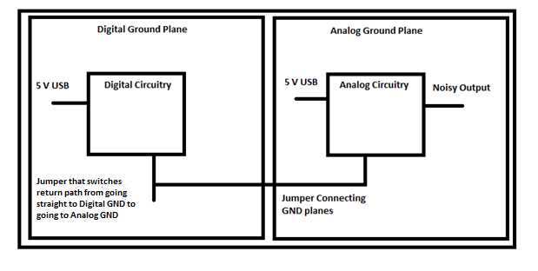

Analog Circuitry will consist of 8 MHz Pierce Crystal Oscillator.  
  
Digital Circuity will be 5 MHz timer.