# Building Signal Integrity Intuition

Tony Muilenburg / Intel System Validation Engineering / tony.a.muilenburg@intel.com

# Problem Statement

As signal speeds increase, analog signal integrity issues that could be ignored for previous platforms can no longer be ignored. It is important that designers and those responsible for validating signal integrity develop an intuition for the contributors to signal integrity degradation. To that end, a board was developed within Intel that exacerbates many of the most significant signaling issues encountered on a modern platform. The first set of boards was manufactured in 2013, and has already been used for training within Intel, as well as undergraduate and graduate university engineering programs.

# Description

The Education Engagement Electrical Validation Board (E3VB) is being developed within Intel to help engineers develop an intuition for the types of signal integrity issues encountered in modern high speed interfaces. The board is made up of ten main experiments. See figure 1 for a picture of the board.

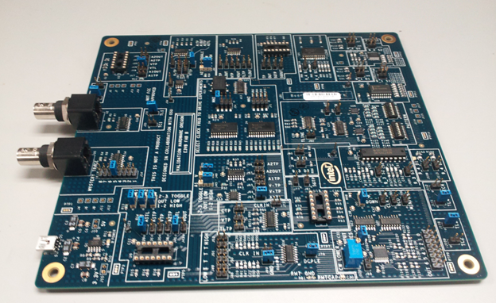

Figure 1: Education Engagement Electrical Validation Board (E3VB)

Experiment list:

1. Single ended crosstalk (near and far end)
2. Differential crosstalk
3. Decoupling
4. Corners and vias
5. Mystery traces (for TDR)
6. Simultaneous switching noise (ground bound and rail collapse)
7. LCR Transmission line (configurable for different values and topologies)
8. Driver circuit comparison, slotted plane
9. Package differences
10. Intersymbol interference

**Capstone Project**

For this project, students will work with engineers at Intel to develop training material to go along with the EV3 board. This effort will include building open source simulations that mimic hardware behavior, as well as building documentation. Oscilloscopes will be provided, as well as access to hardware, and a place to work.

The schematic and board file for this board are documented, and an initial rough draft document has been created to guide participants the through the experiments. Figure 2 shows an example of the differential crosstalk experiment. In this example, the victim transmission line is captured for the case when no aggressors are enabled (top waveform), one aggressor is enabled (middle waveform), and when two aggressors are active (bottom waveform).

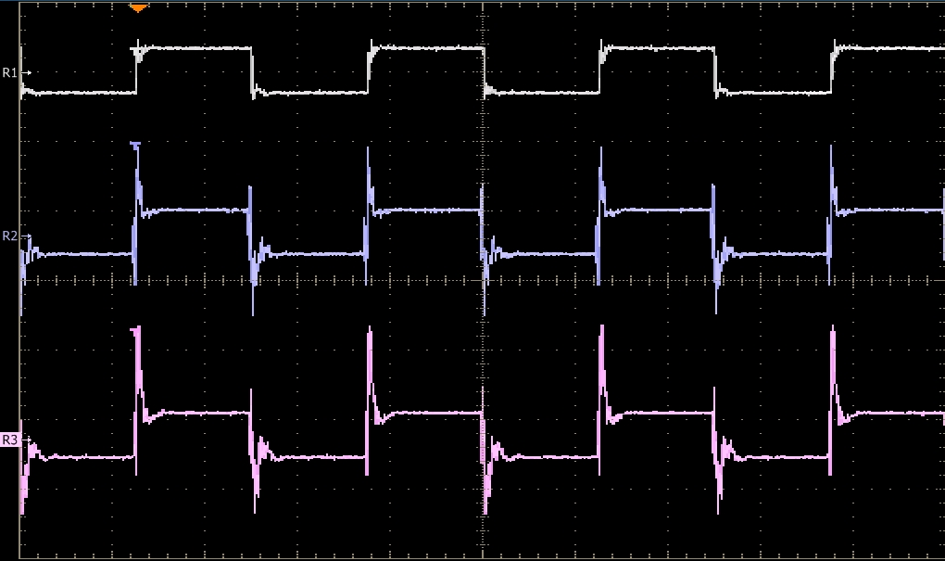

Figure 2: Differential crosstalk experiment