ScanTool

User Manual

Version 4.8.1

Contents

**1. Introduction 3**

1.1 Overview 3

**2. CAN Bus Tools (CANBUS) 4**

2.1 Capture 4

2.2 Send 5

2.3 Capture Files 5

2.4 Baud Rate 5

2.5 Filter and Mask 5

2.6 Auto Baud 5

**3. Vehicle Tools (VEHTOOL) 6**

3.1 PID Scan 6

3.2 PID Stream 6

3.3 PID Gauges 6

3.4 VIN 7

3.5 DTC 7

**4. UTV Offroad Tools (UTVTOOL) 8**

4.1 RZR DTC 8

**5. Testing (TESTING) 9**

5.1 OBD Sim 9

5.2 MSG Spam 9

5.3 Touch Deck 9

**6. Tool Settings (SETTING) 10**

6.1 Memory 10

6.2 About 10

6.3 WiFi MAC 10

6.3 Reset 10

6.3 WiFi Reset 11

6.3 Clock 11

6.3 Dongle 11

**7. Software Development 12**

7.1 IDE 12

7.2 Adding Functions 13

7.3 Hardware API 14

**8. Hardware 15**

8.1 Components 15

8.2 Schematic 15

Introduction

The ScanTool is a multi-purpose device designed to assist with data collection and other commonly used CAN Bus tools. All functions are organized into five menu. Each chapter will document the available menu functions.

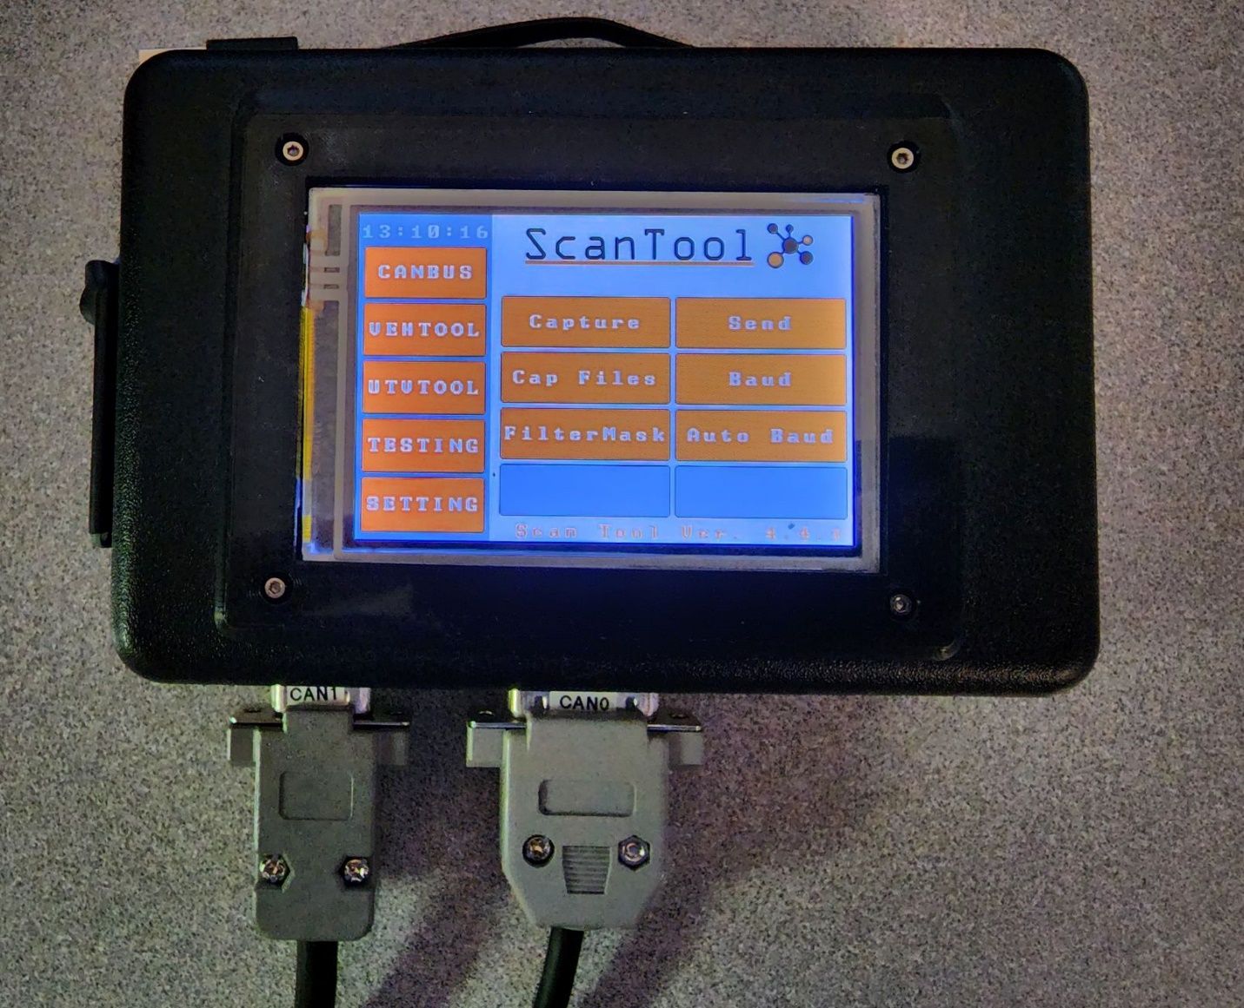

Figure - ScanTool

**2. CAN Bus Tools (CANBUS)**

Read out CAN Bus traffic to the LCD or serial out

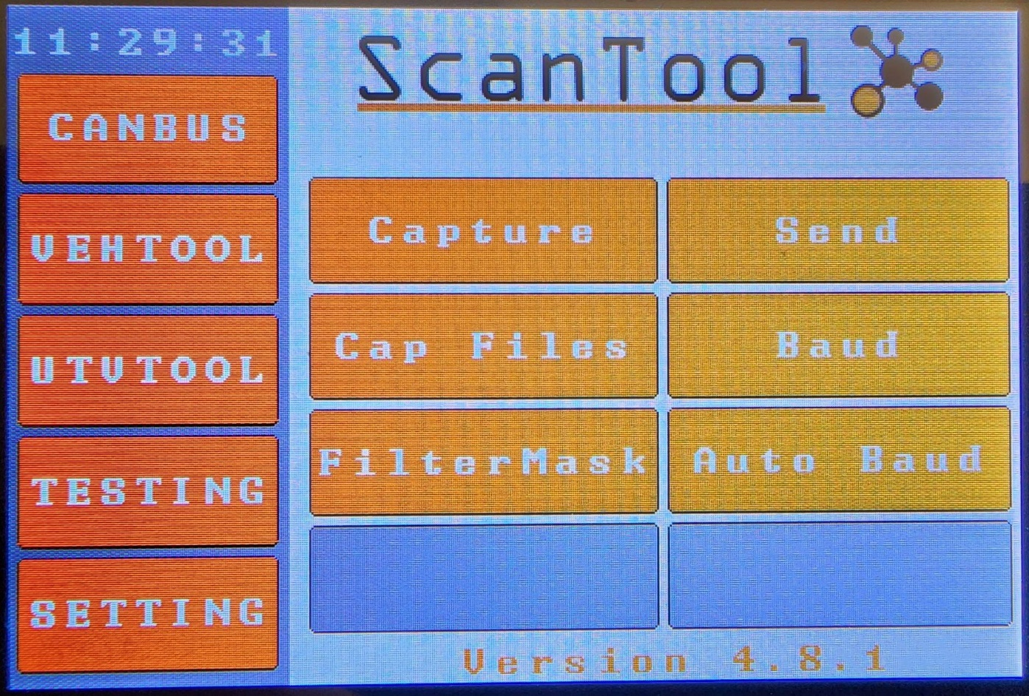

Figure – CANBUS Page.

2.1 Capture

The capture program can read CAN Bus messages. There are three inputs and outputs to choose from.

2.2.1 Input configurations

* CAN0 – CAN Bus messages on connector 0
* CAN1 – CAN Bus messages on connector 1
* CAN0&1 – CAN Bus messages on connector 0 and 1
* CAN0&TX1 – Bridge 0 and 1, display CAN Bus messages sent from CAN1
* Bridge0&1 – CAN Bus messages on connector 0 and 1, bridges the connection
* WIFI – CAN Bus messages from Wi-Fi dongle

2.2.2 Outputs

* LCD: Scrolls CAN Bus traffic across the screen from CAN0. Useful for detecting traffic and reading out data from non-vehicle traffic. Writing to the LCD is resource heavy and has a maximum write speed of approximately 1 message every 12ms. The screen can be paused by pressing and holding over the CAN Bus messages. The screen can be cleared by swiping up or down.
* Serial: Read out CAN Bus traffic on serial out. Can be used with multiple terminal Apps. Arduino IDE is recommended for use. Fast enough to be used on a vehicle’s CAN Bus without dropping messages.
* SD Card: Save CAN Bus messages to user named file. Fast enough to be used on a vehicle’s CAN Bus without dropping messages.

2.2 Send

Create, save, and edit custom CAN Bus message. Can be sent out once by manually tapping the message name or on interval by pressing the message ON/OFF button. Created messages are saved to the SD Card for future use.

2.3 Capture Files

View, replay, and delete SD card recorded CAN Bus captures. Swipe up or down to view the next page of the file.

A file can be split in have using the split function. Two new file names “A” and “B” will be created with the two halves. Either of the new files can also be split until there is 1 remaining CAN Bus message.

2.4 CAN Bus Baud Rate

Set CAN Bus baud rate for both ports. Wi-Fi is currently limited to 500k.

2.5 Filter and Mask

Setup a custom filter and mask for both ports and the Wi-Fi connection.

2.6 Auto Baud

Attempt to automatically find the connected baud rate.

**3. Vehicle Tools (VEHTOOL)**

General vehicle diagnostic tools

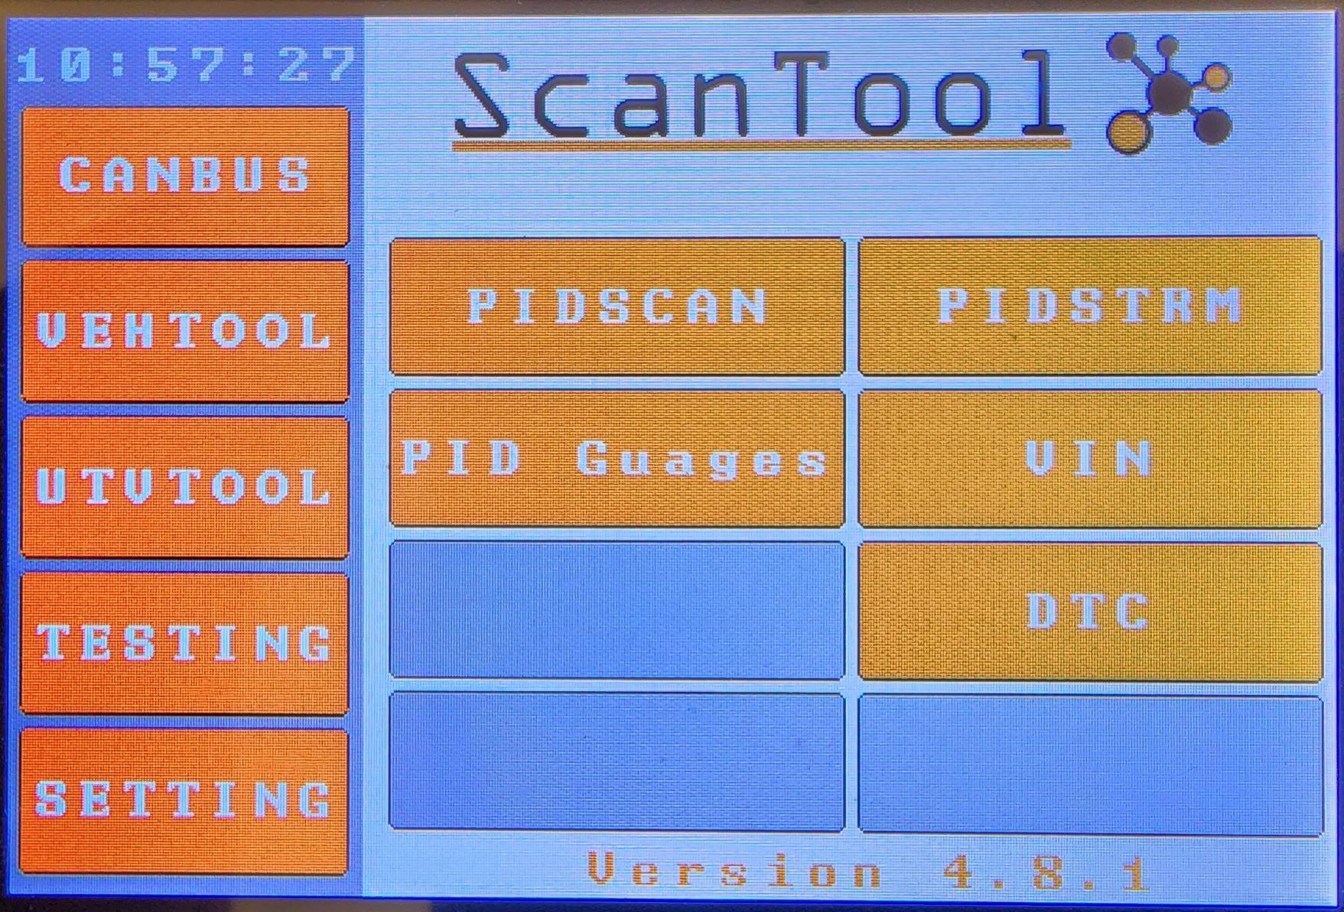

Figure - Vehicle Tool Page

3.1 PID Scan

Scan for all available SAE vehicle PIDs. Results are saved to the micro SD card in a folder with the last 8 characters of the vehicle’s VIN. In the folder, file LOG.txt will be created and contain the full vehicle VIN and a CAN Bus recording of received PID messages. A list of vehicle PIDs will be saved in a PID.txt file.

3.2 PID Stream

This function requires the user to first run PID Scan or an alert will popup informing the user it has not yet been run. PID stream provides the user with a scrollable list of available SAE vehicle PIDS. The user can select a PID and press the Stream PID button to obtain 5 samples of that PID saved to the LOG.txt file.

3.3 PID Gauges

This was an experimental function that contains 4 gauges updated in real time when connected to a vehicle or ECU emulator.

3.4 VIN

Displays the current connected vehicle’s VIN on the LCD screen.

3.5 DTC

3.5.1 Scan DTCs (Under Development)

3.5.2 Clear DTCs

Clear vehicle DTCs.

**4. UTV Offroad Tools (UTVTOOL)**

Tools for offroad sport utility vehicles (Under development)

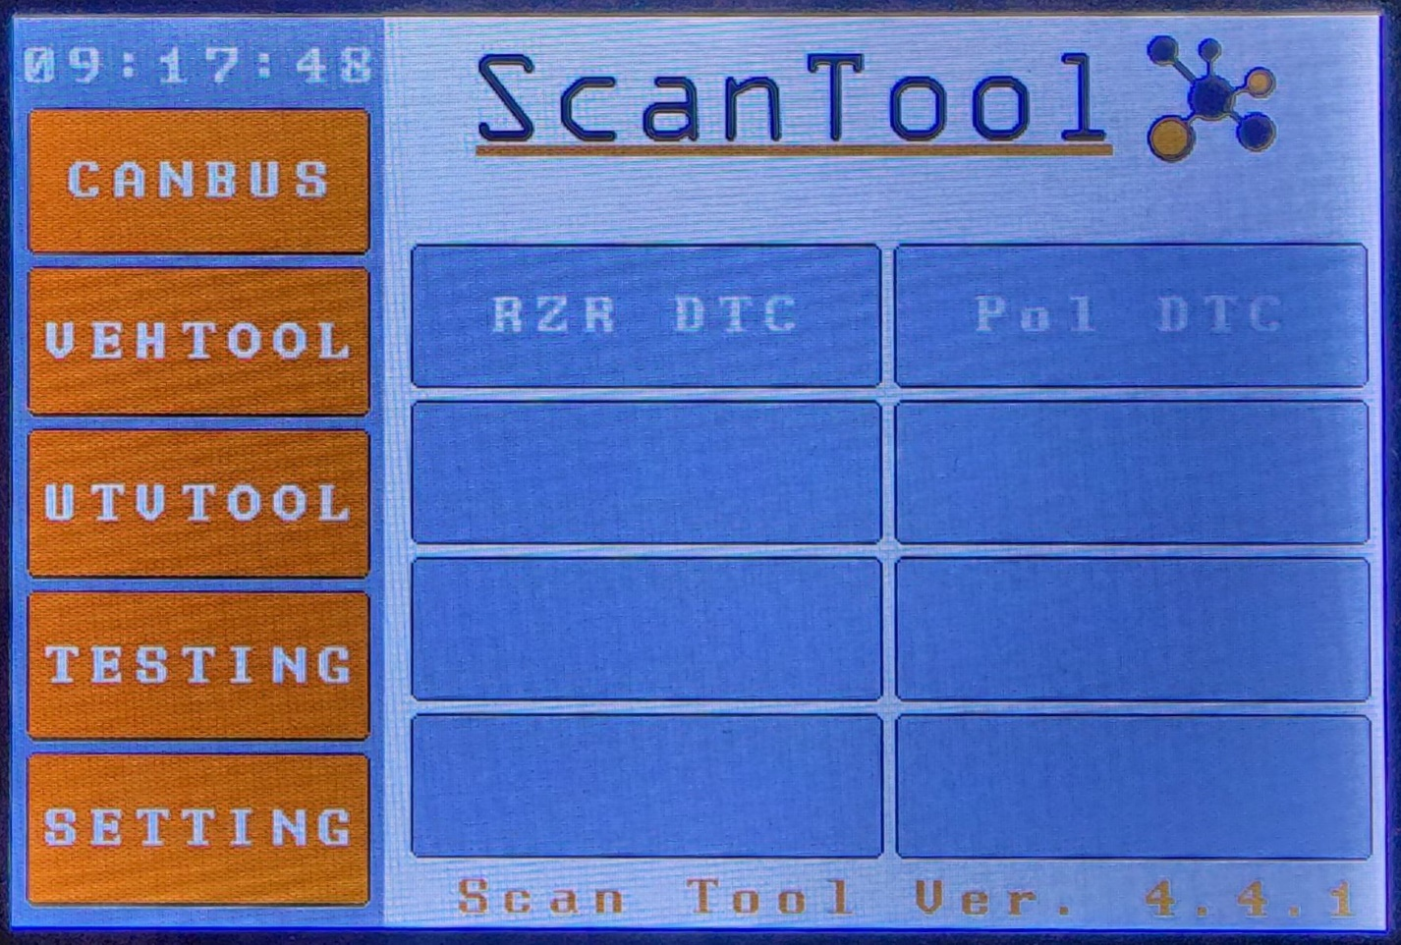

Figure - UTV Tools

4.1 Vehicle DTCs

Under development.

**5. Testing**

The extra functions page is the ideal spot for quick scripted test functions.

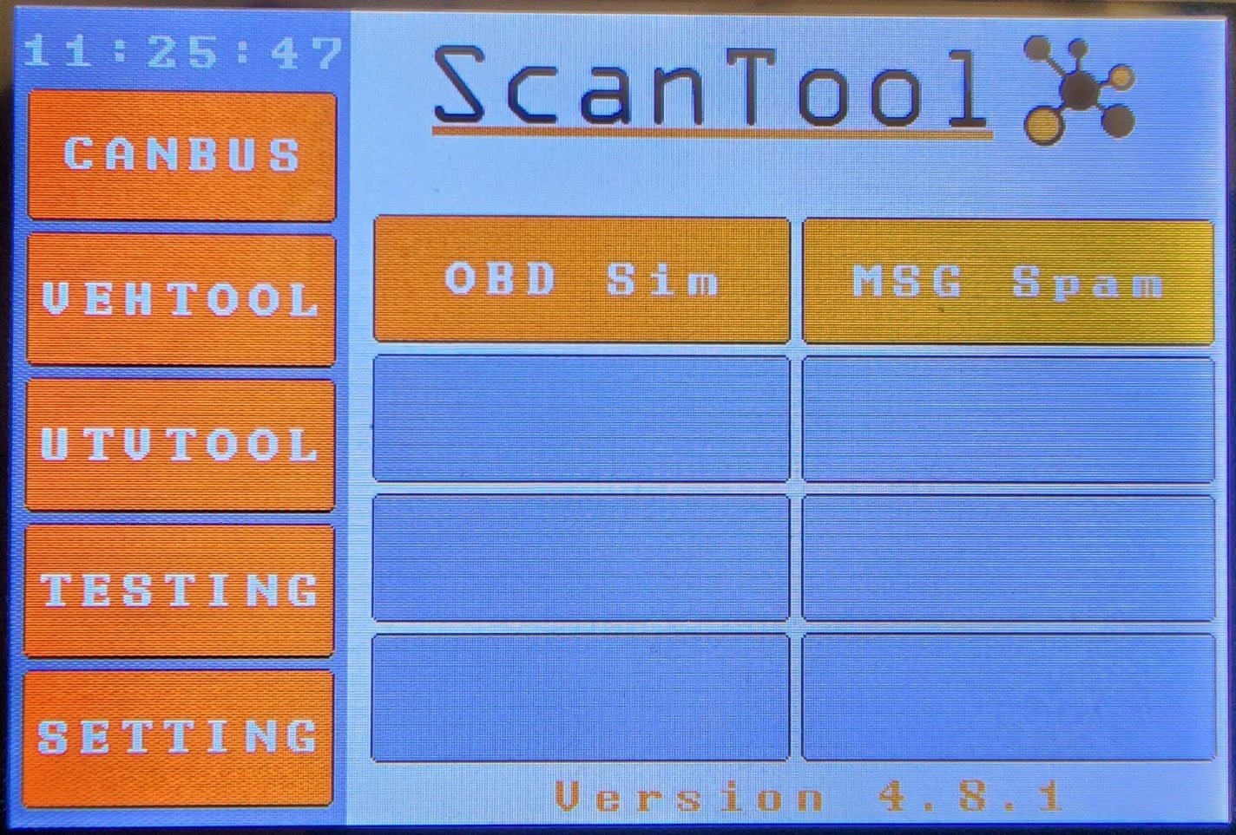

Figure - Extra Functions

5.1 OBD Simulator

Launches a CAN OBD simulator

5.2 Message Spam

Network testing utility.

**6. Tool Settings (SETTING)**

Change global settings for the scan tool

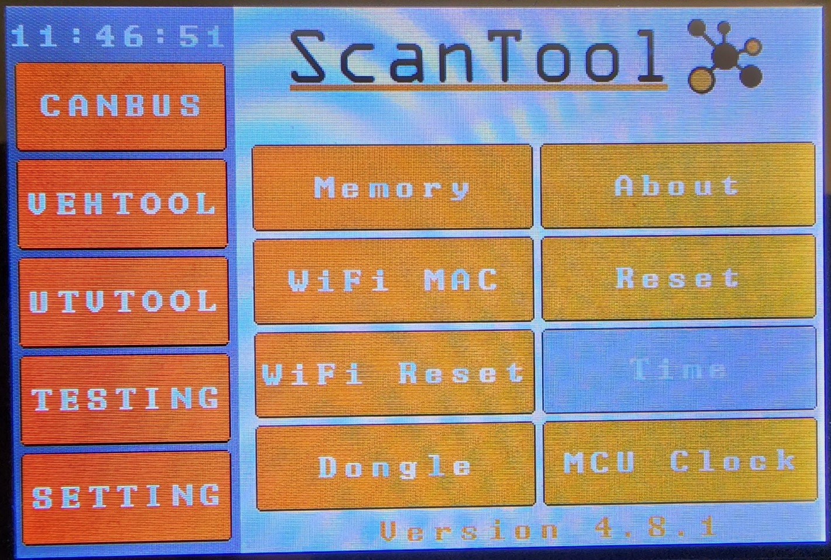

Figure - Tool Settings

6.1 Memory

Display current used and available memory.

6.2 About

Device information.

6.3 WiFi MAC

Display MAC address for WiFi module and connecting dongle MAC.

6.4 Reset

ScanTool MCU reset

6.5 WiFi Reset

Send command to reset ESP8266.

6.6 Time

Set clock time and DST.

6.7 Dongle

Connect dongle for remote WiFi Can Bus streaming.

**7. Software** **Development**

7.1 IDE

The program was developed using Visual Studios 2018 with vMicro extension to interface the Duo directly from Visual Studios. Other software that can be used: Visual Studio Code with Platform IO extension or the Arduino IDE (Not recommended).

7.2 Adding Functions

Each page is preprogrammed to allow 8 functions and has an associated draw page and page buttons. Activating requires uncommenting code. Adding function to EXTRAFN page example:

* Uncomment the button in the draw function:

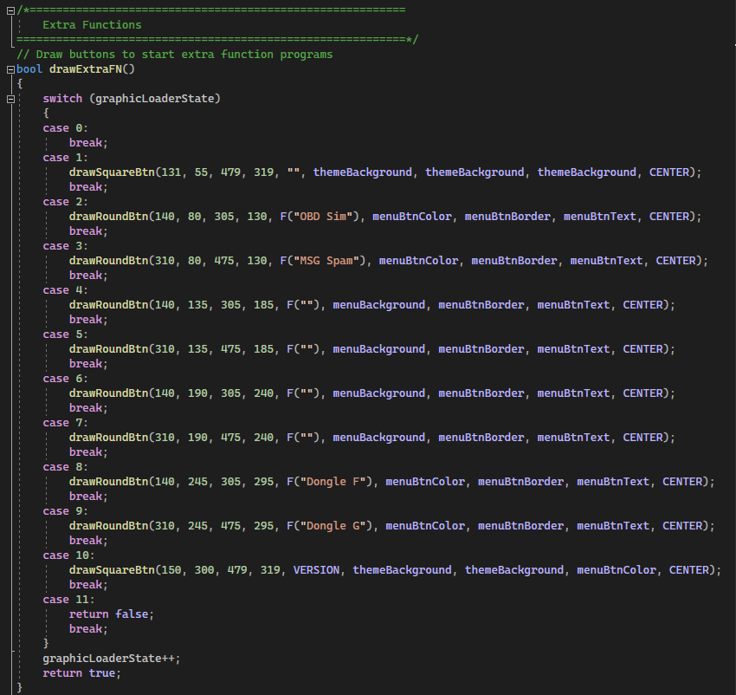

* Next uncomment the button in extraFNButtons(). Buttons of the left side of the LCD have even page numbers and buttons on the ride odd. Page numbers are preassigned, do not change.

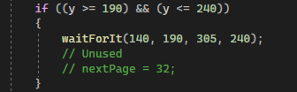

* In this case page 32 is used. Find 32 in pageControl().

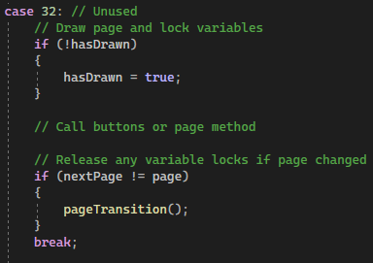

* Add any content you want drawn for your function in the if statement, it will only run once. The menu sidebar is only drawn one time at startup. Avoid drawing over it unless you plan to call the side menu again. Any function buttons you want continuously called add below the if statement. All functions should be non-blocking to allow background functions to run.
* Background processes can be called outside the GUI in the main loop.

7.3 Hardware API (Partial list)

Send CAN Bus messages:

can1. sendFrame(uint32_t id, byte* frame)

Receive CAN Bus messages:

can1. getFrame(buff& msg, uint32_t& id, uint8_t channel)

Set filter and mask:

can1. setFilterMask0(uint32_t filter, uint32_t mask)

can1. setFilterMask1(uint32_t filter, uint32_t mask)

Set baud rate:

can1. setBaud0(uint32_t Baud)

can1. setBaud1(uint32_t Baud)

Read in file:

sdCard. readFile(char* filename, uint8_t* arrayIn)

Write to file:

sdCard. writeFile(char* filename, String incoming)

sdCard. writeFile(char* filename, int incoming, int base)

Delete file:

sdCard. deleteFile(char* filename)

**8. ScanTool Hardware**

7.1 Components

* Arduino Due
* ESP8266 with breakout board
* CAN Bus transceivers Modules x2
* BuyDisplay 2.5: TFT LCP with shield ([Arduino 3.5"TFT LCD Touch Shield Serial SPI Example for Mega/Due (buydisplay.com)](https://www.buydisplay.com/arduino-3-5-tft-lcd-touch-shield-serial-spi-example-for-mega-due))
* Micro SD Card Module
* Barrel Jack for extern power
* DB9 and DB15 connectors
* Enclosure ([SL-68P Low Profile Enclosures for PCBs (polycase.com)](https://www.polycase.com/sl-68p)) (Used Dremel / drill / box cutter for cut outs)
* USB <= 1ft data cable.

7.2 Schematic

Figure – Hardware Scematic