Challenge

Brandon Zimlich-Vining

9/14/2019

* List
* list
* list

1. *list*
2. *list*
3. *list*

* bullet
* bullet
* bullet

# ggplot

ggplot is soooo radical dude…..lol

back ticks then in brackets, the language and then name for chunk

gapminder <- read.table("gapminder.txt", header =TRUE)  
head(gapminder)

## country continent year lifeExp pop gdpPercap  
## 1 Afghanistan Asia 1952 28.801 8425333 779.4453  
## 2 Afghanistan Asia 1957 30.332 9240934 820.8530  
## 3 Afghanistan Asia 1962 31.997 10267083 853.1007  
## 4 Afghanistan Asia 1967 34.020 11537966 836.1971  
## 5 Afghanistan Asia 1972 36.088 13079460 739.9811  
## 6 Afghanistan Asia 1977 38.438 14880372 786.1134

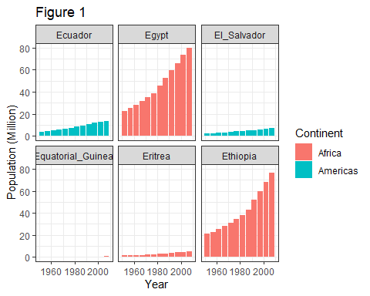

The mean life expectancy of Sweden is 76.177