**Lab Report**

1. SOF file location : “Lab2\rtl\template_de1soc\simple_ipod_solution.sof “
2. Status of lab : functional, no reset button
3. Simulation screenshot (also in doc folder)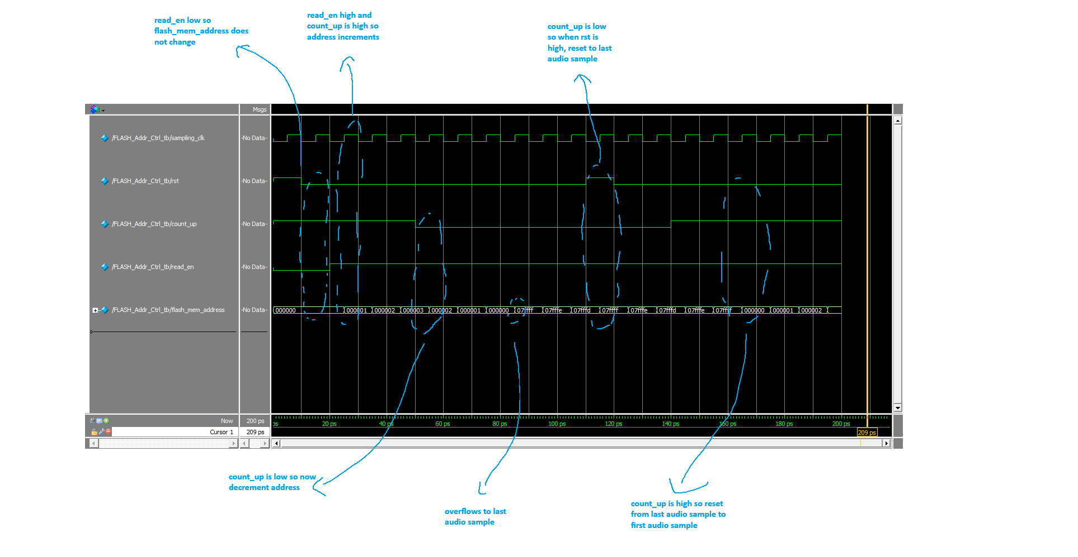
4. Simulations ran using ModelSim 10.5b.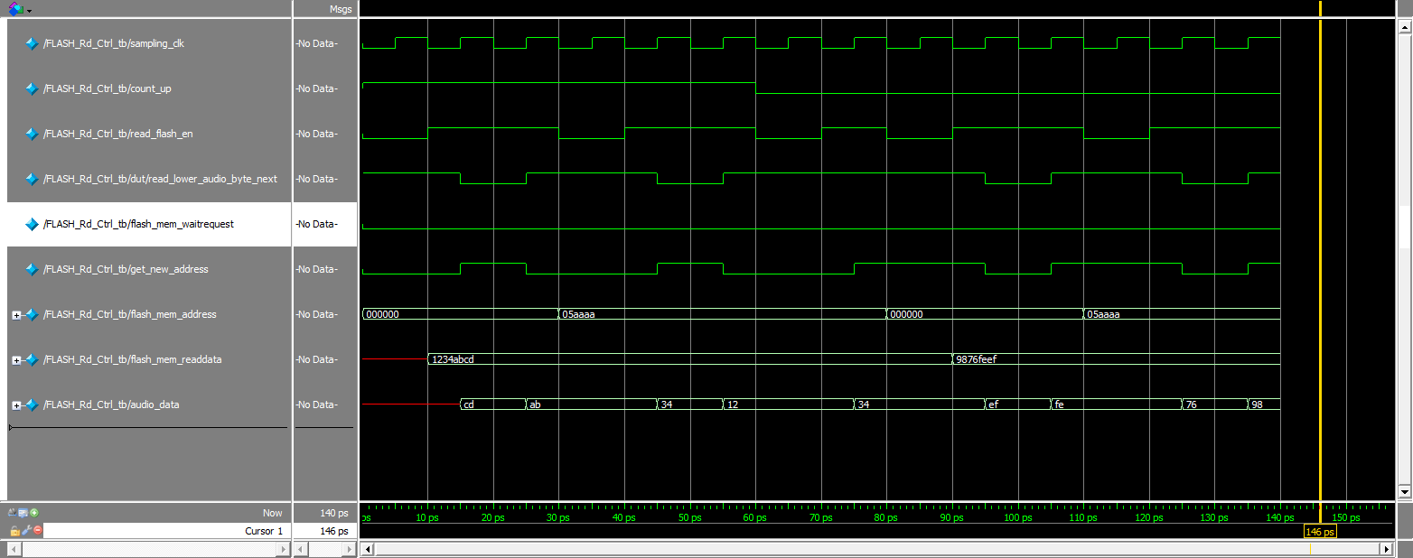
   1. Path of mpf file : “Lab2\sim\lab2.mpf"