Weekly Status - Week 04
Distributed Systems 2026-B - Group 2 - Amaranta
Sprint window: Aug 31 - Sep 6, 2026
Field | Value
FULL_NAME | Brandow Stivent Claros Polania
GITHUB_USER | BrandowC
TEAM | amaranta
SPRINT_GOAL | Deliver the first running slice of Amaranta: a hexagonal modular monolith (Identity, Catalog, Sales) over PostgreSQL with customer registration, login, product browsing and checkout, plus the UX/UI foundations (design system, navigation map, wireframes).

1. Context of the week
Week 04 (Aug 31 - Sep 6, 2026) was the first sprint in which Amaranta, the pet shop and veterinary clinic project, moved from design documents to running code. The team works in a sprint cadence of eight days agreed in Sprint 1, and the course topic of the week was building a service with a layered structure and a walking skeleton (Session 1), followed by sprint planning with a contract-first approach, estimation and MoSCoW prioritisation (Session 2).
The sprint goal was to have something demonstrable instead of only documents: a thin slice that runs end to end against a real PostgreSQL database, protected by the business rules designed in the previous sprint. Session 1 selected Orders (Sales) as the first area to build, and Session 2 fixed the sprint goal as a shield for the scope: a customer can place an order for a product that is in stock.
2. What was done
Code: first running version of the product. On Sep 2 the first MVP was committed to the amaranta repository (commit 20cf133, 116 files). It is a modular monolith written with NestJS, TypeORM and PostgreSQL 16 and organised in three bounded contexts: Identity, Catalog and Sales. Each context has its own PostgreSQL schema and the same layered layout (domain, application, infrastructure). The session reports had planned a standalone orders service; what was delivered keeps the same boundaries and the same layers inside one deployable unit, with the extraction path documented in docs/path-to-microservices.md, so that any context can be extracted later without rewriting its domain.
Architecture rules applied. The dependency rule of hexagonal architecture holds in the whole code base: the domain imports nothing from the application or infrastructure layers, use cases implement inbound ports, and the Sales context reaches Catalog only through an outbound port and an adapter used for stock reservation. Pure domain tests (Product and Order entities and the checkout use case) run without starting Nest or touching a database.
Stories covered. Customer self-registration (HU-IAM-001), login with a JWT that checkout requires (HU-IAM-002), browsing the catalog (HU-CAT-001) and cart plus checkout (HU-SALES-001).
Documentation: UX/UI foundations. In the documentation repository the design system, the navigation map and the wireframes were committed (commit 9db8e3b, folder 12-ux-ui), which gave the web application a visual and navigation baseline.
Course deliverables. The two Sprint 4 session reports were written: Session 1 (Aug 31) on the layered service and the walking skeleton, and Session 2 (Sep 3) on the contract-first plan, task breakdown, MoSCoW and Definition of Done.
3. User stories worked this week
HU ID | Title | Status | Evidence
HU-IAM-001 | Customer self-registration (POST /auth/register) | done | https://github.com/BrandowC/amaranta/commit/20cf133
HU-IAM-002 | Login - issues the JWT required by checkout (support endpoint) | done | https://github.com/BrandowC/amaranta/commit/20cf133
HU-CAT-001 | Browse product catalog (GET /products) | done | https://github.com/BrandowC/amaranta/commit/20cf133
HU-SALES-001 | Add to cart and checkout (POST /orders, GET /orders) | done | https://github.com/BrandowC/amaranta/commit/20cf133

4. Supporting evidence
The figures below are generated from the real git history and from the project artefacts. The tables list every commit and pull request authored by BrandowC in the week.
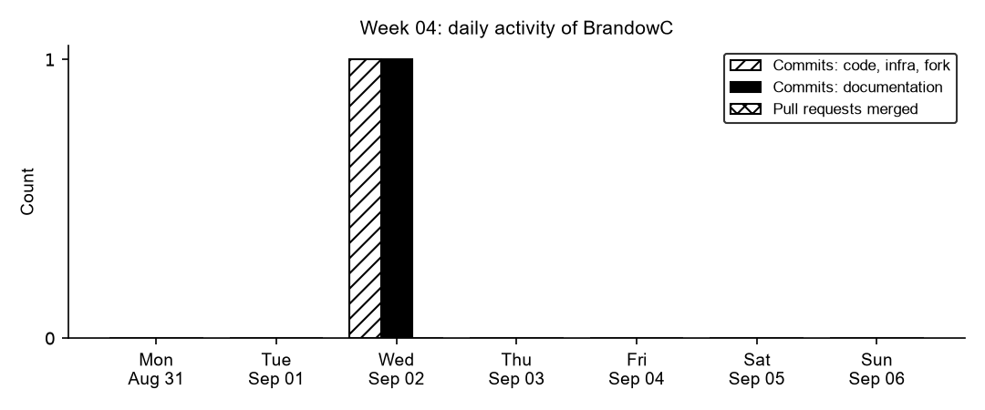
Figure 4.1. Daily commits and merged pull requests authored by BrandowC in week 04, counted from git history of the code, documentation, infrastructure and course-fork repositories.
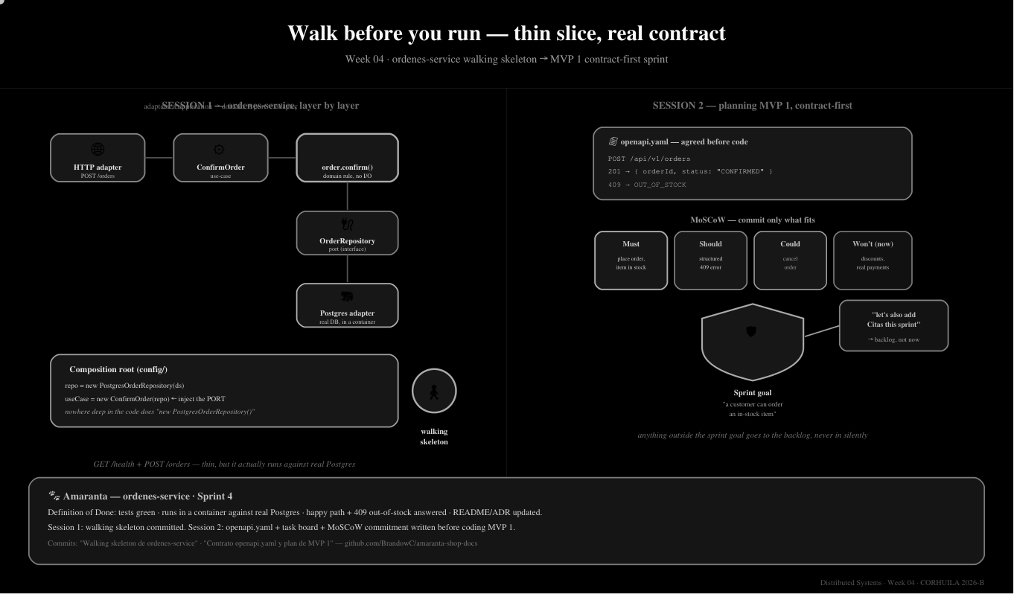
Figure 4.2. Week 04 session diagram: thin-slice walking skeleton (Session 1) and contract-first MVP 1 planning with MoSCoW (Session 2). Source: 04-week/hu-status/week-04-example.svg in the fork.
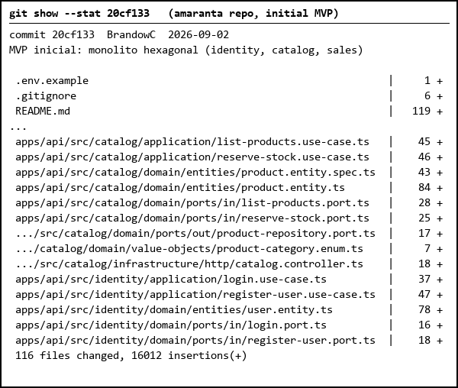
Figure 4.3. Initial modular monolith commit (Sep 2): bounded contexts organised as domain, application and infrastructure layers. Output of git show --stat, shortened.
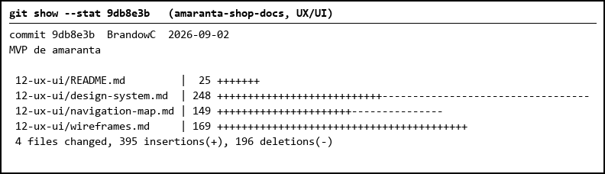
Figure 4.4. UX/UI foundations committed to the documentation repository: design system, navigation map and wireframes.
Table 1. Commits authored in the week
Date | Repository | SHA | Message
2026-09-02 | amaranta | 20cf133 | MVP inicial: monolito hexagonal (identity, catalog, sales) (EN: initial MVP: hexagonal monolith)
2026-09-02 | amaranta-shop-docs | 9db8e3b | MVP de amaranta (EN: Amaranta MVP: UX/UI foundations)

5. Individual contribution
Code - walking skeleton of the product (`amaranta` repo)
- Built and committed the initial MVP as a modular monolith with NestJS + TypeORM + PostgreSQL 16: three bounded contexts (`identity`, `catalog`, `sales`), each with its own PostgreSQL schema and a domain / application / infrastructure layout (commit 20cf133, 116 files; most of the volume is the generated lockfile).
- Applied the hexagonal dependency rule: domain has no framework imports, use cases implement inbound ports, and `sales` reaches `catalog` only through an outbound port plus an adapter (stock reservation), so the context can be extracted later.
- Wrote pure domain unit tests (`*.spec.ts`, Product and Order entities, plus the checkout use case) that do not boot Nest or touch a database.
- Documented the structure, the HU table and the extraction path in the repo README and `docs/path-to-microservices.md`.
Docs (`amaranta-shop-docs`)
- Authored the UX/UI foundations: design system, navigation map and wireframes (commit 9db8e3b, `12-ux-ui/`).
Course deliverables
- Wrote the Sprint 4 session reports (Session 1: layered service + walking skeleton, Aug 31; Session 2: contract-first planning, MoSCoW and Definition of Done, Sep 3) - see `./Semana-04-Amaranta-Sesion1.pdf` and `./Semana-04-Amaranta-Sesion2.pdf`.
6. Blockers and risks
- The MVP is a monolith, while the Session 1 report planned a standalone `ordenes-service`; the extraction path is documented but not executed yet.
- The first MVP landed directly on `main`/`develop`/`qa` as one commit, so there are no per-environment HU branches or PRs as evidence for these four HUs.
7. Plan for next week
- Add the Clinic bounded contexts (Clinical Records and Scheduling) so the MVP covers both the shop and the veterinary clinic.
- Add role-based authorization (staff vs customer) because every endpoint is currently open to any authenticated user.
- Start working with per-environment HU branches and PRs (hu-xxx-dev -> develop).
8. Evidence links
- Initial MVP commit (code repo): https://github.com/BrandowC/amaranta/commit/20cf133
- UX/UI foundations (docs repo): https://github.com/code-corhuila/amaranta-shop-docs/commit/9db8e3b
- Session reports: ./Semana-04-Amaranta-Sesion1.pdf, ./Semana-04-Amaranta-Sesion2.pdf
- Code repo: https://github.com/BrandowC/amaranta
- Docs repo: https://github.com/code-corhuila/amaranta-shop-docs
- Fork: https://github.com/BrandowC/sistemas-distribuidos-2026-b-g2
- Profile repo (CONFIG): https://github.com/BrandowC/BrandowC

