Weekly Status - Week 05
Distributed Systems 2026-B - Group 2 - Amaranta
Sprint window: Sep 7 - Sep 13, 2026
Field | Value
FULL_NAME | Brandow Stivent Claros Polania
GITHUB_USER | BrandowC
TEAM | amaranta
SPRINT_GOAL | Package and publish the individual evidence of weeks 1-4 in the fork and get the Cut 1 backlog (clinic and scheduling stories) ready for the next sprint. Low-activity week: no commits to the code or docs repos.

1. Context of the week
Week 05 (Sep 7 - Sep 13, 2026) was a low-activity week for the project repositories. No commit authored by BrandowC is dated in the code or documentation repositories in this window, and this report says so plainly instead of padding the week.
The week served as a transition between the MVP 1 monolith of Sprint 4 and the Cut 1 backlog (the clinic side of Amaranta) that was implemented in Sprint 6. The individual delivery pipeline of the course moved forward in the fork.
2. What was done
Course deliverables published. On Sep 10 the session reports of weeks 1 to 4 were published in the fork (commit 6ef29d6): six PDF reports and the example diagrams of weeks 3 and 4. The same commit removed the earlier PDR drafts of weeks 1 and 2, which the session reports replaced.
Preparation of Cut 1. The Clinical and Scheduling user stories in 04-requirements/user-stories.md were reviewed together with the domain rules and the data model to decide which stories belong to Cut 1 and which bounded contexts had to be added to the monolith. This preparation has no commit of its own; its result is the implementation delivered in week 06.
3. User stories worked this week
HU ID | Title | Status | Evidence
HU-CLIN-001 | Register a pet - analysis and planning for Cut 1 | todo | No commit yet; implemented in week 06
HU-SCHED-001 | Book an appointment within business hours - analysis and planning for Cut 1 | todo | No commit yet; implemented in week 06

4. Supporting evidence
The figures below are generated from the real git history and from the project artefacts. The tables list every commit and pull request authored by BrandowC in the week.
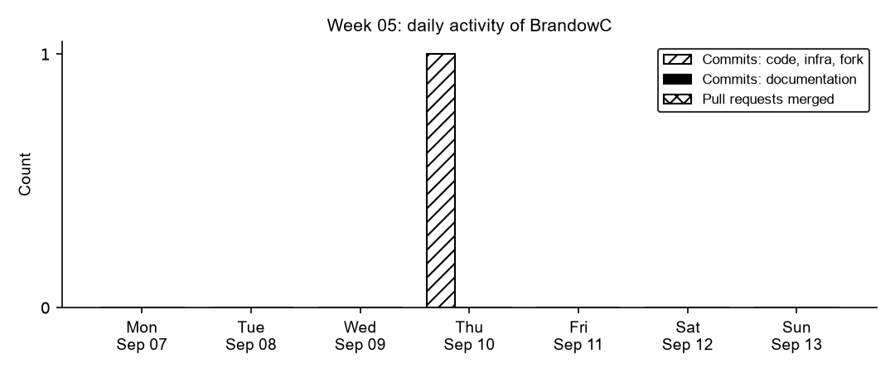
Figure 5.1. Daily commits and merged pull requests authored by BrandowC in week 05, counted from git history of the code, documentation, infrastructure and course-fork repositories.
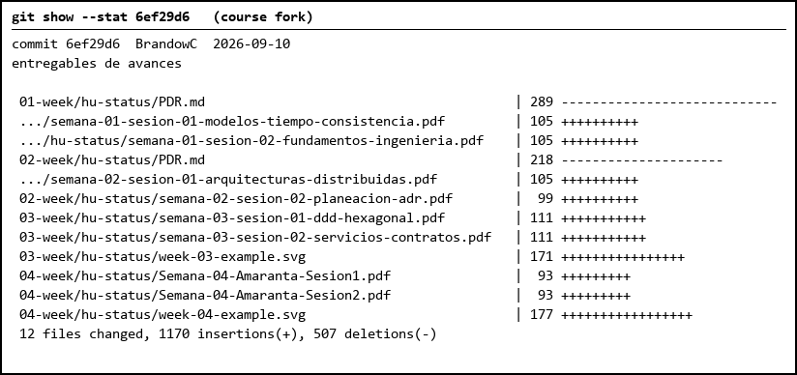
Figure 5.2. The only commit of the window: session reports of weeks 1-4 published in the fork, replacing the PDR drafts.
Table 1. Commits authored in the week
Date | Repository | SHA | Message
2026-09-10 | course fork | 6ef29d6 | entregables de avances (EN: progress deliverables: session reports of weeks 1-4)

5. Individual contribution
Course deliverables
- Published the session reports for weeks 1-4 (six PDFs plus the week 03 and week 04 example diagrams) to the fork, and removed the superseded PDR drafts of weeks 1-2 (commit 6ef29d6, Sep 10).
- Prepared Cut 1 (clinic side of Amaranta): reviewed the Clinical and Scheduling user stories in `04-requirements/user-stories.md`, the domain rules and the data model to scope which stories belong to Cut 1 and which bounded contexts to add to the monolith. The implementation followed in week 06.
Honest status
- There are no commits in `amaranta` or `amaranta-shop-docs` dated in this window. The sprint goal was only partially met: the delivery pipeline of the fork moved forward, product work did not.
6. Blockers and risks
- No product work was committed this week, which weakens the group sprint (board and backlog evidence) for week 05.
- No daily/board evidence of the Cut 1 planning was recorded, so it cannot be demonstrated beyond the user-stories document.
7. Plan for next week
- Implement Clinical and Scheduling with staff RBAC (Cut 1) and merge it through a PR into `develop`.
- Add repository governance: CODEOWNERS and the Git conventions the course requires.
- Record planning, daily and review notes in the board each sprint so the ceremonies leave evidence.
8. Evidence links
- Fork delivery commit (session reports weeks 1-4): https://github.com/BrandowC/sistemas-distribuidos-2026-b-g2/commit/6ef29d6
- Code repo: https://github.com/BrandowC/amaranta
- Docs repo: https://github.com/code-corhuila/amaranta-shop-docs
- Fork: https://github.com/BrandowC/sistemas-distribuidos-2026-b-g2
- Profile repo (CONFIG): https://github.com/BrandowC/BrandowC

