Weekly Status - Week 06
Distributed Systems 2026-B - Group 2 - Amaranta
Sprint window: Sep 14 - Sep 20, 2026
Field | Value
FULL_NAME | Brandow Stivent Claros Polania
GITHUB_USER | BrandowC
TEAM | amaranta
SPRINT_GOAL | Complete the Cut 1 backlog by adding the Clinical Records and Scheduling bounded contexts with staff role-based access, and put repository governance (CODEOWNERS, Git conventions, brand palette) in place.

1. Context of the week
Week 06 (Sep 14 - Sep 20, 2026) was the sprint of the Cut 1 backlog. The goal was to complete the clinic side of Amaranta, adding the Clinical Records and Scheduling bounded contexts with role-based access for staff, and to put repository governance in place before the team grew its branch and pull request traffic.
In the same week the instructor published the course branching policy and CODEOWNERS in the documentation repository, which the team adopted: permanent branches develop, qa and main, no direct commits to them, and promotion through pull requests.
2. What was done
Code: Cut 1 backlog. Commit fb799f6 (96 files, 2,965 insertions) added the two missing bounded contexts. Clinical lets customers register pets, lets veterinarians add medical records and lets staff look up any pet. Scheduling books, cancels and completes appointments and enforces business hours and double-booking invariants. The commit also introduced role-based authorization (RolesGuard and a Roles decorator): before it, every staff-only endpoint was reachable by any authenticated user. It added admin CRUD for the catalog, in-store checkout and mark-as-paid for receptionists, and fixed a bug where OrderRepository.save() re-inserted the items of an existing order on every update, which caused a NOT NULL violation; updates now touch only the order columns. The pull request (#2) was merged into develop.
Governance in the code repository. A CODEOWNERS file was added so main requires approval (commit 2a9dcd2, PR #1). Clinical and Scheduling depend on each other through NestJS forwardRef; the circular dependency and the way to break it at extraction time are documented in docs/path-to-microservices.md.
Documentation. The Git conventions were extended with cherry-pick promotion and the rule of no direct commits to permanent branches, and the design-system palettes were redefined (commit f38b69a, PR #5 merged into main on Sep 19). The repository README tables were reformatted (commit b90b384).
3. User stories worked this week
HU ID | Title | Status | Evidence
HU-CLIN-001 | Register a pet | done | https://github.com/BrandowC/amaranta/commit/fb799f6
HU-CLIN-002 | Veterinarian adds a medical record | done | https://github.com/BrandowC/amaranta/commit/fb799f6
HU-SCHED-001 | Book an appointment within business hours | done | https://github.com/BrandowC/amaranta/commit/fb799f6
HU-SCHED-002 | Prevent double-booking | done | https://github.com/BrandowC/amaranta/commit/fb799f6
HU-SCHED-003 | Cancel my appointment | done | https://github.com/BrandowC/amaranta/commit/fb799f6
HU-SCHED-004 | Receptionist manages appointments for a customer | done | https://github.com/BrandowC/amaranta/commit/fb799f6
HU-IAM-003 | Receptionist registers a walk-in customer (role-based access added) | done | https://github.com/BrandowC/amaranta/commit/fb799f6
HU-CAT-002 | Admin manages the catalog (create, update, stock, activate/deactivate) | done | https://github.com/BrandowC/amaranta/commit/fb799f6
HU-SALES-003 | Receptionist creates an in-store order and marks it as paid | done | https://github.com/BrandowC/amaranta/commit/fb799f6

4. Supporting evidence
The figures below are generated from the real git history and from the project artefacts. The tables list every commit and pull request authored by BrandowC in the week.
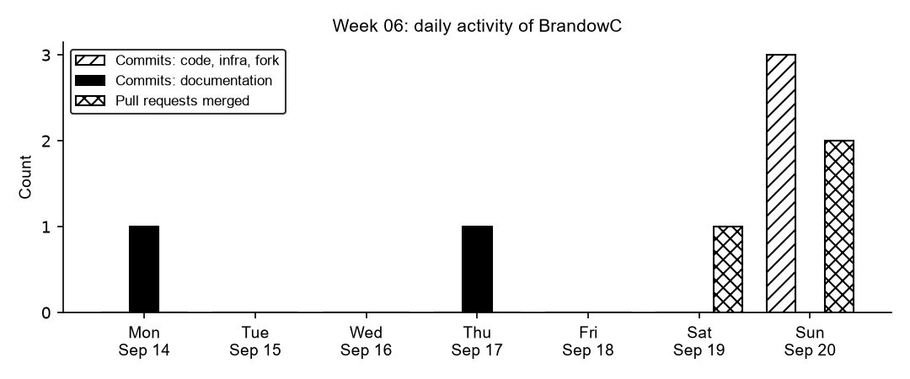
Figure 6.1. Daily commits and merged pull requests authored by BrandowC in week 06, counted from git history of the code, documentation, infrastructure and course-fork repositories.
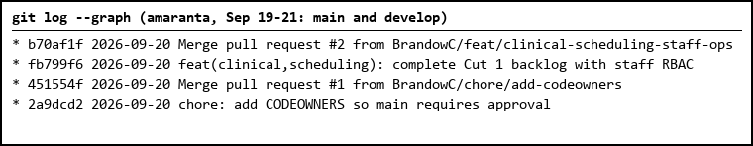
Figure 6.2. Promotion history of the code repository: PR #1 (CODEOWNERS) into main and PR #2 (Cut 1) into develop.
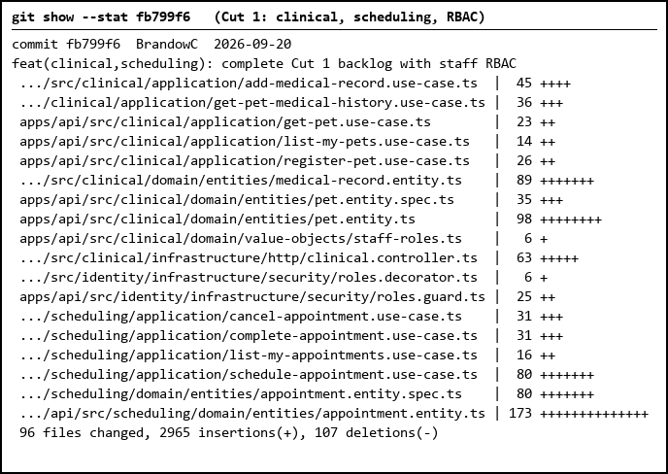
Figure 6.3. Cut 1 commit: the Clinical Records and Scheduling contexts and role-based authorization (selected files; 96 files in total).
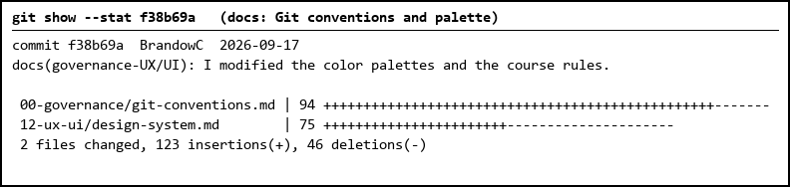
Figure 6.4. Documentation commit that extended the Git conventions and redefined the design-system palettes.
Table 1. Commits authored in the week
Date | Repository | SHA | Message
2026-09-14 | amaranta-shop-docs | b90b384 | docs: reformat README tables and expand license footer
2026-09-17 | amaranta-shop-docs | f38b69a | docs(governance-UX/UI): I modified the color palettes and the course rules.
2026-09-20 | amaranta | 2a9dcd2 | chore: add CODEOWNERS so main requires approval
2026-09-20 | amaranta | 956b456 | feat(clinical,scheduling): complete Cut 1 backlog with staff RBAC (cherry-pick)
2026-09-20 | amaranta | fb799f6 | feat(clinical,scheduling): complete Cut 1 backlog with staff RBAC

Table 2. Pull requests and merges
Date | Repository | PR | Branch
2026-09-19 | amaranta-shop-docs | #5 | to-main/git-conventions
2026-09-20 | amaranta | #1 | chore/add-codeowners
2026-09-20 | amaranta | #2 | feat/clinical-scheduling-staff-ops

5. Individual contribution
Code (`amaranta` repo)
- Added the two remaining bounded contexts, Clinical Records and Scheduling, with domain invariants for business hours and double-booking (commit fb799f6, 96 files; PR https://github.com/BrandowC/amaranta/pull/2 into `develop`).
- Introduced role-based authorization (RolesGuard + @Roles). Before this change every staff-only endpoint was reachable by any authenticated user.
- Fixed a bug where `OrderRepository.save()` re-inserted order items on every update (e.g. mark as paid), which caused a NOT NULL violation; updates now touch only the order columns.
- Opened and merged the CODEOWNERS PR so `main` requires approval (PR https://github.com/BrandowC/amaranta/pull/1, commit 2a9dcd2).
- Documented the circular dependency between Clinical and Scheduling (resolved with forwardRef) and how it would be broken at extraction time.
Docs (`amaranta-shop-docs`)
- Extended the Git conventions (cherry-pick promotion, no direct commits to permanent branches) and redefined the colour palettes in the design system (commit f38b69a; PR https://github.com/code-corhuila/amaranta-shop-docs/pull/5).
- Adopted the course branching policy and CODEOWNERS added by the instructor (75785f5, 3ac0250) and reformatted the repo README tables (b90b384).
Flow
- Used feature branches with PRs into `develop` and a promotion PR to `qa` and `main` for the governance change, instead of committing directly to permanent branches.
6. Blockers and risks
- The Cut 1 PR was large (96 files) and combined two contexts plus RBAC, which makes review harder; it should have been split per HU.
- Branch names used `feat/...` instead of the per-environment `hu-xxx-dev` convention, and no automated test report is attached to the PR.
- Clinical and Scheduling depend on each other, which couples them until they are extracted.
7. Plan for next week
- Contract-first documentation: publish the OpenAPI contract of every service in `07-api`.
- Fix author attribution and the `dev` -> `develop` rename in the governance docs.
- Add the clinical and scheduling database schemas and keep PRs small and per HU.
8. Evidence links
- Cut 1 backlog (clinical, scheduling, RBAC), commit: https://github.com/BrandowC/amaranta/commit/fb799f6
- Cut 1 PR into develop: https://github.com/BrandowC/amaranta/pull/2
- CODEOWNERS PR: https://github.com/BrandowC/amaranta/pull/1
- Git conventions + palette PR (docs): https://github.com/code-corhuila/amaranta-shop-docs/pull/5
- Docs commit: https://github.com/code-corhuila/amaranta-shop-docs/commit/f38b69a
- Code repo: https://github.com/BrandowC/amaranta
- Docs repo: https://github.com/code-corhuila/amaranta-shop-docs
- Profile repo (CONFIG): https://github.com/BrandowC/BrandowC

