Weekly Status - Week 07
Distributed Systems 2026-B - Group 2 - Amaranta
Sprint window: Sep 21 - Sep 27, 2026
Field | Value
FULL_NAME | Brandow Stivent Claros Polania
GITHUB_USER | BrandowC
TEAM | amaranta
SPRINT_GOAL | Documentation-first week: publish the OpenAPI contract of each service (week 08 course topic: API contract spec), close the Sales and Catalog contract gaps, fix repo hygiene (author attribution, dev -> develop, ADR-007 palette), and start the RS256 JWT migration required by the course norm.

1. Context of the week
Week 07 (Sep 21 - Sep 27, 2026) was a contract-first documentation week, aligned with the course material of the following session, which was about API contract specifications. The goal was to publish a real OpenAPI contract for every service, remove ambiguities between the monolith and the future microservices, and keep the repositories clean and traceable.
It was also the busiest week of the period in pull requests: five pull requests in the documentation repository and five in the code repository were merged, all coming from short branches with one purpose each.
2. What was done
API contracts. The 07-api folder was documented with the real contracts of the Auth, Catalog, Sales, Clinical and Scheduling services and the API gateway, plus API guidelines and authentication notes (commit 5054827); the OpenAPI files were translated to English (ee88276, PR #9).
Sales error contract. The Sales error-response contract was closed: guest checkout, the real error shapes returned by the API, a shared error schema and a 296-line decisions document (commit 1853cd5, PR #10).
Architecture decisions. ADR-007 recorded the Fiery Ocean brand palette (PR #6). Author attribution was corrected across ADRs (PR #7) and the Git conventions were aligned to the permanent branch name develop (PR #8). ADR-008 (JWT signing and token lifecycle) and ADR-009 (RS256 per course norm) were written on Sep 27.
Code repository. Clinical and scheduling database schemas were added (5249937, PR #3). The project documentation was updated with the domain-flow diagram and the extraction plan for clinical and scheduling (6b615be, PR #7). CODEOWNERS pull requests were completed for develop and for the qa promotion (PRs #4 and #5). The RS256 implementation was written on Sep 27 (524a088) and left for review.
Why RS256. The MVP signed tokens with HS256, which the course norm forbids. The fix was recorded first as a decision (ADR-009) and then implemented, so the change is traceable from the reason to the code.
3. User stories worked this week
HU ID | Title | Status | Evidence
HU-SALES-001 | Close the Sales error-response contract (guest checkout, real error shapes) | done | https://github.com/code-corhuila/amaranta-shop-docs/commit/1853cd5
HU-CAT-001 | Catalog service OpenAPI contract | done | https://github.com/code-corhuila/amaranta-shop-docs/commit/5054827
HU-CLIN-001 | Clinical and scheduling database schemas (migrations) | done | https://github.com/BrandowC/amaranta/commit/5249937
HU-IAM-002 | Login - sign JWT with RS256 instead of HS256 (ADR-009) | doing | https://github.com/BrandowC/amaranta/commit/524a088
HU-SCHED-001 | Scheduling OpenAPI contract (documented with real endpoints) | done | https://github.com/code-corhuila/amaranta-shop-docs/commit/5054827

4. Supporting evidence
The figures below are generated from the real git history and from the project artefacts. The tables list every commit and pull request authored by BrandowC in the week.
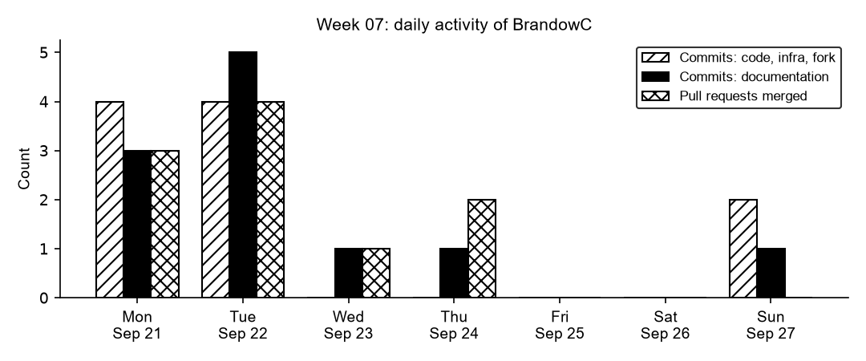
Figure 7.1. Daily commits and merged pull requests authored by BrandowC in week 07, counted from git history of the code, documentation, infrastructure and course-fork repositories.
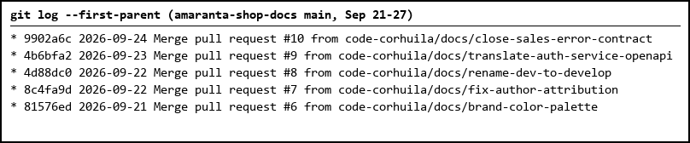
Figure 7.2. Pull requests #6 to #10 merged into main of the documentation repository during the week.
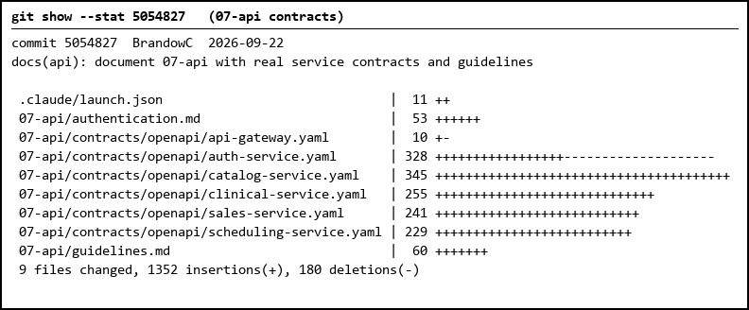
Figure 7.3. The six OpenAPI contracts plus API guidelines and authentication notes added to 07-api.
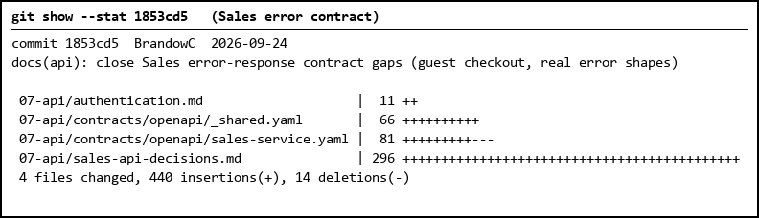
Figure 7.4. Closing of the Sales error-response contract: shared error schema, Sales OpenAPI and a decisions document.
Table 1. Commits authored in the week
Date | Repository | SHA | Message
2026-09-21 | amaranta | 84439b6 | chore(governance): add CODEOWNERS for develop (message mangled by a shell here-doc)
2026-09-21 | amaranta | 9a8d022 | chore(governance): add CODEOWNERS for develop
2026-09-21 | amaranta | b098168 | chore(governance): add CODEOWNERS for develop (cherry-pick)
2026-09-21 | amaranta | d071adb | feat(web): add staff screens for admin, reception, clinic and appointments (cherry-pick)
2026-09-21 | amaranta-shop-docs | 2e64049 | docs: correct author attribution to Brandow Claros
2026-09-21 | amaranta-shop-docs | 74ffccd | docs: correct author attribution to Brandow Claros
2026-09-21 | amaranta-shop-docs | 7daf944 | docs(architecture): add ADR-007 for the Fiery Ocean brand palette
2026-09-22 | amaranta | 5249937 | feat(db): add clinical and scheduling schemas
2026-09-22 | amaranta | 6b615be | docs: update project documentation
2026-09-22 | amaranta | f32f4db | docs: update project documentation (cherry-pick)
2026-09-22 | amaranta | fb784e3 | feat(db): add clinical and scheduling schemas (cherry-pick)
2026-09-22 | amaranta-shop-docs | 5054827 | docs(api): document 07-api with real service contracts and guidelines
2026-09-22 | amaranta-shop-docs | 6a35114 | chore: remove .claude/ from version control
2026-09-22 | amaranta-shop-docs | ad42a41 | docs(governance): rename dev to develop per branching-policy.md
2026-09-22 | amaranta-shop-docs | ee88276 | docs(api): translate OpenAPI contracts to English
2026-09-24 | amaranta-shop-docs | 1853cd5 | docs(api): close Sales error-response contract gaps (guest checkout, real error shapes)
2026-09-27 | amaranta | 1eed7f3 | feat(identity): sign JWT with RS256 per course norm (ADR-009) (cherry-pick)
2026-09-27 | amaranta | 524a088 | feat(identity): sign JWT with RS256 per course norm (ADR-009)
2026-09-27 | amaranta-shop-docs | c2699a5 | docs(architecture): switch JWT signing to RS256 per course norm (ADR-009)

Table 2. Pull requests and merges
Date | Repository | PR | Branch
2026-09-21 | amaranta | #4 | chore/add-codeowners-develop
2026-09-21 | amaranta | #5 | qa-promote/add-codeowners
2026-09-21 | amaranta-shop-docs | #6 | docs/brand-color-palette
2026-09-22 | amaranta | #3 | feat/clinical-scheduling-staff-ops
2026-09-22 | amaranta | #7 | docs/update-project-documentation
2026-09-22 | amaranta-shop-docs | #7 | docs/fix-author-attribution
2026-09-22 | amaranta-shop-docs | #8 | docs/rename-dev-to-develop
2026-09-23 | amaranta-shop-docs | #9 | docs/translate-auth-service-openapi
2026-09-24 | amaranta-shop-docs | #10 | docs/close-sales-error-contract
2026-09-24 | course fork | sync | merge: sync upstream instructor material (week 08 API contract spec)

5. Individual contribution
Docs (`amaranta-shop-docs`) - 5 PRs merged to main
- Documented `07-api` with the real contracts of Auth, Catalog, Sales, Clinical, Scheduling and the gateway, plus API guidelines and authentication notes (commit 5054827); translated the OpenAPI files to English (ee88276; PR https://github.com/code-corhuila/amaranta-shop-docs/pull/9).
- Closed the Sales error-response contract with a decisions document (1853cd5; PR https://github.com/code-corhuila/amaranta-shop-docs/pull/10).
- Added ADR-007 (Fiery Ocean brand palette, 7daf944; PR https://github.com/code-corhuila/amaranta-shop-docs/pull/6), corrected author attribution across ADRs (74ffccd, 2e64049; PR https://github.com/code-corhuila/amaranta-shop-docs/pull/7) and renamed `dev` to `develop` in the Git conventions (ad42a41; PR https://github.com/code-corhuila/amaranta-shop-docs/pull/8).
- Wrote ADR-008 (JWT signing and token lifecycle) and ADR-009 (RS256 per course norm) and updated `authentication.md` and the auth OpenAPI (c2699a5, Sep 27).
Code (`amaranta` repo) - PRs into develop
- Added the clinical and scheduling schemas (5249937; PR https://github.com/BrandowC/amaranta/pull/3) and updated the project documentation with the domain flow diagram and the extraction plan for clinical/scheduling (6b615be; PR https://github.com/BrandowC/amaranta/pull/7).
- Opened and merged CODEOWNERS PRs for `develop`, `qa` promotion and the qa promotion (PRs https://github.com/BrandowC/amaranta/pull/4, https://github.com/BrandowC/amaranta/pull/5).
- Implemented RS256 signing in Identity: RSA key pair, algorithm pinned to RS256 on sign and verify, `scripts/dev-keys.sh`, keys ignored by git (524a088, Sep 27). Review/merge happens next week.
6. Blockers and risks
- ADR-009 exists because the MVP signed JWTs with HS256, which the course norm forbids; this was found late and cost a re-work of Identity.
- The Catalog contract needed a second pass (gap analysis) because the first version described endpoints the monolith did not expose.
- The RS256 PR is waiting for review by the code owner, so HU-IAM-002 is not done yet.
7. Plan for next week
- Get the RS256 PRs (docs and code) reviewed and merged.
- Prepare the MVP 2 extraction decisions: engine per domain, identity design with revocation, stack of the extracted services.
- Write a spec for the Sales checkout before touching the code.
8. Evidence links
- API contracts commit: https://github.com/code-corhuila/amaranta-shop-docs/commit/5054827
- Sales contract gaps PR: https://github.com/code-corhuila/amaranta-shop-docs/pull/10
- ADR-009 commit (RS256): https://github.com/code-corhuila/amaranta-shop-docs/commit/c2699a5
- RS256 code commit: https://github.com/BrandowC/amaranta/commit/524a088
- Schemas PR: https://github.com/BrandowC/amaranta/pull/3
- Docs PRs merged: https://github.com/code-corhuila/amaranta-shop-docs/pull/6, https://github.com/code-corhuila/amaranta-shop-docs/pull/7, https://github.com/code-corhuila/amaranta-shop-docs/pull/8, https://github.com/code-corhuila/amaranta-shop-docs/pull/9, https://github.com/code-corhuila/amaranta-shop-docs/pull/10
- Code PRs merged: https://github.com/BrandowC/amaranta/pull/3, https://github.com/BrandowC/amaranta/pull/4, https://github.com/BrandowC/amaranta/pull/5, https://github.com/BrandowC/amaranta/pull/7
- Code repo: https://github.com/BrandowC/amaranta
- Docs repo: https://github.com/code-corhuila/amaranta-shop-docs
- Profile repo (CONFIG): https://github.com/BrandowC/BrandowC

