Weekly Status - Week 08
Distributed Systems 2026-B - Group 2 - Amaranta
Sprint window: Sep 28 - Oct 4, 2026
Field | Value
FULL_NAME | Brandow Stivent Claros Polania
GITHUB_USER | BrandowC
TEAM | amaranta
SPRINT_GOAL | Close the RS256 migration: get the docs PR (ADR-008/009) and the code PR (Identity signing) reviewed and merged, so the project complies with the course security norm.

1. Context of the week
Week 08 (Sep 28 - Oct 4, 2026) closed the RS256 migration. The work had been written in week 07, so this week is about review, merge and verification, and it contains no new feature commits authored in the window.
The delivery follows the per-environment flow: the change travels as a short branch with a pull request, and the documentation and the code are merged independently after review by the code owner.
2. What was done
Merged pull requests. PR #12 of the documentation repository (ADR-008 and ADR-009 plus the updated authentication contract and auth OpenAPI) was merged into main on Oct 1. PR #8 of the code repository (Identity signing with RS256) was merged into develop on Oct 1 after code-owner review.
What the change does. Identity signs and verifies JWTs with an RSA key pair. The algorithm is pinned to RS256 on both sides, any token declaring another algorithm is rejected, the environment variables JWT_PRIVATE_KEY and JWT_PUBLIC_KEY replace the shared secret, docker-compose requires both, and scripts/dev-keys.sh generates a development key pair that stays out of version control.
Secrets handling. The generated keys and the .env files remain git-ignored, and configuration travels only through environment variables.
3. User stories worked this week
HU ID | Title | Status | Evidence
HU-IAM-002 | Login - JWT signed with RS256 (ADR-009) | done | https://github.com/BrandowC/amaranta/pull/8
HU-IAM-001 | Customer self-registration - regression check after the key change | done | https://github.com/BrandowC/amaranta/pull/8
HU-CAT-002 | Admin manages the catalog - reservation/cutover planning for MVP 2 | todo | No commit yet; started in week 09

4. Supporting evidence
The figures below are generated from the real git history and from the project artefacts. The tables list every commit and pull request authored by BrandowC in the week.
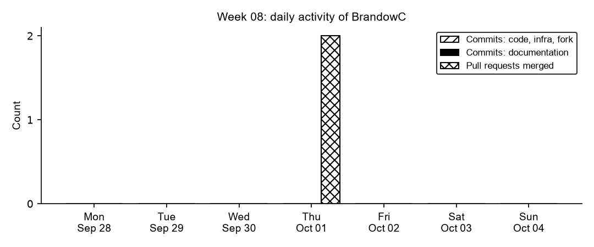
Figure 8.1. Daily commits and merged pull requests authored by BrandowC in week 08, counted from git history of the code, documentation, infrastructure and course-fork repositories.
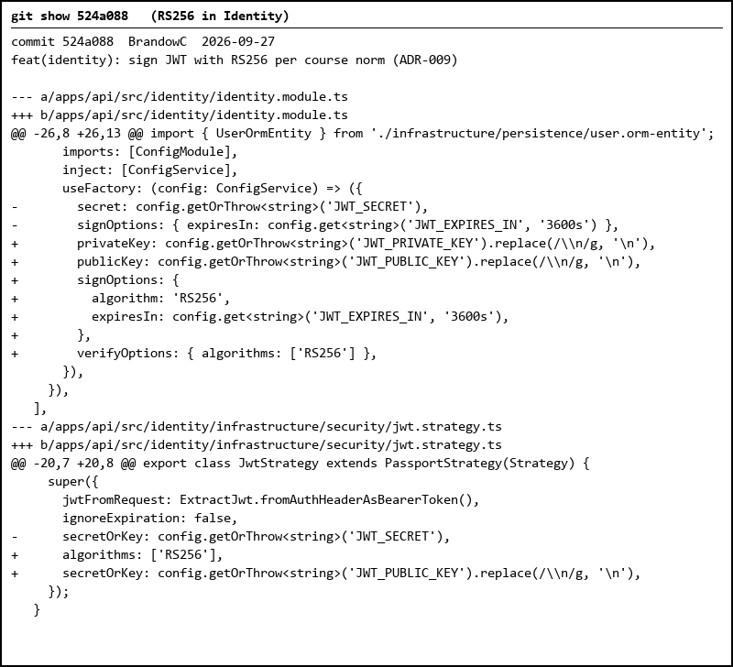
Figure 8.2. Code that was reviewed and merged this week: JWT signing and verification pinned to RS256 with an RSA key pair.
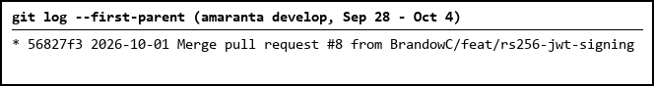
Figure 8.3. PR #8 merged into develop on Oct 1.
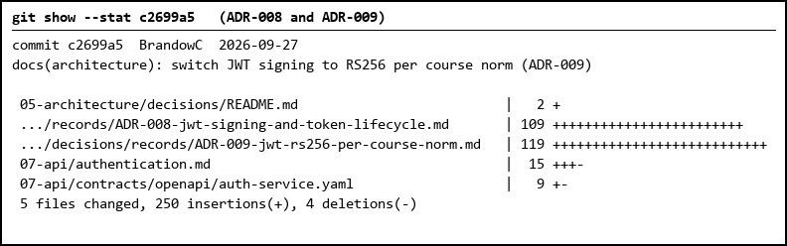
Figure 8.4. Documentation side of the change: ADR-008, ADR-009 and the updated authentication contract, merged through PR #12.
Table 2. Pull requests and merges
Date | Repository | PR | Branch
2026-10-01 | amaranta | #8 | feat/rs256-jwt-signing
2026-10-01 | amaranta-shop-docs | #12 | docs/adr-009-rs256-jwt

5. Individual contribution
Delivery
- Merged the docs PR for ADR-008/009 into `main` (PR https://github.com/code-corhuila/amaranta-shop-docs/pull/12, Oct 1) and the Identity RS256 PR into `develop` (PR https://github.com/BrandowC/amaranta/pull/8, Oct 1, after code-owner review).
- Kept the RSA keys generated by `scripts/dev-keys.sh` out of git (config via environment variables, no secrets committed).
Honest status
- This was a low-commit week: the work was authored in week 07 (Sep 27) and closed here by review and merge. No new feature commits are dated in this window.
6. Blockers and risks
- Review latency: the RS256 PRs waited about four days for the code owner, which pushed the HU close to the next week.
- The MVP 2 direction (which services to extract first, and with which engine) is not decided yet.
7. Plan for next week
- Write ADRs 010-013 (engine per domain, identity with revocation, stack of extracted services, monolith first).
- Write the Sales checkout spec with its extraction path.
- Harden stock reservation in Catalog and compensation in Sales checkout.
8. Evidence links
- Docs PR (ADR-008/009): https://github.com/code-corhuila/amaranta-shop-docs/pull/12
- Code PR (RS256): https://github.com/BrandowC/amaranta/pull/8
- Code repo: https://github.com/BrandowC/amaranta
- Docs repo: https://github.com/code-corhuila/amaranta-shop-docs
- Profile repo (CONFIG): https://github.com/BrandowC/BrandowC

