Weekly Status - Week 09
Distributed Systems 2026-B - Group 2 - Amaranta
Sprint window: Oct 5 - Oct 11, 2026 (current week, report as of Oct 9)
Field | Value
FULL_NAME | Brandow Stivent Claros Polania
GITHUB_USER | BrandowC
TEAM | amaranta
SPRINT_GOAL | Prepare the MVP 2 extraction and its platform: record ADR-010..013 and the Sales checkout spec, harden the monolith (atomic stock reservation, idempotent release, checkout compensation, scheduling slots, public pet history, web screens) and bring up the infrastructure repositories (PostgreSQL, MongoDB, observability, security base).

1. Context of the week
Week 09 (Oct 5 - Oct 11, 2026) prepared the MVP 2 step: extracting services from the monolith without breaking it. The goal had three parts: record the architecture decisions and a written spec for the first extraction (Sales checkout), harden the monolith so that the extraction can happen on a safe baseline, and bring up the platform repositories (PostgreSQL, MongoDB, observability and the security base).
The work followed the course norm: every change on a short branch with one purpose, conventional commits, documentation committed before the code it governs, and one branch per user story for the code.
2. What was done
Decisions and spec (documentation repository). ADR-010 (database engine per domain: Sales on PostgreSQL, Catalog on MongoDB), ADR-011 (identity design with token revocation), ADR-012 (stack of the extracted services) and ADR-013 (monolith first, strangler fig) were written, together with specs/checkout.md, a 411-line single-capability spec with stories, fifteen business rules traced to tests, the contract changes of the extraction, the cutover and an executable Definition of Done. The Sales API decisions also record the checkout stock compensation. The branches were pushed on Oct 7; the pull requests of the checkout spec (#14), ADR-012/013 (#16) and the housekeeping branch (#17) were merged into main on Oct 12, after the week closed, and the ADR-010/011 branch is still waiting for review.
Monolith hardening (one branch per story). Catalog: stock reservation became a conditional UPDATE (stock >= quantity), so two concurrent reservations cannot take the last unit; release is an idempotent compensating increment; product deletion and image upload were added, with a concurrency spec (32862eb, fd757e1). Sales: checkout releases the reservation whenever the order is rejected or cannot be persisted (bdd83bd). Scheduling: availability honours business hours and conflicts and exposes available slots (94559a3). Clinical: public pet history, pets directory and symptoms on medical records (d26b05f). Web: reception, clinic and public pet screens with a QR code and the appointment slot picker (cffbbf4). The five branches were pushed on Oct 8 and merged into develop through pull requests #14 (HU-CAT-002), #11 (HU-SALES-001), #10 (HU-SCHED-001), #12 (HU-CLIN-001) and #15 (HU-WEB-001) on Oct 9 after code-owner review.
Repository hygiene. Local keys, tsbuildinfo and tooling files were git-ignored. The change went into develop through PR #13 and was promoted to qa with git cherry-pick -x (de414d0, PR #16), which leaves the verifiable promotion trace the norm requires.
Platform repositories. amaranta-shop-infra-postgres received the pull request template and board tracking, one PostgreSQL 16 instance with an idempotent bootstrap, one login user per domain, one environment file per environment and the Annex J privilege self-check, tested in CI by running the bootstrap twice, and an OpenTelemetry collector with Prometheus and Grafana. amaranta-shop-infra-mongo received the same template and one MongoDB 7.0 instance with one database and one restricted user per domain, with CI proving that the user cannot write outside its database. amaranta-shop-security received the minimum content of a code repository and the README that records the ADR-011 token design (lifetimes, rotating refresh token, revocation). Eight pull requests were merged into develop on Oct 9.
Quality of the audit trail. Two CI details were fixed so that the secret-scanning audit of the norm has no false positives: fixed throwaway passwords were replaced by random per-run values and a bootstrap variable was renamed.
3. User stories worked this week
HU ID | Title | Status | Evidence
HU-CAT-002 | Atomic stock reservation, idempotent release and product deletion (admin catalog) | done | https://github.com/BrandowC/amaranta/pull/14
HU-SALES-001 | Checkout compensates reserved stock when the order fails | done | https://github.com/BrandowC/amaranta/pull/11
HU-SCHED-001 | Validate business hours and expose available slots | done | https://github.com/BrandowC/amaranta/pull/10
HU-CLIN-001 | Public pet medical history, pets directory and symptoms | done | https://github.com/BrandowC/amaranta/pull/12
HU-WEB-001 | Reception, clinic and public pet screens with slot picker | done | https://github.com/BrandowC/amaranta/pull/15
N/A (infra) | amaranta-shop-infra-postgres: single PostgreSQL instance, observability stack and PR/board tracking | done | https://github.com/code-corhuila/amaranta-shop-infra-postgres/pull/2 , /pull/3 , /pull/1
N/A (infra) | amaranta-shop-infra-mongo: single MongoDB instance with one user per domain | done | https://github.com/code-corhuila/amaranta-shop-infra-mongo/pull/2 , /pull/1
N/A (infra) | amaranta-shop-security: service base and design record (ADR-011) | done | https://github.com/code-corhuila/amaranta-shop-security/pull/2 , /pull/1

4. Supporting evidence
The figures below are generated from the real git history and from the project artefacts. The tables list every commit and pull request authored by BrandowC in the week.
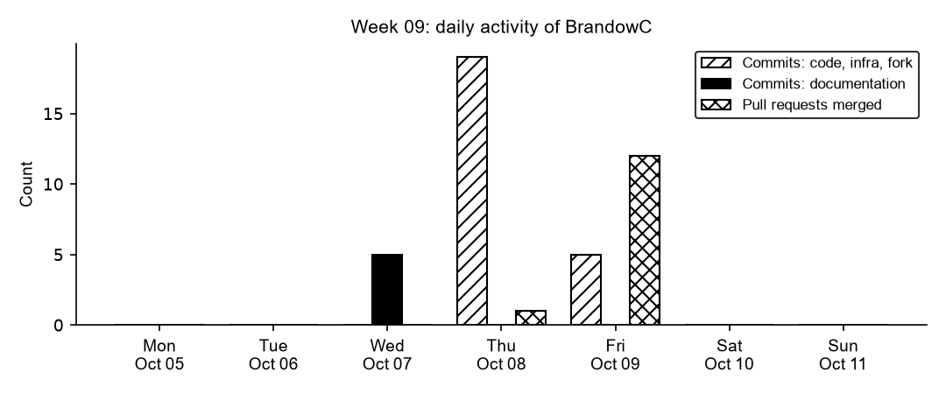
Figure 9.1. Daily commits and merged pull requests authored by BrandowC in week 09, counted from git history of the code, documentation, infrastructure and course-fork repositories.
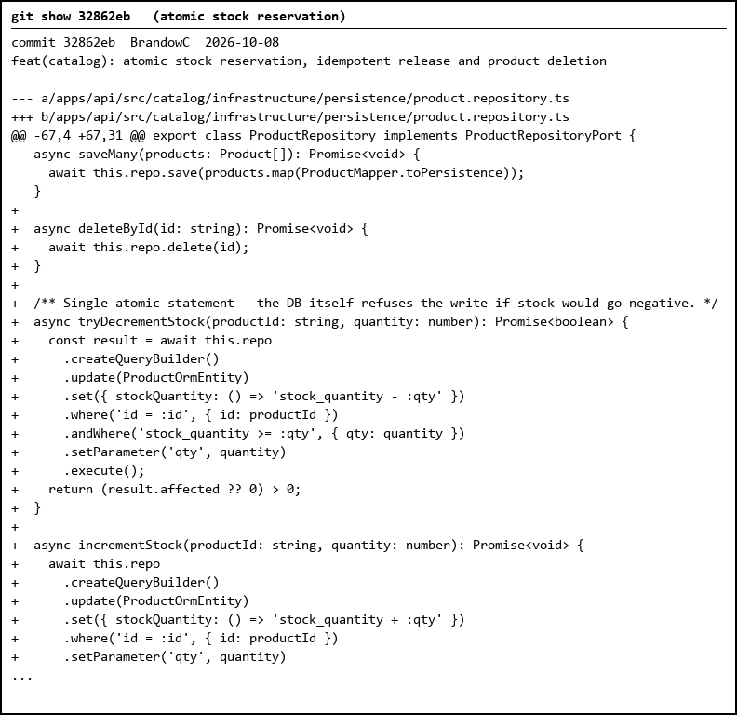
Figure 9.2. Atomic reservation: a conditional UPDATE (stock >= quantity) replaces read-then-write, so two concurrent reservations cannot take the last unit.
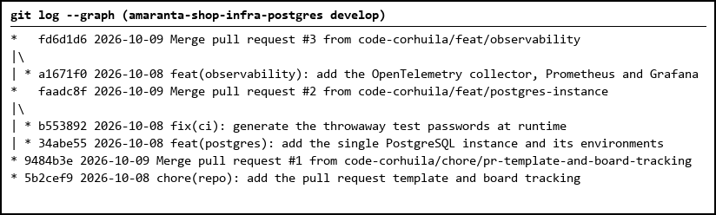
Figure 9.3. Infrastructure repository: PR template, PostgreSQL instance and observability stack merged into develop through PRs #1 to #3.
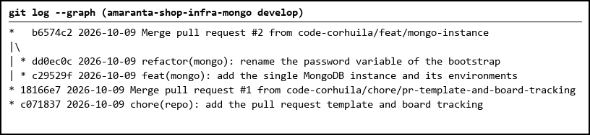
Figure 9.4. MongoDB repository: PR template and single MongoDB instance with one restricted user per domain.
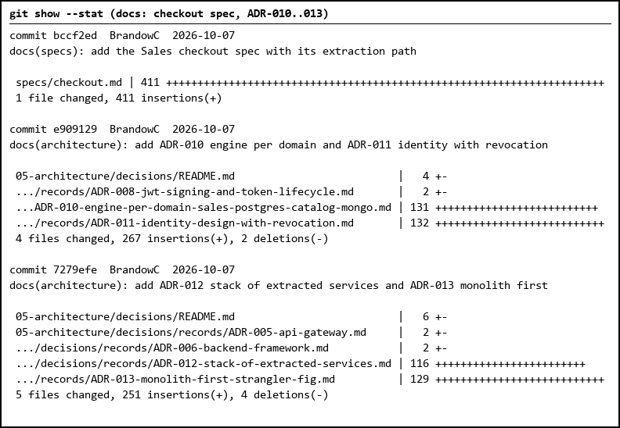
Figure 9.5. Documentation commits of the week: Sales checkout spec (411 lines) and ADR-010 to ADR-013.
Table 1. Commits authored in the week
Date | Repository | SHA | Message
2026-10-07 | amaranta-shop-docs | 6f6990a | docs(api): record the checkout stock compensation in the Sales decisions
2026-10-07 | amaranta-shop-docs | 7279efe | docs(architecture): add ADR-012 stack of extracted services and ADR-013 monolith first
2026-10-07 | amaranta-shop-docs | bccf2ed | docs(specs): add the Sales checkout spec with its extraction path
2026-10-07 | amaranta-shop-docs | ded0bbc | docs: link the code repo and the spec, fix stale amaranta-shop-mvp names
2026-10-07 | amaranta-shop-docs | e909129 | docs(architecture): add ADR-010 engine per domain and ADR-011 identity with revocation
2026-10-08 | amaranta | 32862eb | feat(catalog): atomic stock reservation, idempotent release and product deletion
2026-10-08 | amaranta | 47d721b | chore(repo): ignore JWT keys, tsbuildinfo and .claude
2026-10-08 | amaranta | 5105ae1 | feat(clinical): public pet medical history, pets directory and symptoms (cherry-pick)
2026-10-08 | amaranta | 9279d1e | fix(sales): compensate reserved stock when checkout fails (cherry-pick)
2026-10-08 | amaranta | 94559a3 | feat(scheduling): validate business hours and expose available slots
2026-10-08 | amaranta | a6c5eec | feat(catalog): atomic stock reservation, idempotent release and product deletion (cherry-pick)
2026-10-08 | amaranta | bdd83bd | fix(sales): compensate reserved stock when checkout fails
2026-10-08 | amaranta | c5e983b | feat(web): reception, clinic and public pet screens with slot picker (cherry-pick)
2026-10-08 | amaranta | cfa95c2 | feat(scheduling): validate business hours and expose available slots (cherry-pick)
2026-10-08 | amaranta | cffbbf4 | feat(web): reception, clinic and public pet screens with slot picker
2026-10-08 | amaranta | d26b05f | feat(clinical): public pet medical history, pets directory and symptoms
2026-10-08 | amaranta | de414d0 | chore(repo): ignore JWT keys, tsbuildinfo and .claude (cherry-pick)
2026-10-08 | amaranta | f2143f3 | feat(catalog): wire release use case and add product image upload (cherry-pick)
2026-10-08 | amaranta | fc08910 | chore(repo): ignore JWT keys, tsbuildinfo and .claude (cherry-pick)
2026-10-08 | amaranta | fd757e1 | feat(catalog): wire release use case and add product image upload
2026-10-08 | amaranta-shop-infra-postgres | 34abe55 | feat(postgres): add the single PostgreSQL instance and its environments
2026-10-08 | amaranta-shop-infra-postgres | 5b2cef9 | chore(repo): add the pull request template and board tracking
2026-10-08 | amaranta-shop-infra-postgres | a1671f0 | feat(observability): add the OpenTelemetry collector, Prometheus and Grafana
2026-10-08 | amaranta-shop-infra-postgres | b553892 | fix(ci): generate the throwaway test passwords at runtime
2026-10-09 | amaranta-shop-infra-mongo | c071837 | chore(repo): add the pull request template and board tracking
2026-10-09 | amaranta-shop-infra-mongo | c29529f | feat(mongo): add the single MongoDB instance and its environments
2026-10-09 | amaranta-shop-infra-mongo | dd0ec0c | refactor(mongo): rename the password variable of the bootstrap
2026-10-09 | amaranta-shop-security | 461a6fe | chore(repo): add the pull request template and board tracking
2026-10-09 | amaranta-shop-security | 9bb9598 | feat(security): add the base of the service and record its design

Table 2. Pull requests and merges
Date | Repository | PR | Branch
2026-10-08 | amaranta | #13 | chore-gitignore-dev
2026-10-09 | amaranta | #10 | hu-sched-dev
2026-10-09 | amaranta | #11 | hu-sales-001-dev
2026-10-09 | amaranta | #12 | hu-clin-dev
2026-10-09 | amaranta | #15 | hu-web-dev
2026-10-09 | amaranta | #16 | chore-gitignore-qa
2026-10-09 | amaranta-shop-infra-mongo | #1 | chore/pr-template-and-board-tracking
2026-10-09 | amaranta-shop-infra-mongo | #2 | feat/mongo-instance
2026-10-09 | amaranta-shop-infra-postgres | #1 | chore/pr-template-and-board-tracking
2026-10-09 | amaranta-shop-infra-postgres | #2 | feat/postgres-instance
2026-10-09 | amaranta-shop-infra-postgres | #3 | feat/observability
2026-10-09 | amaranta-shop-security | #1 | chore/pr-template-and-board-tracking
2026-10-09 | amaranta-shop-security | #2 | feat/service-base

5. Individual contribution
Docs (`amaranta-shop-docs`) - 4 branches pushed
- ADR-010 (database engine per domain: Sales on PostgreSQL, Catalog on MongoDB) and ADR-011 (identity design with token revocation) - commit https://github.com/code-corhuila/amaranta-shop-docs/commit/e909129.
- ADR-012 (stack of extracted services) and ADR-013 (monolith first, strangler fig) - commit https://github.com/code-corhuila/amaranta-shop-docs/commit/7279efe.
- `specs/checkout.md`: single-capability Sales checkout spec with stories, 15 business rules traced to tests, contract changes of the extraction, cutover and an executable definition of done - commit https://github.com/code-corhuila/amaranta-shop-docs/commit/bccf2ed.
- Recorded the checkout stock compensation in the Sales API decisions (6f6990a) and linked the code repo and the spec from the README, fixing stale repo names (ded0bbc).
Code (`amaranta` repo) - one branch per HU, pushed on Oct 8 and merged into develop on Oct 9
- Catalog: reserve now uses a conditional UPDATE (stock >= qty) so two concurrent reservations cannot take the last unit; release is an idempotent compensating increment; added product deletion, image upload and a concurrency spec (32862eb, fd757e1; branch `hu-cat-002-dev`).
- Sales: checkout releases the reservation when the aggregate rejects the order or persisting fails; added shop-hours and walk-in customer value objects (bdd83bd; branch `hu-sales-001-dev`).
- Scheduling: availability respects business hours and conflicts through the repository port; new get-available-slots use case (94559a3; branch `hu-sched-dev`).
- Clinical: public pet history with an optional JWT guard, pets directory and symptoms on medical records, migration V010 (d26b05f; branch `hu-clin-dev`).
- Web: reception, clinic and public pet screens with QR code and the appointment slot picker (cffbbf4; branch `hu-web-dev`).
- Pull requests: https://github.com/BrandowC/amaranta/pull/14 (HU-CAT-002), https://github.com/BrandowC/amaranta/pull/11 (HU-SALES-001), https://github.com/BrandowC/amaranta/pull/10 (HU-SCHED-001), https://github.com/BrandowC/amaranta/pull/12 (HU-CLIN-001) and https://github.com/BrandowC/amaranta/pull/15 (HU-WEB-001) were merged into `develop` on Oct 9 after code-owner review.
- Repo hygiene: ignored JWT keys, tsbuildinfo and local tooling files; merged into `develop` through PR https://github.com/BrandowC/amaranta/pull/13 (47d721b) and promoted to `qa` with `git cherry-pick -x` (de414d0, branch `chore-gitignore-qa`, merged into `qa` through PR #16 on Oct 9).
Infrastructure and security repositories (`code-corhuila` organisation) - 9 commits, 8 PRs merged into develop
- `amaranta-shop-infra-postgres`: PR template and board tracking so every PR cites its user story (5b2cef9, PR #1); one PostgreSQL 16 instance with an idempotent bootstrap, one login user per domain, one environment file per environment and the Annex J privilege self-check, tested in CI by running the bootstrap twice (34abe55, b553892, PR #2); OpenTelemetry collector, Prometheus and Grafana (a1671f0, PR #3).
- `amaranta-shop-infra-mongo`: the same PR template and board tracking (c071837, PR #1); one MongoDB 7.0 instance with one database and one user per domain restricted to its own database, with CI proving the user cannot write outside it (c29529f, dd0ec0c, PR #2).
- `amaranta-shop-security`: PR template (461a6fe, PR #1) and the minimum content of a code repository plus the README that records the token design of ADR-011: lifetimes, rotating refresh token and revocation (9bb9598, PR #2). The implementation is explicitly pending its own spec.
- CI fix: replaced fixed throwaway passwords with random per-run values and renamed a bootstrap variable, so the secret-scanning audit of the norm has no false positives (b553892, dd0ec0c).
6. Blockers and risks
- The five HU branches are in `develop`, but they are not promoted to `qa` and `main` yet; promotion has to be done by `git cherry-pick -x` through `qa/...` and `release/...` branches, with the `qa` branch name conflict still open with the teacher.
- The docs PRs of the checkout spec (#14), ADR-012/013 (#16) and housekeeping (#17) were merged into `main` on Oct 12, after the week closed; the ADR-010/011 branch is still pending review.
- The infrastructure and security repositories were merged into `develop` only; `main` of those repositories is still the empty scaffold until the release PR.
- The Catalog engine decision (MongoDB, ADR-010) is a course requirement but is not implemented yet; the Catalog read service of the monolith still uses PostgreSQL.
- Commit `84439b6` of week 07 has a malformed message (a shell here-doc was committed as the subject); history cannot be rewritten under the norm, so it is justified here.
7. Plan for next week
- Promote the five HUs merged into `develop` to `qa` and then to `main` through `qa/...` and `release/...` branches with `git cherry-pick -x`.
- Get the ADR-010/011 branch of the docs repo reviewed and merged.
- Start the extracted Sales service following `specs/checkout.md`, using the PostgreSQL instance of `amaranta-shop-infra-postgres`.
- Cut the first release (`release/1.0.0`) with the five elements required by norm 11.3 and publish the version tag after teacher approval.
8. Evidence links
- ADR-010/011: https://github.com/code-corhuila/amaranta-shop-docs/commit/e909129
- ADR-012/013: https://github.com/code-corhuila/amaranta-shop-docs/commit/7279efe
- Checkout spec: https://github.com/code-corhuila/amaranta-shop-docs/commit/bccf2ed
- Sales API decisions update: https://github.com/code-corhuila/amaranta-shop-docs/commit/6f6990a
- Housekeeping: https://github.com/code-corhuila/amaranta-shop-docs/commit/ded0bbc
- Catalog reservation: https://github.com/BrandowC/amaranta/commit/32862eb and https://github.com/BrandowC/amaranta/commit/fd757e1
- Checkout compensation: https://github.com/BrandowC/amaranta/commit/bdd83bd
- Scheduling slots: https://github.com/BrandowC/amaranta/commit/94559a3
- Clinical public history: https://github.com/BrandowC/amaranta/commit/d26b05f
- Web screens: https://github.com/BrandowC/amaranta/commit/cffbbf4
- HU PRs merged into develop: https://github.com/BrandowC/amaranta/pull/14 , https://github.com/BrandowC/amaranta/pull/11 , https://github.com/BrandowC/amaranta/pull/10 , https://github.com/BrandowC/amaranta/pull/12 , https://github.com/BrandowC/amaranta/pull/15
- Gitignore PRs: https://github.com/BrandowC/amaranta/pull/13 (develop) , https://github.com/BrandowC/amaranta/pull/16 (qa)
- Docs PRs merged on Oct 12: https://github.com/code-corhuila/amaranta-shop-docs/pull/14 , https://github.com/code-corhuila/amaranta-shop-docs/pull/16 , https://github.com/code-corhuila/amaranta-shop-docs/pull/17
- Infra PostgreSQL PRs: https://github.com/code-corhuila/amaranta-shop-infra-postgres/pull/1 , /pull/2 , /pull/3
- Infra MongoDB PRs: https://github.com/code-corhuila/amaranta-shop-infra-mongo/pull/1 , /pull/2
- Security PRs: https://github.com/code-corhuila/amaranta-shop-security/pull/1 , /pull/2
- Full list of commits and PRs per week: ./commits-week-09.md (in this folder)
- Code repo: https://github.com/BrandowC/amaranta
- Docs repo: https://github.com/code-corhuila/amaranta-shop-docs
- Profile repo (CONFIG): https://github.com/BrandowC/BrandowC

