Weekly Status - Week 10
Distributed Systems 2026-B - Group 2 - Amaranta
Sprint window: Oct 12 - Oct 18, 2026 (in progress, report as of Oct 13)

Field | Value
FULL_NAME | Brandow Stivent Claros Polania
GITHUB_USER | BrandowC
TEAM | amaranta
SPRINT_GOAL | Start the MVP 2 extraction on the new service repositories: merge the week 09 decisions into main, build and merge the Sales and Catalog database repositories, implement the Sales API against its spec, and open the MVP 2 release flow (qa, release branch, main) in the monolith repository.

1. Context of the week
Week 10 is the first week of the MVP 2 extraction. Week 09 left the monolith hardened and the decisions written: the database engine per domain (ADR-010), identity with revocation (ADR-011), the stack of the extracted services (ADR-012: Java for Sales, Python for Catalog, nginx as gateway) and the monolith-first strategy (ADR-013), plus the Sales checkout spec. On Oct 10 the teacher created ten repositories for the target topology.
This report is written on Oct 13 and describes what has been done in the first two days. On that day the decisions were merged into main, both databases were built and merged into develop, the Sales API was implemented locally against its spec, and the release flow of MVP 2 was opened in the monolith repository. The report will be updated at the end of the week.
2. What was done
Documentation (`amaranta-shop-docs`)
- Merged into main the pull requests of the Sales checkout spec (#14), ADR-012/013 (#16) and the housekeeping branch (#17) on Oct 12. The commits were written in week 09 (bccf2ed, 7279efe, ded0bbc, 6f6990a); merging them puts the decisions (Java for Sales, Python for Catalog, nginx gateway, monolith first) on main, where the service repositories can cite them.
- Replaced the placeholder authors of ADR-001 (commit 86da83f, branch docs/fix-adr-001-authors).
Sales database (`amaranta-shop-sales-db`) - 3 PRs merged into develop
- feat/sales-schema (PR #1): Flyway runner reading DDL, DML, DCL and TCL as one version sequence (a537c8f), the sales schema with orders and order_items as the monolith created them (82b7448), a rebuild check that runs on every pull request (3e99fda) and the README (a24c0f2).
- feat/sales-idempotency-key (PR #2): sales.idempotency_key with an 8-128 character primary key and a foreign key to the order (RN-15), and the "my orders, newest first" index built CONCURRENTLY in its own migration (490b3a3), with a test and documentation (a4cb46c, f0b53b3).
- feat/sales-roles-and-grants (PR #3): sales_reader and sales_writer NOLOGIN roles, table-by-table grants (c544749), a test that logs in as the service user and checks every permission that must and must not exist (2c36d4c) and documentation (d52a60d).
Catalog database (`amaranta-shop-catalog-db`) - 3 PRs merged into develop
- chore/catalog-rebuild-check (PR #1): Liquibase runner and the layout of the three families (bc1030c), the product collection with its validator and indexes (feb6b8f), a rebuild of the collections from empty on every pull request (74fa0bb) and documentation (2a6b2b5).
- feat/catalog-seed-products (PR #2): seed of the ten products under the ids the monolith issued (5de4c92), with a test that proves the seed leaves ten products and never resets a live stock (4e5c175) and documentation of the cutover caveat (24fdab9).
- feat/catalog-roles (PR #3): catalog roles and the grant to catalog_app (cc880c9), a test that logs in as the service user (a39f2c8) and documentation (3c2eed1).
Sales API (`amaranta-shop-sales-api`) - 29 commits on 21 local one-task branches, not pushed yet
- Build and deploy: three Maven modules (core without Spring, adapters, app), composition root, container image, compose file and CI build (d23ffe2, aff79f5, ffb335a).
- Domain and application, test-first with a table that maps each rule of specs/checkout.md to the test that proves it: Money in whole pesos, shop hours of Bogota, the Order aggregate, placing an order reserving stock only after the rules that cannot fail, giving the stock back when the order cannot be saved, marking an order as paid and listing my orders (74805cf ... 65c79bc).
- HTTP layer: RS256 verification in the service with a closed list of algorithms, authentication on every /api/ route with one declared guest exception, one error envelope with a correlation id, online order with or without an account, counter order for the receptionist only, mark as paid and list my orders (962d4a3 ... c2ce782).
- Persistence and integration: in-memory repository behind the same contract as the database, PostgreSQL repository connecting as sales_app, reserve and release through the internal endpoints of Catalog, wiring in the composition root and an end-to-end container test including the failure with Catalog down (e73a403, ab4d494, 3bf1664, 49440c3, 5d34163).
Monolith repository (`amaranta`) - MVP 2 release flow
- Opened and merged the qa sync (PR #19) and the release documents release.md and changelog for v2.0.0 (commit 09eb5ba, PR #20) into qa, then promoted qa and the CODEOWNERS alignment (4a825bc) into the release.2.0.0 branch (PRs #21 and #22). The release pull request into main (PR #23) is open and waits for teacher approval.
Ten service repositories - repository base
- Added the commit chore(repo): add the minimum content of a code repository to api-gateway, front, worker, workflow, catalog-db, catalog-api, catalog-portal, sales-db, sales-api and sales-portal (gitignore, environment example, PR template citing the user story, board-tracking workflow, CI that guards what does not depend on the language, README with role, dependencies and stack).
Decisions taken
- One version sequence per database repository, with the migration control table kept in the domain's own schema so that two database repositories never share it (Annex J, J.6); the compose file only runs the migrations because the instance lives in the infra repository.
- The tables and the seed keep the names and ids the monolith issued, so every migration is safe over the monolith's database and the Catalog seed never resets a live stock.
- The idempotency key is enforced by the database (primary key, length check, foreign key) so that the service writes the order and its key in one transaction and answers a retry with the order that already exists.
- Least privilege by construction: service users can only do what the spec allows (lines and keys insert-only, nothing deleted, migration history out of reach), and a test proves it by logging in as the service user.
- The Sales service verifies the RS256 token itself with a closed list of algorithms and keeps a single declared public exception (guest checkout), as ADR-009 and ADR-012 decided.
- Work is split into one branch per task, so every pull request stays small and cites a single concern.
3. User stories worked this week
HU ID | Title | Status | Evidence
N/A (docs) | Sales checkout spec, ADR-012/013 and housekeeping merged into main of the documentation repository | done | https://github.com/code-corhuila/amaranta-shop-docs/pull/14 , /pull/16 , /pull/17
HU-SALES-001 | Sales database: Flyway runner, sales schema, checkout tables, idempotency key, roles and grants, rebuild check on every PR | done | https://github.com/code-corhuila/amaranta-shop-sales-db/pull/1 , /pull/2 , /pull/3 (merged into develop)
HU-CAT-001 | Catalog database (MongoDB): Liquibase runner, product collection with validator and indexes, seed of the ten products, roles and grants | done | https://github.com/code-corhuila/amaranta-shop-catalog-db/pull/1 , /pull/2 , /pull/3 (merged into develop)
HU-SALES-001 | Sales API (Java 21): domain, application ports, HTTP layer with RS256 and error envelope, PostgreSQL and Catalog adapters, container image | doing | 29 commits d23ffe2 ... 4a3d20c on 21 local one-task branches of https://github.com/code-corhuila/amaranta-shop-sales-api (not pushed yet)
N/A (release) | MVP 2 release flow in the monolith repository: qa sync, release.md and changelog, release.2.0.0 branch | doing | https://github.com/BrandowC/amaranta/pull/19 , /pull/20 , /pull/21 , /pull/22 merged; /pull/23 (release.2.0.0 into main) open
N/A (repo base) | Minimum content of a code repository (norm 5.1) in the ten new service repositories | doing | 10 commits on branch chore/repo-base (pushed); PRs into develop pending

4. Supporting evidence
The figures are generated from the real git history of the repositories.
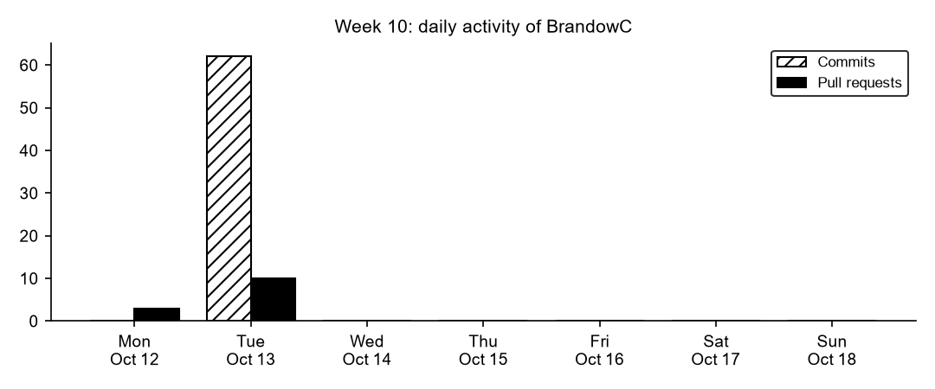
Figure 10.1. Daily commits and merged pull requests authored by BrandowC in week 10.
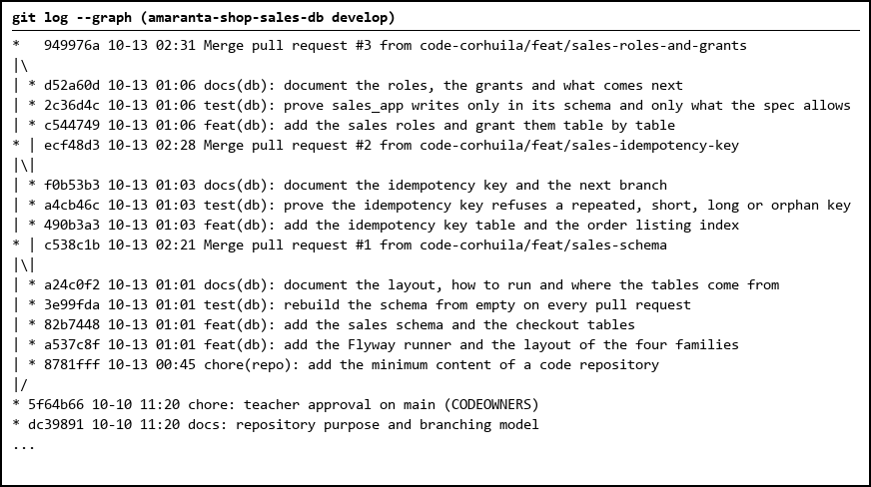
Figure 10.2. Sales database: three pull requests merged into develop.
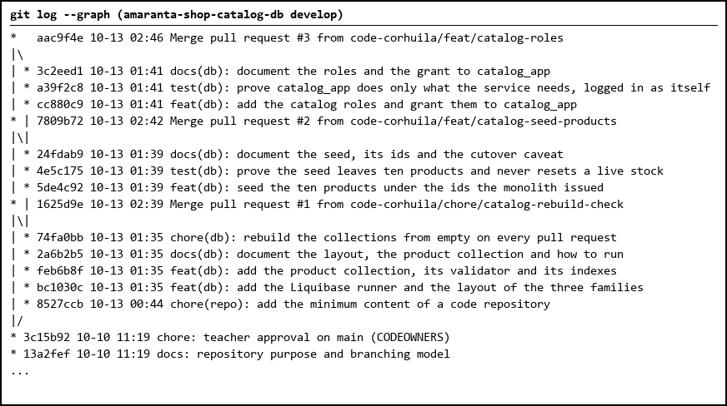
Figure 10.3. Catalog database: three pull requests merged into develop.
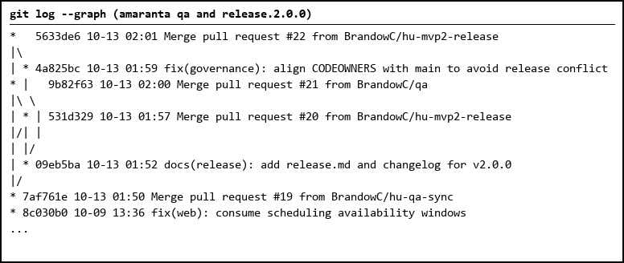
Figure 10.4. MVP 2 release flow in the monolith repository.
Table 1. Commits authored in the week (62)
Date | Repository | SHA | Message | State
2026-10-13 | amaranta | 4a825bc | fix(governance): align CODEOWNERS with main to avoid release con | pushed
2026-10-13 | amaranta | 09eb5ba | docs(release): add release.md and changelog for v2.0.0 | pushed
2026-10-13 | amaranta-shop-docs | 86da83f | docs(architecture): replace the placeholder authors of ADR-001 | pushed
2026-10-13 | api-gateway | 19a8739 | chore(repo): add the minimum content of a code repository | pushed
2026-10-13 | catalog-api | b9c66de | chore(repo): add the minimum content of a code repository | pushed
2026-10-13 | catalog-db | 3c2eed1 | docs(db): document the roles and the grant to catalog_app | pushed
2026-10-13 | catalog-db | a39f2c8 | test(db): prove catalog_app does only what the service needs, lo | pushed
2026-10-13 | catalog-db | cc880c9 | feat(db): add the catalog roles and grant them to catalog_app | pushed
2026-10-13 | catalog-db | 24fdab9 | docs(db): document the seed, its ids and the cutover caveat | pushed
2026-10-13 | catalog-db | 4e5c175 | test(db): prove the seed leaves ten products and never resets a | pushed
2026-10-13 | catalog-db | 5de4c92 | feat(db): seed the ten products under the ids the monolith issue | pushed
2026-10-13 | catalog-db | 74fa0bb | chore(db): rebuild the collections from empty on every pull requ | pushed
2026-10-13 | catalog-db | 2a6b2b5 | docs(db): document the layout, the product collection and how to | pushed
2026-10-13 | catalog-db | feb6b8f | feat(db): add the product collection, its validator and its inde | pushed
2026-10-13 | catalog-db | bc1030c | feat(db): add the Liquibase runner and the layout of the three f | pushed
2026-10-13 | catalog-db | 8527ccb | chore(repo): add the minimum content of a code repository | pushed
2026-10-13 | catalog-portal | db53aa2 | chore(repo): add the minimum content of a code repository | pushed
2026-10-13 | front | 4a2aa2b | chore(repo): add the minimum content of a code repository | pushed
2026-10-13 | sales-api | 4a3d20c | docs(api): document the contract, how to build and run with Dock | local
2026-10-13 | sales-api | 136d438 | chore(ci): run the database checks in CI when the organization l | local
2026-10-13 | sales-api | 5d34163 | test(app): prove the container end to end, including the failure | local
2026-10-13 | sales-api | 49440c3 | feat(app): wire the ports to their adapters in the composition r | local
2026-10-13 | sales-api | 3bf1664 | feat(catalog): reserve and release stock through the internal en | local
2026-10-13 | sales-api | ab4d494 | feat(persistence): store the orders in PostgreSQL as sales_app | local
2026-10-13 | sales-api | c2ce782 | feat(http): mark an order as paid and list my orders | local
2026-10-13 | sales-api | 5bf220b | feat(http): place an order at the counter, for the receptionist | local
2026-10-13 | sales-api | 3dbde9a | feat(http): place an online order, with or without an account | local
2026-10-13 | sales-api | 71fc7ab | feat(http): translate an order to the representation clients see | local
2026-10-13 | sales-api | e73a403 | feat(persistence): keep orders in memory behind the same contrac | local
2026-10-13 | sales-api | c566a0e | feat(http): authenticate every /api/ route, with one declared gu | local
2026-10-13 | sales-api | 962d4a3 | feat(http): verify RS256 tokens in the service with a closed lis | local
2026-10-13 | sales-api | 5860ca8 | feat(http): answer every error with one envelope, in one place, | local
2026-10-13 | sales-api | 5ef74b1 | docs(application): map the payment and listing criteria to their | local
2026-10-13 | sales-api | 65c79bc | feat(application): mark an order as paid and list my orders | local
2026-10-13 | sales-api | 6589d46 | docs(application): add the compensation and idempotency rules to | local
2026-10-13 | sales-api | b5c983e | feat(application): give the stock back when the order cannot be | local
2026-10-13 | sales-api | e120e4b | feat(application): place an order, reserving the stock only afte | local
2026-10-13 | sales-api | 6bf29e6 | feat(application): declare the ports of the checkout | local
2026-10-13 | sales-api | eaed26c | docs(domain): map every rule of the spec to the test that proves | local
2026-10-13 | sales-api | a4e0431 | feat(domain): let a pending order be paid, and nothing else chan | local
2026-10-13 | sales-api | 3131988 | feat(domain): add the Order aggregate that places an order | local
2026-10-13 | sales-api | d83a810 | feat(domain): add the shop hours of Bogota, the order line and t | local
2026-10-13 | sales-api | 74805cf | feat(domain): add Money in whole pesos and the typed domain erro | local
2026-10-13 | sales-api | 2826155 | docs(build): document the layout, the dependency rule and how to | local
2026-10-13 | sales-api | ffb335a | chore(deploy): add the container image, its compose file and the | local
2026-10-13 | sales-api | aff79f5 | chore(build): add the composition root, its limits and Maven in | local
2026-10-13 | sales-api | d23ffe2 | chore(build): add the three Maven modules of the service | local
2026-10-13 | sales-api | 92057f6 | chore(repo): add the minimum content of a code repository | pushed
2026-10-13 | sales-db | d52a60d | docs(db): document the roles, the grants and what comes next | pushed
2026-10-13 | sales-db | 2c36d4c | test(db): prove sales_app writes only in its schema and only wha | pushed
2026-10-13 | sales-db | c544749 | feat(db): add the sales roles and grant them table by table | pushed
2026-10-13 | sales-db | f0b53b3 | docs(db): document the idempotency key and the next branch | pushed
2026-10-13 | sales-db | a4cb46c | test(db): prove the idempotency key refuses a repeated, short, l | pushed
2026-10-13 | sales-db | 490b3a3 | feat(db): add the idempotency key table and the order listing in | pushed
2026-10-13 | sales-db | a24c0f2 | docs(db): document the layout, how to run and where the tables c | pushed
2026-10-13 | sales-db | 3e99fda | test(db): rebuild the schema from empty on every pull request | pushed
2026-10-13 | sales-db | 82b7448 | feat(db): add the sales schema and the checkout tables | pushed
2026-10-13 | sales-db | a537c8f | feat(db): add the Flyway runner and the layout of the four famil | pushed
2026-10-13 | sales-db | 8781fff | chore(repo): add the minimum content of a code repository | pushed
2026-10-13 | sales-portal | caece51 | chore(repo): add the minimum content of a code repository | pushed
2026-10-13 | worker | 0ce03f7 | chore(repo): add the minimum content of a code repository | pushed
2026-10-13 | workflow | 9e673ff | chore(repo): add the minimum content of a code repository | pushed

Table 2. Pull requests (13)
Date | Repository | PR | Branch | Target
2026-10-13 | amaranta | #19 | hu-qa-sync | qa
2026-10-13 | amaranta | #20 | hu-mvp2-release | qa
2026-10-13 | amaranta | #21 | qa | release.2.0.0
2026-10-13 | amaranta | #22 | hu-mvp2-release | release.2.0.0
2026-10-12 | amaranta-shop-docs | #14 | docs/checkout-spec | main
2026-10-12 | amaranta-shop-docs | #16 | docs/adr-012-013-stack-and-strangl | main
2026-10-12 | amaranta-shop-docs | #17 | docs/housekeeping-sales-and-links | main
2026-10-13 | catalog-db | #1 | chore/catalog-rebuild-check | develop
2026-10-13 | catalog-db | #2 | feat/catalog-seed-products | develop
2026-10-13 | catalog-db | #3 | feat/catalog-roles | develop
2026-10-13 | sales-db | #1 | feat/sales-schema | develop
2026-10-13 | sales-db | #2 | feat/sales-idempotency-key | develop
2026-10-13 | sales-db | #3 | feat/sales-roles-and-grants | develop

5. Blockers and risks
- The 29 commits of the Sales API are only on 21 local branches. They have to be pushed and merged in order before their links resolve and before the HU can be done.
- The release pull request into main (PR #23) needs teacher approval; the tag is created only after the merge (norm 11.5).
- The ten chore/repo-base branches are pushed but their pull requests into develop are not merged yet.
- The week is not over, so every status in this report is as of Oct 13.
6. Plan for next week
- Push the Sales API branches and open the pull requests in order, each citing its user story.
- Configure the nginx gateway route for Sales with its single public exception for guest checkout.
- Start the Catalog API in Python and the portals, following ADR-010 and ADR-012.
- Merge the ten repository-base pull requests and publish the version tag after teacher approval.
- Update this report at the end of the week with the real pull requests and results.
7. Evidence links
- Docs PRs merged on Oct 12: https://github.com/code-corhuila/amaranta-shop-docs/pull/14 , /pull/16 , /pull/17
- Sales database PRs: https://github.com/code-corhuila/amaranta-shop-sales-db/pull/1 , /pull/2 , /pull/3
- Catalog database PRs: https://github.com/code-corhuila/amaranta-shop-catalog-db/pull/1 , /pull/2 , /pull/3
- Monolith release flow PRs: https://github.com/BrandowC/amaranta/pull/19 , /pull/20 , /pull/21 , /pull/22 , /pull/23 (open)
- Sales API repository: https://github.com/code-corhuila/amaranta-shop-sales-api
- Full list of commits and PRs: ./commits-week-10.md (in this folder)
- Docs repo: https://github.com/code-corhuila/amaranta-shop-docs
- Profile repo (CONFIG): https://github.com/BrandowC/BrandowC

