RESOURCE MANAGEMENT GAME

*Purpose:*

This game is designed to measure the ability of the users to use their effective resources to their maximum potential. Users are provided with different scenarios to identify different types of targets. The ability of the users to identify and track different targets with the maximum utilisation of available resources under stipulated time is measured and it is tagged to a score. Each score is a reflection of user’s smart interactive thinking with the application.

*Game Rules:*

Here is a small representation of the game in as a screenshot.

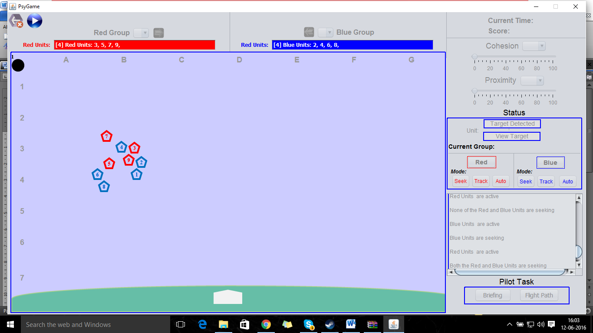

The Game is divided into two groups:

1. Red Group
2. Blue Group

The user has control over both the groups. Each group may contain a minimum of one search area to a maximum of ‘n’ search areas, where the limit ‘n’ is set by the administrator.

What is a Search Area?

It is defined by the area within which the units fly across. Each Search area may contain different units. From the fig above, we can see the red search area having 4 different units and the blue search area having 5 different units.

What is a Unit?

A Unit is responsible to detect a target. Each Unit has different characteristics.

Here are some of different characteristics for a unit.

Detection Range: It is defined by the area surrounding each unit within which it can detect a target.

Mobility: It is defined by maximum speed of the units to move inside a search area.

Reliability: It is measured by how far it can reach to detect a given target within a given detection range.

Units with 100% reliability, very fast mobility and large detection ranges can easily predict the targets. In usual scenarios, such units are not provided.

Number of search areas, units is defined by the administrator and the user has no control over both the elements. The user can toggle the units from one group to another.

The game is loaded with a standard set of search areas and units which are set by the administrator. The game provides different scenarios where each scenario may be different by the characteristic of number of search areas and the units which the user is provided with.

There are two different limits for the number of search areas.

1. Soft Limit: The maximum number of search areas set by the administrator.
2. Hard Limit: The user can choose to exceed the number of search areas set by the administrator, but he/she has to spend his available resources to buy subsequent search areas.

In most cases, the hard limit and the soft limit will be the same. More the number of search areas, more will be the probability of target detection which is directly proportional to increase the score.

The user will be able to increase or decrease the proximity of the units inside a given search area. They can either fly very close or very far among themselves depending upon the position of the target. At any given point of time, the user should be able to see the search area boundaries to get an idea of how far the units can fly within the given search area. The boundaries will be displayed only upon users request and it will be for a brief period for the user to analyse the boundaries and play accordingly.

Once a unit, detects a target, the user can choose to track the target again and again in order to gain more points. The scoring criteria for the game are provided below.

*Scoring Criteria:*

The scoring is determined by the how quickly the user directs the units to identify the target and track the same.

First Contact Points:

The user gets first contact points when the target is detected by the user for the first time. Once the user detects the target, the user zooms in the target and will be provided with different target options. The user should be able to choose the correct target to get the first contact points. The first contact points can only be obtained once.

Tracking Points:

After the user obtains the first contact points for a target, the user can choose to track the target more than once to get the tracking points. Tracking points may vary depending upon the priority of the target. High priority targets will have high tracking points as opposed to low priority targets.

The user’s ability to identify all the targets and track them in an effective way with the best utilisation of the available resources gets him maximum score.

Following below is a brief summary indicating different access controls for Admin and User/

Admin Control:

1. Number of Search Areas
2. Hard Limit and Soft Limit for Search Areas
3. Number of Units for each Search Area
4. Detection Range for each Unit
5. Mobility for each unit
6. Reliability for each unit
7. Scoring Criteria ( First Contact Points, Tracking Points)
8. Time Period for the game

All the above specifications could potentially be stored in the configuration file for which the admin will be the only person to access it.

User Control:

1. Proximity
2. Cohesion control
3. Transfer of units from one group to another in order to track the target in a better way