FEEDBACK TB
Untuk portfolio, overall sebenarnya sudah cukup baik dan nantinya bisa langsung submit dalam bentuk link, jadi tidak perlu diubah menjadi PDF.

Yang masih perlu dikembangkan adalah cara penyajian tiap project/assignment. Saat ini beberapa bagian masih terasa seperti hanya menampilkan hasil tugas, tetapi belum ada background story yang menjelaskan konteksnya.

Baiknya setiap project dibreakdown secara singkat menjadi:

Brand / Project Background → Objective → Role / Contribution → Process / Scope of Work → Result / Output → Evidence

Jadi recruiter tidak hanya melihat hasil akhirnya, tapi juga memahami project ini tentang apa, problem/objective-nya apa, bagian yang Kakak kerjakan apa, dan output atau hasil yang dihasilkan.

Tidak perlu dibuat terlalu panjang ya, Kak. Cukup 1–2 kalimat untuk background dan objective, lalu highlight kontribusi serta evidence yang paling relevan.

REVISI
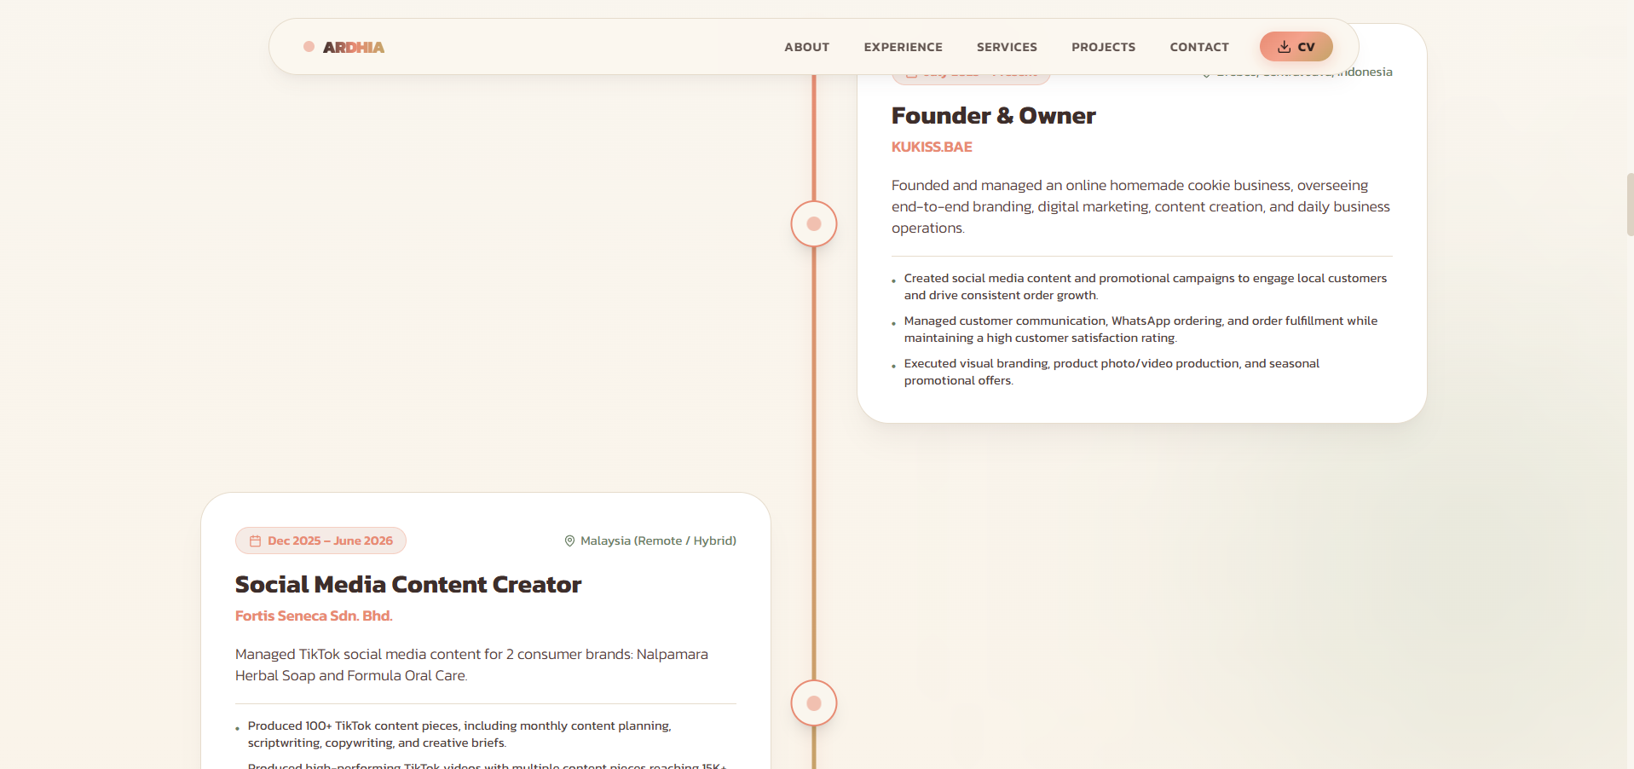
- Bagian ini bullet pointsnya diupdate lagi sesuai CV terbaru, OIYAAA CV KU DI UPDATE LAGI AJA YAK TRIMS<3 https://drive.google.com/file/d/1_rrnxFrQoJANmDPRcjfgMz8oCbSyhb2o/view?usp=sharing
- Bagian DM Bootcamp ini
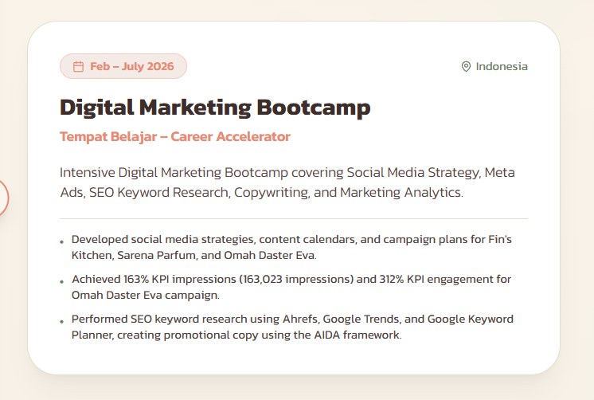
Isinya ngikut yg ini
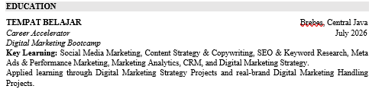
Tambahin info ini → Additional Projects: Fin's Kitchen – Social Media Marketing | Lamis Resto – Market Research | Kandang Jeletot – Copywriting | Landing Page Optimization | SEO Optimization
- Tambahkan section brand yang pernah berkolaborasi, logonya disini https://drive.google.com/drive/folders/1sqCiqe3wZm4u1SgWdhAwIcF1p4-3HpPs?usp=sharing
- Bagian PROJECTS tolong ubah sesuai urutan project yg ada di drive
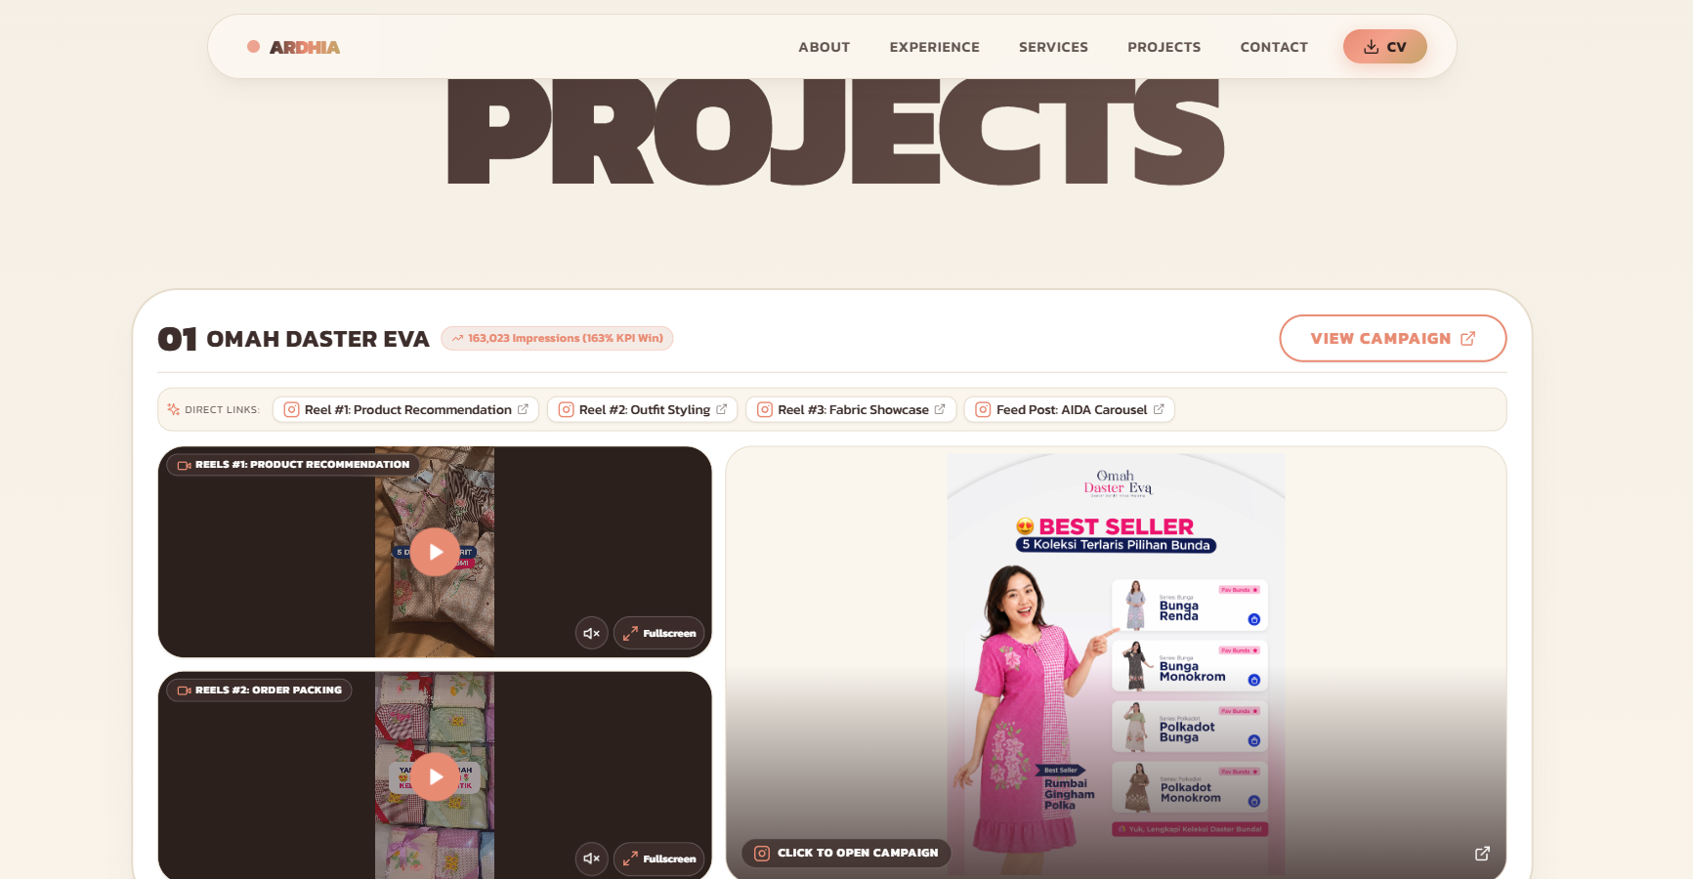

Evidencenya udah ada di drive semua urut nomer dibawah yaa..
Untuk setiap project, formatnya kurang lebih:
Project Background → Objective → My Role → Process / Scope of Work → Result / Output → Evidence

1. FORTIS SENECA SDN. BHD.
Social Media Content Creator

Brands: Nalpamara Herbal Soap | Formula Oral Care
Platform: TikTok

100+ Content Pieces

15K+ Organic Views

Project / Brand Background

Managed TikTok content for two consumer brands, Nalpamara Herbal Soap and Formula Oral Care, with a focus on creating audience-focused content aligned with each brand's objectives and TikTok trends.

Objective

To develop engaging TikTok content that strengthens brand communication, increases audience reach, and supports the brands' social media marketing objectives.

My Role & Contribution

Managed TikTok content for two consumer brands, covering content planning, storyboard development, scriptwriting, copywriting, and video editing.

Developed and produced 100+ TikTok content pieces across both brands.

Conducted trend research and competitor analysis to identify relevant content opportunities and develop audience-focused concepts.

Collaborated with designers and internal teams to develop creative briefs and execute promotional campaigns while maintaining consistent brand messaging.

EVIDENCE ADA DI DRIVE, urutannya gini
01 — Content Planning
Selected storyboards and content planning examples.
02 — Content Development
Examples of TikTok scripts, copywriting, and creative briefs developed for the brands.
03 — Content Execution
Selected TikTok videos produced for Nalpamara Herbal Soap and Formula Oral Care.
04 — Performance Highlights
Selected TikTok content that achieved 15K+ organic views.

2. OMAH DASTER EVA
Digital Marketing Handling Project | June–July 2026
Role: Social Media Team

Project Background
Omah Daster Eva is a Malang-based women’s fashion brand specializing in homewear with distinctive handmade Malang embroidery. The brand already had strong awareness and an established customer base, while the campaign focused on strengthening Instagram performance and supporting online conversion.

Objective
To develop and execute an Instagram social media strategy aligned with the target audience and optimize content performance throughout the campaign period.

My Role & Contribution
- Conducted Instagram content analysis to identify top- and low-performing content formats and audience preferences.
- Developed Instagram content planning and campaign messaging based on brand objectives and target audience insights.
- Created content concepts across Feed, Reels, and Stories, including product education, product visualization, relatable content, and interactive content.
- Monitored weekly Instagram performance and used insights to optimize content direction and formats.

Result
Bikin 3 angka ini jadi highlight/card besar:
163,023
Instagram Impressions
163% of KPI
624
Total Engagements
312% of KPI
18,930
Accounts Reached
94% of KPI

Evidence / Project Deliverables
- Content Strategy
- Content Planning
- Content Execution
- Performance Analysis
- Campaign Results
NOTES: bagian Evidence / Project Deliverables ini nggak harus semuanya ditulis sebagai paragraf di website. Bisa dijadikan judul kecil di atas screenshot/gallery supaya website tetap clean.

3. SARÉNA PARFUM
Digital Marketing Strategy Project | May–June 2026
Role: Social Media Team
Background
SARÉNA is a local women's fragrance brand targeting modern and socially active women aged 18–35.
Objective
To develop a structured social media strategy to strengthen brand awareness, audience engagement, and conversion.
My Role & Contribution
• Conducted social media and competitor research to identify content opportunities and audience preferences.
• Developed content pillars and content direction based on audience insights and brand positioning.
• Created a social media content calendar covering awareness, engagement, education, social proof, and conversion content.
• Developed content concepts across Reels, Carousel, Feed, and Stories, including POV, storytelling, UGC, product education, testimonials, and promotional content.
Output
Social Media Strategy, Content Pillars, Content Direction, Content Calendar & Content Concepts

4. FIN’S KITCHEN
Social Media Marketing Project | March 2026
Role: Social Media Team

Project Background
Fin’s Kitchen is a dessert brand targeting young consumers aged 18–35 in Pekalongan and surrounding areas. The brand had strong potential for reach through Instagram, with its top Reels reaching 28.9K views despite a relatively small follower base.

Objective
To develop a social media marketing campaign that strengthens brand awareness, engagement, and conversion through relatable and visually appealing dessert content.

My Role & Contribution
- Conducted audience and social media analysis to identify audience characteristics, interests, and content opportunities.
- Developed the “Bad Day? Dessert Dulu” campaign concept based on relatable everyday moments and the brand’s positioning.
- Developed content pillars covering Customer Experience, Product Showcase, and Relatable Moments.
- Created a monthly content calendar across Feed, Reels, and Stories.

Output
Social Media Campaign Blueprint
Campaign concept, content pillars, content calendar, and promotional content direction.

Evidence
- Audience analysis
- Campaign concept
- Content pillars
- Content calendar
- Sample content

5. LAMIS RESTO
Market Research Project | March 2026

Background
Lamis Resto is a family-friendly restaurant in Bali preparing to launch new Cafe Latte + Snack bundle options.

Objective
To identify customer preferences, suitable pricing, and purchase interest to support the new bundle launch.

My Contribution
• Conducted quantitative research through an online survey.
• Analyzed customer preferences, spending behavior, bundle preferences, and price expectations.
• Translated research findings into product, pricing, and promotional recommendations.

Key Findings
74.6% — High interest in trying the new bundle
Rp36K–45K — Preferred price range
Top Bundles — Latte + French Fries & Latte + Cinnamon Roll

Output
Customer Insights & Strategic Recommendations for the new Cafe Latte + Snack bundle.

6. KANDANG JELETOT
Copywriting Project

Project Background
Kandang Jeletot is a food brand introducing new basreng and makaroni products through promotional social media content.

Objective
To create promotional copy that captures attention, communicates the new product launch, and encourages audiences to take action.

My Role & Contribution
- Developed short-form copywriting for Reels and Feed content using an audience-focused and humorous approach.
- Created hooks designed to capture attention within the first few seconds of the video.
- Developed captions and CTAs to support the product launch and promotional message.
- Applied the AIDA framework to structure promotional communication.

Output
Social Media Copywriting Package
Reels script, Feed copy, caption, hook, and CTA for the new product launch.

Evidence
- Reels storyboard/script
- Feed copy
- Caption
- Before/after copywriting if available

7. SEO OPTIMIZATION
SEO Content & Keyword Research Project

Project Background
This project focused on developing SEO-optimized content around travel destinations in Bogor, targeting users searching for relevant travel recommendations.

Objective
To create search-intent-driven content that targets relevant keywords and provides useful information for users planning a trip to Bogor.

My Role & Contribution
- Conducted keyword research using Ahrefs, Google Trends, and Google Keyword Planner.
- Identified relevant search topics and structured content based on user search intent.
- Developed an SEO-focused article covering travel recommendations in Bogor, including nature, family, and Instagrammable destinations.

Output
SEO-Optimized Article
Keyword research, search-intent mapping, content structure, and final SEO article.

Evidence
- Keyword research
- Keyword mapping
- Content structure
- Final article

8. PERSONAL PROJECT — KUKISS.BAE
Small Business & Social Media Marketing | July 2025 – Present
Role: Founder & Owner
Project Background
KUKISS.BAE is a Brebes-based homemade cookie business that I developed from the ground up, using Instagram as its primary social media and marketing channel.
Objective
To build brand awareness, engage potential customers, and drive product conversion through Instagram content and promotional campaigns.
My Role & Contribution
- Developed the brand identity and managed Instagram marketing, customer communication, order fulfillment, and daily operations.
- Planned and created Instagram content and promotional campaigns around seasonal moments, payday, double-date campaigns, and product bundling to support awareness and conversion.
- Managed pre-order operations, with orders typically starting from 50 soft cookies per order cycle.
Social Media Highlight
88.3% of views came from non-followers

Evidence
Cukup tampilin:
- Instagram profile
- Selected content
- Campaign/promo content
- Instagram Insights

