CAP 6619 Deep Learning
2026 Fall
Homework 1 [13 Pts, Due: Sep 27 2026. Late Penalty: -2/day]
[If two homework submissions are found to be similar to each other, both submissions will receive 0 grade]
No email submission is accepted. Homework solutions must be submitted through Canvas. We can only grade materials submitted to the Canvas.
If you have multiple files, you can submit them to the Canvas with a clear heading to each file, e.g., Answers to Q1, Q2, etc., (only PDF, WORD, and HTML files are accepted). You can update your submissions, but only the latest version will be graded.]

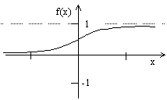
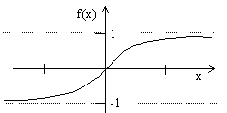
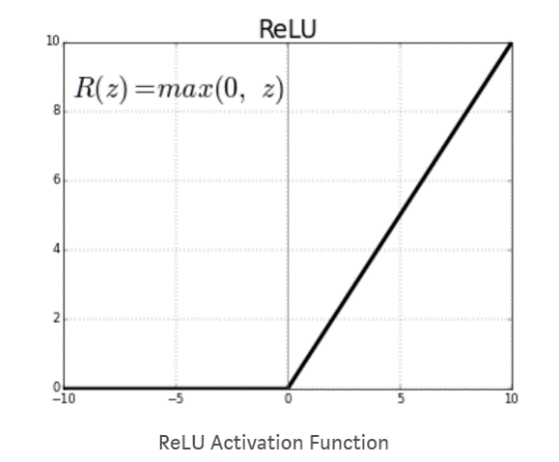
Question 1 [1pt] Figure 1 shows four activation functions in the neural network, please show the mathematical formulation of each activation function [0.5], and explain the characteristics of each activation function [0.5 pt].
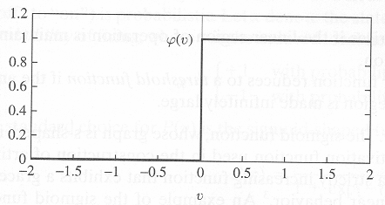
- (b) (c) (d)
Figure 1 Activation Functions.
Question 2 [1 pt]. Derive gradient of Sigmoid activation function Figure 1(b) and the gradient of the ReLU activation function Figure1(d) [0.5pt]. Explain advantage vs. disadvantage of each of the activation function, respectively [0.5 pt].

Question 3 [2 pts] Figure 2 shows a set of samples (dots) which are labeled as red and green (red dots belong to class C2, and green dots belong to class C1).
- Explain how a neuron can be trained to correctly classify dots into different classes (C1 vs. C2) [0.5 pt]
- What are the roles of the weight values of the neuron [0.5 pt]
- Assume a neuron with weight values [w₀, w₁, w₂] is used to learn decision surface to separate the two group instances (w₀ is the weight value for bias), Draw decision surfaces corresponding to [1, 1, 1], [1, -1, 1], and [-1, -1, 1], respectively (mark each line on the plot) [0.5 pt]
- Explain how each weight values, w₀, w₁, w₂, control the decision surface, respectively [0.25 pt].
- Among the three decision surfaces, which line is the best decision surface to separate instances, why? [0.25 pt]
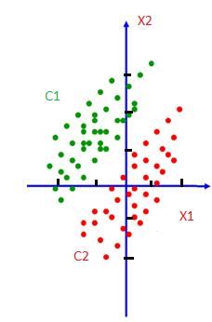
Figure 2. Examples of a linearly separable classification task with two feature dimensions

Question 4 [2 pts] Figure 3 shows a perceptron with three weight values (including bias).
- Given a single training instance x(n), assume desired label of the instance is d(n), define squared error of the instance with respect to the network [0.5 pt].
- Use gradient descent learning to derive weight updating rules for w₀, w₁, and w₂, respectively [0.5 pt]
- Given N training instances x(1), x(2), …, x(N), assume their desired labels are d(1), d(2), …, d(N), respectively, define squared error of all instances with respect to the network [0.5 pt].
- Use gradient descent learning to derive weight updating rules for w₁ [0.5 pt]
x₁
1
x₂
w2
w1
w0
Figure 3: Single layer neural network
Question 5 [1 pt]: The following figure shows a quadratic function y=2x²-4x+1. Assume we are at the point x=0, and is searching for the next movement to find the minimum value of the quadratic function using gradient descent (the learning rate is 0.1).
- What is the gradient at point x=0? (Show your solutions) [0.5 pt]
- Following gradient decent principle, find the next movement towards the global minimum [0.5 pt]
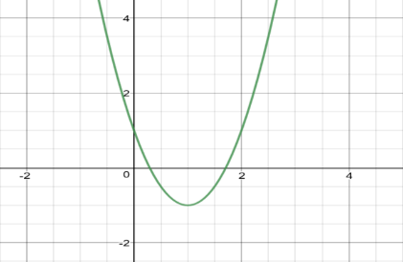
Figure 4. A quadratic function
Question 6 [1.5 pts] Assuming we have two sets of instances, which belong to two classes, with each class containing three instances. C1={(1, 0), (1, 1), (0, -1)}; C2={(0, 1), (-1, 0), (-1, -1)}. Assuming the class label for C1 and C2 are 1 and -1, respectively, the learning η=0.1, and the initial weights are w₀=1, w₁=1, and w₂=1. Please use gradient learning rule to learn a linear decision surface to separate the two classes. List the results in the first two rounds by using tables in the following form (Report the mean squared errors of all instances with respect to the initial weight values, and the mean squared errors E(W) AFTER the weight updating for each round).
Mean squared errors E(W) corresponding to the initial weights:
First Round
Input | Weight | v | Desired | Output | Δw
(1,-1,0)
(1,1,0)
(1,0,-1)
(1,0,1)
(1,1,1)
(1,-1,-1)
New weight after first round:
Mean squared errors E(W) after the first-round weight updating:
Second Round
Input | Weight | v | Desired | Output | Δw
(1,-1,0)
(1,1,0)
(1,0,-1)
(1,0,1)
(1,1,1)
(1,-1,-1)

New weight after second round:
Mean squared errors E(W) after the second-round weight updating:
Question 7 [1.5 pts] Assuming we have two sets of instances, which belong to two classes, with each class containing three instances. C1={(1, 0), (1, 1), (0, -1)}; C2={(0, 1), (-1, 0), (-1, -1)}. Assuming the class label for C1 and C2 are 1 and -1, respectively, the learning rate η=0.1, and the initial weights are w₀=1, w₁=1, and w₂=1. Use Delta rule (AdaLine) to learn a linear decision surface to separate the two classes. List the results in the first round by using tables in the following form (Please report the mean squared errors of all instances with respect to the initial weight values, and also report the mean squared errors E(W) AFTER the weight updating of the last instance).
Input | Weight | v | Desired | Output | Δw | New Weight
(1,-1,0)
(1,1,0)
(1,0,-1)
(1,0,1)
(1,1,1)
(1,-1,-1)

Questions 8 and Question 9 are programming tasks.
For all programming tasks, solutions must be submitted as notebook (html or pdf) files for grading (your submission must include scrips/code and the running results of the script).
If you are not familiar with Python programming (and want to use Python for the coding tasks), please check Python Plotting notebook and Python Simple Analysis notebook posted in the Canvas, before working the coding tasks.
For each subtask, please use task description (requirement) as comments, and report your coding and results in following format:
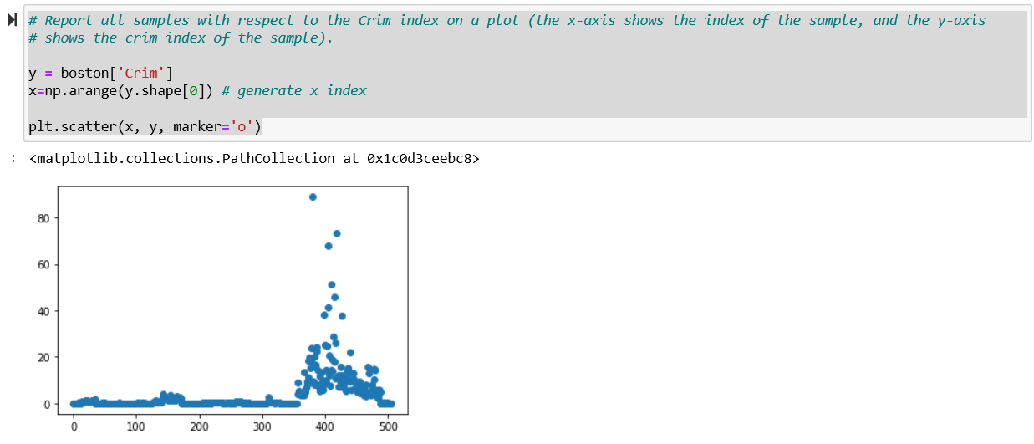
Question 8 [1 pt] programming task: Please download housing.header.txt dataset from Canvas, and use a programming language (Python, R, etc.) to implement following tasks (a brief description of this dataset is available from the following URL)
https://www.cs.toronto.edu/~delve/data/boston/bostonDetail.html
- Read housing.header.txt as a dataframe. Report number of instances and features, and report all samples with respect to the Crim index on a plot (the x-axis shows the index of the sample, and the y-axis shows the crim index of the sample). [0.1 pt]
- Show following four scatter plots in one frame (1x4), crim-medv, Rm-medv, Age-medv,Tax-medv, and explain how are they (Crim, Rm, Age, Tax) correlated to the medium house value (Medv) [0.1 pt]
- Create a subset which only includes properties with Crim less than 1 (inclusive), and Rm greater than 6 (inclusive). [0.1 pt]
- Show a scatter plot between Rm and Medv (x-axis shows Rm and y-axis denote Medv), please color all properties with 7 or larger Rm values as “red”, and rest properties as “black”. [0.1 pt]
- Create a scatter plot between Rm and Crim and show all 506 properties on the plot. Color property whose Medv value greater or equal to 24 as red, and the rest as blue. [0.2 pt]
- Report the pairwise correlation between every two variables (either as a matrix or as a level plot) [0.1 pt]
- Please explain which variable is mostly positively correlated to Medv (medium house value), and which variable is mostly negatively correlated to Medv. [0.1 pt]
- Draw scatterplots to show relationship between each attribute and Medv, respectively. [0.1 pt]
- Please create a new instance with following attribute value
Crim=1.0,Zn=0.2,Indus=6,Chas=0.1,Nox=6.5,Rm=5,Age=100,Dis=4.1,Rad=4.5,Tax=21,Ptratio=20,B=300,Lstat=12,Medv=20.5
include this instance into the original dataframe, and report the number of instances and features of the new dataframe. [0.1 pt]
- Create a new feature (named “Dummy”), and include the new feature into the new dataframe as the last feature. The values of the Dummy feature for each instance are randomly generated within range [0,5]. [0.1 pt]

Question 9 [2 pts]: programming task
Given two functions f₁(x,y)=(x-2)² + (y-3)², and f₂(x,y)=(1 - (y-3))² + 20((x+3) - (y-3)²)², please implement gradient descent learning to search for global minimum value for each function. Your code needs to implement following components:
- Use two Plots to show f₁(x,y) and f₂(x,y) values with respect to the two dimensional input x and y (You can specify the range of the x and y values) [0.5 pt]
- Starting from initial value: (x,y)=(0,0), use learning rate η=0.5, report f₁(x,y) and f₂(x,y) values in T=100 iterations. (your code can report f₁(x,y) and f₂(x,y) values as tables, or simple print out the values). Explain whether the gradient descent learning is effective finding the solutions for f₁(x,y) and f₂(x,y), why or why not? [0.5 pt]
- Following step 2, please change your code (e.g., using different learning rates, such as η=0.01) to try to search minimum for f₁(x,y) and f₂(x,y), respectively. Run algorithms for T=100 iterations Explain the motivation of your changes, and the final minimum values [0.5 pt]
- Explain why gradient descent learning can be used to help search solutions for f₁(x,y) and f₂(x,y), and what are the impact of the learning rate in the gradient descent learning [0.5 pt]

