CAP 6619 Deep Learning
2026 Fall
Homework 1 [13 Pts, Due: Sep 27 2026. Late Penalty: -2/day]
[If two homework submissions are found to be similar to each other, both submissions will receive 0 grade]
No email submission is accepted. Homework solutions must be submitted through Canvas. We can only grade materials submitted to the Canvas.
If you have multiple files, you can submit them to the Canvas with a clear heading to each file, e.g., Answers to Q1, Q2, etc., (only PDF, WORD, and HTML files are accepted). You can update your submissions, but only the latest version will be graded.]

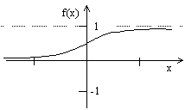
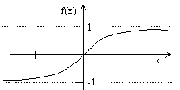
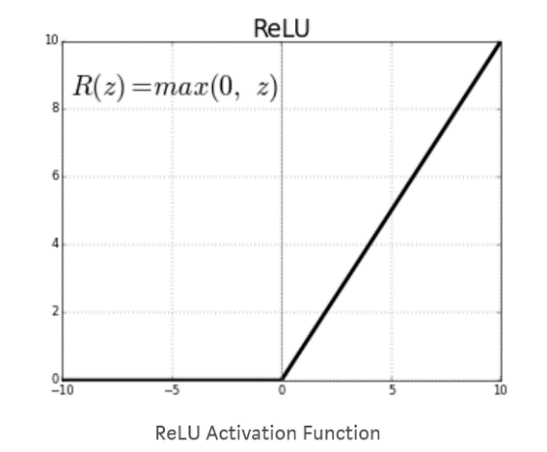
Question 1 [1pt] Figure 1 shows four activation functions in the neural network, please show the mathematical formulation of each activation function [0.5], and explain the characteristics of each activation function [0.5 pt].
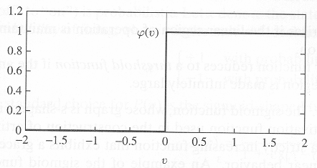
- (b) (c) (d)
Figure 1 Activation Functions.

Question 2 [1 pt]. Derive gradient of Sigmoid activation function Figure 1(b) and the gradient of the ReLU activation function Figure1(d) [0.5pt]. Explain advantage vs. disadvantage of each of the activation function, respectively [0.5 pt].
Answer for Question 1 and 2:^{1,2}
The purpose of an activation function is to convert the inputs of an artificial neuron towards one output, typically for classification (i.e., binary classification). The inputs are summed up via weights and input values. The summation is given a value ‘v’ (i.e., a local field) and once this summation reaches the activation function, as based on a specified range and the nature of the function itself – stated as a function of v ‘f(v)’ - the activation function results in a value based whether or not a threshold is met. Activation functions can differ based on how differential and continuous they are.
For the activation functions given in Figure 1:
a. Step function (hard-limiter/binary-step)
An activation function that uses a direct threshold value via a piecewise function for a binarized output. Although simple, it is not well suited for complex datasets beyond binary classification. It is also not continuous, so it can’t be used with backpropagation.
$$f\left(x\right)= \left\{\begin{aligned}1 if x≥0 \\ 0 if x<0\end{aligned}\right.$$
b. Sigmoid function (logistic)
An activation function that is differentiable and continuous. Rather than a step function with a break, the function is continuous with a range from 0 to 1 [0,1]. With a value within a range, the gradient is smoother, meaning that, based on the derivative of the function, values that are near zero decrease back to zero while values that are at or over the threshold go further to 1. For the sigmoid function though, the values of the output can only be positive, leading to potential biases. The derivative of the function also suffers from a vanishing problem – the gradient is only existent for limited values, leading to training difficulties and limits for differentiability
$$f\left(x\right)=\frac{1}{1+e^{-x}}$$
$$f^{'}\left(x\right)=f\left(x\right)×\left(1-f\left(x\right)\right)$$
c. Hyperbolic tangent (Tanh)
The activation function is like the sigmoid function, but it has a wide range where it is bound by both -1 and 1 [-1,1]. As such, the curve, as based on the derivate, is zero centered. This zero-based curve, with both negative and positive values leading towards the center, results in a larger gradient compared to the sigmoid function, with a smaller vanishing point. This allows for the completion of more complex computing tasks.
$$f\left(x\right)=\frac{e^{x}-e^{-x}}{e^{x}+e^{-x}}$$

$$f^{'}\left(x\right)=1-f{\left(x\right)}^{2}$$
d. Rectified Linear Unit (ReLU)
ReLU is like the step function. But, instead of a straight jump to 1 from 0, ReLU is shaped like a linear function (i.e., $x$) for the former. This is more specifically the ‘input’ going into the function; if the function is below the threshold, the function results in zero; but, if the value is above the threshold, then the ‘input’ itself is simply returned. This results in the value of the ReLU being either 0 or infinity (as based on $x$); $(0,x)$. So, neurons are either ‘off’ (i.e., zero) or are firing (i.e., $x$). This makes ReLU continuous; but with the caveat of not being differentiable in certain areas. Despite this, ReLU is highly used due to having a more robust gradient descent that leads faster to a global minimum; it is also less computationally expensive than sigma or tanh activation functions via bypassing the arithmetic of exponentials. But a disadvantage is that the ReLU activates a limited number of neurons, specifically neurons that are only positive, making backpropagation difficult, specifically with more nuanced weight updates.
There also exists a variant of ReLU known as the leaky ReLU. The leaky ReLU accounts for negative values, thus making the range of the Leaky ReLU go from negative infinity to infinity i.e., $-x,x$; but, for practical purposes, an actual range is $0.1x,x$. The Leaky ReLU is important in that it prevents a problem in learning known as ‘dead neurons. With regular ReLU, any neuron that has values less than 0 are inactive. This prevents neurons that may have the potential to learn to fail due not be activated from a negative value (or if they encounter negative values). With the leaky ReLU, activation can be more nuanced, specifically by allowing neurons with very small values to pass through and become activated, even with negative values. This is done specifically with an $α$ value, where $α$ helps set the ‘leakiness’ (i.e., slope) for negative values, typically ranging from 0.1 to 0.3; hence $αx,x$. Like, ReLU, leaky ReLU is not differentiable in certain areas; but, it does allow for backpropagation. Although the Leaky ReLU addresses the dead neuron problem there may be times whjere it is more straightforward to simply use ReLU, especially since leaky ReLU deals with the extra $α$ parameter, still, ReLU can prove useful for more deeper networks.
It’s noted that both ReLU and leaky ReLU are not zero centered; the outputs are nonnormalized.
ReLU
$$f\left(x\right)= \left\{\begin{aligned}0 if x<0 \\ x if x≥0\end{aligned}\right. or f\left(x\right)=\max\left(0,x\right)$$
$$f^{'}\left(x\right)= \left\{\begin{aligned}0 if x<0 \\ 1 if x≥0\end{aligned}\right.$$
Leaky ReLU
$$f\left(x\right)= \left\{\begin{aligned}αx if x<0 \\ x if x≥0\end{aligned}\right. or f\left(x\right)=\max\left(αx, x\right)$$
$$f^{'}\left(x\right)= \left\{\begin{aligned}α if x<0 \\ 1 if x≥0\end{aligned}\right.$$

Question 3 [2 pts] Figure 2 shows a set of samples (dots) which are labeled as red and green (red dots belong to class C2, and green dots belong to class C1).
- Explain how a neuron can be trained to correctly classify dots into different classes (C1 vs. C2) [0.5 pt]
- What are the roles of the weight values of the neuron [0.5 pt]
- Assume a neuron with weight values [w₀, w₁, w₂] is used to learn decision surface to separate the two group instances (w₀ is the weight value for bias), Draw decision surfaces corresponding to [1, 1, 1], [1, -1, 1], and [-1, -1, 1], respectively (mark each line on the plot) [0.5 pt]
- Explain how each weight values, w₀, w₁, w₂, control the decision surface, respectively [0.25 pt].
- Among the three decision surfaces, which line is the best decision surface to separate instances, why? [0.25 pt]
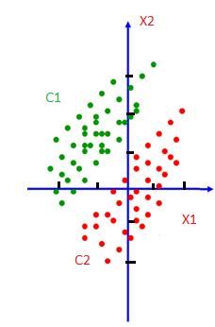
Figure 2. Examples of a linearly separable classification task with two feature dimensions
Answer for Question 3
- Classification in machine learning is predicting an output based on a series of inputs. This requires a dataset (i.e., the points) where the inputs have labeled outputs. In this case, it would be the y values for each x value given. The framework to produce a prediction requires three essential components:
  - Weights – applied to inputs to ‘do’ the actual learning, as based on parallels to biological nerves and firing activity (i.e., neurons that have different weights have different importance).
  - A transfer function – the ‘model’ that utilizes the inputs paired with the weights. In this case, it’s a linear function of the form
$$f\left(x\right)=w_{0}+w_{1}x_{1}+w_{2}x_{2}+...+w_{N}x_{N}$$This can also be stated as
$$f\left(x\right)=w_{0}+\sum_{i=0}^{N}{w_{i}}+x_{i}$$
where $w_{0}$ is a weight bias (such as a pre-state of the neuron); $w$’s are the weights; and $x$’s are the input values. For this example, the transfer function is what forms the ‘line’ for the decision boundary.
  - An activation function – as discussed in the previous questions, there exist several activation functions. The sum of the neurons is passed into this function where if they meet a threshold value, they ‘activate’ another neuron or produce an output. If they don’t meet that output, then the neuron remains inactive. The output of the activation function is often compared to a ‘truth’ or ‘desired’ value which is the actual value (or labeled value) within the dataset. Based on the principles of supervised learning, weights are adjusted to properly ‘learn’ how to correspond inputs to desired outputs (for example, with backpropagation).
Since the decision boundary is essentially a linear regression, the form of the function for this example is given as
$$f\left(x\right)=w_{0}+w_{1}x_{1}+w_{2}x_{2}$$
To match a closer linear function $y=mx+b$, $f\left(x\right)=0$; $x_{2}=y$. Hence:
$$0=w_{0}+w_{1}x_{1}+w_{2}x_{2}$$
$$x_{2}=-\frac{w_{1}}{w_{2}}x_{1}-\frac{w_{0}}{w_{2}}$$
Here, $x_{2}$ is $y$; $-\frac{w_{0}}{w_{2}}$ is the intercept, and $-\frac{w_{1}}{w_{2}}$ is the slope. Weights are responsible for the ‘learning’ and here they heavily influence the position and slope of the linear decision boundary. Though, there actually exists countless decision boundaries; but, the ‘best’ boundary is attained via gradient descent.
Using the values of the weights, they can be substituted into $x_{2}$ to find the inquired decision boundaries.
From this, for weight gradients: $$Δw_{1}=\left[1,1,1\right];Δw_{2}=\left[1,-1,1\right];Δw_{3}=\left[-1,-1,1\right]$$The corresponding linear equations are: $x_{2;Δw_{1}}=-x_{1}-1;$ $x_{2;Δw_{2}}=x_{1}-1;x_{2;Δw_{3}}=x_{1}+1$
This results in x-intercepts being:
$$x_{1;Δw_{1}}=-1;x_{1;Δw_{2}}=1;x_{1;Δw_{3}}=-1$$
And y-intercepts being:
$$x_{2;Δw_{1}}=-1;x_{2;Δw_{2}}=-1;x_{2;Δw_{3}}=1$$
The linear equations can be graphed as
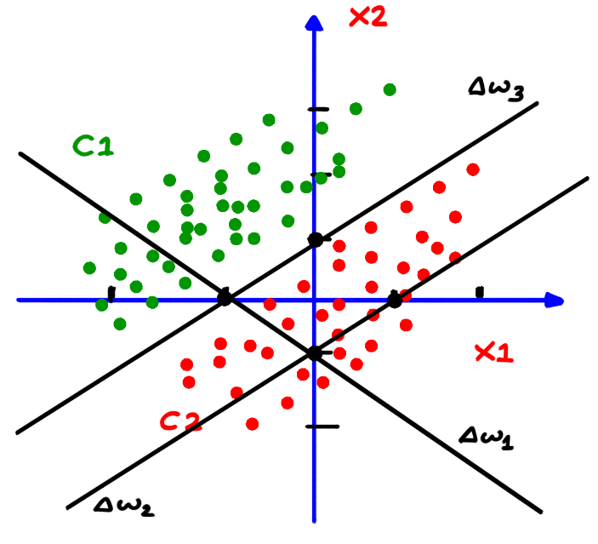
Here, it’s shown that weight gradient $Δw_{3}$, in this example, is the best line that splits the decision boundary between classes $C_{1}$ and $C_{2}$. $Δw_{2}$ comes close but results in misclassification of several $C_{2}$ data points (i.e., false positives) and $Δw_{3}$ is the most erroneous, resulting in a poor decision boundary with mis classifications. From the general structure of the linear equation, it’s clear that in the example $w_{2}$ holds sway over the influence of the line, particularly the slope and intercepts.
Question 4 [2 pts] Figure 3 shows a perceptron with three weight values (including bias).
- Given a single training instance x(n), assume desired label of the instance is d(n), define squared error of the instance with respect to the network [0.5 pt].
- Use gradient descent learning to derive weight updating rules for w₀, w₁, and w₂, respectively [0.5 pt]
- Given N training instances x(1), x(2), …, x(N), assume their desired labels are d(1), d(2), …, d(N), respectively, define squared error of all instances with respect to the network [0.5 pt].
- Use gradient descent learning to derive weight updating rules for w₁ [0.5 pt]
x₁
1
x₂
w2
w1
w0
Figure 3: Single layer neural network
Answer for Question 4:³
1. With respect to the instances (with features) within the dataset of a network, the Mean Squared Error (MSE) assesses the validity of how the model predicted values when compared to the actual labeled values within a dataset. The MSE takes into the account the squared error over all instances as an average. This is generally expressed as:
$$MSE=\frac{1}{N}\sum_{i=1}^{N}{{\left(y_{i}-{\overset{ˆ}{y}}_{i}\right)}^{2}}$$
Where $N$ is the average over the number instances – two in this example – $y_{i}$ is the true value of the instance within the dataset (i.e., the desired value) and ${\overset{ˆ}{y}}_{i}$ is the predicted value of the output made by the neuron (i.e., the output). What drives the MSE is the difference between the output value and the predicted value. This can be expressed simply as error $e$ where
$$e(n) = d(n) - o(n)$$
Here, the MSE can be written as:
$$E\left(n\right)=\frac{1}{N}{\left(e\right)}^{2}=\frac{1}{N}×{\left(d\left(n\right)-o\left(n\right)\right)}^{2}$$
With $n$ corresponding to each instance within the dataset. For the example, this can be written as:
$$E\left(n\right)=\frac{1}{2}×{\left(d\left(n\right)-o\left(n\right)\right)}^{2}$$
Considering the hyperplane/decision boundary in mind – weights multiplied by input values - this is expressed as:
$$E\left(n\right)=\frac{1}{N}×{\left(d\left(n\right)-\sum_{i=0}^{N}{w_{i}}x_{i}\right)}^{2}$$
For the example:
$$E\left(n\right)=\frac{1}{2}×{\left(d\left(n\right)-\sum_{i=0}^{N}{w_{i}}x_{i}\right)}^{2}$$
2. Gradient descent, as the name implies, is an act where the error of all the instances of a training set go down to a global minimum within a step-by-step manner, with the error diminishing with each step. This is all based on the weight values leading to a global minimum.
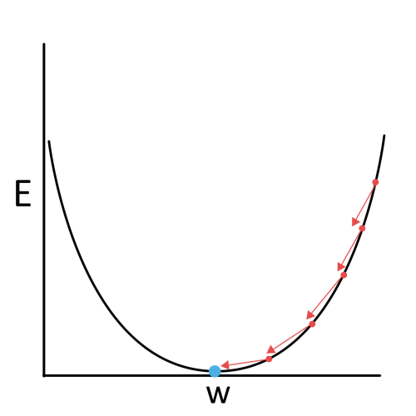
For each step, the weights as updated. This update in weight is expressed as:
$$w_{i}\left(k+1\right)=w_{i}\left(k\right)+Δw_{i}$$
Where $w_{i}\left(k+1\right)$ is the updated weight; $w_{i}\left(k\right)$ is the initial weight; and $Δw_{i}$ is the current weight. $k$ specifically corresponds to the epoch of the weight updating. An epoch is essentially all the instances of a dataset going through a sequence of weight updates in one go, like stroking a mallet across on a xylophone. Multiple epochs would lead to multiple times where the weights of the dataset are updated in tandem.
Deriving the specific rules for updating weights deals with partial derivatives relative to the error function and specific weights within the weight gradient. As gradient descent goes against the gradient towards the minimum, the error relative to each weight goes in a negative direction. In addition, to adjust the size of each ‘step’ for a gradient descent, a constant variable known as the learning coefficient $η$ is compounded with the error and individual weight.
To achieve this, the gradient for descent is expressed as a vector field (specifically a gradient field) $∇E\left(w\right)$
$$∇E\left(w\right)=\left[\frac{∂E}{∂w_{0}},\frac{∂E}{∂w_{1}},⋯,\frac{∂E}{∂w_{i}}\right]$$
Where for the error, it is partially derived for each weight. The current weight gradient $Δw_{i}$, applied to the error, equates to a negative gradient field $∇E\left(w\right)$ multiplied by $η$
$$Δw_{i}=-η∇E\left(w\right)$$
For the gradient field $∇E\left(w\right)$, the specific expression related to the inputs, predicted outputs, and desired outputs can be derived as follows, specifically for calculating gradients at each step.
With $∇E\left(w\right)=\frac{∂E}{∂w_{i}}$
$$\frac{∂E}{∂w_{i}}=\frac{∂}{∂w_{i}}\frac{1}{2}\sum_{n∈D}{{\left(d\left(n\right)-o\left(n\right)\right)}^{2}}$$
With $n$ being an instance and $D$ being the set of instances within the dataset to train. This can be evaluated as.
$$=\frac{1}{2}\sum_{n∈D}{\frac{∂}{∂w_{i}}}{\left(d\left(n\right)-o\left(n\right)\right)}^{2}$$
$$=\frac{1}{2}\sum_{n∈D}{2}\left(d\left(n\right)-o\left(n\right)\right)\frac{∂}{∂w_{i}}\left(d\left(n\right)-o\left(n\right)\right)$$
$$=\sum_{n∈D}{\left(d\left(n\right)-o\left(n\right)\right)}\frac{∂}{∂w_{i}}\left(d\left(n\right)-w_{i}x_{i}\right)$$
$$\frac{∂E}{∂w_{i}}=\sum_{n∈D}{\left(d\left(n\right)-o\left(n\right)\right)}×-x_{i}$$
With $Δw_{i}=-η∇E\left(w\right)$, $-x_{i}$ cancels out. This results in $Δw_{i}$ equating to
$$Δw_{i}=η\sum_{n∈D}{\left(d\left(n\right)-o\left(n\right)\right)}x_{i}$$
Hence, the updated weight $w_{i}\left(k+1\right)$ is
$$w_{i}\left(k+1\right)=w_{i}+η\sum_{n∈D}{\left(d\left(n\right)-o\left(n\right)\right)}x_{i}$$
3. From the MSE derived from part 2, it can be ascribed to an example with two instances; N=2. For weight gradient $Δw=\left[w_{0},w_{1},w_{2}\right]$, each output would correspond to
$$o\left(1\right)=w_{1}x_{1} \\ o\left(2\right)=w_{2}x_{2} \\ o\left(3\right)=w_{0}×1$$
With two desired outputs $d\left(1\right)$ and $d\left(2\right)$, the errors for each instance would be expressed as
$$e_{1}=d\left(1\right)-w_{1}x_{1} \\ e_{2}=d\left(2\right)-w_{2}x_{2}$$
The MSE would be
$$MSE=\frac{1}{2}\left[\left(d\left(1\right)-w_{1}x_{1}\right)+\left(d\left(2\right)-w_{2}x_{2}\right)+w_{0}\right]$$
Going to the Nth instance in a dataset, this can be expanded as
$$MSE=\frac{1}{N}\left[\left(d\left(1\right)-w_{1}x_{1}\right)+\left(d\left(2\right)-w_{2}x_{2}\right)+⋅+\left(d\left(N\right)-w_{N}x_{N}\right)+w_{0}\right]$$
4. For the weight gradient $w=\left[w_{0},w_{1},w_{2}\right]$, each new altered weight gradient within an epoch $k$ will be different as the error is applied to each instance. The weight for each instance within the $k$th epoch is updated, as based on the derived update rule from part 3: $w_{i}\left(k+1\right)=w_{i}=η\sum_{n∈D}{\left(d\left(n\right)-o\left(n\right)\right)}x_{i}$; or, more simply, $w_{i}\left(k+1\right)=w_{i}\left(k\right)+Δw_{i}$.
As such, it would be the previous weight gradient (i.e., the initial weight relative to each instance) added to $η$ multiplied by the error of the desired output subtracted from the predicted output, but, multiplied by the input of the instance (as per epoch of instances being gone through via application of the error). For this example, updating weight $w_{1}$ would like as follows, with $w_{i}$ the initial weight gradient; $w_{i}=\left[w_{0},w_{1},w_{2}\right]$:
$$w_{1}\left(k+1\right)=w_{i}+η\sum{\left(d\left(n\right)-o\left(n\right)\right)}x_{1}$$
Question 5 [1 pt]: The following figure shows a quadratic function y=2x²-4x+1. Assume we are at the point x=0, and is searching for the next movement to find the minimum value of the quadratic function using gradient descent (the learning rate is 0.1).
- What is the gradient at point x=0? (Show your solutions) [0.5 pt]
- Following gradient decent principle, find the next movement towards the global minimum [0.5 pt]
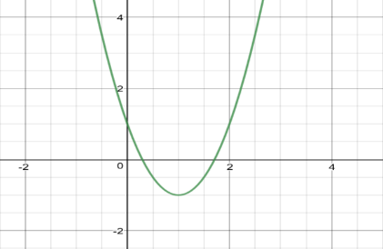
Figure 4. A quadratic function
Question 6 [1.5 pts] Assuming we have two sets of instances, which belong to two classes, with each class containing three instances. C1={(1, 0), (1, 1), (0, -1)}; C2={(0, 1), (-1, 0), (-1, -1)}. Assuming the class label for C1 and C2 are 1 and -1, respectively, the learning η=0.1, and the initial weights are w₀=1, w₁=1, and w₂=1. Please use gradient learning rule to learn a linear decision surface to separate the two classes. List the results in the first two rounds by using tables in the following form (Report the mean squared errors of all instances with respect to the initial weight values, and the mean squared errors E(W) AFTER the weight updating for each round).
Mean squared errors E(W) corresponding to the initial weights:
First Round
Input | Weight | v | Desired | Output | Δw
(1,-1,0)
(1,1,0)
(1,0,-1)
(1,0,1)
(1,1,1)
(1,-1,-1)
New weight after first round:
Mean squared errors E(W) after the first-round weight updating:
Second Round
Input | Weight | v | Desired | Output | Δw
(1,-1,0)
(1,1,0)
(1,0,-1)
(1,0,1)
(1,1,1)
(1,-1,-1)

New weight after second round:
Mean squared errors E(W) after the second-round weight updating:
Question 7 [1.5 pts] Assuming we have two sets of instances, which belong to two classes, with each class containing three instances. C1={(1, 0), (1, 1), (0, -1)}; C2={(0, 1), (-1, 0), (-1, -1)}. Assuming the class label for C1 and C2 are 1 and -1, respectively, the learning rate η=0.1, and the initial weights are w₀=1, w₁=1, and w₂=1. Use Delta rule (AdaLine) to learn a linear decision surface to separate the two classes. List the results in the first round by using tables in the following form (Please report the mean squared errors of all instances with respect to the initial weight values, and also report the mean squared errors E(W) AFTER the weight updating of the last instance).
Input | Weight | v | Desired | Output | Δw | New Weight
(1,-1,0)
(1,1,0)
(1,0,-1)
(1,0,1)
(1,1,1)
(1,-1,-1)

Questions 8 and Question 9 are programming tasks.
For all programming tasks, solutions must be submitted as notebook (html or pdf) files for grading (your submission must include scrips/code and the running results of the script).
If you are not familiar with Python programming (and want to use Python for the coding tasks), please check Python Plotting notebook and Python Simple Analysis notebook posted in the Canvas, before working the coding tasks.
For each subtask, please use task description (requirement) as comments, and report your coding and results in following format:
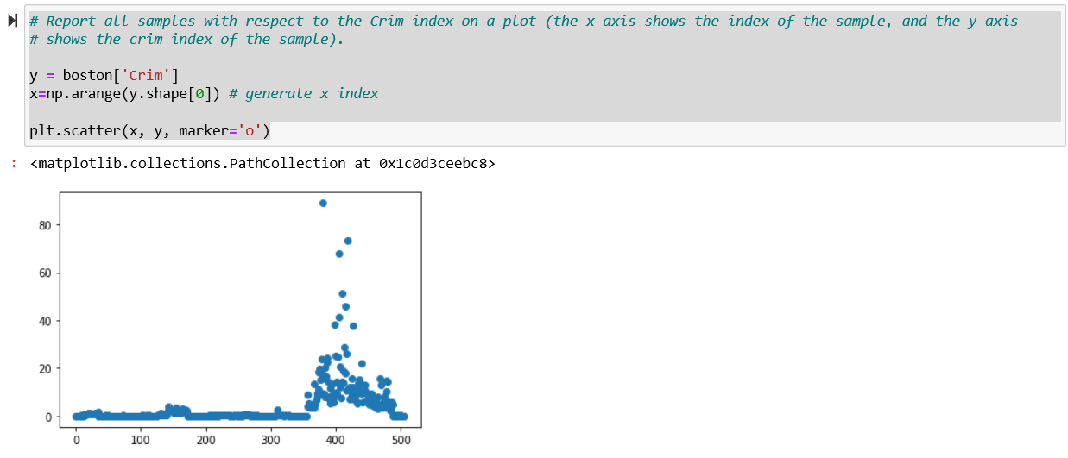
Question 8 [1 pt] programming task: Please download housing.header.txt dataset from Canvas, and use a programming language (Python, R, etc.) to implement following tasks (a brief description of this dataset is available from the following URL)
https://www.cs.toronto.edu/~delve/data/boston/bostonDetail.html
- Read housing.header.txt as a dataframe. Report number of instances and features, and report all samples with respect to the Crim index on a plot (the x-axis shows the index of the sample, and the y-axis shows the crim index of the sample). [0.1 pt]
- Show following four scatter plots in one frame (1x4), crim-medv, Rm-medv, Age-medv,Tax-medv, and explain how are they (Crim, Rm, Age, Tax) correlated to the medium house value (Medv) [0.1 pt]
- Create a subset which only includes properties with Crim less than 1 (inclusive), and Rm greater than 6 (inclusive). [0.1 pt]
- Show a scatter plot between Rm and Medv (x-axis shows Rm and y-axis denote Medv), please color all properties with 7 or larger Rm values as “red”, and rest properties as “black”. [0.1 pt]
- Create a scatter plot between Rm and Crim and show all 506 properties on the plot. Color property whose Medv value greater or equal to 24 as red, and the rest as blue. [0.2 pt]
- Report the pairwise correlation between every two variables (either as a matrix or as a level plot) [0.1 pt]
- Please explain which variable is mostly positively correlated to Medv (medium house value), and which variable is mostly negatively correlated to Medv. [0.1 pt]
- Draw scatterplots to show relationship between each attribute and Medv, respectively. [0.1 pt]
- Please create a new instance with following attribute value
Crim=1.0,Zn=0.2,Indus=6,Chas=0.1,Nox=6.5,Rm=5,Age=100,Dis=4.1,Rad=4.5,Tax=21,Ptratio=20,B=300,Lstat=12,Medv=20.5
include this instance into the original dataframe, and report the number of instances and features of the new dataframe. [0.1 pt]
- Create a new feature (named “Dummy”), and include the new feature into the new dataframe as the last feature. The values of the Dummy feature for each instance are randomly generated within range [0,5]. [0.1 pt]

Question 9 [2 pts]: programming task
Given two functions f₁(x,y)=(x-2)² + (y-3)², and f₂(x,y)=(1 - (y-3))² + 20((x+3) - (y-3)²)², please implement gradient descent learning to search for global minimum value for each function. Your code needs to implement following components:
- Use two Plots to show f₁(x,y) and f₂(x,y) values with respect to the two dimensional input x and y (You can specify the range of the x and y values) [0.5 pt]
- Starting from initial value: (x,y)=(0,0), use learning rate η=0.5, report f₁(x,y) and f₂(x,y) values in T=100 iterations. (your code can report f₁(x,y) and f₂(x,y) values as tables, or simple print out the values). Explain whether the gradient descent learning is effective finding the solutions for f₁(x,y) and f₂(x,y), why or why not? [0.5 pt]
- Following step 2, please change your code (e.g., using different learning rates, such as η=0.01) to try to search minimum for f₁(x,y) and f₂(x,y), respectively. Run algorithms for T=100 iterations Explain the motivation of your changes, and the final minimum values [0.5 pt]
- Explain why gradient descent learning can be used to help search solutions for f₁(x,y) and f₂(x,y), and what are the impact of the learning rate in the gradient descent learning [0.5 pt]

