
SKY IT
SKY IS THE LIMIT

JTI LDLP Slovakia
Large Data Lakehouse Platform technical documentation
Project: | JTI LDLP — Large Data Lakehouse Platform Slovakia
Client: | JTI Slovak Republic, s.r.o.
Version: | 1.0
Date: | 16/4/2026
Author: | Branislav Chromiak
Status: | Draft

info@skyit.sk · +421 905 395 686 · www.skyit.sk

Revision History
– REVISION LOG
Version | Date | Author | Changes
1.0 | 16/04/2026 | [Author] | Initial draft — Customer Data source documentation

Table of Contents
– Contents
[Insert table of contents: References › Table of Contents in MS Word]
Contents
Revision History 2
Table of Contents 3
1. Introduction 5
1.1 Scope 5
1.2 Target Audience 5
2. LDLP Platform Overview 6
2.1 Ingestion Pattern 6
2.2 Key Business Mapping Concepts 6
3. Source Data 7
3.1 Source System Overview 7
3.2 Customer Data — Key Account (KA) 9
3.2.1 ABAR 9
3.2.2 Billa 11
3.2.3 CBA GVP 12
3.2.4 CBA Komfos 14
3.2.5 CBA Verex 15
3.2.6 COOP 16
3.2.7 Dalioil 17
3.2.8 GAS P&S 18
3.2.9 Geco 19
3.2.10 Geco Weekly 20
3.2.11 GGT 21
3.2.12 GGT Weekly 22
3.2.13 Labas KA 23
3.2.14 Malina 24
3.2.15 OMV 25
3.2.16 Orlen 26
3.2.17 Real K 27
3.2.18 Shell 28
3.2.19 SK Catering 29
3.2.20 Slovnaft 30
3.2.21 TAM 31
3.2.22 Tanker 32
3.2.23 Tesco 33
3.3 Customer Data — Wholesale (WHS) 34
3.3.1 GGT WHS 34
3.3.2 Becica 36
3.3.3 Fajo 37
3.3.4 Gaza 39
3.3.5 Labas WHS 40
3.3.6 M+M 41
3.3.7 Mikros 42
3.3.8 Noba Smoker 43
3.3.9 PIMA 45
3.3.10 Rover 47
3.3.11 Tabak Slovensko 48
4. CRM Data 50
5. Open Data 51
6. Power BI Semantic Model 51
6.1 Introduction 51
6.1.1 Model Structure 51
6.2 Data Model Diagrams 52
6.2.1 Sales Facts (Sales Facts, Sales Facts 12m, Sales Facts Weekly) 52
6.2.2 Warehouse 52
6.2.3 Gifts 53
6.2.4 Opendata 53
6.2.5 CRM 54
6.3 Tables 55
6.3.1 Fact Tables 55
6.3.2 Dimension Tables 56
6.4 Relationships 57
6.5 Measures and Calculated Columns 59
6.5.1 Sales Facts Measures 59
6.5.2 Visit Facts Measures 59
6.5.3 Warehouse Measures 59
6.5.4 Calculated Columns 61
6.5.5 Calculated Tables 61
6.6 Data Refresh 62
6.7 Security 62
6.7.1 Row-Level Security (RLS) 62

1. Introduction
– DOCUMENT OVERVIEW
This document provides technical documentation of all source data inputs feeding the JTI Large Data Lakehouse Platform (LDLP). It serves as the primary reference for data engineers implementing Bronze-layer ingestion pipelines and as a migration reference from the legacy SQL Server 2016 / SSIS on-premises solution to the target Databricks architecture.
For each source system the document captures: file format and naming convention, column-level schema, key business mapping columns, and special parsing rules required for successful ingestion.

1.1 Scope
This document covers source-layer (Raw/Bronze) input specifications. Transformation logic in Silver and Gold layers is documented separately.
- Customer Data — Key Account (KA): retail chains and fuel station POS files
- Customer Data — Wholesale (WHS): distributor delivery and sell-through files
- CRM Data — Synapse Analytics views (Chapter 4 — placeholder)
- Open Data — Statistical Office of SR datasets (Chapter 5 — placeholder)

1.2 Target Audience
Audience | Role | Relevant Sections
Data Engineers | Pipeline implementation & debugging | All
Data Architects | Design review & governance | 2, 3.1
Business Analysts | Data understanding & mapping validation | 3.1, individual source schemas
QA / DevOps | Pipeline testing & CI/CD promotion | 2, parsing notes per source

2. LDLP Platform Overview
– ARCHITECTURE SUMMARY
The LDLP (Large Data Lakehouse Platform) is the target cloud data platform replacing the legacy SQL Server 2016 + SSIS on-premises architecture. All design decisions are governed by the LDLP WIKI — the authoritative reference for approved technologies, naming conventions, and architectural patterns.

Ingestion orchestration | Azure Data Factory (ADF)
Storage | Azure Data Lake Storage Gen2 — dlmsfnex5038regeeupdev
Processing & transformation | Databricks (Delta Live Tables, PySpark)
Data catalogue | Unity Catalog — ldlp-ms-sl-dp-default-dev
Secret management | Azure Key Vault (Key Vault-backed secret scope)
Authentication (QA/PRD) | Service Principal brickSpn via Key Vault
Reporting | Power BI via Microsoft Fabric capacity
ADLS namespace | market: ms/sl | dataproject: dp

2.1 Ingestion Pattern
Customer data files are delivered to ADLS Gen2 landing zones. ADF pipelines orchestrate file movement and trigger DLT execution. The medallion architecture is applied:
- Raw zone — files land as-is (XLSX, CSV, XML, XLS) under raw/ms/sl/dp/customer/<source>/YYYY/MM/
- Bronze layer — Auto Loader ingests raw files; XLSX/XLS pre-converted to Parquet; XML parsed via spark-xml
- Silver layer — cleansed, validated, standardised; PoS-to-CRM and SKU-to-CRM mappings applied
- Gold layer — aggregated business metrics for Power BI reporting

2.2 Key Business Mapping Concepts
Each source must enable four key business mappings, highlighted in green in the schema tables throughout Chapter 3.

Mapping Key | Description | Target
Account (PoS) | Point-of-sale outlet — links source data to CRM account. Primary keys: FID/TTT, ICO, or address composite. | CRM Account / dim_account
Product (SKU) | Product — links source codes/EANs/names to CRM product master. Primary key: EAN, then source product code. | CRM Product / dim_product
Sold Count | Quantity sold in pieces or stick-equivalents. Unit of measure varies by source. | Fact metric
Date | Sale period — date column, Rok+Mesiac columns, or derived from file name. | Date dimension

ℹ Note Competitor identification (manufacturer/brand column) is documented per source. The full competitor mapping strategy will be added as a separate chapter.

3. Source Data
– CUSTOMER POS FILES

3.1 Source System Overview
The following table inventories all 34 customer data source systems. File naming convention: <source_system>_YYYYMM.<format> (monthly), <source_system>_YYYY.<format> (yearly), <source_system>_YYYYWww.<format> (weekly). The "template_" prefix found in SSIS connection managers is a legacy caching convention — absent in actual delivered file names.

Source System | Category | Format | Frequency | File — Own Sales | File — Competitor | SSIS Package
ABAR | KA | CSV | Monthly | ABAR_YYYYMM.csv | — | Load_ABAR.dtsx
Billa | KA | XLSX | Monthly | BILLA_YYYYMM.xlsx | Total_BILLA_YYYYMM.xlsx | Load_KA_BILLA.dtsx
CBA GVP | KA | XLSX | Yearly | GVP_YYYY.xlsx | — | Load_KA_CBA_GVP.dtsx
CBA Komfos | KA | XLS | Monthly | Komfos_YYYYMM.xls | — | Load_KA_CBA_Komfos.dtsx
CBA Verex | KA | XLSX | Monthly | CBA Verex_YYYYMM.xlsx | — | Load_KA_CBA_Verex.dtsx
COOP | KA | XLSX | Monthly | COOP_YYYYMM.xlsx | — | Load_COOP.dtsx
Dalioil | KA | CSV | Monthly | Dalioil_YYYYMM.CSV | — | Load_KA_Dalioil.dtsx
GAS P&S | KA | XLSX | Monthly | GAS PaS_YYYYMM.xlsx | — | Load_KA_GASandPAS.dtsx
Geco | KA | XLSX | Monthly | Geco_YYYYMM.xlsx | — | Load_KA_Geco.dtsx
Geco Weekly | KA | XLSX | Weekly | Geco Weekly_YYYYWww.xlsx | — | Load_Geco_Weekly.dtsx
GGT | KA | XLSX | Monthly | GGT_YYYYMM.xlsx | — | Load_KA_GGT.dtsx
GGT Weekly | KA | XLSX | Weekly | Predaj BTV JTI týždenný YYYYWww.xlsx | — | Load_GGT_Weekly.dtsx
Labas KA | KA | XLSX | Monthly | Labas KA_YYYYMM.xlsx | — | Load_KA_Labas.dtsx
Malina | KA | XLSX | Monthly | Malina_YYYYMM.xlsx | — | Load_KA_Malina.dtsx
OMV | KA | XLSX | Monthly | OMV_YYYYMM.xlsx | — | Load_KA_OMV.dtsx
Orlen | KA | XLSX | Monthly | Orlen_YYYYMM.xlsx | — | Load_KA_Orlen.dtsx
Real K | KA | XLSX | Monthly | RealK_YYYYMM.xlsx | — | Load_KA_REALK.dtsx
Shell | KA | XLSX | Yearly | Shell_YYYY.xlsx | — | Load_KA_Shell.dtsx
SK Catering | KA | XLSX | Monthly | SK Catering_YYYYMM.xlsx | — | Load_KA_SKCatering.dtsx
Slovnaft | KA | XLSX | Monthly | Slovnaft_YYYYMM.xlsx | Konkurencia_Slovnaft_YYYYMM.xlsx | Load_KA_Slovnaft.dtsx
TAM | KA | XLSX | Monthly | TAM_YYYYMM.xlsx | — | Load_KA_TAM.dtsx
Tanker | KA | CSV | Monthly | Tanker_YYYYMM.csv | — | Load_KA_Tanker.dtsx
Tesco | KA | XLSX | Monthly | Tesco_YYYYMM.xlsx | — | Load_KA_TESCO.dtsx
GGT WHS | WHS | XLSX | Monthly | GGT WHS_YYYYMM.xlsx | — | Load_WHS_GGT.dtsx
Becica | WHS | CSV | Monthly | Becica_YYYYMM.csv | — | Load_WHS_Becica.dtsx
Fajo | WHS | XML | Monthly | fajo_YYYYMM.xml | — | Load_WHS_Fajo.dtsx
Gaza | WHS | XML | Monthly | Gaza_YYYYMM.xml | — | Load_WHS_Gaza.dtsx
Labas WHS | WHS | CSV | Monthly | Labas_YYYYMM.csv | — | Load_WHS_Labas.dtsx
M+M | WHS | XML | Monthly | M+M_YYYYMM.xml | — | Load_WHS_MM.dtsx
Mikros | WHS | XLS | Monthly | MIKROS_YYYYMM.xls | — | Load_WHS_Mikros.dtsx
Noba Smoker | WHS | XML | Monthly | Noba Smoker_YYYYMM.xml | — | Load_WHS_Noba_Smoker.dtsx
PIMA | WHS | XLS | Monthly | PIMA_YYYYMM.xls | — | Load_WHS_PIMA.dtsx
Rover | WHS | XML | Monthly | Rover_YYYYMM.xml | — | Load_WHS_Rover.dtsx
Tabak Slovensko | WHS | XML | Monthly | Tabak GEMER_YYYYMM.xml | — | Load_WHS_Tabak_Slovensko.dtsx

ℹ Note Sources with a competitor file deliver two separate files per period — own (JTI) sales and competitor market data.
ℹ Note Legacy XLS sources (CBA Komfos, Mikros, PIMA) require the xlrd engine — openpyxl does not support the older binary XLS format.

3.2 Customer Data — Key Account (KA)
Key Account sources cover major retail chains, supermarkets, and fuel station networks reporting directly to JTI. Legacy SSIS naming: Load_KA_<source>.dtsx.

3.2.1 ABAR
ABAR is a wholesale/retail distributor in western Slovakia. The file contains mixed JTI and competitor product sales across the ABAR network.

File Information
Format | CSV
Frequency | Monthly
Own sales file naming | ABAR_YYYYMM.csv
Competitor file naming | — (not applicable)
Sheet name(s) | — (flat file)
Skip rows | 0
Encoding | UTF-8 (BOM)
Field separator | Semicolon
SSIS package (legacy) | Load_ABAR.dtsx
LDLP Bronze target table | [TBD]
LDLP ADLS path | raw/ms/sl/dp/customer/abar/YYYY/MM/

Column Schema
Rows highlighted in green indicate the 4 key business mapping columns: Account (PoS), Product (SKU), Sold Count, and Date.
Column Name | Data Type | Mapping Role | Notes
Datum | Date | Date | Sale date — DD.MM.YYYY string
Nazov | String | Product (SKU) | Product name
Znacka1 | String | Reference | Brand/manufacturer code — requires mapping table
Kusy | Integer | Sold Count | Sold quantity in pieces
MJ | String | Reference | Unit of measure
OdberatelKod | String | Account (PoS) | Customer/outlet code
Firma | String | Account (PoS) | Company name of outlet
Ulica | String | Reference | Street address
PSC | String | Reference | Postal code
Obec | String | Reference | City/municipality
ICO | String | Account (PoS) | Company registration number (IČO)
FID | String | Account (PoS) | CRM T&T identifier — primary PoS-to-CRM key
ArtiklSkupina | Integer | Reference | Product category code
ArtiklSkupinaNazev | String | Reference | Product category name
TypPredaja | String | Reference | Sale type (MO=retail, VO=wholesale)
AdresniKlicNazev | String | Reference | Address key / outlet type label

Parsing & Ingestion Notes
- Encoding: UTF-8 with BOM — strip on read (pandas encoding="utf-8-sig")
- Datum: string DD.MM.YYYY — parse to date type
- Mixed JTI and competitor products — manufacturer identified via Znacka1 brand code mapping
- TypPredaja separates retail (MO) from wholesale (VO)

3.2.2 Billa
Billa provides two monthly files: own-sales (JTI) in pivot format and a total-market aggregate. The own-sales sheet uses a transposed pivot layout — each store-product pair repeats per time period column.

File Information
Format | XLSX
Frequency | Monthly
Own sales file naming | BILLA_YYYYMM.xlsx
Competitor file naming | Total_BILLA_YYYYMM.xlsx
Sheet name(s) | JTI (own) / Zostava 1 (total)
Skip rows | None / 1
Encoding | N/A
Field separator | N/A
SSIS package (legacy) | Load_KA_BILLA.dtsx
LDLP Bronze target table | [TBD]
LDLP ADLS path | raw/ms/sl/dp/customer/billa/YYYY/MM/

Column Schema
Rows highlighted in green indicate the 4 key business mapping columns: Account (PoS), Product (SKU), Sold Count, and Date.
Column Name | Data Type | Mapping Role | Notes
Column1 | Integer | Account (PoS) | Billa store code
Column2 | String | Reference | City
Column3 | String | Reference | Address
Column4 | Integer | Account (PoS) | Billa internal store ID
Column5 | String | Reference | Supplier name
Column6 | Integer | Product (SKU) | Billa product code
Column7 | String | Product (SKU) | Product description
Attribute | String | Date | Time-period column ID — unpivot key
Value | Integer | Sold Count | Sold quantity per period — unpivot value

Parsing & Ingestion Notes
- Own file Sheet "JTI": Column1–7 are fixed dimensions; Attribute/Value are time-period quantities — unpivot required
- Column1=store code, Column2=city, Column3=address, Column4=internal ID, Column5=supplier, Column6=product code, Column7=product name
- Competitor file Sheet "Zostava 1": store totals only, no product detail. Skip row 0.

3.2.3 CBA GVP
CBA GVP — cooperative retail in eastern Slovakia. Yearly file with all-manufacturer product sales. Sheet name is dynamic (contains the year range).

File Information
Format | XLSX
Frequency | Yearly
Own sales file naming | GVP_YYYY.xlsx
Competitor file naming | — (not applicable)
Sheet name(s) | zdroj<YYYY>-<YYYY> (dynamic)
Skip rows | 0
Encoding | N/A
Field separator | N/A
SSIS package (legacy) | Load_KA_CBA_GVP.dtsx
LDLP Bronze target table | [TBD]
LDLP ADLS path | raw/ms/sl/dp/customer/cba_gvp/YYYY/MM/

Column Schema
Rows highlighted in green indicate the 4 key business mapping columns: Account (PoS), Product (SKU), Sold Count, and Date.
Column Name | Data Type | Mapping Role | Notes
cislo | Integer | Product (SKU) | GVP internal product code
nazov | String | Product (SKU) | Product name
rok | Integer | Date | Year
mesiac | Integer | Date | Month (1–12)
stredisko | Integer | Account (PoS) | Store centre ID
ean | Long | Product (SKU) | EAN barcode — primary product mapping key
mnoz | Decimal | Sold Count | Quantity sold
trzba | Decimal | Reference | Revenue in EUR
idkobp | Long | Account (PoS) | Customer-of-business-partner ID
idkobpvyr | Long | Reference | Manufacturer customer ID
naz_str | String | Account (PoS) | Store centre name
typ | String | Reference | PoS type (P=retail, G=gastro, D=discount, V=wholesale)
kategoria | String | Reference | Product category
dodavatel | String | Reference | Manufacturer — competitor identification
distr | String | Reference | Distributor name

Parsing & Ingestion Notes
- Sheet "zdroj<year>-<year>": raw data — detect dynamically, do not hardcode name
- Other sheets (po mesiacoch, po predajniach, typy predajni, dodavatelia+graf) are pivot summaries — skip
- Partition by rok + mesiac on ingestion (no separate date column)
- dodavatel explicitly identifies manufacturer — primary competitor identification key

3.2.4 CBA Komfos
CBA Komfos — cooperative retail in Prešov region. Legacy XLS with 6 metadata header rows before actual data.

File Information
Format | XLS
Frequency | Monthly
Own sales file naming | Komfos_YYYYMM.xls
Competitor file naming | — (not applicable)
Sheet name(s) | Sheet1
Skip rows | 6
Encoding | CP1250
Field separator | N/A
SSIS package (legacy) | Load_KA_CBA_Komfos.dtsx
LDLP Bronze target table | [TBD]
LDLP ADLS path | raw/ms/sl/dp/customer/cba_komfos/YYYY/MM/

Column Schema
Rows highlighted in green indicate the 4 key business mapping columns: Account (PoS), Product (SKU), Sold Count, and Date.
Column Name | Data Type | Mapping Role | Notes
Predajňa | Integer | Account (PoS) | Store number
Predajňa názov | String | Account (PoS) | Store name
Číslo karty | Long | Reference | Internal card number
PLU/EAN | Long | Product (SKU) | EAN barcode — primary product key
Kod | Integer | Product (SKU) | Komfos internal product code
Názov tovaru | String | Product (SKU) | Product name
Predaj NC | Decimal | Reference | Revenue at cost price in EUR
Predaj KS | Integer | Sold Count | Sold quantity in pieces
Predaj PC bez DPH | Decimal | Reference | Revenue excl. VAT in EUR
Predaj PC s DPH | Decimal | Reference | Revenue incl. VAT in EUR
Výrobca symbol | String | Reference | Manufacturer — competitor identification key

Parsing & Ingestion Notes
- Legacy XLS — use xlrd engine (openpyxl will fail)
- Skip rows 0–5 (company, date range, filter, store list, movement filter). Header at row 6.
- Výrobca symbol explicitly identifies manufacturer — competitor key

3.2.5 CBA Verex
CBA Verex — cooperative retail. Two sheets: JTI (product-level) and Total (store aggregates). Row 0 is a report title.

File Information
Format | XLSX
Frequency | Monthly
Own sales file naming | CBA Verex_YYYYMM.xlsx
Competitor file naming | — (not applicable)
Sheet name(s) | JTI / Total
Skip rows | 1 (title row)
Encoding | N/A
Field separator | N/A
SSIS package (legacy) | Load_KA_CBA_Verex.dtsx
LDLP Bronze target table | [TBD]
LDLP ADLS path | raw/ms/sl/dp/customer/cba_verex/YYYY/MM/

Column Schema
Rows highlighted in green indicate the 4 key business mapping columns: Account (PoS), Product (SKU), Sold Count, and Date.
Column Name | Data Type | Mapping Role | Notes
Reg.č. | String | Account (PoS) | Store registration number
EAN ks | Long | Product (SKU) | EAN barcode — primary product key
Krátky názov tovaru | String | Product (SKU) | Short product name
Množstvo | Integer | Sold Count | Sold quantity in pieces
Názov OSH | String | Account (PoS) | Store/outlet name
Dominant. dod. | String | Reference | Dominant supplier/manufacturer — competitor identification

Parsing & Ingestion Notes
- Skip row 0 (title). Header at row 1.
- Sheet JTI = product detail; Total = store aggregates.
- Dominant. dod. = dominant supplier — competitor identification key
- Strip leading/trailing spaces from column names

3.2.6 COOP
COOP Jednota — largest cooperative retail network in Slovakia. JTI sheet = JTI product-level; TOT sheet = store totals (all manufacturers).

File Information
Format | XLSX
Frequency | Monthly
Own sales file naming | COOP_YYYYMM.xlsx
Competitor file naming | — (not applicable)
Sheet name(s) | JTI / TOT
Skip rows | 0
Encoding | N/A
Field separator | N/A
SSIS package (legacy) | Load_COOP.dtsx
LDLP Bronze target table | [TBD]
LDLP ADLS path | raw/ms/sl/dp/customer/coop/YYYY/MM/

Column Schema
Rows highlighted in green indicate the 4 key business mapping columns: Account (PoS), Product (SKU), Sold Count, and Date.
Column Name | Data Type | Mapping Role | Notes
CJNAZOV | String | Account (PoS) | Cooperative region name
PJNAZOV | String | Account (PoS) | Store name — combine with CJNAZOV for unique PoS
EAN | String | Product (SKU) | EAN barcode (string) — primary product key
NAZOV_TOVARU | String | Product (SKU) | Product name
Množstvo | Integer | Sold Count | Sold quantity in pieces

Parsing & Ingestion Notes
- Sheet "JTI": JTI products only. Sheet "TOT": store totals — market denominator.
- Clean header row 0. EAN as string (preserve leading zeros).
- CJNAZOV = cooperative region; PJNAZOV = store — combine for unique PoS key

3.2.7 Dalioil
Dalioil (Dalitrans) — fuel station chain. Clean flat CSV. No manufacturer column — product identification relies on IDZBO code mapping.

File Information
Format | CSV
Frequency | Monthly
Own sales file naming | Dalioil_YYYYMM.CSV
Competitor file naming | — (not applicable)
Sheet name(s) | — (flat file)
Skip rows | 0
Encoding | UTF-8
Field separator | Comma
SSIS package (legacy) | Load_KA_Dalioil.dtsx
LDLP Bronze target table | [TBD]
LDLP ADLS path | raw/ms/sl/dp/customer/dalioil/YYYY/MM/

Column Schema
Rows highlighted in green indicate the 4 key business mapping columns: Account (PoS), Product (SKU), Sold Count, and Date.
Column Name | Data Type | Mapping Role | Notes
IDZBO | String | Product (SKU) | Internal product code — map to CRM SKU
NAZEVZBO | String | Product (SKU) | Product name
IDODBER | Integer | Account (PoS) | Customer/outlet ID
NAZEV | String | Account (PoS) | Outlet name
ULICE | String | Reference | Street address
PSC | String | Reference | Postal code
MESTO | String | Reference | City
DATUM | Date | Date | Sale date — DD.MM.YYYY string
MNOZSTVI | Decimal | Sold Count | Sold quantity (decimal)

Parsing & Ingestion Notes
- Extension is uppercase .CSV — handle case-insensitively in Auto Loader glob
- DATUM: DD.MM.YYYY string — parse to date
- IDZBO mapping to CRM SKU required (no EAN)

3.2.8 GAS P&S
GAS product & services — fuel station network. Formatted sales report with company header block and interspersed section-header rows within the data area.

File Information
Format | XLSX
Frequency | Monthly
Own sales file naming | GAS PaS_YYYYMM.xlsx
Competitor file naming | — (not applicable)
Sheet name(s) | cigarety
Skip rows | 9
Encoding | N/A
Field separator | N/A
SSIS package (legacy) | Load_KA_GASandPAS.dtsx
LDLP Bronze target table | [TBD]
LDLP ADLS path | raw/ms/sl/dp/customer/gas_p_s/YYYY/MM/

Column Schema
Rows highlighted in green indicate the 4 key business mapping columns: Account (PoS), Product (SKU), Sold Count, and Date.
Column Name | Data Type | Mapping Role | Notes
Tovar | String | Product (SKU) | Product name — filter section-header rows
Stanica | String | Account (PoS) | Station/store name
Množstvo | Integer | Sold Count | Sold quantity in pieces
Pokladňa | Decimal | Reference | Cash register total in EUR
Faktúra | Decimal | Reference | Invoice amount in EUR
Suma s DPH | Decimal | Reference | Revenue incl. VAT in EUR

Parsing & Ingestion Notes
- Sheet: "cigarety". Skip rows 0–9. Column header at row 4, data from row 10.
- Filter rows where Tovar matches "Predaj Tovaru…" or "Tovarová Skupina" pattern and Stanica is null — section separators
- No manufacturer column — product name mapping required

3.2.9 Geco
Geco — independent tobacco wholesaler. Three sheets at different granularity. "Predaj cigariet predaje spolu" provides full product×store detail — recommended for ingestion.

File Information
Format | XLSX
Frequency | Monthly
Own sales file naming | Geco_YYYYMM.xlsx
Competitor file naming | — (not applicable)
Sheet name(s) | 3 sheets (see notes)
Skip rows | 2–7 (varies)
Encoding | N/A
Field separator | N/A
SSIS package (legacy) | Load_KA_Geco.dtsx
LDLP Bronze target table | [TBD]
LDLP ADLS path | raw/ms/sl/dp/customer/geco/YYYY/MM/

Column Schema
Rows highlighted in green indicate the 4 key business mapping columns: Account (PoS), Product (SKU), Sold Count, and Date.
Column Name | Data Type | Mapping Role | Notes
MOP | String | Account (PoS) | Geco outlet code
Index 2 - dodavatel | String | Reference | Manufacturer — competitor identification key
Index 3 - rodina - Klíč | String | Product (SKU) | Product family key
Artikel | String | Product (SKU) | Geco product code
Názov | String | Product (SKU) | Product name
Krabičky | Integer | Sold Count | Carton quantity (×20 = pieces)
Kusy | Integer | Sold Count | Piece quantity
Percento | Decimal | Reference | Market share %
Celkom PC | Decimal | Reference | Total revenue in EUR
PC | Decimal | Reference | Unit price in EUR

Parsing & Ingestion Notes
- Sheet "Predaj cigariet predaje spolu": skip row 0 (title), header at row 1 — recommended
- Krabičky = cartons; Kusy = pieces (Krabičky × 20)
- Index 2 - dodavatel explicitly identifies manufacturer — primary competitor key
- Filter rows where Krabičky is null (subtotal rows)

3.2.10 Geco Weekly
Weekly Geco BTV product sales per ISO week. Competitor data available only at outlet-total level — no individual competitor SKU breakdown.

File Information
Format | XLSX
Frequency | Weekly
Own sales file naming | Geco Weekly_YYYYWww.xlsx
Competitor file naming | — (not applicable)
Sheet name(s) | 3 sheets
Skip rows | 0–1
Encoding | N/A
Field separator | N/A
SSIS package (legacy) | Load_Geco_Weekly.dtsx
LDLP Bronze target table | [TBD]
LDLP ADLS path | raw/ms/sl/dp/customer/geco_weekly/YYYY/MM/

Column Schema
Rows highlighted in green indicate the 4 key business mapping columns: Account (PoS), Product (SKU), Sold Count, and Date.
Column Name | Data Type | Mapping Role | Notes
MOP | String | Account (PoS) | Geco outlet code
Dodávateľ | String | Reference | Manufacturer name
Artikel | String | Product (SKU) | Product code
Názov | String | Product (SKU) | Product name
Krabičky | Integer | Sold Count | Carton quantity
Kusy | Integer | Sold Count | Piece quantity
Percento | Decimal | Reference | Market share %

Parsing & Ingestion Notes
- File naming: YYYYWww (ISO week, e.g. 2024W43)
- Sheet "Predaj BTV predaje spolu": skip row 0, header row 1
- Competitor total (not product-level) provided in summary columns

3.2.11 GGT
GGT a.s. — main tobacco wholesaler in Slovakia. Report1 = product-level; Report2 = store totals. Use Report1 for product analysis.

File Information
Format | XLSX
Frequency | Monthly
Own sales file naming | GGT_YYYYMM.xlsx
Competitor file naming | — (not applicable)
Sheet name(s) | Report1 / Report2
Skip rows | 7
Encoding | N/A
Field separator | N/A
SSIS package (legacy) | Load_KA_GGT.dtsx
LDLP Bronze target table | [TBD]
LDLP ADLS path | raw/ms/sl/dp/customer/ggt/YYYY/MM/

Column Schema
Rows highlighted in green indicate the 4 key business mapping columns: Account (PoS), Product (SKU), Sold Count, and Date.
Column Name | Data Type | Mapping Role | Notes
Rok | Integer | Date | Year
Mesiac | Integer | Date | Month (1–12)
Mandant | String | Account (PoS) | GGT franchisee/operator name
Číslo skladu | String | Account (PoS) | GGT outlet/store code — primary PoS key
Dodávateľ produktu | String | Reference | Manufacturer — competitor identification key
Kód produktu | String | Product (SKU) | GGT product code — primary product key
Názov produktu | String | Product (SKU) | Product name
Množstvo | Integer | Sold Count | Sold quantity in packs
Množstvo SD | Decimal | Sold Count | Stick-equivalent quantity

Parsing & Ingestion Notes
- Sheet "Report1": skip rows 0–6. Header at row 7, data from row 8.
- Sheet "Report2": store aggregates only. Skip rows 0–2, header at row 3.
- Dodávateľ produktu explicitly identifies manufacturer — primary competitor key
- Množstvo SD = stick-equivalent (÷20 = packs)

3.2.12 GGT Weekly
Weekly GGT BTV and Devices data across 8 sheets (JTI/competitor × wholesale/retail × BTV/Devices). Note non-standard file naming (full Slovak report title).

File Information
Format | XLSX
Frequency | Weekly
Own sales file naming | Predaj BTV JTI týždenný YYYYWww.xlsx
Competitor file naming | — (not applicable)
Sheet name(s) | 8 sheets
Skip rows | 0
Encoding | N/A
Field separator | N/A
SSIS package (legacy) | Load_GGT_Weekly.dtsx
LDLP Bronze target table | [TBD]
LDLP ADLS path | raw/ms/sl/dp/customer/ggt_weekly/YYYY/MM/

Column Schema
Rows highlighted in green indicate the 4 key business mapping columns: Account (PoS), Product (SKU), Sold Count, and Date.
Column Name | Data Type | Mapping Role | Notes
Deň | Date | Date | Sale day (datetime type)
Typ firmy (MU) | String | Reference | Business type (VO sheets only)
Mandant | String | Account (PoS) | GGT franchisee (MO sheets only)
Odberateľ | String | Account (PoS) | Outlet name and address
T&T identifikátor (GGT) | String | Account (PoS) | CRM T&T / FID identifier — primary PoS-to-CRM key
Kód produktu | String | Product (SKU) | JTI product code (JTI sheets only)
Názov produktu | String | Product (SKU) | Product name (JTI sheets only)
Množstvo | Integer | Sold Count | Sold quantity in packs

Parsing & Ingestion Notes
- File naming exception: "Predaj BTV JTI týždenný YYYYWww.xlsx" — not standard <source>_YYYYMM pattern
- 8 sheets: BTV/Zariadenia × JTI/ostatní × VO/MO
- JTI sheets: product-level (Kód + Názov produktu). "ostatní" sheets: competitor total only.
- T&T identifikátor (GGT) = CRM FID — primary PoS mapping key

3.2.13 Labas KA
Labas (Labaš s.r.o.) KA retail data — JTI products only. Also provides a separate WHS CSV.

File Information
Format | XLSX
Frequency | Monthly
Own sales file naming | Labas KA_YYYYMM.xlsx
Competitor file naming | — (not applicable)
Sheet name(s) | Labaš s.r.o. JTI mesačne
Skip rows | 2
Encoding | N/A
Field separator | N/A
SSIS package (legacy) | Load_KA_Labas.dtsx
LDLP Bronze target table | [TBD]
LDLP ADLS path | raw/ms/sl/dp/customer/labas_ka/YYYY/MM/

Column Schema
Rows highlighted in green indicate the 4 key business mapping columns: Account (PoS), Product (SKU), Sold Count, and Date.
Column Name | Data Type | Mapping Role | Notes
SKLAD | String | Account (PoS) | Store/outlet name
ID SKLAD | Integer | Account (PoS) | Labas store ID — primary PoS key
INT KOD | String | Product (SKU) | Labas internal product code
NAZOV | String | Product (SKU) | Product name
(empty) | N/A | — | Column D is empty — skip on ingestion
POCET KS | Integer | Sold Count | Sold quantity in pieces

Parsing & Ingestion Notes
- Sheet: "Labaš s.r.o. JTI mesačne". Skip rows 0–1. Header at row 2.
- Column D (index 4) is empty — skip
- JTI products only — no competitor data in this file

3.2.14 Malina
Malina — independent retail chain in Bratislava. Contains all manufacturers. Competitor EANs masked as "xxx" — only manufacturer-level identification for competitors.

File Information
Format | XLSX
Frequency | Monthly
Own sales file naming | Malina_YYYYMM.xlsx
Competitor file naming | — (not applicable)
Sheet name(s) | Sheet1
Skip rows | 0
Encoding | N/A
Field separator | N/A
SSIS package (legacy) | Load_KA_Malina.dtsx
LDLP Bronze target table | [TBD]
LDLP ADLS path | raw/ms/sl/dp/customer/malina/YYYY/MM/

Column Schema
Rows highlighted in green indicate the 4 key business mapping columns: Account (PoS), Product (SKU), Sold Count, and Date.
Column Name | Data Type | Mapping Role | Notes
vyrobca cigariet | String | Reference | Manufacturer — JTI vs competitor
Mesiac | String | Date | Month name in Slovak — derive from file name
prevádzka - názov | String | Account (PoS) | Store/outlet name — primary PoS key
c20_ean | String | Product (SKU) | EAN (JTI only; "xxx" for competitors)
t_nazov | String | Product (SKU) | Product name
Predané množstvo v ks | Integer | Sold Count | Sold quantity in pieces

Parsing & Ingestion Notes
- Clean header row 0
- vyrobca cigariet: manufacturer (PMI/JTI/BAT...) — identifies brand but competitor SKU is masked
- c20_ean: numeric for JTI; "xxx" for competitors
- Mesiac = text month name in Slovak — combine with file date for period

3.2.15 OMV
OMV — fuel station network. Cleanest and most standardised format: English column names, explicit Manufacturer column, numeric product codes.

File Information
Format | XLSX
Frequency | Monthly
Own sales file naming | OMV_YYYYMM.xlsx
Competitor file naming | — (not applicable)
Sheet name(s) | Total
Skip rows | 0
Encoding | N/A
Field separator | N/A
SSIS package (legacy) | Load_KA_OMV.dtsx
LDLP Bronze target table | [TBD]
LDLP ADLS path | raw/ms/sl/dp/customer/omv/YYYY/MM/

Column Schema
Rows highlighted in green indicate the 4 key business mapping columns: Account (PoS), Product (SKU), Sold Count, and Date.
Column Name | Data Type | Mapping Role | Notes
Material | Long | Product (SKU) | OMV SAP material number — primary product key
Material Name | String | Product (SKU) | Product name
Material Group | String | Reference | Product category
Manufacturer | String | Reference | Manufacturer — competitor identification key
Account | String | Account (PoS) | OMV station code — primary PoS key
Sold Count | Integer | Sold Count | Sold quantity in pieces

Parsing & Ingestion Notes
- Clean header row 0. English column names.
- Manufacturer column explicitly identifies JTI vs all competitors
- Account = OMV SAP station code — requires station-to-CRM mapping

3.2.16 Orlen
Orlen (formerly Benzina) — fuel station chain. Czech product names. Month and year in separate columns.

File Information
Format | XLSX
Frequency | Monthly
Own sales file naming | Orlen_YYYYMM.xlsx
Competitor file naming | — (not applicable)
Sheet name(s) | Orlen
Skip rows | 0
Encoding | N/A
Field separator | N/A
SSIS package (legacy) | Load_KA_Orlen.dtsx
LDLP Bronze target table | [TBD]
LDLP ADLS path | raw/ms/sl/dp/customer/orlen/YYYY/MM/

Column Schema
Rows highlighted in green indicate the 4 key business mapping columns: Account (PoS), Product (SKU), Sold Count, and Date.
Column Name | Data Type | Mapping Role | Notes
ČS | Integer | Account (PoS) | Fuel station code — primary PoS key
Název ČS | String | Account (PoS) | Station name
Číslo produktu | Integer | Product (SKU) | Orlen product code — primary product key
Název produktu | String | Product (SKU) | Product name (Czech)
Měsíc | Integer | Date | Month (1–12)
Rok | String | Date | Year
Množství | Integer | Sold Count | Sold quantity in pieces
Obrat bez DPH | Decimal | Reference | Revenue excl. VAT in EUR

Parsing & Ingestion Notes
- Clean header row 0
- Date: Měsíc (month integer) + Rok (year string) — combine for period
- Czech product names — map via Číslo produktu to CRM SKU
- No manufacturer column — product mapping required

3.2.17 Real K
REAL-K — independent retail chain in Komárno. Same report format as GAS P&S — company header block with interspersed section-header rows.

File Information
Format | XLSX
Frequency | Monthly
Own sales file naming | RealK_YYYYMM.xlsx
Competitor file naming | — (not applicable)
Sheet name(s) | Hárok1
Skip rows | 9
Encoding | N/A
Field separator | N/A
SSIS package (legacy) | Load_KA_REALK.dtsx
LDLP Bronze target table | [TBD]
LDLP ADLS path | raw/ms/sl/dp/customer/real_k/YYYY/MM/

Column Schema
Rows highlighted in green indicate the 4 key business mapping columns: Account (PoS), Product (SKU), Sold Count, and Date.
Column Name | Data Type | Mapping Role | Notes
Tovar | String | Product (SKU) | Product name — filter section-header rows
Stanica | String | Account (PoS) | Store/location name — primary PoS key
Množstvo | Integer | Sold Count | Sold quantity in pieces
Pokladňa | Decimal | Reference | Cash register total in EUR
Faktúra | Decimal | Reference | Invoice total in EUR
Suma s DPH | Decimal | Reference | Revenue incl. VAT in EUR

Parsing & Ingestion Notes
- Sheet: "Hárok1". Skip rows 0–9. Column header at row 4, data from row 10.
- Filter interspersed section-header rows: Tovar matches "Predaj Tovaru…" / "Tovarová Skupina" and Stanica is null
- No manufacturer column — product name mapping required

3.2.18 Shell
Shell Slovakia — fuel station chain. Yearly file with Month and Year columns. Manufacturer column uses "Other" for all non-JTI products — individual competitor identification not available.

File Information
Format | XLSX
Frequency | Yearly
Own sales file naming | Shell_YYYY.xlsx
Competitor file naming | — (not applicable)
Sheet name(s) | Table_Query_from_RadiantBOS_SK
Skip rows | 0
Encoding | N/A
Field separator | N/A
SSIS package (legacy) | Load_KA_Shell.dtsx
LDLP Bronze target table | [TBD]
LDLP ADLS path | raw/ms/sl/dp/customer/shell/YYYY/MM/

Column Schema
Rows highlighted in green indicate the 4 key business mapping columns: Account (PoS), Product (SKU), Sold Count, and Date.
Column Name | Data Type | Mapping Role | Notes
sta_code | Integer | Account (PoS) | Shell station code — primary PoS key
sta_name | String | Account (PoS) | Station name
category_name | String | Reference | Product category code + name
Category | String | Reference | Category short code
Manufacturer | String | Reference | "JTI" for own; "Other" for all competitors combined
Item name 2 | String | Product (SKU) | Product name — primary product key
sales_amount_incl_VAT | Decimal | Reference | Revenue incl. VAT in EUR
sales_volume | Integer | Sold Count | Sold quantity in pieces
Month | Integer | Date | Month (1–12)
Year | Integer | Date | Year

Parsing & Ingestion Notes
- Yearly file (YYYY) — partition by Year + Month on ingestion
- Sheet name: "Table_Query_from_RadiantBOS_SK" (fixed POS system export name)
- Manufacturer: "JTI" = own; "Other" = all competitors combined
- Sheet "Sheet1" is empty — ignore

3.2.19 SK Catering
SK Catering — HoReCa (hotel/restaurant/café) operator. Contains TTT identifier for direct CRM account mapping and explicit manufacturer name.

File Information
Format | XLSX
Frequency | Monthly
Own sales file naming | SK Catering_YYYYMM.xlsx
Competitor file naming | — (not applicable)
Sheet name(s) | Hárok1
Skip rows | 0
Encoding | N/A
Field separator | N/A
SSIS package (legacy) | Load_KA_SKCatering.dtsx
LDLP Bronze target table | [TBD]
LDLP ADLS path | raw/ms/sl/dp/customer/sk_catering/YYYY/MM/

Column Schema
Rows highlighted in green indicate the 4 key business mapping columns: Account (PoS), Product (SKU), Sold Count, and Date.
Column Name | Data Type | Mapping Role | Notes
Názov + variant | String | Product (SKU) | Product name and variant
Čís | String | Account (PoS) | SK Catering outlet number
TTT | String | Account (PoS) | CRM T&T identifier — primary PoS-to-CRM key (direct)
Predaj Mn | Integer | Sold Count | Sold quantity
Predaj PC | Decimal | Reference | Selling price in EUR
Predaj NC | Decimal | Reference | Cost price in EUR
Čiarový kód | String | Product (SKU) | EAN barcode — primary product key
Názov dod | String | Reference | Supplier/distributor name
NázovVýrobcu | String | Reference | Manufacturer — competitor identification key

Parsing & Ingestion Notes
- Clean header row 0
- TTT = CRM T&T identifier — direct PoS-to-CRM mapping without address lookup
- NázovVýrobcu = manufacturer — explicit competitor identification
- Rows with Predaj Mn = 0 may be filtered per business rule

3.2.20 Slovnaft
Slovnaft (MOL Group) — fuel station chain. Two separate monthly files: JTI own-sales and Konkurencia competitor-sales. Identical column structure, 5 metadata rows at top.

File Information
Format | XLSX
Frequency | Monthly
Own sales file naming | Slovnaft_YYYYMM.xlsx
Competitor file naming | Konkurencia_Slovnaft_YYYYMM.xlsx
Sheet name(s) | JTI (own) / Sheet (competitor)
Skip rows | 5
Encoding | N/A
Field separator | N/A
SSIS package (legacy) | Load_KA_Slovnaft.dtsx
LDLP Bronze target table | [TBD]
LDLP ADLS path | raw/ms/sl/dp/customer/slovnaft/YYYY/MM/

Column Schema
Rows highlighted in green indicate the 4 key business mapping columns: Account (PoS), Product (SKU), Sold Count, and Date.
Column Name | Data Type | Mapping Role | Notes
Kód čerpacej stanice | String | Account (PoS) | Slovnaft station code — primary PoS key
Adresa čerpacej stanice | String | Reference | Station address
Popis tovaru | String | Product (SKU) | Product description
Cislo tovaru | String | Product (SKU) | Slovnaft internal product number
Ean | String | Product (SKU) | EAN barcode — primary product key
Počet položiek (lit,ks) SUM | Integer | Sold Count | Sold quantity in pieces
Predajna cena s DPH (Obrat) [EUR] SUM | Decimal | Reference | Revenue incl. VAT in EUR (own file only)

Parsing & Ingestion Notes
- Both files: skip rows 0–4. Header at row 5, data from row 6.
- Own file Sheet "JTI": JTI products + revenue column. Competitor file Sheet "Sheet": competitor, no revenue.
- Tag rows on ingestion with own_competitor flag before union

3.2.21 TAM
TAM — independent retail chain. Simple clean format. EAN is the primary product mapping key for both JTI and competitor products.

File Information
Format | XLSX
Frequency | Monthly
Own sales file naming | TAM_YYYYMM.xlsx
Competitor file naming | — (not applicable)
Sheet name(s) | Export
Skip rows | 0
Encoding | N/A
Field separator | N/A
SSIS package (legacy) | Load_KA_TAM.dtsx
LDLP Bronze target table | [TBD]
LDLP ADLS path | raw/ms/sl/dp/customer/tam/YYYY/MM/

Column Schema
Rows highlighted in green indicate the 4 key business mapping columns: Account (PoS), Product (SKU), Sold Count, and Date.
Column Name | Data Type | Mapping Role | Notes
Dátum | Date | Date | Sale date — datetime type, extract date part
Prevádzka | String | Account (PoS) | Store/outlet name — primary PoS key
Produkt | String | Product (SKU) | Product name
EAN | String | Product (SKU) | EAN barcode — primary product key
Množstvo | Integer | Sold Count | Sold quantity in pieces

Parsing & Ingestion Notes
- Sheet: "Export". Clean header row 0.
- Dátum: datetime type in Excel — extract date part on ingestion
- No manufacturer column — EAN primary key for product mapping

3.2.22 Tanker
Tanker — fuel station/convenience chain. CSV with latin-1 encoding. No EAN — product identification relies on IDZBO internal code.

File Information
Format | CSV
Frequency | Monthly
Own sales file naming | Tanker_YYYYMM.csv
Competitor file naming | — (not applicable)
Sheet name(s) | — (flat file)
Skip rows | 0
Encoding | latin-1 (ISO-8859-1)
Field separator | Semicolon
SSIS package (legacy) | Load_KA_Tanker.dtsx
LDLP Bronze target table | [TBD]
LDLP ADLS path | raw/ms/sl/dp/customer/tanker/YYYY/MM/

Column Schema
Rows highlighted in green indicate the 4 key business mapping columns: Account (PoS), Product (SKU), Sold Count, and Date.
Column Name | Data Type | Mapping Role | Notes
IDZBO | String | Product (SKU) | Tanker product code — map to CRM SKU (no EAN)
NAZEVZBO | String | Product (SKU) | Product name (Czech)
MNOZSTVI | Integer | Sold Count | Sold quantity in pieces
IDODBER | Integer | Account (PoS) | Customer/outlet ID
NAZEV | String | Account (PoS) | Outlet name
ULICE | String | Reference | Street address
PSC | String | Reference | Postal code
MESTO | String | Reference | City
DATUM | Date | Date | Sale date — D.M.YYYY (no leading zeros)

Parsing & Ingestion Notes
- Encoding: latin-1 (ISO-8859-1) — special characters ľ, č, š
- DATUM: D.M.YYYY string (no leading zeros) — parse to date
- IDZBO is the primary product key — requires mapping to CRM SKU (no EAN)

3.2.23 Tesco
Tesco — largest supermarket chain in Slovakia. Uses Tesco-proprietary TPN product codes — no EAN. Calendar month encoded as string pattern (e.g. C2023m01).

File Information
Format | XLSX
Frequency | Monthly
Own sales file naming | Tesco_YYYYMM.xlsx
Competitor file naming | — (not applicable)
Sheet name(s) | List1
Skip rows | 0
Encoding | N/A
Field separator | N/A
SSIS package (legacy) | Load_KA_TESCO.dtsx
LDLP Bronze target table | [TBD]
LDLP ADLS path | raw/ms/sl/dp/customer/tesco/YYYY/MM/

Column Schema
Rows highlighted in green indicate the 4 key business mapping columns: Account (PoS), Product (SKU), Sold Count, and Date.
Column Name | Data Type | Mapping Role | Notes
Local TPN item TPN | Long | Product (SKU) | Full Tesco Product Number (13 digits) — primary product key
Local TPN item TPNB | String | Product (SKU) | Short Tesco Product Base Number — secondary key
Local TPN item Short description | String | Product (SKU) | Short product description
Calendar month | String | Date | Period format C<YYYY>m<MM> — parse to year/month
Store code | Integer | Account (PoS) | Tesco store code — requires store-to-CRM account mapping
Store name | String | Account (PoS) | Tesco store name
Sold units | Integer | Sold Count | Sold quantity in pieces

Parsing & Ingestion Notes
- Sheet: "List1". Clean header row 0.
- Calendar month format: "C<YYYY>m<MM>" — parse to year+month
- TPN/TPNB must be mapped to CRM SKU via Tesco product mapping table (no EAN)
- Store code requires store-to-CRM account mapping — no FID/TTT column

3.3 Customer Data — Wholesale (WHS)
Wholesale sources cover independent tobacco distributors and cash-and-carry operators. Several use the proprietary datawindow XML format (PowerBuilder export). Legacy SSIS naming: Load_WHS_<source>.dtsx.

3.3.1 GGT WHS
GGT wholesale delivery data — product deliveries from GGT warehouses to retail outlets. JTI products only.

File Information
Format | XLSX
Frequency | Monthly
Own sales file naming | GGT WHS_YYYYMM.xlsx
Competitor file naming | — (not applicable)
Sheet name(s) | Mesačný report / TOTAL
Skip rows | 3
Encoding | N/A
Field separator | N/A
SSIS package (legacy) | Load_WHS_GGT.dtsx
LDLP Bronze target table | [TBD]
LDLP ADLS path | raw/ms/sl/dp/customer/ggt_whs/YYYY/MM/

Column Schema
Rows highlighted in green indicate the 4 key business mapping columns: Account (PoS), Product (SKU), Sold Count, and Date.
Column Name | Data Type | Mapping Role | Notes
Číslo skladu | String | Account (PoS) | GGT warehouse/DC code
Názov skladu | String | Account (PoS) | Warehouse name
Interný kód | String | Account (PoS) | Outlet code in GGT system
Odberateľ | String | Account (PoS) | Outlet name and address
Matka odberateľa | String | Reference | Parent company
Typ firmy (MU) | String | Reference | Business type code
T&T identifikátor (GGT) | String | Account (PoS) | CRM T&T / FID identifier — primary PoS-to-CRM key
Kód produktu | String | Product (SKU) | JTI product code — primary product key
Množstvo SD | Decimal | Sold Count | Delivery qty in stick-equivalents
Množstvo | Integer | Sold Count | Delivery qty in packs/cartons

Parsing & Ingestion Notes
- Sheet "Mesačný report": skip rows 0–2. Header at row 3, data from row 4.
- JTI products only — no competitor data.
- Množstvo SD = stick-equivalent; Množstvo = pack quantity
- T&T identifikátor (GGT) = CRM FID — primary PoS key

3.3.2 Becica
Bečica (Veľkoobchod Bečica s.r.o.) — independent wholesale distributor in western Slovakia. Contains TTC (T&T code) for CRM account mapping.

File Information
Format | CSV
Frequency | Monthly
Own sales file naming | Becica_YYYYMM.csv
Competitor file naming | — (not applicable)
Sheet name(s) | — (flat file)
Skip rows | 0
Encoding | latin-1 (ISO-8859-1)
Field separator | Semicolon
SSIS package (legacy) | Load_WHS_Becica.dtsx
LDLP Bronze target table | [TBD]
LDLP ADLS path | raw/ms/sl/dp/customer/becica/YYYY/MM/

Column Schema
Rows highlighted in green indicate the 4 key business mapping columns: Account (PoS), Product (SKU), Sold Count, and Date.
Column Name | Data Type | Mapping Role | Notes
IDZBO | String | Product (SKU) | Bečica product code — primary product key
NAZEVBO | String | Product (SKU) | Product name
MNOZSTVI | Integer | Sold Count | Sold quantity in pieces
DATUM | Date | Date | Sale date — DD.MM.YYYY
IDODBER | String | Account (PoS) | Customer ID
NAZEV | String | Account (PoS) | Outlet name
ULICE / PSC / MESTO | String | Reference | Outlet address fields
FULICE / FPSC / FMESTO | String | Reference | Company HQ address fields
ICO | String | Account (PoS) | Company IČO
TTC | String | Account (PoS) | CRM T&T identifier — primary PoS-to-CRM key
TYP_ODB | Integer | Reference | Customer type code

Parsing & Ingestion Notes
- Encoding: latin-1
- DATUM: DD.MM.YYYY string — parse to date
- TTC = CRM T&T identifier (note: TTC not TTT) — primary PoS key
- ULICE/PSC/MESTO = outlet; FULICE/FPSC/FMESTO = company HQ address

3.3.3 Fajo
Fajo — independent tobacco wholesaler. Uses the proprietary "datawindow" XML format (PowerBuilder export). Rows stored as XML attributes within <row> elements inside a <data> block.

File Information
Format | XML
Frequency | Monthly
Own sales file naming | fajo_YYYYMM.xml
Competitor file naming | — (not applicable)
Sheet name(s) | N/A
Skip rows | 0
Encoding | UTF-8
Field separator | N/A
SSIS package (legacy) | Load_WHS_Fajo.dtsx
LDLP Bronze target table | [TBD]
LDLP ADLS path | raw/ms/sl/dp/customer/fajo/YYYY/MM/

Column Schema
Rows highlighted in green indicate the 4 key business mapping columns: Account (PoS), Product (SKU), Sold Count, and Date.
Column Name | Data Type | Mapping Role | Notes
idzbo | String | Product (SKU) | Fajo product code
nazev | String | Product (SKU) | Product name
ean | String | Product (SKU) | EAN barcode — primary product key
idodber | String | Account (PoS) | Customer ID
ico / dic | String | Account (PoS) | Company IČO / Tax ID
nazev_odb | String | Account (PoS) | Outlet name
nazov_po | String | Reference | Legal entity name
ulice / psc / mesto / fulice / fpsc / fmesto | String | Reference | Outlet and HQ address fields
datum | Date | Date | Sale date
mnozstvi | Integer | Sold Count | Sold quantity
mj / a1 / kod_kategorie | String | Reference | UoM, classification, category code
dlcomptypz / dlcomptypo / dealer | String | Reference | Distribution type codes and dealer code
FID | String | Account (PoS) | CRM T&T identifier — primary PoS-to-CRM key

Parsing & Ingestion Notes
- Format: datawindow XML — root <datawindow>, data in <data>/<row attr="v" …/> structure
- Parse using XML library reading row attributes (not child elements)
- FID attribute = CRM T&T identifier — primary PoS key

3.3.4 Gaza
Gaza — independent wholesale distributor. Same datawindow XML as Fajo but without FID and nazov_po. PoS mapping uses idodber+ico+address.

File Information
Format | XML
Frequency | Monthly
Own sales file naming | Gaza_YYYYMM.xml
Competitor file naming | — (not applicable)
Sheet name(s) | N/A
Skip rows | 0
Encoding | UTF-8
Field separator | N/A
SSIS package (legacy) | Load_WHS_Gaza.dtsx
LDLP Bronze target table | [TBD]
LDLP ADLS path | raw/ms/sl/dp/customer/gaza/YYYY/MM/

Column Schema
Rows highlighted in green indicate the 4 key business mapping columns: Account (PoS), Product (SKU), Sold Count, and Date.
Column Name | Data Type | Mapping Role | Notes
idzbo / nazev / ean | String | Product (SKU) | Product code, name, EAN — EAN is primary product key
idodber | String | Account (PoS) | Customer ID — primary PoS key (no FID)
ico / dic / nazev_odb | String | Account (PoS) | Company IČO, Tax ID, outlet name
ulice / psc / mesto / fulice / fpsc / fmesto | String | Reference | Outlet and HQ address fields
datum | Date | Date | Sale date
mnozstvi | Integer | Sold Count | Sold quantity
mj / a1 / kod_katego / dlcomptypz / dlcomptypo / dealer | String | Reference | UoM, category (truncated name), distribution codes

Parsing & Ingestion Notes
- Same datawindow XML as Fajo — root <datawindow>, <data>/<row> structure
- No FID — PoS mapping via idodber + ico + address combination
- kod_katego = truncated field name (vs kod_kategorie in other XML sources)

3.3.5 Labas WHS
Labas WHS (Labaš s.r.o.) wholesale distribution data. Net quantity (purchase minus returns). Explicit manufacturer (VYROBCE) column.

File Information
Format | CSV
Frequency | Monthly
Own sales file naming | Labas_YYYYMM.csv
Competitor file naming | — (not applicable)
Sheet name(s) | — (flat file)
Skip rows | 0
Encoding | UTF-8
Field separator | Semicolon
SSIS package (legacy) | Load_WHS_Labas.dtsx
LDLP Bronze target table | [TBD]
LDLP ADLS path | raw/ms/sl/dp/customer/labas_whs/YYYY/MM/

Column Schema
Rows highlighted in green indicate the 4 key business mapping columns: Account (PoS), Product (SKU), Sold Count, and Date.
Column Name | Data Type | Mapping Role | Notes
IDZBO / NAZEV | String | Product (SKU) | Product code and name
IDODBER / ICO / PARTNER | String | Account (PoS) | Customer ID, IČO, outlet name
ULICE / PSC / MESTO / FULICE / FPSC / FMESTO | String | Reference | Outlet and HQ address fields
DATUM | Date | Date | Sale date
A_Z_MNOZST | Integer | Sold Count | Net sold qty (purchase minus returns)
TYPODBER | String | Reference | Customer type code
VYROBCE | String | Reference | Manufacturer — explicit competitor identification key
ZARADENIE | String | Reference | Product/outlet category
TTT | String | Account (PoS) | CRM T&T identifier — primary PoS-to-CRM key

Parsing & Ingestion Notes
- A_Z_MNOZST = net quantity (purchase minus returns) — use for sold count
- TTT = CRM T&T identifier — primary PoS key
- VYROBCE = manufacturer — explicit competitor identification
- Template file was empty — verify column order with first live file

3.3.6 M+M
M+M s.r.o. — independent wholesale distributor. Extended datawindow XML schema with stredisko, EOID and FID for direct CRM account mapping.

File Information
Format | XML
Frequency | Monthly
Own sales file naming | M+M_YYYYMM.xml
Competitor file naming | — (not applicable)
Sheet name(s) | N/A
Skip rows | 0
Encoding | UTF-8
Field separator | N/A
SSIS package (legacy) | Load_WHS_MM.dtsx
LDLP Bronze target table | [TBD]
LDLP ADLS path | raw/ms/sl/dp/customer/m_m/YYYY/MM/

Column Schema
Rows highlighted in green indicate the 4 key business mapping columns: Account (PoS), Product (SKU), Sold Count, and Date.
Column Name | Data Type | Mapping Role | Notes
idzbo / nazev / ean | String | Product (SKU) | Product code, name, EAN — EAN is primary key
idodber / ico / nazev_odb | String | Account (PoS) | Customer ID, IČO, outlet name
ulice / psc / mesto / fulice / fpsc / mesto_fm | String | Reference | Outlet and HQ address fields
datum | Date | Date | Sale date
mnozstvi | Integer | Sold Count | Sold quantity
mj / a1 / kod_kategorie / dlcomptypz / dlcomptypo / dealer / stredisko | String | Reference | UoM, classification, distribution codes, sub-location
EOID | String | Account (PoS) | CRM Entity/Outlet ID — secondary PoS key
FID | String | Account (PoS) | CRM T&T identifier — primary PoS-to-CRM key

Parsing & Ingestion Notes
- XML structure: rows are DIRECT children of root <datawindow> (NO intermediate <data> wrapper — different from Fajo/Gaza)
- FID + EOID = CRM T&T identifiers — use FID as primary PoS key
- stredisko = sub-location/branch code

3.3.7 Mikros
Mikros Trade — wholesale distributor. 11 sheets by product type (Cigarety, e-cigarettes, HnB tobacco, HnB devices, ITV, rolling tobacco 30–120g). All sheets share the same 18-column schema.

File Information
Format | XLS
Frequency | Monthly
Own sales file naming | MIKROS_YYYYMM.xls
Competitor file naming | — (not applicable)
Sheet name(s) | 11 product-type sheets
Skip rows | 0
Encoding | CP1250
Field separator | N/A
SSIS package (legacy) | Load_WHS_Mikros.dtsx
LDLP Bronze target table | [TBD]
LDLP ADLS path | raw/ms/sl/dp/customer/mikros/YYYY/MM/

Column Schema
Rows highlighted in green indicate the 4 key business mapping columns: Account (PoS), Product (SKU), Sold Count, and Date.
Column Name | Data Type | Mapping Role | Notes
evc | Integer | Product (SKU) | Mikros EVC product code — primary product key
ean | String | Product (SKU) | EAN (often NULL — use evc as fallback)
nazov | String | Product (SKU) | Product name
ico / dic / firma | String | Account (PoS) | IČO, Tax ID, company/outlet name
mesto / ulica / psc | String | Reference | Outlet address fields
datum | Date | Date | Sale date
mn | Integer | Sold Count | Sold quantity
kategoria | Integer | Reference | Product category code
dealer / dod2 | String | Reference | Dealer and secondary supplier codes
fid | String | Account (PoS) | CRM T&T identifier — primary PoS-to-CRM key
kodzar / nazovzar | String | Reference | Outlet type code and name (1=Potraviny, 2=Tabak, 5=Horeca...)

Parsing & Ingestion Notes
- Legacy XLS — use xlrd engine
- 11 sheets — loop through all; add derived column "product_type_sheet" = sheet name
- fid = CRM T&T identifier — direct PoS mapping
- ean is NULL for most rows — evc + nazov are primary product keys

3.3.8 Noba Smoker
Noba Smoker — specialist tobacco retailer/wholesaler. Datawindow XML with a completely different attribute schema from all other XML sources — uses pocet, nazov_prod, kod_produk instead of idzbo/nazev/mnozstvi.

File Information
Format | XML
Frequency | Monthly
Own sales file naming | Noba Smoker_YYYYMM.xml
Competitor file naming | — (not applicable)
Sheet name(s) | N/A
Skip rows | 0
Encoding | UTF-8
Field separator | N/A
SSIS package (legacy) | Load_WHS_Noba_Smoker.dtsx
LDLP Bronze target table | [TBD]
LDLP ADLS path | raw/ms/sl/dp/customer/noba_smoker/YYYY/MM/

Column Schema
Rows highlighted in green indicate the 4 key business mapping columns: Account (PoS), Product (SKU), Sold Count, and Date.
Column Name | Data Type | Mapping Role | Notes
typ_dokl / interny_ko / ktora_mj | String | Reference | Document type, internal code, UoM indicator
dlcomptypzak / dlcomptypodb | String | Reference | Distribution type codes
pocet | String | Sold Count | Sold quantity (pocet = count)
nazov_firm | String | Account (PoS) | Company/outlet name
datum | Date | Date | Sale date
nazov_prod | String | Product (SKU) | Product name
kod_produk | Integer | Product (SKU) | Product code — primary product key
ean | Long | Product (SKU) | EAN barcode — secondary product key
mesto / psc / ulice / fmesto / fpsc / fulice | String | Reference | Outlet and HQ address fields
ico | String | Account (PoS) | Company IČO
fid | String | Account (PoS) | CRM T&T identifier — primary PoS-to-CRM key
obchodny_zastupca | Integer | Reference | Sales representative code

Parsing & Ingestion Notes
- XML structure: root <datawindow>, <data>/<row> pattern
- DIFFERENT schema from all other XML sources — parse independently
- fid = CRM T&T identifier — primary PoS key
- pocet = sold count (not mnozstvi)

3.3.9 PIMA
PIMA — wholesale distributor with the richest classification schema: explicit Výrobca (manufacturer), full product hierarchy, and direct F_ID for CRM mapping.

File Information
Format | XLS
Frequency | Monthly
Own sales file naming | PIMA_YYYYMM.xls
Competitor file naming | — (not applicable)
Sheet name(s) | PIMA
Skip rows | 0
Encoding | CP1250
Field separator | N/A
SSIS package (legacy) | Load_WHS_PIMA.dtsx
LDLP Bronze target table | [TBD]
LDLP ADLS path | raw/ms/sl/dp/customer/pima/YYYY/MM/

Column Schema
Rows highlighted in green indicate the 4 key business mapping columns: Account (PoS), Product (SKU), Sold Count, and Date.
Column Name | Data Type | Mapping Role | Notes
Názov odberateľa / Prevádzka | String | Account (PoS) | Customer company name and outlet/branch
Dodávateľ | String | Reference | Supplier name
Výrobca | String | Reference | Manufacturer — competitor identification key
Tovarová skupina / Podskupina / Sortiment | String | Reference | Product hierarchy: group / sub-group / assortment
EAN | String | Product (SKU) | EAN barcode — primary product key
EO_ID/Firma | String | Account (PoS) | CRM Entity/Outlet ID — secondary PoS key
F_ID/Prevádzka | String | Account (PoS) | CRM FID — primary PoS-to-CRM key (direct)
Obec odberateľa / Názov tovaru | String | Reference | Customer city and product name
Rok / Kvartal / Mesiac | Integer | Date | Year / Quarter (Q1–Q4) / Month (1–12)
Množtvo (mj) | Decimal | Sold Count | Sold qty — note header typo "Množtvo" preserved from source

Parsing & Ingestion Notes
- Legacy XLS — use xlrd engine
- Sheet: "PIMA". Clean header row 0.
- F_ID/Prevádzka = CRM FID — direct PoS-to-CRM key
- Výrobca = manufacturer — explicit competitor identification
- Time: Rok + Kvartal + Mesiac (no separate date column)
- Header typo: "Množtvo" (missing "s") — handle as-is

3.3.10 Rover
Rover — tobacco wholesale distributor. Identical datawindow XML schema to M+M — rows directly under root element, EOID and FID present. Same code path can be reused.

File Information
Format | XML
Frequency | Monthly
Own sales file naming | Rover_YYYYMM.xml
Competitor file naming | — (not applicable)
Sheet name(s) | N/A
Skip rows | 0
Encoding | UTF-8
Field separator | N/A
SSIS package (legacy) | Load_WHS_Rover.dtsx
LDLP Bronze target table | [TBD]
LDLP ADLS path | raw/ms/sl/dp/customer/rover/YYYY/MM/

Column Schema
Rows highlighted in green indicate the 4 key business mapping columns: Account (PoS), Product (SKU), Sold Count, and Date.
Column Name | Data Type | Mapping Role | Notes
idzbo / nazev / ean | String | Product (SKU) | Product code, name, EAN — EAN is primary key
idodber / ico / nazev_odb | String | Account (PoS) | Customer ID, IČO, outlet name
ulice / psc / mesto / fulice / fpsc / mesto_fm | String | Reference | Outlet and HQ address fields
datum | Date | Date | Sale date
mnozstvi | Integer | Sold Count | Sold quantity
mj / a1 / kod_kategorie / dlcomptypz / dlcomptypo / dealer / stredisko | String | Reference | Classification and distribution codes; sub-location
EOID | String | Account (PoS) | CRM Entity/Outlet ID
FID | String | Account (PoS) | CRM T&T identifier — primary PoS-to-CRM key

Parsing & Ingestion Notes
- XML structure identical to M+M: rows as direct children of root <datawindow>
- FID + EOID = CRM identifiers — use FID as primary PoS key

3.3.11 Tabak Slovensko
Tabak Slovensko (Gemer/Pannonia brand) — wholesale distributor in southern Slovakia. Extends Rover/M+M schema with a "znacka" (brand) attribute for explicit manufacturer identification.

File Information
Format | XML
Frequency | Monthly
Own sales file naming | Tabak GEMER_YYYYMM.xml
Competitor file naming | — (not applicable)
Sheet name(s) | N/A
Skip rows | 0
Encoding | UTF-8
Field separator | N/A
SSIS package (legacy) | Load_WHS_Tabak_Slovensko.dtsx
LDLP Bronze target table | [TBD]
LDLP ADLS path | raw/ms/sl/dp/customer/tabak_slovensko/YYYY/MM/

Column Schema
Rows highlighted in green indicate the 4 key business mapping columns: Account (PoS), Product (SKU), Sold Count, and Date.
Column Name | Data Type | Mapping Role | Notes
idzbo / nazev | String | Product (SKU) | Product code and name
znacka | String | Reference | Brand/manufacturer — EXPLICIT competitor key (unique to this source)
ean | String | Product (SKU) | EAN barcode — primary product key
idodber / ico / nazev_odb | String | Account (PoS) | Customer ID, IČO, outlet name
ulice / psc / mesto / fulice / fpsc / mesto_fm | String | Reference | Outlet and HQ address fields
datum | Date | Date | Sale date
mnozstvi | Integer | Sold Count | Sold quantity
mj / a1 / kod_kategorie / dlcomptypz / dlcomptypo / dealer / stredisko | String | Reference | Classification and distribution codes
EOID | String | Account (PoS) | CRM Entity/Outlet ID
FID | String | Account (PoS) | CRM T&T identifier — primary PoS-to-CRM key

Parsing & Ingestion Notes
- XML structure identical to Rover/M+M: rows as direct children of root <datawindow>
- Extra attribute: znacka = brand/manufacturer — explicit competitor identification (unique to this source)
- File naming: "Tabak GEMER_YYYYMM.xml" — uses GEMER brand name

4. CRM Data
– SYNAPSE ANALYTICS VIEWS
[Placeholder — CRM source documentation will be added in the next iteration.]

- 24 confirmed Synapse Analytics views containing CRM master data
- Watermark column: _TF_LAST_UPDATE (incremental load; full load for Month_Dim only)
- Ingestion: ADF → JDBC pull from Synapse → ADLS Parquet → Bronze DLT
- View inventory table with column schemas and load type per view

5. Open Data
– STATISTICAL OFFICE OF SR
[Placeholder — Open Data source documentation will be added in a subsequent iteration.]

- 17 CSV files from the Slovak Statistical Office (Štatistický úrad SR)
- Coverage: population, demographics, economic indicators, retail index data
- Used as contextual reference data for market and competitive analysis

6. Power BI Semantic Model
– REPORTING LAYER DOCUMENTATION
This chapter documents the structure and logic of the Power BI semantic model used for analytical reporting of JTI Slovak Republic sales and CRM data. It covers data model architecture, table definitions with Power Query (M) expressions, table relationships, DAX measure definitions, and security configuration.

6.1 Introduction
The semantic model provides curated data structures optimised for analytical reporting. It organises transactional and reference data into a star schema suitable for Power BI reporting.

Source type | Relational database (SQL Server)
Database server | MSFWEP01-SQL-40
Database name | ClusterDWH
Access method | Import (scheduled refresh)
Refresh frequency | Daily — scheduled refresh via Power BI Service

6.1.1 Model Structure
Table Type | Description
Fact Tables | Contain transactional or measurable data (sales, visits, activities, assets, etc.)
Dimension Tables | Provide descriptive attributes used for filtering and grouping (dates, accounts, products, etc.)
Calculated Tables | DAX-defined tables (Vendors lookup, Email Users for RLS)

6.2 Data Model Diagrams
The following screenshots show the Power BI Model View for each subject area.

6.2.1 Sales Facts (Sales Facts, Sales Facts 12m, Sales Facts Weekly)
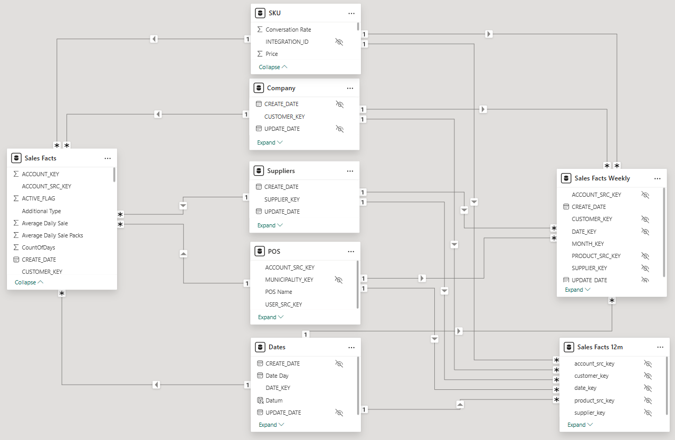
Figure 1 — Sales Facts data model

6.2.2 Warehouse
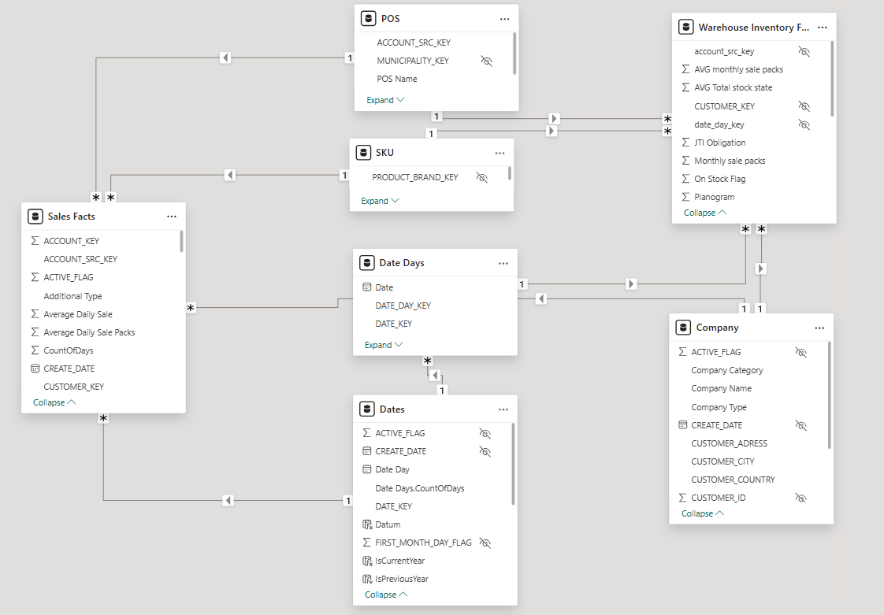
Figure 2 — Warehouse data model

6.2.3 Gifts
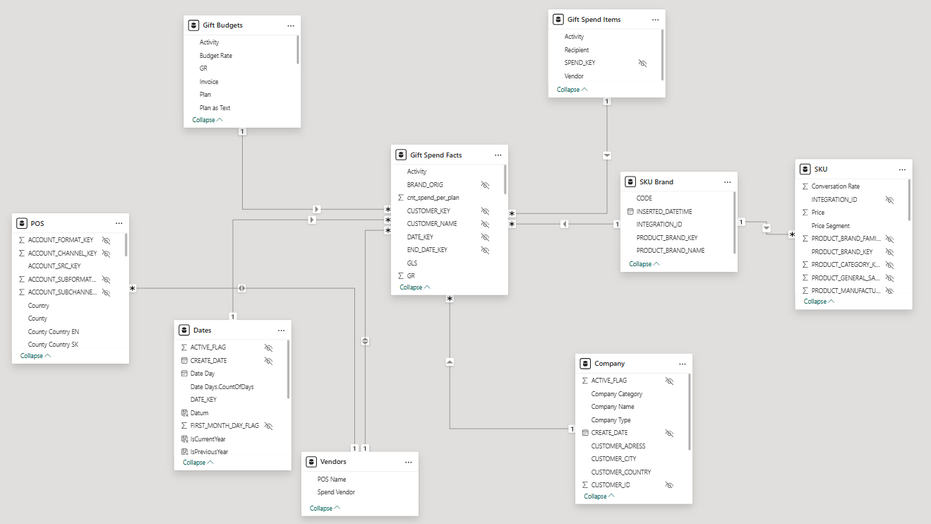
Figure 3 — Gifts data model

6.2.4 Opendata
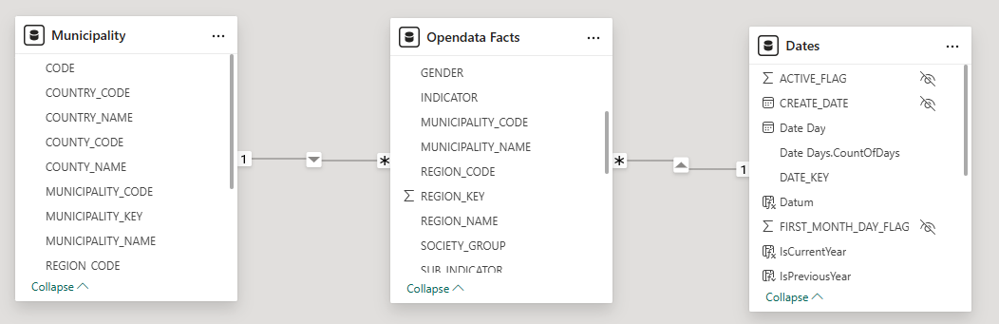
Figure 4 — Opendata data model

6.2.5 CRM
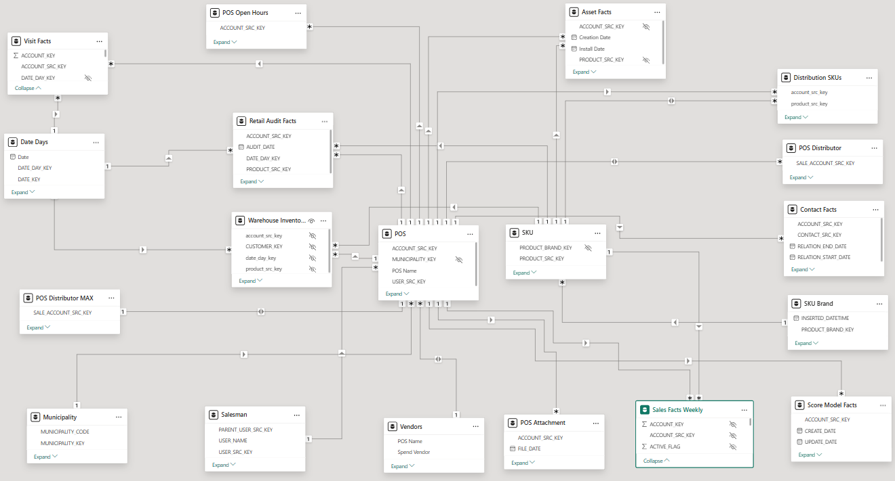
Figure 5 — CRM data model

6.3 Tables
All tables connect to the ClusterDWH database on MSFWEP01-SQL-40 using Power Query M (Import mode). Below are the Power Query expressions and column rename mappings for each table.

6.3.1 Fact Tables
Table ID | Table Name | Source / Notes
12 | Sales Facts | [off].[PL_SALES_FACTS] — joined to TL_CUSTOMERS + TL_DIM_DATE_DAYS. Added: Average Daily Sale, Average Daily Sale Packs. Filtered: DATE_KEY >= 202401. Renamed: SOLD_COUNT → Sold Count SUM, SOLD_COUNT_PACK → Sold Count Pack SUM.
7009 | Activity Facts | [off].[PL_FCT_ACTIVITY]
7015 | Asset Facts | [off].[PL_FCT_ASSET] — renamed: NB_TOBACCO_SLOTS, NB_TOBACCO_FACINGS, OPERATING_STATUS, LOCATION_TYPE, LOCATION_SUBTYPE, AUDITABLE, CONDITION, OWNER, QUANTITY, MANUFACTURER, EXTERNAL_SOURCE, CREATION_DATE, INSTALL_DATE, OWNED_JTI, STATUS, NUMBER
7027 | Contact Facts | [off].[PL_FCT_CONTACT] — renamed: RELATION_STATUS, PRIMARY_FLAG
7048 | Opendata Facts | [off].[PL_OPENDATA_FACTS]
13095 | Planning Spending | [off].[PL_PLANNING_AND_SPENDING] — renamed: BUDGET_COUNT, BUDGET_VALUE_EUR, DESCRIPTION, PLAN_TYPE, COMPANY, BRAND
13113 | Retail Audit Facts | [off].[PL_FCT_RETAIL_AUDIT] — filtered: date_day_key >= 20250101
13119 | Sales Facts 12m | [off].[PL_SALES_FACTS_12M] — renamed: AVG_SOLD_COUNT_PACK_12m, AVG_SOLD_COUNT_12m, SOLD_COUNT_PACK, SOLD_COUNT, SOLD_COUNT_12m, SOLD_COUNT_PACK_12m
13122 | Sales Facts Weekly | [off].[PL_SALES_FACTS_WEEKLY]
13131 | Score Model Facts | [off].[PL_FCT_SCORE_MODEL] — renamed: SCORE_TOTAL, SCORE_NAME, SCORE_A2C
13140 | Survey Answer Facts | [off].[PL_FCT_SURVEY_ANSWER] — renamed: ANSWER, RESPONSE_STATUS, SCORE (Answer Score), SEQUENCE, QUESTION, EXECUTION_DATE
13146 | Visit Facts | [off].[PL_FCT_VISIT] — renamed: DESCRIPTION, DURATION, DURATION_PLANNED, STATUS, PRIORITY, TYPE, VISIT_COUNT, PLANNED_END/START_DATE, VISIT_UID (Visit Code), ACTUAL_START/END_DATE
13161 | Visit Notes Facts | [off].[PL_FCT_VISIT_NOTES] — renamed: NOTE
74045 | Warehouse Inventory Facts | Complex SQL: joins PL_WS_PLANOGRAM_FACT + PL_WS_INVENTORY + monthly avg sales + asset facts. Added calculated fields: ON_STOCK, planogram_vs_on_stock, Stock Coverage, estimated days left, AVG Total stock state
3245610 | Gift Budgets | [off].[TL_FCT_GIFT] (aggregated) joined to [off].[TL_DIM_PLAN]. Added: GR, PO, Invoice, Plan amounts grouped by plan_key/plan_type/plan_vendor

6.3.2 Dimension Tables
Table ID | Table Name | Source / Notes
1439 | Company | [off].[TL_CUSTOMERS] — renamed: CUSTOMER_NAME → Company Name, SALES_TYPE, CUSTOMER_TYPE → Company Type, CUSTOMER_CATEGORY → Company Category
1448 | Suppliers | [off].[TL_SUPPLIERS] — renamed: SUPPLIER_NAME
1457 | Dates | [off].[TL_DATES] — filtered: YEAR > 2022 AND YEAR <= YEAR(GETDATE()). Merged with Date Days. Renamed: DATE_DAY, YEAR, YEARMONTH → Month Number, MONTH, MONTH_NAME
– | Date Days | [off].[TL_DIM_DATE_DAYS] — used for count of days per month
– | Weeks | Calendar weeks dimension
– | POS | Point-of-sale accounts dimension — joined to Salesman via USER_SRC_KEY
– | SKU | Product/SKU dimension — [off].[TL_DIM_PRODUCT]
– | Contact | CRM contact dimension
– | Salesman | Sales representative dimension — FIRST_NAME + LAST_NAME concatenated
– | Teamleader | Team leader dimension — FIRST_NAME + LAST_NAME concatenated; linked to Manager via PARENT_USER_SRC_KEY
– | Manager | Sales manager dimension
– | Distribution SKUs | Distribution status dimension — distributed_flag Y/N
– | POS Attachment | POS attachment facts dimension
– | POS Open Hours | POS opening hours dimension

6.4 Relationships
The following table lists all model relationships (many-to-one unless otherwise noted).

From Table | From Column | To Table | To Column
Sales Facts | DATE_KEY | Dates | DATE_KEY
Sales Facts | CUSTOMER_KEY | Company | CUSTOMER_KEY
Sales Facts | SUPPLIER_KEY | Suppliers | SUPPLIER_KEY
Sales Facts | ACCOUNT_SRC_KEY | POS | ACCOUNT_SRC_KEY
Sales Facts | PRODUCT_SRC_KEY | SKU | PRODUCT_SRC_KEY
Opendata Facts | DATE_KEY | Dates | DATE_KEY
Asset Facts | ACCOUNT_SRC_KEY | POS | ACCOUNT_SRC_KEY
Contact Facts | ACCOUNT_SRC_KEY | POS | ACCOUNT_SRC_KEY
Contact Facts | CONTACT_SRC_KEY | Contact | CONTACT_SRC_KEY
Sales Facts Weekly | DATE_KEY | Weeks | DATE_KEY
Sales Facts Weekly | CUSTOMER_KEY | Company | CUSTOMER_KEY
Sales Facts Weekly | SUPPLIER_KEY | Suppliers | SUPPLIER_KEY
Sales Facts Weekly | ACCOUNT_SRC_KEY | POS | ACCOUNT_SRC_KEY
Sales Facts Weekly | PRODUCT_SRC_KEY | SKU | PRODUCT_SRC_KEY
Planning Spending | CUSTOMER_KEY | Company | CUSTOMER_KEY
Planning Spending | DATE_KEY | Dates | DATE_KEY
Sales Facts 12m | customer_key | Company | CUSTOMER_KEY
Sales Facts 12m | supplier_key | Suppliers | SUPPLIER_KEY
Sales Facts 12m | account_src_key | POS | ACCOUNT_SRC_KEY
Sales Facts 12m | product_src_key | SKU | PRODUCT_SRC_KEY
POS Attachment | ACCOUNT_SRC_KEY | POS | ACCOUNT_SRC_KEY
POS Open Hours | ACCOUNT_SRC_KEY | POS | ACCOUNT_SRC_KEY
Retail Audit Facts | ACCOUNT_SRC_KEY | POS | ACCOUNT_SRC_KEY
Retail Audit Facts | PRODUCT_SRC_KEY | SKU | PRODUCT_SRC_KEY
Score Model Facts | ACCOUNT_SRC_KEY | POS | ACCOUNT_SRC_KEY
Visit Facts | ACCOUNT_SRC_KEY | POS | ACCOUNT_SRC_KEY
Visit Facts | DATE_DAY_KEY | Date Days | DATE_DAY_KEY
Survey Answer Facts | VISIT_FACT_KEY | Visit Facts | VISIT_FACT_KEY
Visit Notes Facts | VISIT_FACT_KEY | Visit Facts | VISIT_FACT_KEY
Activity Facts | VISIT_FACT_KEY | Visit Facts | VISIT_FACT_KEY
POS | USER_SRC_KEY | Salesman | USER_SRC_KEY
Salesman | PARENT_USER_SRC_KEY | Teamleader | USER_SRC_KEY
Teamleader | PARENT_USER_SRC_KEY | Manager | USER_SRC_KEY
Date Days | DATE_KEY | Dates | DATE_KEY

6.5 Measures and Calculated Columns
DAX measures are grouped by source table. Expressions use standard DAX syntax. CALCULATE, FILTER, DIVIDE and VAR patterns are used throughout.

6.5.1 Sales Facts Measures
Measure Name | DAX Expression (summary) | Format
Sum of Sold Count SUM | SUM('Sales Facts'[Sold Count SUM]) | #,0
Total Market Volume | SUM('Sales Facts'[Sum of Sold Count SUM]) | 0
JTI Volume | CALCULATE(SUM('Sales Facts'[Sold Count SUM]), 'Suppliers'[Supplier Name] = "JTI Slovak Republic s r.o.") | #,0
JTI Packs | CALCULATE(SUM('Sales Facts'[Sold Count Pack SUM]), 'Suppliers'[Supplier Name] = "JTI Slovak Republic s r.o.")
Total Packs | SUM('Sales Facts'[Sold Count Pack SUM])
JTI Share of Market | VAR BASELINE_VALUE = CALCULATE(SUM(…), Suppliers[Supplier Name]="JTI…") VAR MEASURE_VALUE = SUM(…) RETURN IF(NOT ISBLANK(MEASURE_VALUE), DIVIDE(BASELINE_VALUE, MEASURE_VALUE)) | 0.00%
Winston Volume | CALCULATE(SUM('Sales Facts'[Sold Count SUM]), Suppliers[Supplier Name]="JTI…", SKU[SKU Brand Family]="Winston Family") | #,0
Winston Volume YTD | CALCULATE([Winston Volume], FILTER(ALL(Dates), Dates[Date Day] <= MAX(Dates[Date Day]) && YEAR(…)=YEAR(…))) | 0
Total Market Volume YTD | CALCULATE([Total Market Volume], FILTER(ALL(Dates), YTD filter))
Share of Market Winston | DIVIDE([Winston Volume], [Total Market Volume], 0) | 0.00%
JTI Volume / visit | DIVIDE([JTI Volume], [Visit count completed]) | #,0
Sum of ACCOUNT_KEY | DISTINCTCOUNT('Sales Facts'[ACCOUNT_SRC_KEY]) | 0
JTI / Počet obyvateľov | DIVIDE([JTI Volume], [Počet obyvateľov]) | #,0.00

6.5.2 Visit Facts Measures
Measure Name | DAX Expression (summary) | Format
Visit count completed | SUM(Visit Facts[Visit Count]) | #,0
Visit Duration AVG | AVERAGEX(Visit Facts, Visit Facts[Visit Duration])
Visit KPI Completion | DIVIDE([Visits Completed], [Visits Planned]) | 0%

6.5.3 Warehouse Measures
Measure Name | DAX Expression (summary) | Format
Total Stock | SUM(Warehouse Inventory Facts[Total warehouse]) | #,0
Stock Coverage (days) | AVERAGE(Warehouse Inventory Facts[Stock Coverage]) | #,0.0
AVG Daily Sale Packs | SUM(Warehouse Inventory Facts[Total AVG daily sale packs]) | #,0.0
On Stock % | DIVIDE(SUMX(Warehouse Inventory Facts, [On Stock Flag]), COUNTROWS(Warehouse Inventory Facts)) | 0%
Planogram vs On Stock | SUM(Warehouse Inventory Facts[Planogram vs. on Stock]) | #,0

ℹ Note Full DAX expressions for all measure groups (POS, Opendata, Planning Spending, Retail Audit, Sales Facts 12m, Gift Budgets, PowerBI Selectors) are documented in the source Power BI Semantic Model Documentation file.

6.5.4 Calculated Columns
Table | Column Name | Expression | Format
Dates | YearMonth | Dates[DATE_KEY] | 0
Dates | IsCurrentYear | IF(YEAR(Dates[Datum]) = YEAR(TODAY()), TRUE(), FALSE()) | "TRUE";"TRUE";"FALSE"
POS | County Map | "Okres " & 'POS'[County] & ", Slovakia"
POS | POS Name - POS Code | POS[POS Name] & " - " & POS[POS Code]
Teamleader | Teamleader Name | [FIRST_NAME] & " " & Teamleader[LAST_NAME]
Salesman | Salesman Name | Salesman[FIRST_NAME] & " " & Salesman[LAST_NAME]
Distribution SKUs | Distribution | IF('Distribution SKUs'[distributed_flag]="Y", "Distribution", "ND")

6.5.5 Calculated Tables
Two calculated tables are defined using DATATABLE:

Table Name | Description
Vendors | Static mapping of COOP cooperative abbreviations (COOP BR, CA, DS, GA, HE, KA, KN, LM, LV, MI, NO, NR, NZ, PD, PO, PP, RA, SE, TO, TRS, TT, VT) to full POS Name. Used for spend/budget reporting joins.
Email Users | Static mapping of JTI user IDs (BTSBROSMR, BTSDANKOI, BTSDIBDIG, … and ~44 others) to @CORP.JTI.COM email addresses. Used by Row-Level Security filter via USERPRINCIPALNAME().

6.6 Data Refresh
Refresh frequency | Daily
Refresh method | Scheduled refresh via Power BI Service
Access mode | Import

6.7 Security

6.7.1 Row-Level Security (RLS)
Row-level security is implemented using a join between the Salesman dimension and the calculated EmailUsers table.

Security role name | JTI_Security_app
Filter table | EmailUsers (calculated table)
DAX filter expression | trim(lower('EmailUsers'[Email address])) = trim(lower(USERPRINCIPALNAME())) || trim(lower(USERPRINCIPALNAME())) in {"vfj3927@corp.jti.com", "btsrykuln@corp.jti.com", "BTSVACLAM@CORP.JTI.COM"}
Admin bypass users | vfj3927, btsrykuln, BTSVACLAM (listed in the IN clause — bypass RLS)

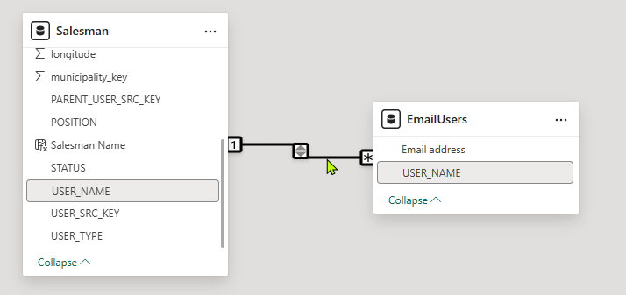
Figure 6 — RLS security configuration in Power BI

