Epsilon: 0.035 Test Accuracy = 6 / 10000 = 0.0006 Percent Misclassified as Closest Class = 9804 / 10000 = 0.9804 [2, 2, 3, 5, 9, 3, 5, 9, 5, 8] Average Cycles: 4.5554 Wall time: 2min 45s

Range: 10

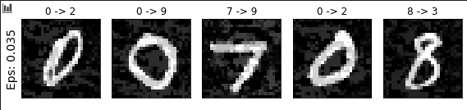

Epsilon: 0.0175 Test Accuracy = 4 / 10000 = 0.0004 Percent Misclassified as Closest Class = 9806 / 10000 = 0.9806 [2, 2, 3, 5, 9, 3, 5, 9, 5, 8] Average Cycles: 8.3921 Wall time: 5min 40s

Range: 20

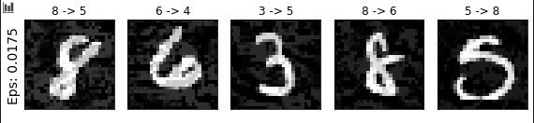

Original 1->2 Transformation by closest gradient system

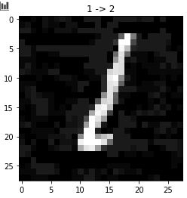

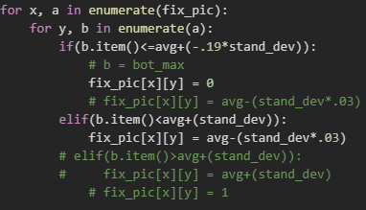 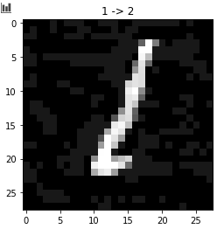

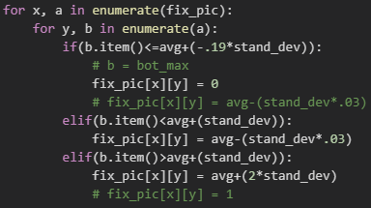 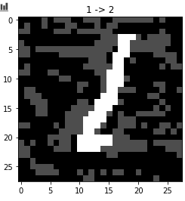

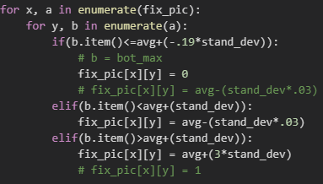 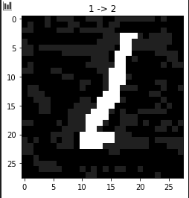

Epsilon: 0.05 Test Accuracy = 1073 / 10000 = 0.1073

CPU times: user 15min 33s, sys: 18.1 s, total: 15min 51s

Wall time: 15min 41s

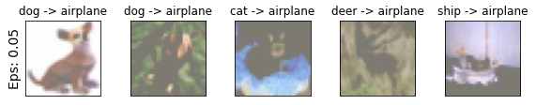

Epsilon: 0.05 Test Accuracy = 748 / 10000 = 0.0748 Percent Misclassified as Closest Class = 8380 / 10000 = 0.838

[2, 9, 0, 5, 2, 3, 3, 5, 0, 0]

Average Cycles: 1.6132

CPU times: user 3min 46s, sys: 10 s, total: 3min 56s

Wall time: 3min 46s

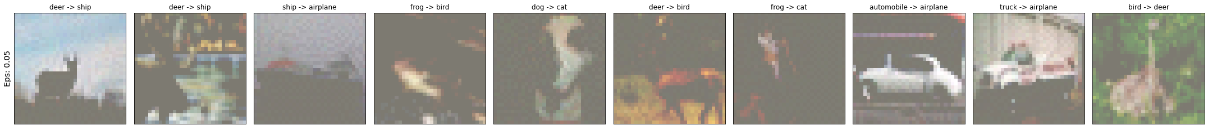

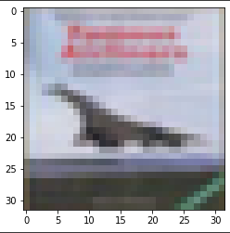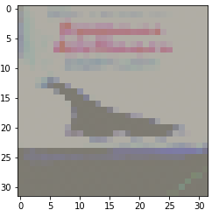

Airplane -> Ship

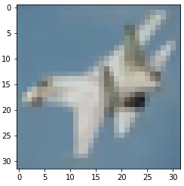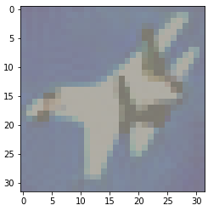

Airplane -> bird

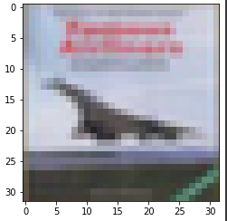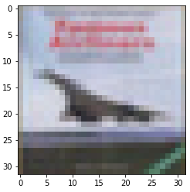

Airplane -> ship

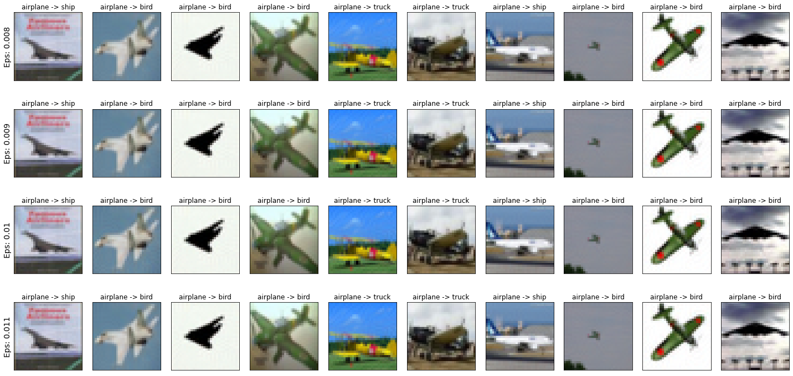

Epsilon: 0.008 Test Accuracy = 66 / 10000 = 0.0066 Percent Misclassified as Closest Class = 9062 / 10000 = 0.9062

Average Cycles: 3.4138

Epsilon: 0.009 Test Accuracy = 29 / 10000 = 0.0029 Percent Misclassified as Closest Class = 9099 / 10000 = 0.9099

Average Cycles: 3.1102

Epsilon: 0.01 Test Accuracy = 22 / 10000 = 0.0022 Percent Misclassified as Closest Class = 9106 / 10000 = 0.9106

Average Cycles: 2.8683

Epsilon: 0.011 Test Accuracy = 19 / 10000 = 0.0019 Percent Misclassified as Closest Class = 9109 / 10000 = 0.9109

Average Cycles: 2.6624

Range: 10