## Download u-boot

Get version u-boot-2017.01.tar.bz2 from URL https://src.fedoraproject.org/lookaside/extras/uboot-tools/

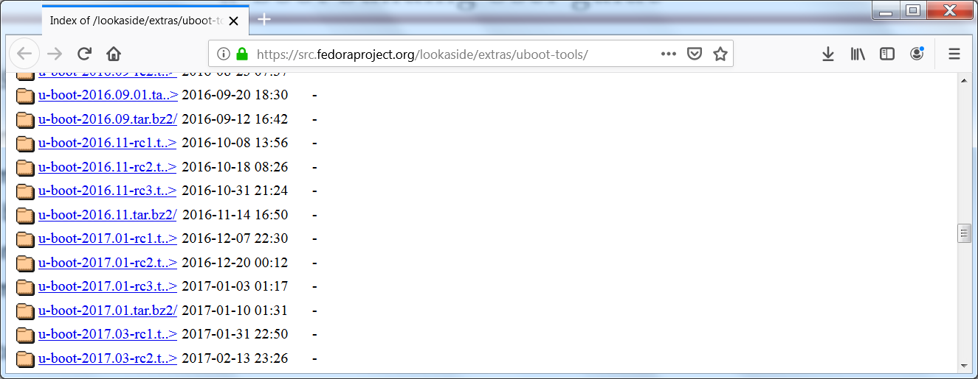

1. **Create a Project on Wind River**

Create a project from **u-boot-2017.01.tar.bz2** zip file and name it U-Boot SD card or U-Boot QSPI this will depend of what patch file you are going to apply (**U-Boot_QSPI_FIX_GSX.patch** or **U-Boot_SDcard_FIX_GSX.patch**), and finally copy all the files into the project. Note: Paths files are in _Support_Tools in integration stream.

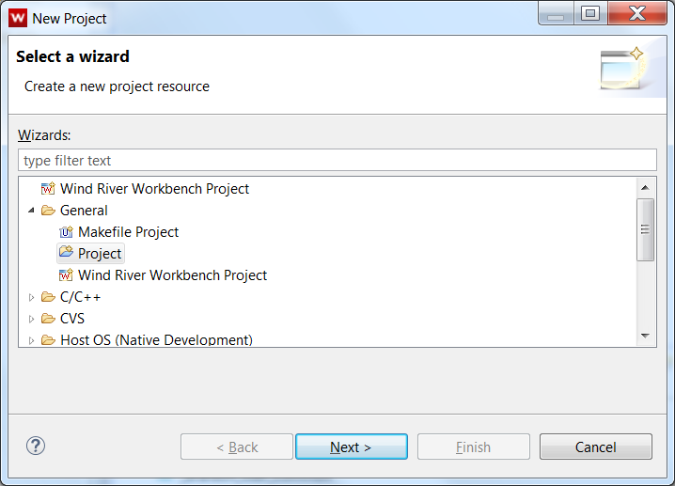 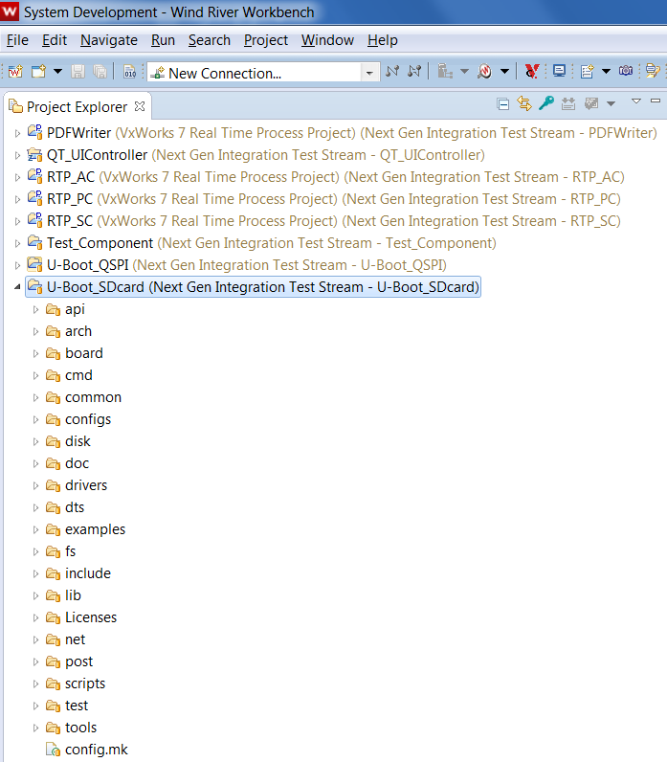

## Publish a Component

Select the project, right click and create a component to publish to the RTC Jazz Repository.

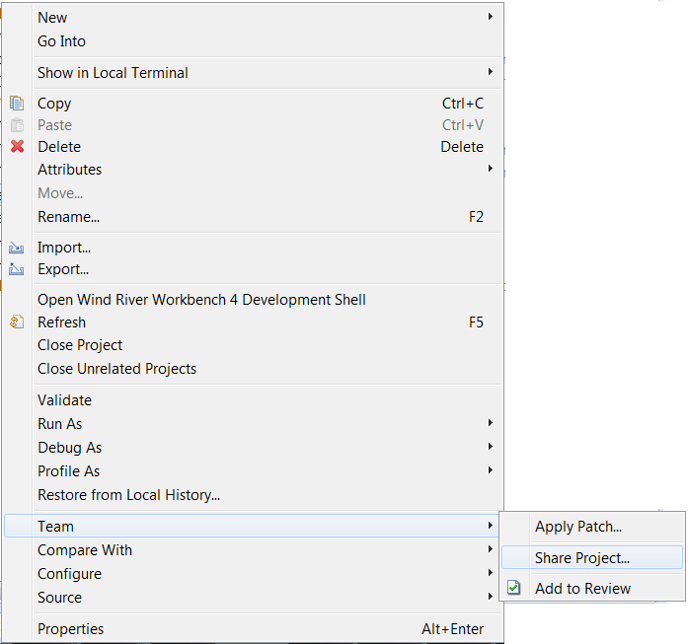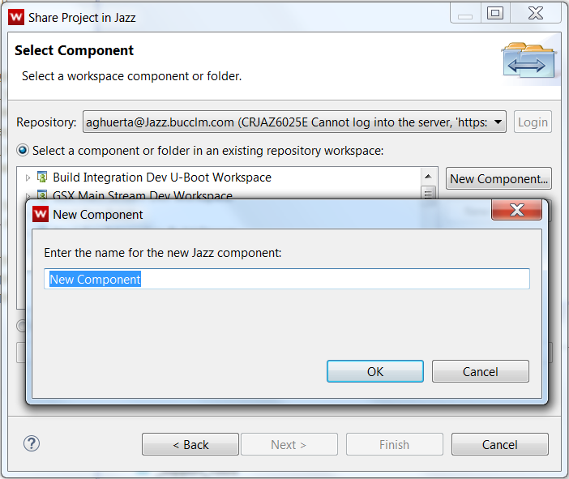

Add the component to the stream, you selected.

Note: this is a test development stream, example.

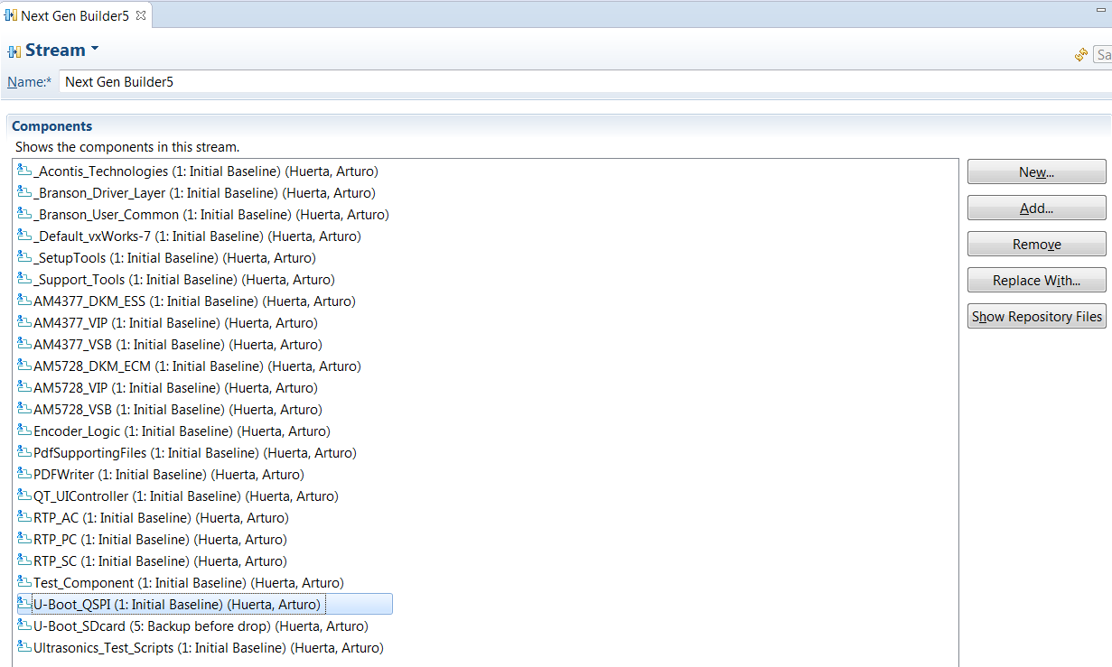

## Apply the patch fix

After publishing and synchronizing your component from the Jazz repository, right click to your project and apply the select file patch

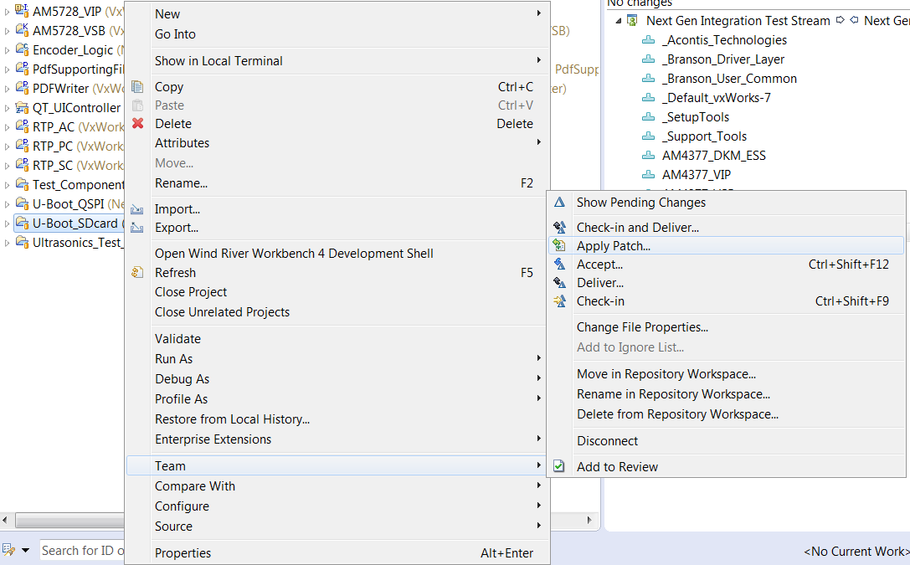

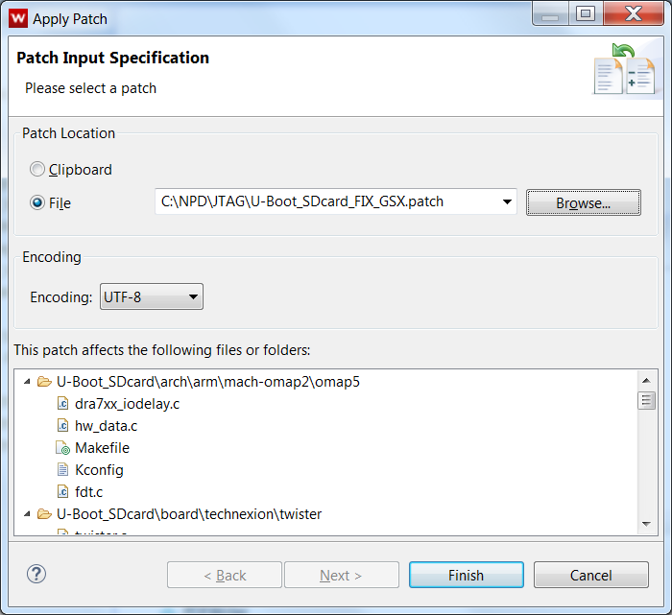

## Build the binary’s

Install Ubuntu or use builder4 for building the binaries.

Give permission to all the project as root access and run the script build_sdcard_sc.sh or build_uboot_sc.sh

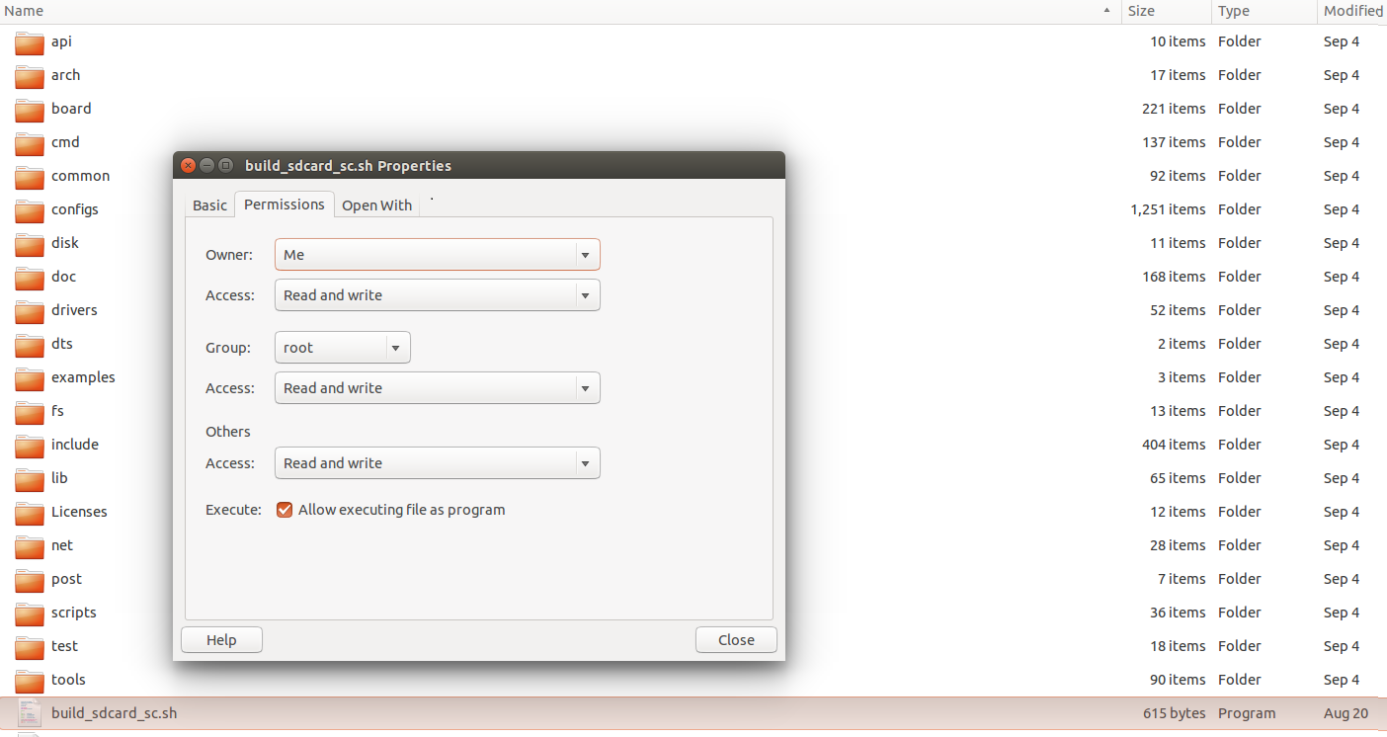

Run the script with “sudo ./build_uboot_sc.sh”

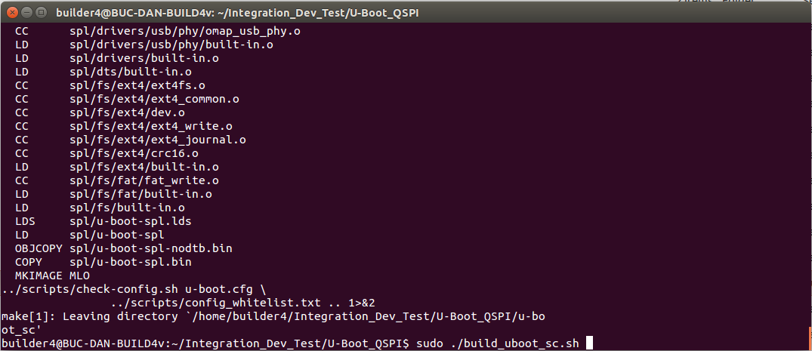

Note: Please make sure you have GCC LINARO 6.2.1 install in your system

