|  |  |  |
| --- | --- | --- |
| **Power Puff Girls** | | |
| **LEADER:** | | |
| **Name** | **Section** | **Grade** |
| Jhon Paul Tadiamon | T222 | 10 |
|  | | |
| **MEMBERS:** | | |
| **Name** | **Section** | **Grade (5-10), (N/A) if no participation** |
| Justine Binanlao | T222 | 10 |
| Shereen Kate Amor P. Dumatal | T222 | 10 |
| Mharian Dave Estopito | T222 | 10 |
| Klinton Jay Noto | T177 | 10 |
| Anthony Paglas | T204 | 10 |
|  | | |
| **LEADER E-SIGNATURE:**  Jhon Paul Tadiamon | | |

Note:

Leader should grade their members based on the member’s contribution and performance in making the final project.

5 = lowest

10 = Highest

N/A = No participation

**QAMIS Evaluation Screen Shots**

Use the following codes for QAMIS evaluation

|  |  |  |
| --- | --- | --- |
| **SECTION** | **Flexible Learning Teacher Performance** | **Evaluation of a Module (Teacher-User Evaluation)** |
| T222 | 13AA35 | F18730 |
| T204 | 13AE33 | 13AE24 |
| T177 | 13AE1E | 13AE26 |

Attached all your screenshots below.

Klinton Jay Noto

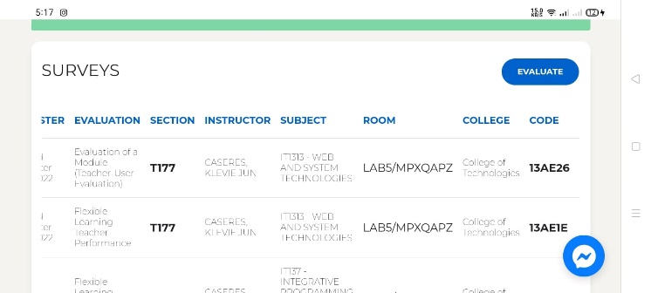

Anthony Paglas



Mhariane Estopito

Shereen Kate Amor P. Dumatal

Justine Binanlao