­­­­­

|  |  |
| --- | --- |
|  |  |



Solution Design

Document

Table of Contents

I. Purpose 3

II. Automated process details 4

3 Runtime guide 5

3.1 Architectural structure of the Master Project 5

3.2 Master Project Runtime Details 5

3.3 Project name 1 6

3.4 Project(s) workflows 6

3.5 Packages 7

3.6 Architectural structure of the Master Project 7

4 Other Details 8

Future Improvements 8

Other Remarks 8

5 Glossary 9

# Purpose



Outlines the major components of the Master Project (the overall output of the development, containing one or multiple projects that together cover the scope of the robotic process automation) taking into account all the business restrictions (scheduling, peaks, future increases in volume etc.). The focus of the Solution Architect will be on:

* Robustness;
* Efficiency;
* Replicability;
* Reusability of component

The information herein is targeted primarily at the developers that will initially implement the solution and subsequently at the support developers in case of change requests.

# Automated process details

Details filled in need to reflect the actual information for the Master Project released for production. The following table will be populated:

|  |  |
| --- | --- |
| Item | Description |
| Master Project Name | Best Tablet Finder |
| Robot Type | FOR |
| Orchestrator used? | No |
| Scalable | No |
| UiPath version used | 2023.12.0 |

# Runtime guide

## Architectural structure of the Master Project

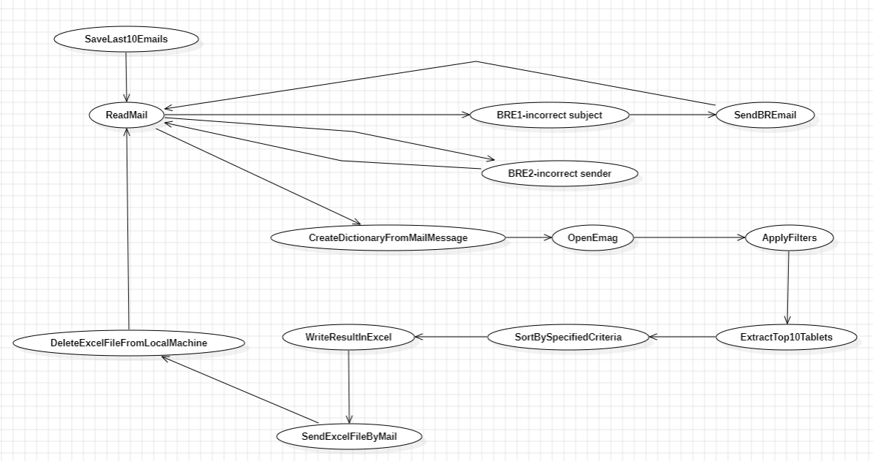

## Master Project Runtime Details

Outlines the details of the automated process by filling in the table below.

|  |  |
| --- | --- |
| ITEM NAME | DESCRIPTION  *Fill in each bolded section - empty fields are not allowed. If the section does not apply to your automation then mark as n/a.* |
| Production environment details | ***Running locally on my machine.*** |
| Prerequisites to run | ***Having Excel, Outlook and Edge on the machine*** |
| Input Data | ***Last 10 E-Mails received*** |
| Expected output | ***Sent mails to users with the expected data*** |
| How to start the automated process | ***The process will be started from UiPath Studio*** |
| Reporting  (queues reporting, Kibana or another platform) | ***Logs in UiPath Studio*** |
| How is Orchestrator used? | ***Orchestrator is not used*** |
| Password policies  (mention any specific compliance requests) | ***Outlook password only, not expiring.*** |
| Stored credentials  (Never use hardcoded credentials in the workflow!) | ***Stored credentials are not used*** |
| List of queues names  (Naming convention: ProcessName_QueueName) | ***None*** |
| Schedule Details | ***None*** |
| Multiple Resolutions Supported?  (in case of image automation / Citrix and VDI) | ***No*** |
| Recommended Resolution | ***1920x1080*** |

## Project name

|  |  |
| --- | --- |
| ITEM NAME | DESCRIPTION  *Fill in each section - empty fields are not allowed. If the section does not apply to your automation then mark as n/a.* |
| Environment used for development  (name, location, configuration details etc) | ***UiPath Studio*** |
| Environment prerequisites  (OS details, libraries, required apps) | ***Windows 10/11, Microsoft licenses*** |
| Repository for project  (where is the developed project stored) | *Locally*  *On github : https://github.com/BratuAndreiEugen/proiect_RPA* |
| Configuration method  (assets, excel file, Json file) | ***n/a*** |
| List of reused components | ***n/a*** |
|
| List of new reusable components | ***n/a*** |

## Project workflows

For the workflow files defined below please specify the input and output parameters.

|  |  |
| --- | --- |
| Workflow Name | Description |
| Main | ***Specifies the interaction between states*** |
| ApplyFilters | ***Applies filters on the eMAG browser page*** |
| OpenEMAG | ***Opens eMAG in browser*** |
| CloseEMAG | ***Closes eMAG in browser*** |
| CreateDictionaryFromMailMessage | ***Creates a dictionary of filters from a mail message (OUT : dictionary )*** |
| DeleteFile | ***Deletes the excel file after it was sent*** |
| VerifySender | ***Checks the validity of a sender with the Config.xlsx file*** |
| VerifySubject | ***Checks the validity of the subject with the Config.xlsx file*** |
| ReadMail | ***Reads the top 10 e-mails from the inbox*** |
| SendMail | ***Sends the response e-mail containing the excel file*** |
| WriteExcelFile | ***Writes the scraped results given as input to the excel file*** |
| SendBusinessException | ***Sends an email notifying the user of a mistake in their imput*** |

## Packages

Include the list of packages and high-level description for each of them, to explain their purpose

|  |  |
| --- | --- |
| Package Name | Description |
| *ApplicationLayer* | Handles all interactions with eMAG |
| *DataLayer* | Handles data validation and convertion |
| *ServiceLayer* | Handles e-mail sending and reading |

# Other Details

### Future Improvements

Fill in any improvements that need to be considered for the future:

*• Optimize the processing algorithm ( if two e-mails contain the same filter, we should do only one scrape for it’s response*

*• Scale the application to work for other categories*

# Glossary

The main terms used in the Solution Architecture Document are defined below:

**Master project** - the overall output of the development, containing one or multiple projects that together cover the scope of the robotic process automation. There is a 1 to 1 connection between the Master Project and the Process to be automated (As presented in the PDD).

**Project** - an UiPath Studio project containing one or multiple workflow files. A project can be converted to a package and run independently, covering a particular scope within the master project. Or multiple projects can be converted into one package depending on the aims and restrictions of the automation. The project is used when defining the development and support phase of the automation.

**Package** - the output of compiling one or multiple projects. A package can be deployed on the robot machine and be executed by the robot service. Only one package can be executed at a given time by a robot. The package is used when defining the running phase of the automation.

Workflow - a component of the package, the workflow encapsulates a part of the project logic. The workflow can be of type: sequence, flowchart or state machine. A workflow is saved as an .xaml file inside the project folder. A workflow file can be invoked from another workflow and by default there is an initial workflow file that will run when executing the package.

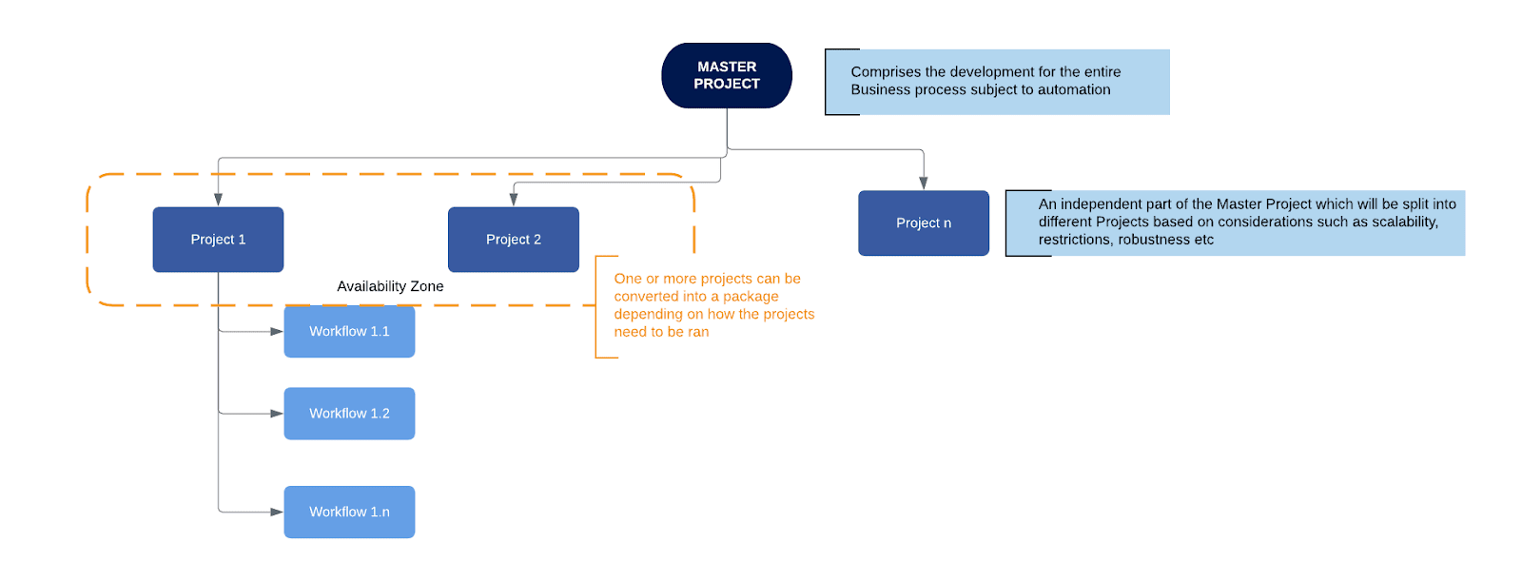

**Activity** - an action that the robot executes.

**Sequence** - a workflow where activities are executed one after another, in a sequential order

**Flowchart** - a workflow where activities are connected by arrows and the logic of the workflow can be easily followed in a visual manner. The flowchart can also be exported as an image from UiPath studio.

**State machine** - a more advanced way of organizing a workflow, similar to a flowchart.

**BOR** - Back office robot

**FOR** – Front office robot

**Orchestrator** – Enterprise architecture server platform supporting: release management, centralized logging, reporting, auditing and monitoring tools, remote control, centralized scheduling, queue/robot workload management, assets management.