Formulas that we will solve using our algorithms :

The equation of motion only with gravity:

$$\ddot{r}=\frac{-μ}{r^{3}}r$$

Equation of motion with gravity and corrections for additional forces

$$\ddot{r}=\frac{-μ}{r^{3}}r+a_{d}+a_{c}$$

Where $a_{d}$ is the acceleration due to friction and $a_{c}$ It is the acceleration resulting from the Earth's motion

Mathematical Functions for RK4,RK8,ODE45

$$y_{i+1}=y_{i}+h\sum_{J=1}^{12}{b_{j}}k_{j}$$

$$k_{i}=f\left(t_{n}+c_{i}h,y_{n}+h\sum_{J=1}^{s}{a_{ij}k_{j}}\right),ⅈ=1,⋯,s$$

$$h=t_{i+1}-t_{i}$$

**RK4**



**RK8**

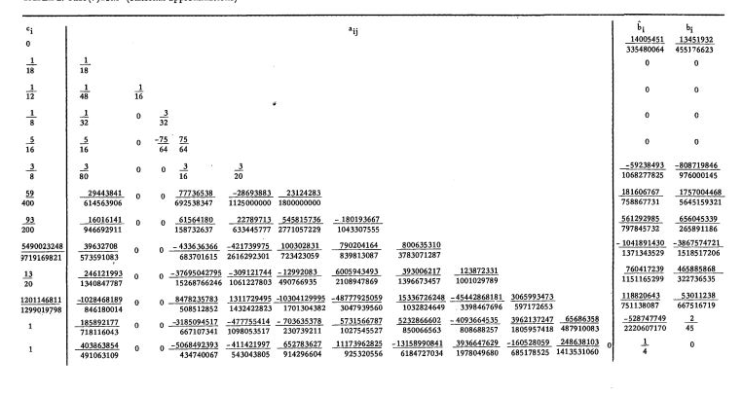

**ODE45**

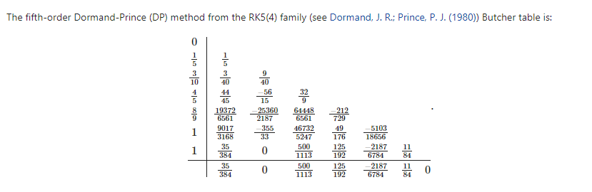

**ODE113**  
 In general, a method of order s can be stated as

$$y_{n+s}=y_{n+s-1}+h\sum_{i=0}^{S-1}{aif\left(y_{n+i} ,t_{n+i}\right)}$$



