SOW Phase 2: Deliverables
- Run the code on https://github.com/Braumeister-Stefan/ParticleSimulator2/tree/Fiverr_branch2 for Test1_long and confirm the above TE Error threshold matches the one above. Any differences to be discussed with the client before continuing.

- Identify root causes for the TE energy error reported in the outputs for Test1_long, Test_1_long_step001. Share in (half a page):

  - For each found root cause A) what, B) where in the code it occurs
  - Whether this confirms/contradicts the final report of the previous order (below for reference)

- Share updated code with changes to fix the underlying violation of energy conservation.
  - This can be delivered by sharing the changed cpp/.h files over WeTransfer or by creating a branch of the code

- Provide printscreen of simulation results of Test1_long evidencing an abs(TE <1%) as per the above metric.

- Provide a gif/mp4 illustrating system orbital dynamics is maintained for Test1_long. This can be provided over Wetransfer or by creating a branch of the code.

Relevant documentation shared by client
- Branch to start work from: https://github.com/Braumeister-Stefan/ParticleSimulator2/tree/Fiverr_branch2
- Reported outputs of the scenarios run from the client’s side

Specification of scenarios and objects of relevance. Please note Test1_long_step001 is provided to illustrate error does not significantly depend on dt and no expectation to rerun this scenario.
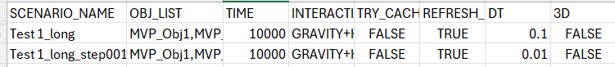

BEFORE: Simulation Output Test_1_long (dt=0.1)
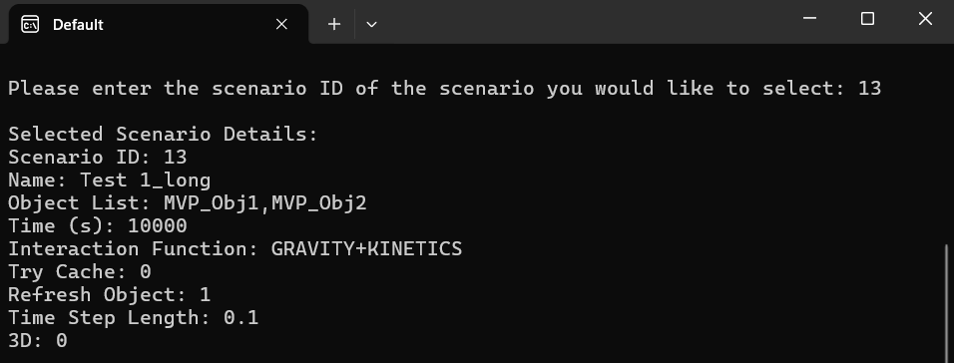
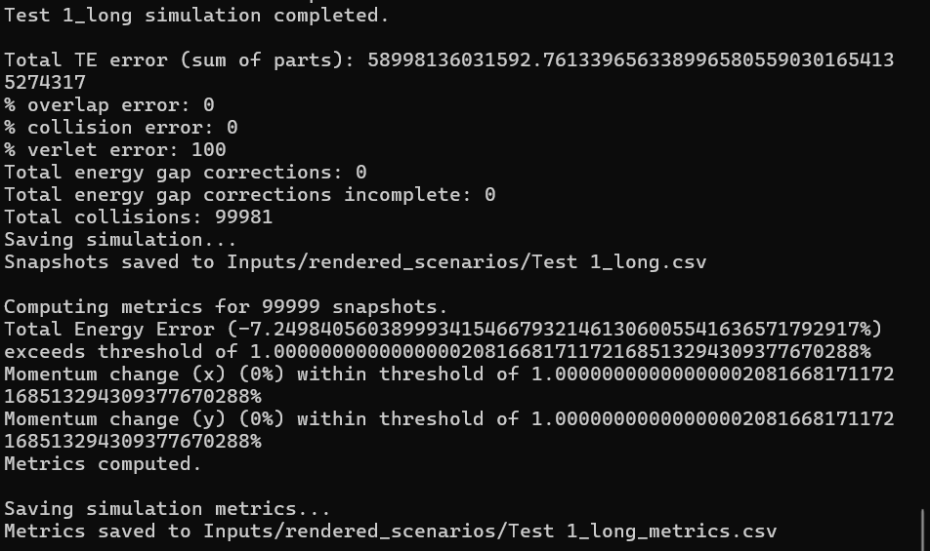
BEFORE: Simulation Output Test_1_long_step001 (dt=0.01)
Note there is no expectation to provide outputs for this scenario. It is there to illustrate that a smaller timestep does not resolve the TE error.
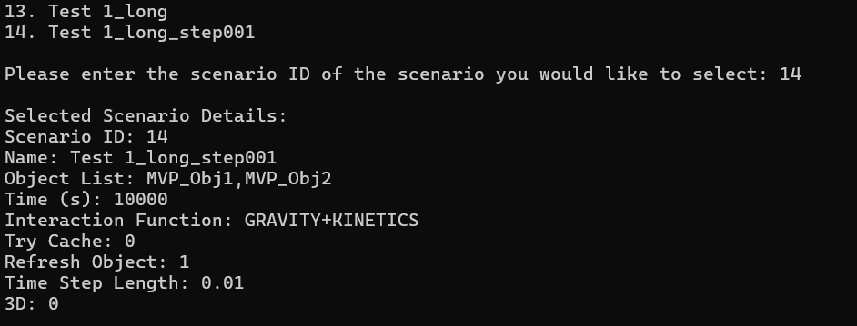
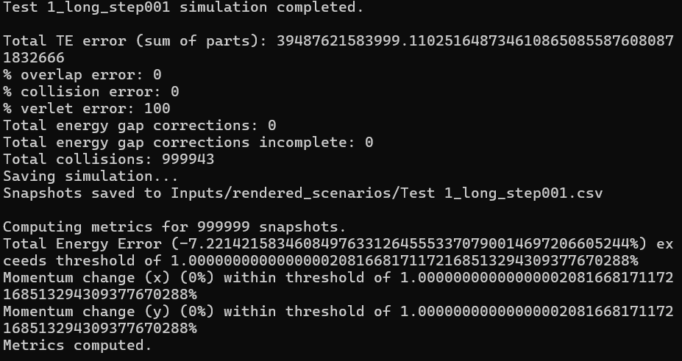
- Final Technical report produced by Junaid as per previous Fiverr order:

Technical Report Energy Conservation in Inelastic Collisions Executive Summary We identified three critical bugs causing energy conservation violations in inelastic collisions. All involve missing heat conversion: kinetic energy lost during inelastic processes is not converted to thermal energy, causing systematic energy loss. Test Results: Inelastic scenarios show -0.005% to ~0.0000002% energy drift (within 0) heat_ij(delta_E, particle1, particle2); Priority: HIGH - If Bug #2 is fixed (overlap becomes positional), this function may become unused. Secondary Findings (Verified Correct) Component Status Notes Velocity Verlet integration ✅ Correct Lines 761-887, standard implementation Force-potential consistency ✅ Consistent Both use softened distance ε²=1e-12 Precision (double ↔ high_prec) ⚠️ Minor Measurement drift only Integration order ✅ Reasonable Overlap → Collision → Verlet Implementation Plan Phase 1 (Fix Primary Cause): 1. Add heat_ij() call in resolve_collission() after line 745 2. Run Test1-4 inelastic → expect energy error near zero Phase 2 (Fix Overlap Logic): 3. Implement Bug #2 Fix Option A (positional-only overlap) 4. Add heat_ij() call in resolve_energy_gap() if still needed 5. Run long-duration tests → verify stable total energy Phase 3 (Validation): 6. Test edge cases: perfectly inelastic (e=0), grazing collisions, multi-body systems 7. Verify all conservation laws: energy, momentum, angular momentum Explanation of Observed Symptoms Client observation: "Particles keep speeding up rotation → disintegration" Analysis: Code has no rotational dynamics (particles are point masses). "Rotation" refers to orbital motion in multi-body systems. Mechanism: - Bug #2 injects energy during overlaps → orbits gain KE → expand/accelerate - Bug #1 loses energy during collisions → unstable equilibrium - Net: Energy fluctuates, orbits become unbound, systems disintegrate Why drift is negative: Bug #1 (missing heat in collisions) is systematic - every inelastic collision loses energy. Bug #2 adds energy, but Bug #3 correction removes more than added. Overall: more deleted than injected → TE consistently decreases. Summary Three bugs all stem from the same issue: incomplete thermodynamic bookkeeping. When kinetic energy is removed from the system (via inelastic collisions or energy corrections), it must be converted to thermal energy to satisfy TE = KE + PE + HE. The heat_ij() function was implemented for this purpose but is never called, causing systematic energy loss. Recommended priority: Fix Bug #1 first (add heat conversion in collisions) as it addresses the primary mechanism. Bugs #2 and #3 are secondary issues that compound the problem.
- GIF showing orbital dynamics of the system for Test1_long
https://github.com/Braumeister-Stefan/ParticleSimulator2/blob/Fiverr_branch2/proof%20of%20concept%2005-10-24.gif

