Exercise #B1(**AnalogWrite,** **Pulse Width Modulation, PWM**):

**Reading an analog sensor (TMP 36)**

The TMP36 is a low voltage, precision centigrade temperature sensor. It provides a voltage output that is linearly proportional to the Celsius temperature. It also doesn't require any external calibration to provide typical accuracies of ±1°C at +25°C and ±2°C over the −40°C to +125°C temperature range.

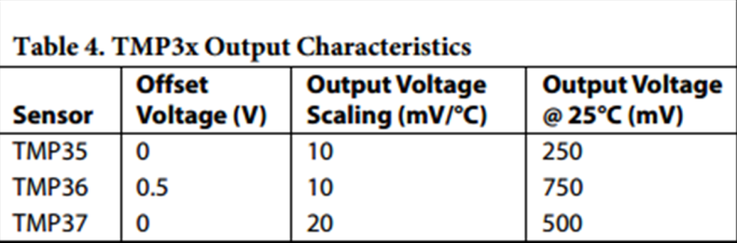 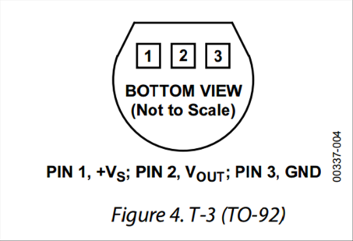

**For the complete datasheet of the TMP36, please check the ‘links’ page at the workshop webpages.**

**Controlling LED illumination**

Light emitting diodes (LEDs) are two-terminals devices that emit light at an intensity that is proportional to the current the flows through the device.

LEDs are polar devices: the long leg should be connected to the positive voltage and the short leg should be connected to the GND pin.

In order not to kill an LED, its current should be limited. Here we use 270 Ohms resistor (which is connected in series to the LED) to limit the LED current to below 20 mA (For a 5V source).

**The circuit:**

* thermometer TMP 36 (pin 2 – center) attached to analog input 0;

* thermometer TMP 36 (pin 3) to ground; * thermometer TMP 36 (pin 1) to +5V

* 3 color LED: short leg(s) to the GND; long leg(s) to the 5V via 150-270 ohm resistor.

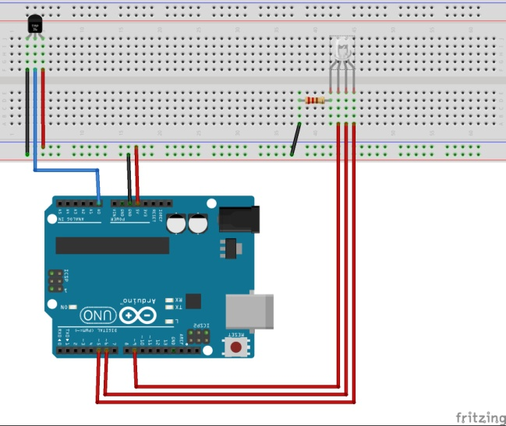!!! Connecting the TMP in an opposite polarity causes an excessive heating that may kill the device and/or cause burns !!!

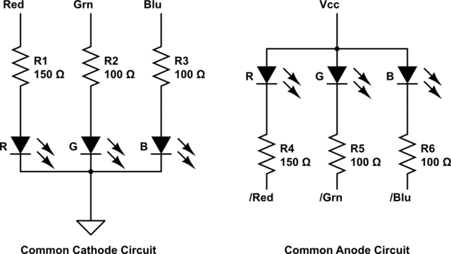

**#B1: vary the color of the LED (from blue to red) with increase in the reading temperature – from red at 22oC to Blue at 34oC.**

Use the following example from the Arduino examples library: 03 Analog/AnalogInOutSerial

**Hints:**

1. read the value of the TMP sensor and convert it to temperature
2. map the temperature range over which you want to change the colors into a range of 1-255
3. using analogWrite(LED,#) vary the voltage of the LEDs to achieve the desired color

**modifications:**

1. Use the serial monitor to define a threshold temperature (integer) below which the LEDs is turned off
2. Fade-out the LED

__________________________________________________________

Exercise #B2 (reading sensor, and **plotting results**).

Download Megunolink LITE from the following link: [http**://www.megunolink.com/megunolink-lite/**](http://www.megunolink.com/megunolink-lite/)

Download and install the Arduino Library: [**http://www.megunolink.com/download/GraphSeries.zip**](http://www.megunolink.com/download/GraphSeries.zip)

* Plot the measured temperature
* Save the data to a text file

**The circuit:**

* thermometer TMP 36 (pin 2 – center) attached to analog input 0

* thermometer TMP 36 (pin 3) to ground

* thermometer TMP 36 (pin 1) to +5V