Peer Evaluation for Lab 5 – Chapter 12
Your name: (Your lab is the one being evaluated) | Martin Braunlich
Name(s) of peer evaluator(s)
Date: | 2/21/2019
Github: https://github.com/BraunlichMartin/C-sharp-part-2-lab5-completed.git
Instructions
You should have already completed Lab 5. After you and a peer have evaluated your work, you will submit this evaluation along with screen shots and source code indicated in moodle. You may make corrections to your work as a result of the evaluation.
In Class Exercises – Customer Maintenance Application
Completed Application?  - Implemented Add Customer Form?  - Added a private instance variable that will refer to a customer?  - Added a public method GetNewCustomer? Method instantiates and shows the form as a dialog box and returns the customer object?  - Added a click event handler on the ok button? Event handler validates all of the data, creates a new customer object with those values, sets the dialog result property and closes the dialog?  - Added a click event handler on the cancel button? Event handler sets the dialog result property and closes the dialog?  - Implemented Customer Maintenance Form?  - Added a private instance variable that will refer to a list of customer objects?  - Added a load event handler for the form? Event handler uses the static method GetCustomers in the CustomerDB class to load the Customers from the file? Uses a loop to iterate through each customer in the list, calls the method GetDisplayText on each customer object and adds that string to the list box on the form? Created a method on the form to fill the list box from the list (because it’s used in 3 places on the form)?  - Added a click event handler for the Add button? Instantiates an Add Customer Form and calls an appropriate method to display the form and get the new customer information? If the user clicked the ok button, add the customer to the list, save the customer list and re-fill the list box? If the user clicked the cancel button, doesn’t do anything?  - Added a click event handler for the Delete button? Removes customer from the list? Calls the save method in the DB class to save the changes? Refreshes the list? | Yes.  Yes.  Yes.  Yes.  Yes.  Yes.  Yes.  Yes.
One thing that you learned from using the class in an application:

Creating custom classes
Something that you’d like to continue working on:
Using database classes

Time you spent completing the application:
First time in class. Second time ~2 hours
Screen shot of the application running. Source code for UI.
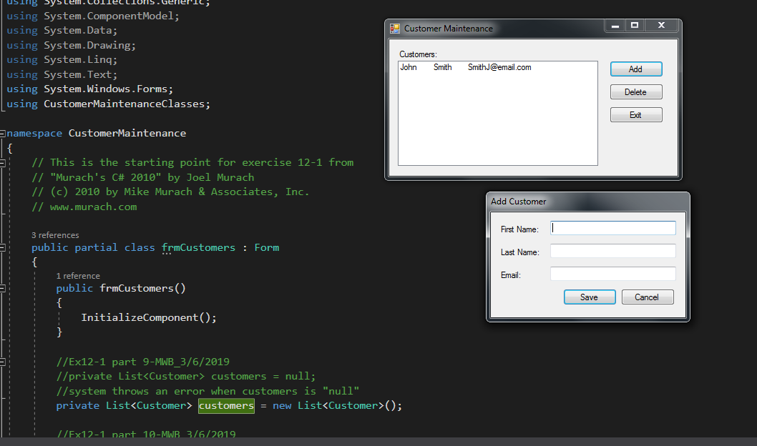
frmCustomers:
//Ex12-1 part 9-MWB_3/6/2019
//private List<Customer> customers = null;
//system throws an error when customers is "null"
private List<Customer> customers = new List<Customer>();

//Ex12-1 part 10-MWB_3/6/2019
private void frmCustomerMain_Load(object sender, System.EventArgs e)
{
customers = CustomerDB.GetCustomers();
FillCustomerListBox();
}
private void FillCustomerListBox()
{
lstCustomers.Items.Clear();
foreach (Customer c in customers)
{
lstCustomers.Items.Add(c.GetDisplayText("\t"));
}
}
//Ex12_1 part 11-MWB_3/6/2019
private void btnAdd_Click(object sender, System.EventArgs e)
{
frmAddCustomer newCustomerForm = new frmAddCustomer();
Customer customer = newCustomerForm.GetNewCustomer();
if(customer != null)
{
customers.Add(customer);
CustomerDB.SaveCustomers(customers);
FillCustomerListBox();
}
}
//Ex12-1 part12 -MWB_3/6/2019
private void btnDelete_Click(object sender, System.EventArgs e)
{
int i = lstCustomers.SelectedIndex;
if (i != -1)
{
Customer customer = customers[i];
string message = "Are you sure you want to delete " + customer.LastName + "?";
DialogResult button = MessageBox.Show(message, "Confirm Delete", MessageBoxButtons.YesNo);
if (button == DialogResult.Yes)
{
customers.Remove(customer);
CustomerDB.SaveCustomers(customers);
FillCustomerListBox();
}
}
}
private void btnExit_Click(object sender, EventArgs e)
{
this.Close();
}

frmAddCustomers:
//Ex12-1 part5 MWB
private Customer customer = null;

//Ex12-1 part6: add a public method named "GetNewCustomer" that displays the form as a dialog box and returns a Customer as object
public Customer GetNewCustomer()
{
this.ShowDialog();
return customer;
}

//Ex12-1 part7 -MWB_3/6/2019
private void btnSave_Click(object sender, EventArgs e)
{
if(IsValidData())
{
customer = new Customer(txtFirstName.Text, txtLastName.Text,
txtEmail.Text);
this.Close();
}
}
private bool IsValidData()
{
return Validator.IsPresent(txtFirstName) &&
Validator.IsPresent(txtLastName) &&
Validator.IsPresent(txtEmail) &&
Validator.IsValidEmail(txtEmail);
}
//Ex12-1 part8 -MWB_3/6/2019
private void btnCancel_Click(object sender, System.EventArgs e)
{
this.Close();
}

Concentration Problem
Create a solution that included 3 project? (Windows form, class library, console app for testing?) Concentration GUI is the startup project? Added a using using statement in the concentration form to access the class library? Added a reference in the gui project to access the class library? | Yes.  Yes.  Yes.  Yes.  Yes.
Added an instance variable that is an array of cards? | Yes.
Methods that originally manipulated “Cards in the UI” now manipulate array of cards? Which methods are those? | Yes.
Does the application function appropriately? Can you interact with the application in a way that causes it to “degrade” and not gracefully? | Yes.  Didn’t find one.
One thing that you learned from using the class in an application:

Creating classes and validation of programs
Something that you’d like to continue working on:
Validation; these tests were very simple(there are many more ways for an email address to be wrong).

Time you spent completing the application:
~3hours

Screen shot of the application running. Source code for the UI.
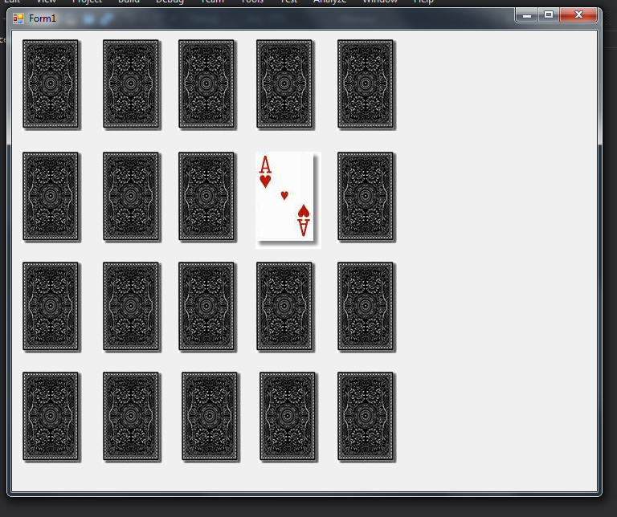
Cards.cs:

public class Card
{
private int suit; //the suit can range from 1 to 4
private int value; //the value can range from 1 to 13

private string[] suits = { "????", "clubs", "diamonds", "hearts", "spades" };
private string[] values = { "???", "ace", "2", "3", "4", "5", "6", "7", "8", "9", "10", "jack", "queen", "king" };

//Default card of ace of clubs constructed
public Card()
{
value = 1;
suit = 1;
}

//Card with specified value and suit created
public Card(int v, int s)
{
value = v;
suit = s;
}

public int Value
{
get
{
return value;
}
set
{
this.value = value;
}
}
public int Suit
{
get
{
return suit;
}
set
{
this.suit = value;
}
}

public bool IsBlack()
{
if (suit == 1 || suit == 4)
{
return true;
}
else
{
return false;
}
}

public bool IsQueen()
{
if (value == 12)
{
return true;
}
else
{
return false;
}
}

public bool IsClub()
{
if (suit == 1)
{
return true;
}
else
{
return false;
}
}
public bool IsDiamond()
{
if (suit == 2)
{
return true;
}
else
{
return false;
}
}
public bool IsHeart()
{
if (suit == 3)
{
return true;
}
else
{
return false;
}
}

public bool IsSpade()
{
if (suit == 4)
{
return true;
}
else
{
return false;
}
}
public bool IsFaceCard()
{
if (value >= 11 && value <= 13)
{
return true;
}
else
{
return false;
}
}

public string FileName
{
get
{
return "card" + values[value].Substring(0,1) + suits[suit].Substring(0, 1) + ".jpg";
}
}

//Checks for a match on values of two cards
//could use "value" instead of "this.value"
public bool HasMatchingValue (Card other)
{
if (other.Value == this.value)
return true;
else
return false;
}

//Sets the image of the given PictureBox to the proper filename
public void Show(PictureBox p)
{
p.Image = Image.FromFile(System.Environment.CurrentDirectory + "\\Cards\\" + FileName);
}

//Sets the image of the given PictureBox to the card back image
public void ShowBack(PictureBox p)
{
p.Image = Image.FromFile(System.Environment.CurrentDirectory + "\\Cards\\black_back.jpg");
}

public override string ToString()
{
return values[value] + " of " + suits[suit];
}
}
}

Card tests:

namespace CardTests
{
public class Program
{
static void Main(string[] args)
{
TestCardConstructors();

Card aS = new Card(1, 4);
Card qH = new Card(12, 3);

TestCardIsMethods(aS);
TestCardIsMethods(qH);

TestHasMatchingValue();

Console.WriteLine();
Console.ReadLine();
}

static void TestHasMatchingValue()
{
Console.WriteLine("Testing has matching value");

Card aS = new Card(1, 4);
Card qH = new Card(12, 3);

Console.WriteLine("Expecting card value not to match");
if (aS.HasMatchingValue(qH))
Console.WriteLine("the card values match");
else
Console.WriteLine("The card values do not match");

Card qS = new Card(1, 4);

Console.WriteLine("Expecting card value to match");
if (qS.HasMatchingValue(qH))
Console.WriteLine("the card values match");
else
Console.WriteLine("The card values do not match");
}
static void TestCardConstructors()
{
Card card1 = new Card();
Card card2 = new Card(11, 4);

Console.WriteLine("Testing Constructors");
Console.WriteLine("Default Constructor. Expecting Ace of Clubs: " + card1);
Console.WriteLine("Default Constructor. Expecting Jack of Spades: " + card2);
}

static void TestCardIsMethods(Card card)
{
Card card1 = new Card(11, 4);
Card card2 = new Card(11, 3);
Card card3 = new Card(12, 3);
Card card4 = new Card(2, 4);

Console.WriteLine("Testing TestCardIsMethods");
Console.WriteLine("Expecting true for IsFaceCard() when applied to (11, 4) ie Jack of Spades: " + card1.IsFaceCard());
Console.WriteLine("Expecting false for IsFaceCard() when applied to (2, 4) ie two of Spades: " + card4.IsFaceCard());
Console.WriteLine("Expecting true for isHeart() when applied to (11,3) ie Jack of Hearts: " + card2.IsHeart());
Console.WriteLine("Expecting false for isHeart() when applied to (11,4) ie Jack of Spades: " + card1.IsHeart());
Console.WriteLine("Expecting true for IsQueen() when applied to (12,3) ie Queen of Hearts: " + card3.IsQueen());
Console.WriteLine("Expecting false for IsQueen() when applied to (11,4) ie Jack of Spades: " + card1.IsQueen());
Console.WriteLine("Expecting true for IsBlack() when applied to (11,4) ie Jack of Spades: " + card1.IsBlack());
Console.WriteLine("Expecting false for IsBlack() when applied to (11,3) ie Jack of Spades: " + card2.IsBlack());
}
}
}

BoardForm.cs:

namespace Memory
{
public partial class boardForm : Form
{
public boardForm()
{
InitializeComponent();
}

#region Instance Variables
const int NOT_PICKED_YET = -1;

int firstCardNumber = NOT_PICKED_YET;
int secondCardNumber = NOT_PICKED_YET;
int matches = 0;
Card[] cards = new Card[21]; //Will use 20 cards referenced as Card[1] to Card[20]
#endregion

#region Methods

// This method finds a picture box on the board based on it's number (1 - 20)
// It takes an integer as it's parameter and returns the picture box controls
// that's name contains that number
private PictureBox GetCard(int i)
{
PictureBox card = (PictureBox)this.Controls["card" + i];
return card;
}

// This method gets the filename for the image displayed in a picture box given it's number
// It takes an integer as it's parameter and returns a string containing the
// filename for the image in the corresponding picture box
private string GetCardFilename(int i)
{
return GetCard(i).Tag.ToString();
}

// This method changes the filename for a given picture box
// It takes an integer and a string that represents a filename as it's parameters
// It doesn't return a value but stores the filename for the image to be displayed
// in the picture box. It doesn't actually display the new image
private void SetCardFilename(int i, string filename)
{
GetCard(i).Tag = filename;
}

// These 2 methods get the value (and suit) of the card in a given picturebox
// Both methods take an integer as the parameter and return a string
private string GetCardValue(int index)
{
return GetCardFilename(index).Substring(4, 1);
}

private string GetCardSuit(int index)
{
return GetCardFilename(index).Substring(5, 1);
}

// TODO: students should write this one
private bool IsMatch(int index1, int index2)
{
/* if (GetCardValue(index1) == GetCardValue(index2))
return true;
else
return false;
*/
if (cards[index1].HasMatchingValue(cards[index2]))
return true;
else
return false;
}

// This method fills each picture box with a filename
/* private void FillCardFilenames()
{
string[] values = { "a", "2", "j", "q", "k" };
string[] suits = { "c", "d", "h", "s" };
int i = 1;

for (int suit = 0; suit <= 3; suit++)
{
for (int value = 0; value <= 4; value++)
{
SetCardFilename(i, "card" + values[value] + suits[suit] + ".jpg");
i++;
}
}
}
*/
private void FillCards()
{
int i = 1;
for (int suit = 1; suit <= 4; suit++)
{
for (int value = 1; value<=5; value++)
{
cards[i] = new Card(value, suit);
i++;
}
}
}

// TODO: students should write this one
/* private void ShuffleCards()
{
Random generator = new Random();
for (int i = 1; i <= 20; i++)
{
int randomIndex = generator.Next(1, 21);
string temp = GetCardFilename(randomIndex);
SetCardFilename(randomIndex, GetCardFilename(i));
SetCardFilename(i, temp);
}
}*/
private void ShuffleCards()
{
Random generator = new Random();
for (int i = 1; i <= 20; i++)
{
int randomIndex = generator.Next(1, 21);
Card temp1 = cards[randomIndex];

cards[randomIndex] = cards[i];
cards[i] = temp1;

//PictureBox randomIndex = temp1;
//SetCardFilename(randomIndex, GetCard(i));
//SetCardFilename(i, temp);

//PictureBox card = temp;
//cards[i].ShowBack(card);
}
}

// TODO: students should write all of these
// This method loads (shows) an image in a picture box. Assumes that filenames
// have been filled in an earlier call to FillCardFilenames
private void LoadCard(int i)
{
PictureBox card = GetCard(i);
cards[i].Show(card);
}

// This method loads the image for the back of a card in a picture box
private void LoadCardBack(int i)
{
PictureBox card = GetCard(i);
cards[i].ShowBack(card);
}

// shows (loads) the backs of all of the cards
private void LoadAllCardBacks()
{
for (int i = 1; i <= 20; i++)
{
LoadCardBack(i);
}

}

// Hides a picture box
private void HideCard(int i)
{
PictureBox card = GetCard(i);
card.Visible = false;
}

private void HideAllCards()
{
for (int i = 1; i <= 20; i++)
{
HideCard(i);
}
}

// shows a picture box
private void ShowCard(int i)
{
PictureBox card = GetCard(i);
card.Visible = true;
}

private void ShowAllCards()
{
for (int i = 1; i <= 20; i++)
{
ShowCard(i);
}
}

// disables a picture box
private void DisableCard(int i)
{
PictureBox card = GetCard(i);
card.Enabled = false;
}

private void DisableAllCards()
{
for (int i = 1; i <= 20; i++)
{
DisableCard(i);
}
}

private void EnableCard(int i)
{
PictureBox card = GetCard(i);
card.Enabled = true;
}

private void EnableAllCards()
{
for (int i = 1; i <= 20; i++)
{
EnableCard(i);
}
}

private void EnableAllVisibleCards()
{
for (int i = 1; i <= 20; i++)
{
PictureBox card = GetCard(i);
if (card.Visible)
card.Enabled = true;
}
}

#endregion
private void boardForm_Load(object sender, EventArgs e)
{
/*
* Fill the picture boxes with filenames
* Shuffle the cards
* Load all of the card backs
*/
//FillCardFilenames();
FillCards();
ShuffleCards();
LoadAllCardBacks();
}

private void card_Click(object sender, EventArgs e)
{
PictureBox card = (PictureBox)sender;
int cardNumber = int.Parse(card.Name.Substring(4));

/*
* if the first card isn't picked yet
* save the first card index
* load the card
* disable the card
* else (the user just picked the second card)
* save the second card index
* load the card
* disable all of the cards
* start the flip timer
* end if
*/
if (firstCardNumber == NOT_PICKED_YET)
{
firstCardNumber = cardNumber;
LoadCard(cardNumber);
DisableCard(cardNumber);
}
else
{
secondCardNumber = cardNumber;
LoadCard(cardNumber);
DisableAllCards();
flipTimer.Enabled = true;
}
}

private void flipTimer_Tick(object sender, EventArgs e)
{
/*
* stop the flip timer
* if the first card and second card are a match
* increment the number of matches
* hide the first card
* hide the second card
* reset the first card number
* reset the second card number
* if the number of matches is 10
* show a message box
* else
* enable all of the cards left on the board
* end if
* else
* flip the first card back over
* flip the second card back over
* reset the first card number
* reset the second card number
* enable all of the cards left on the board
* end if
*/
flipTimer.Enabled = false;
if (IsMatch(firstCardNumber, secondCardNumber))
{
HideCard(firstCardNumber);
HideCard(secondCardNumber);
firstCardNumber = NOT_PICKED_YET;
secondCardNumber = NOT_PICKED_YET;
matches++;
if (matches == 10)
{
MessageBox.Show("Game Over");
}
else
EnableAllVisibleCards();
}
else
{
LoadCardBack(firstCardNumber);
LoadCardBack(secondCardNumber);
firstCardNumber = -1;
secondCardNumber = -1;
EnableAllVisibleCards();
}
}
}
}

Programming style for all programs
Is proper indentation used? Is each event handler indented properly? Is each method indented properly? | Yes.  Yes.  Yes.
Are comments used appropriately? | Yes.  They reference the step in the book
Do variable names use camel case? (camelCase for example) | Yes.
Do property/method names use Title Case (or Pascal Case?) | Yes.

General comments and notes from the evaluator:
Self-evaluation due to the snow storm.
I think we competed the customer maintenance class during class time, but I haven’t been able to find that folder so I rewrote it.

One thing that you learned from completing the evaluation:
LINQ(which will be covered in chapter 23) will take advantage of object initializers

