Blake Levine
Assignment 8
07/15/15
CSC 2110 – Summer Term

1)
a)
Statements that may generate an exception are placed in a try block. The
try block also contains statements that should not be executed if an
exception occurs.
A catch block specifies the type of exception it can catch and contains an
exception handler.
b)
If the program does not handle the exception, then the function terminate
is called to terminate the program.
c)
If no exceptions are thrown in a try block, all catch blocks associated
with that try block are ignored and program execution resumes after the
last catch block.
d)
If an exception is thrown in a try block, the remaining statements in the try
block are ignored. The program searches the catch blocks, in the order they
appear after the try block, and looks for an appropriate exception handler. If
the type of the thrown exception matches the parameter type in one of the
catch blocks, then the code in that catch block executes and the remaining
catch blocks after this catch block are ignored.
e)
If the heading of a catch block contains ... (ellipses) in place of parameters,
then this catch block can catch exceptions of all types.
f)
A catch block can have, at most, one catch block parameter.
g)
If only the data type is specified in a catch block heading, that is, if there is
no catch block parameter, then the thrown value may not be accessible in
the catch block exception-handling code.
h)
The two classes that are immediately derived from the class exception
are logic_error and runtime_error . Both of these classes are defined in
the header file stdexcept .

2)
a)
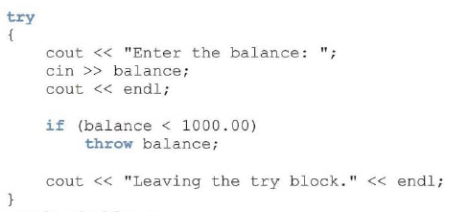

b)
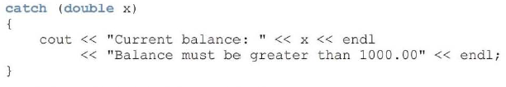

c)
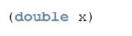

d)

3)
a) Entering the try block.
Exception: Lower Limit Viloation.
b) Entering the try block.
Exiting the try block.
After the catch block

4)
Immedieate attention required!
MyException thrown!

Attention required!
May Day, May Day

5)
class tornadoException {
private:
string message;
public:
tornadoException() {
message = “Tornado: take cover immediately!”;
}
tornadoException(string m) {
message = “Tornado: ” + m + “miles away; and approaching!”;
}
string what() {
return message;
}
}

