# CS 211 Homework #2

Please complete the homework problems on the following page using a separate piece of paper. Note that this is an individual assignment and all work must be your own. Be sure to show your work when appropriate. This assignment is due **in lab** on Monday, October 24, 2016.

1. [3] Remove 5 from the following AVL tree; draw the results:

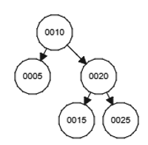

2. [3] Insert the value "8" into the following AVL tree; draw the result:

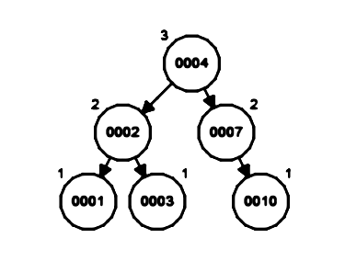

3. Given the following AVL tree:

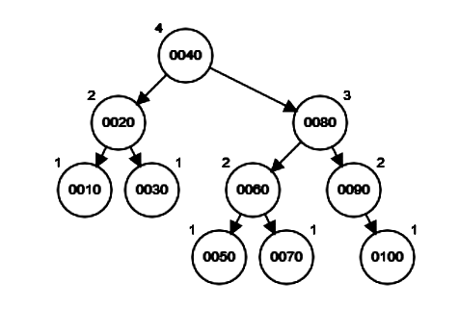

A. [3] Add 45 to the tree.

B. [3] Ignoring all previous tasks, add values 9 and 8 to the tree.

C. [3] Ignoring all previous tasks, remove values 10 and 30 from the tree.

D. [3] Ignoring all previous tasks, remove 80 and 100 from the tree.

4. **Binary Heaps (i.e. Priority Queues)** Starting with an empty binary **min heap**, show the following. Be sure to clearly label each diagram.

1. [3] The final state of the heap, in tree form, after adding in the values: 5, 4, 3, 6, 7, 8, 10, 2, 9, 1
2. [3] The state of the heap, in tree form, after two Dequeue() operations
3. [2] The final, array-based version of the heap

|  |  |  |  |  |  |  |  |  |  |
| --- | --- | --- | --- | --- | --- | --- | --- | --- | --- |
|  |  |  |  |  |  |  |  |  |  |
| 0 | 1 | 2 | 3 | 4 | 5 | 6 | 7 | 8 | 9 |